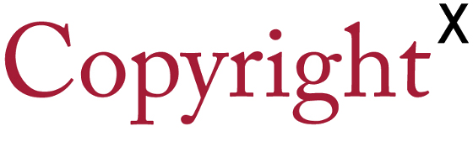

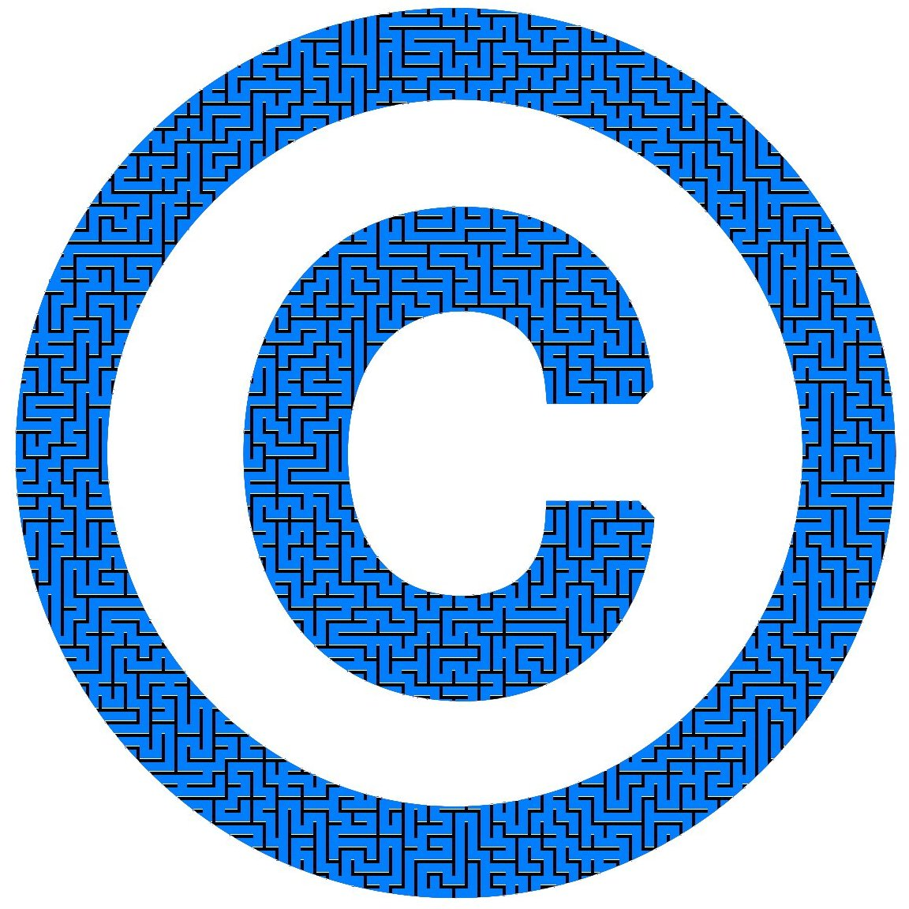

Lecture Transcripts
Based on the Lectures of Prof. William W. Fisher III, Harvard Law School
Compiled by Marc Pelteret, student of CopyrightX: UCT 2017

Version 1.2 (7 February 2018)

Preface
There are many ways to learn, and which way is best is up to the individual to decide. Personally, I find it quicker and easier to read rather than listen to lectures. Because of this, I decided to extract the transcriptions of Prof. Fisher’s excellent lectures from the YouTube videos. Only later I did I discover that the FLAX project (http://flax.nzdl.org) had already done this. What the project lacks, however, is the visual references, and so I decided to continue with my effort to create a comprehensive set of transcripts, complete with as much referenced material as possible.
This text includes most images, diagrams, graphs and textual material referenced in the video lectures. Some material was left out because while it is interesting to see, it is not critical to understanding the subject and would only have extended the length of the text. Many of the diagrams and graphs were re-drawn, initially just to make a few of them clearer, but later to ensure they have a consistent look. In a few cases I added extra detail.
Most of the text is a direct transcription of Prof. Fisher’s videos. Some editing was necessary to refer to figures and tables, rather than the screen. Additional editing was done to correct mistakes in the transcriptions, remove repetition (particularly in the introduction of each lecture), and to improve the readability of the text.
Following Prof. Fisher’s example, this work is released under the Creative Commons Attribution 4.0 License. I may revise it as the lecture videos are updated, but if I do not, others are welcome to do so. A list of which versions of the videos the text is based on can be found in Appendix B.
I hope you find this document useful, and the course as enjoyable and interesting as I did. Many thanks to Prof. Fisher and Dr. Tobias Schonwetter of the Dept. of Commercial Law at the University of Cape Town for all the work they put into presenting a very worthwhile course.

Marc Pelteret
Student of the CopyrightX: UCT 2017 at the University of Cape Town in South Africa


Creative Commons Attribution 4.0 License
https://creativecommons.org/licenses/by/4.0/

Contents
- The Foundations of Copyright Law 1
1.1. Introduction 1
1.2. Originality 5
1.3. The Idea/Expression Distinction 11
1.4. The System of Multilateral Treaties 15
- Fairness and Personality Theories 26
2.1. Introduction 26
2.2. Fairness 28
2.3. Personality 36
- The Subject Matter of Copyright 46
3.1. Literature (and Software) 46
3.2. Drama and Choreography 52
3.3. Music 56
3.4. Audiovisual Works 65
3.5. Fictional Characters 67
3.6. Architectural Works 69
- Welfare Theory 81
4.1. The Utilitarian Framework 81
4.2. The Incentive Theory of Copyright 90
4.3. Applications and Assessment 103
- Authorship 108
5.1. Sole Authorship 108
5.2. Joint Authorship 113
5.3. Works for Hire 121
- The Mechanics of Copyright 130
6.1. The Decline of Formalities 130
6.2. Duration 140
6.3. Protective Provisions 145
- The Rights to Reproduce and Modify 156
7.1. Reproduction 156
7.2. Improper Appropriation 164
7.3. Derivative Works 178
- Distribution & Performance Rights 183
8.1. Distribution 183
8.2. Performances 198
8.3. Exceptions & Limitations 208
- Fair Use 218
9.1. The History of Fair Use 218
9.2. Fair Use Today 229
9.3. Other Approaches 242
- Cultural Theory 257
10.1. Premises 257
10.2. Implications 264
10.3. Supplements and Concerns 274
- Supplements to Copyright 280
11.1. Secondary Liability 280
11.2. Dual-Use Technologies 286
11.3. Tech Protection Measures 299
- Remedies 308
12.1. Equitable Relief 308
12.2. Damages 312
12.3. Criminal Penalties 321
- Appendices 326
A. Sources 326
B. Document History 329

List of Figures
Figure 1: “The Thinker” by Auguste Rodin 5
Figure 2: “Mona Lisa” by Leonardo da Vinci 5
Figure 3: A poster advertising the Great Wallace circus 7
Figure 4: Studio photograph of Oscar Wilde taken by Napoleon Sarony, the subject of Burrow-Giles Lithographic Co. v. Sarony 111 U.S. 53 (1884) 10
Figure 5: Bill Diodato Photography v Kate Spade – original photograph (top) and accused photograph (bottom) 12
Figure 6: Gentieu v. Tony Stone Images/Chicago Inc. et al (2003) – Gentieu’s photograph (left) and accused photograph (right) 13
Figure 7: Screenshot of Google Maps showing the sector of Cambridge, Mass., that includes Harvard University 14
Figure 8: A maps showing the Berne Convention signatory countries (as of January 2016) 19
Figure 9: Berlin Hauptbahnhof, designed by Meinhard von Gerkan 36
Figure 10: Two cartoons by Gary Larson 39
Figure 11: White v. Samsung Electronics America, Inc. (1992) – magazine adverts run by Samsung; the one in the top right was the subject of the lawsuit 43
Figure 12: The real Vanna White and the image of the robot in the Samsung advert 43
Figure 13: The Dickson-Edison Kinetoscope 47
Figure 14: The growth of US copyright law 48
Figure 15: A timeline of the creation of forms of intellectual property for software 52
Figure 16: Buddhist monks from the Namgyal Monastery creating a sand mandala 55
Figure 17: Parties involved in the copyrighting and licensing of music works (compositions), and their interactions 57
Figure 18: Parties involved in the copyrighting and licensing of sound recordings, and their interactions 58
Figure 19: Press release by the Recording Industry Association of America (RIAA) welcoming the introduction of the Performance Rights Act 60
Figure 20: Press release by the National Association of Broadcasters (NAB) opposing the introduction of the Performance Rights Act 61
Figure 21: Parties involved in the copyrighting and licensing of sound recordings and the payments between them (in green) 62
Figure 22: Parties involved in the copyrighting and licensing of movies, and their interactions 66
Figure 23: Omega S.A. v. Costco Wholesale Corp. – the Omega globe design 70
Figure 24: Carol Barnhart Inc. v. Economy Cover Corporation (1985) – mannequins 72
Figure 25: Barry Kieselstein-Cord v. Accessories by Pearl, Inc. (1980) – belt buckles 72
Figure 26: Brandir International, Inc. v. Cascade Pacific Lumber Co. – the Bandir ribbon rack 73
Figure 27: Two of cheerleading uniforms offered by Varsity Brand 74
Figure 28: Five of the cheerleading uniform registrations belonging to Varisty Brand 75
Figure 29: The Jewish Museum in Berlin, designed by Daniel Libeskind 77
Figure 30: The National Museum of Australia, designed by Howard Raggatt 79
Figure 31: Compare the National Museum of Australia (left) to the Jewish Museum in Berlin (right) 79
Figure 32: The basic axes 91
Figure 33: The marginal cost of producing a DVD 92
Figure 34: Plotting price vs demand 92
Figure 35: The demand curve 93
Figure 36: A possible initial price for the DVD and the resultant revenue 93
Figure 37: A rival copies the DVD and sells it at a lower price 94
Figure 38: Competition drives the price down to (almost) the marginal cost 94
Figure 39: At marginal cost, there is a consumer surplus, but there is no incentive to make the film 95
Figure 40: Perfect price discimination leads to maximum “monopoly profits” 95
Figure 41: Price experimentation in month 1 and the resultant revenues 96
Figure 42: The month 1 revenue broken down into costs and profits 96
Figure 43: Price experimentation in month 2 and the resultant revenue gain and loss 97
Figure 44: The total profit for month 2 97
Figure 45: Price experimentation in month 3 and the resultant revenue gain and loss 97
Figure 46: Price experimentation in month 4 and the resultant revenue gain and loss 97
Figure 47: The total profit in month 4 97
Figure 48: The marginal revnue curve 98
Figure 49: Using the marginal curve to find the profit-maximizing price and output, which yield monopoly profits 98
Figure 50: Price experimentation in month 4 and the resultant revenue gain and loss 99
Figure 51: Pricing on Amazon for the DVD of Schindler’s List 100
Figure 52: Purchase pricing for the short film Defending Our Lives. 100
Figure 53: At a high price, CDF will earn some monopoly profit, but it will forfeit a large potential market 101
Figure 54: The first steps in showing the demand curves for regular consumers and instutions 101
Figure 55: The instituional and consumer demand curves 101
Figure 56: The Toyota Solera 110
Figure 57: Meshwerks' wireframes for the Toyota Solera 110
Figure 58: G&W's additions to Meshwerks' wireframes 110
Figure 59: The RMS Titanic 111
Figure 60: A photo of the bow of the Titatnic wreck 112
Figure 61: Poster for the musical play “Rent” – Oregon version 113
Figure 62: Poster for the musical play “Rent” – Jarkarta version 114
Figure 63: The facts of the Thomson case 114
Figure 64: James Earl Reid's sculpture commemorating homelesness 123
Figure 65: The second page of Gone with the Wind, showing the book’s copyright information 132
Figure 66: The timeline of copyright protection under the 1909 regime 133
Figure 67: Copyright registrations (excluding renewals), 1910 – 2000 136
Figure 68: Rate of copyright renewals, 1910 – 2000 136
Figure 69: The timeline of copyright protection under the current regime 137
Figure 70: The effect of Creative Commons 139
Figure 71: Durations under the 1909 copyright regime 141
Figure 72: Copyright duration of works published before 1923 142
Figure 73: Copyright duration of works published 1923 – 1963 142
Figure 74: Copyright duration of works published 1964 – 1977 143
Figure 75: Copyright duration of works created but not published before 1978 144
Figure 76: Duration of works created in 1978 or later 144
Figure 77: Duration of works created in 1978 or later, for anonymous works, pseudonymous works, and works for hire 144
Figure 78: Copyright under the 1909 regime, showing the ability to assign renewal rights 145
Figure 79: The parties involved in and the timeline of Fred Fisher Music v. M. Witmark & Sons 148
Figure 80: Termination rights for works created in 1978 or later 151
Figure 81: Termination rules that apply if rights were assigned after 1978 152
Figure 82: Termination rules that apply if rights were assigned before 1978 153
Figure 83: The operations of Cablevision 162
Figure 84: The Nichols "pattern" test 172
Figure 85: Pattern test for software, step 1 – remove elements dictated by efficiency 173
Figure 86: Pattern test for software, step 2 – remove elements dictated by external factors 173
Figure 87: Pattern test for software, step 3 – remove elements taken from public domain 173
Figure 88: Pattern test for software, step 4 – compare elements of defendant’s program vs protected parts of plaintiff’s program 173
Figure 89: Comparing a magazine photo of Kevin Garnett and a photo prepared for a billboard advertising Coors beer 174
Figure 90: A cover of The New Yorker magazine compared to a poster advertising the movie Moscow on the Hudson 175
Figure 91: The mayor character in the TV show “Fun Stuff” contrasted with the mayor of McDonaldland 176
Figure 92: Comparing the photos in the Kisch case 176
Figure 93: Prince’s “Love Symbol #2” 182
Figure 94: Pickett's guitar design 182
Figure 95: Pricing on the American Airlines website for a flight 143 on 1 June 2014 184
Figure 96: Seating configuration of the Boeing 757-200 aircraft 184
Figure 97: Market windows for major films from release date, circa 1990 186
Figure 98: The relationship between provisions of sections 602, 106 and 109 191
Figure 99: An example of the import restriction text on a textbook 192
Figure 100: Vernor v Autodesk, Inc. – Vernor’s narrative 196
Figure 101: Vernor v Autodesk, Inc. – Autodesk’s narrative 196
Figure 102: Case law affecting the provisions of sections 602, 106 and 109 198
Figure 103: Violations of § 106 200
Figure 104: The economic effects of a copyright vs that of a compulsory licensing system 217
Figure 105: An advert for Sony Betamax tape storage cabinets 222
Figure 106: Interoperability 230
Figure 107: Sega Enterprises Ltd. v. Accolade, Inc. (9th Cir. 1992) 231
Figure 108: The Vanity Fair cover featuring Demi Moore, a portion of Botecelli's "The Birth of Venus", and the Naked gun 33⅓: The Final Insult poster that parodies the Vanity Fair cover 234
Figure 109: Mattel’s Barbie and photos from Forsythe’s series “Food Chain Barbie” 235
Figure 110: Art Rogers, photograph: Puppies, 1980 237
Figure 111: Jeff Koons, wood painted sculpture: String of Puppies, 1998 237
Figure 112: The nature of “transformative” and leading cases involving fair use 238
Figure 113: Strength of copyright protection 241
Figure 114: Implementation status of the 22 exceptions and limitations to copyright for all 28 EU member states 249
Figure 115: Implementation status of the 22 exceptions and limitations to copyright for all 28 EU member states, with China added for comparison 251
Figure 116: Leading cases where “transformative” was defined as “creative” highlighted by the green ellipse 269
Figure 117: Actions that a copyright owner can take against parties for publicly performing their work in a dance hall without permission 285
Figure 118: How Napster’s MusicShare software functioned 289
Figure 119: Grokster’s software functioned using FastTrack technology, which uses supernodes 292
Figure 120: The state of the law governing OSPs after the Viacom decision 299
Figure 121: US consumer home entertainment rental and sell-through spending (2010) 305
Figure 122: Ranges of statutory damages 316
Figure 123: Verdicts in the Thomas-Rassett case 320
Figure 124: David LaMacchia (right) with his lawyer 321
List of Tables
Table 1: The lecture topics for the course 2
Table 2: Selected “Covers” of Hendrix, Little Wing 64
Table 3: Test for determining when a person should be considered an employee, applied to the CCNV case 124
Table 4: Copright formalities for US works over time 131
Table 5: The application of the fair use factors in the Sony, Harper & Row, and Campbell cases 228

The Foundations of Copyright Law

Introduction
This is the introduction to a series of twelve lectures on copyright. My hope, in these lectures, is to provide you the following things:
- First, an understanding of the basic principles of copyright law.
- Second, an appreciation of the ways in which that law affects, for better and worse, creativity and innovation in a wide variety of artistic and technical fields. (To that end, I will be providing you, along the way, illustrations of the ways that copyright works in literature; music; film; photography; graphic art; software; comedy; fashion; architecture; and so forth.)
- Third, I will try to provide you a critical understanding of the main theories of copyright by which I mean, the arguments, developed over several centuries by economists, philosophers, and political theorists, concerning the purposes or functions of the copyright system.
These theories are not mere matters of academic curiosity and dispute.
Copyright law is changing very fast, in part in an attempt to address new technologies, and the lawmakers who are making the changes are influenced by and in turn help to shape the competing theories of copyright. So, to understand where the law is going and certainly if you wish to affect its trajectory you need to know a fair amount about theory.
This bring me to the fourth and last of the ambitions: By the end of these lectures, I hope to have increased your ability and confidence to make informed judgments concerning how, if at all, the copyright system should be reformed.
So, to summarize: copyright law; its impact on creativity; theories of copyright; and ways in which the system could be improved those are the general themes I will be addressing. The themes are intertwined, of course, and I will try to identify, in the lectures, the relationships among them.

The topics of the twelve lectures, in which I will be addressing these themes are set forth in Table 1. This first lecture is called “the foundations of copyright law.” Once I am finished with the introductory material, I will discuss three aspects of copyright that can be thought of as fundamental:
Table 1: The lecture topics for the course
- The Foundations of Copyright Law  - Fairness and Personality Theory *  - The Subject Matter of Copyright  - Welfare Theory *  - Authorship  - The Mechanics of Copyright | - The Rights to Reproduce and Modify  - Distribution & Performance Rights  - Fair Use  - Cultural Theory *  - Supplements to Copyright  - Remedies

- the concept of originality;
- the crucial distinctions in copyright law between ideas, facts, and expression;
- and the system of multilateral treaties that constrain the freedom of almost all countries when shaping and administering their national copyright systems.
Along the way, I will discuss some current controversies that those basic principles affect.
The second lecture will examine and contrast two theories of copyright law specifically the fairness theory, which is especially prominent in countries (like Great Britain, the United States, and Australia) that have been influenced by the common-law legal tradition; and the personality or personhood theory, which tends to be somewhat more prominent in countries (including Continental Europe and Latin America) that have been influenced by the civil-law tradition.
In the third lecture, we will return to legal doctrine. Specifically, I will survey the kinds of original works that are subject to copyright protection. Some of these (such as novels, musical compositions, and films) will be unsurprising. Others (such as software, fictional characters, and three-dimensional useful objects) may be somewhat more eye-opening.
The fourth lecture will concentrate on the most complex of the copyright theories: the welfare theory, an outgrowth of the philosophic tradition of utilitarianism. As we will see, this theory has growing influence, certainly among scholars and increasingly among lawmakers, in all jurisdictions in the world.
The fifth lecture will consider the complex set of rules that define the term, “author” – and identify the persons and organizations that qualify as authors.
The sixth lecture, entitled “the mechanics of copyright,” considers how the copyright system works in practice. I will discuss, for example,
- what, if anything, an author must do to secure copyright protection;
- the preconditions for bringing a copyright infringement suit;
- how long copyrights last;
- how the rights associated with copyright are transferred from one person to another;
- and how the copyright system attempts to shield authors (or their families) against exploitation.
The seventh and eighth lectures will examine in some detail the legal rights that a copyright owner enjoys. The primary entitlements, we will see, are the exclusive rights to reproduce, modify, distribute, or perform their works. We will examine the scope of each of those rights – and the equally important list of specific exceptions and limitations upon those rights, which are designed to protect the public’s interest in enjoying and transforming copyrighted materials.
The ninth lecture will examine the general defense to copyright infringement known variously as fair use and fair dealing. This is among the most controversial and unstable aspects of the copyright system. How this doctrine evolves in the near future will have a big impact on journalism, music, film, graphic art, and so forth.
In the tenth lecture, we will return for the last time to copyright theory, examining an approach that seems gradually to be growing in influence in many countries. It goes by various names, but I will use the term cultural theory.
In the eleventh lecture, we will examine 2 important supplements to the set of legal rights enjoyed by copyright owners. The first of these is the doctrine of secondary liability, which enables copyright owners sometimes to control the behavior of organizations that do not themselves engage in copyright infringement, but rather facilitate the infringing behavior of others. (Included in this group are some quaint organizations, like flea markets, and some modern ones, like peer-to-peer file sharing systems.) The second supplement is the recent addition to the copyright system of prohibitions on the circumvention of technological protection measures. That cumbersome term refers to legal efforts to increase the ability of copyright owners to control uses of their works through encryption.
Finally, in the twelfth lecture, I will survey the legal remedies that are available to a copyright owner whose rights have been abridged.
The lectures marked using an asterisk (*) focus on theoretical or policy considerations, while the others focus on copyright law and its applications. When discussing details concerning copyright law, I will most often make reference to the rules currently in force in the United States partly because I know that system best, and partly because, for better or worse, US law is influential in many other jurisdictions. But I will also devote significant attention to the differences between US law and the legal systems in other countries.
Now, a few words about the logistics of these lectures: Each will last roughly 90 minutes. A fair amount of graphic and audiovisual materials will company the presentations. Consequently, it will be best if you view recordings of the lectures on a computer or on a screen of some sort. You could, of course, just listen to them, but you would be missing much illustrative material.
The most important of the supplementary visual materials will be two maps I have prepared. One covers the main features of copyright law. The other covers the main features of copyright theory. Because the maps themselves and my use of them are unusual, I will say a few more words about this feature. The heart of the first map looks like this. As you might imagine, the “plus” signs identify opportunities for expansion. If you click on a “plus” sign, it will open additional branches of the map – like so. These icons identify links. Some of the links will open slide presentations that I have prepared. Others lead to copies of statutes or judicial decisions – or to supplementary materials prepared by other scholars or lawyers that are accessible through the Internet.
The second map, which examines Intellectual Property Theory, works the same way. Both of the maps were created using the Mindmanager software program, and I will be displaying the Mindmanager versions on your screens during these lectures. If you want to explore the maps at your leisure, you can gain access to them through the CopyrightX website or through my personal homepage, the address of which is: tfisher.org.
If you want to edit the maps, for example, to add your own notes or to supplement the links you will need a software program of some sort. You can, of course, use Mindmanager – which you can obtain from the website for Mindjet – but it is expensive. Other programs that can be used to import and edit the maps include thoughts, which is available for a modest price, and Xmind, an open-source program that is available for free.
Last but not least, if you want to explore the maps but not edit them, the easiest way to do so is to use the “flash” based versions, which are available on the CopyrightX website. To use those, you do not need any software at all; they will open in most modern browsers. Together, the two maps contain all of my lecture notes for all 12 of these lectures, plus links to a wide variety of additional materials. The result is that they contain – or provide access to – a large amount of information and commentary.
However, it is important that you understand their limitations. In particular, you should not think of the first map as the equivalent of a treatise on copyright law; it is certainly not a comprehensive survey of the law, and it contains some opinionated material that would be inappropriate in a treatise. Rather it is a pedagogic aid – a device intended to facilitate your understanding of – and capacity to remember – the main features of the copyright system. I modify both of the maps with some frequency. Most often, I do this to take into account changes in copyright statutes or treaties or new judicial decisions. But I also sometimes revise the maps when I change my mind on a particular issue or when another commentator deploys a novel argument. Accordingly, if you find the maps useful in the future, you should probably check the CopyrightX website to make sure that you have the most current versions. I will try to keep the maps reasonably up to date as long as I am able.
Finally, if you have suggestions concerning the content of either map (bearing in mind, of course, their limited purposes), feel free to e-mail me using the address listed on the CopyrightX website. The same principle applies to these lectures. If you have suggestions concerning how they might be improved – please let me know, by sending a message to the same email address.
This concludes the introduction to lecture one. In the next segment, I will take up the first of the substantive topics in the course: the concept of originality.

Originality
To be entitled to copyright protection, something must be original. That term encompasses two distinct requirements. The first is independent creation. If you copy your work from someone else, you cannot assert a copyright in it. Suppose, for example, that you read a poem and like it. You memorize it, then you write it down verbatim. Someone photocopies the piece of paper on which you have written down the poem. Do you have a copyright claim against the person who makes the photocopy? No. The author who first created the poem might, but you don’t. That’s certainly true if the poem is recent and still covered by copyright. But what if the poem is old and no longer covered by copyright? You still have no claim against the person who makes the photocopy, because your work is not original.
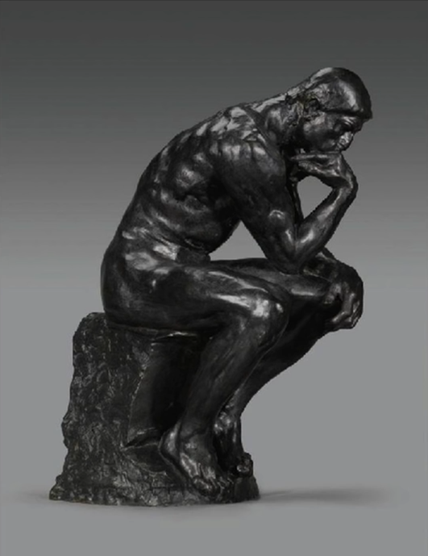 | 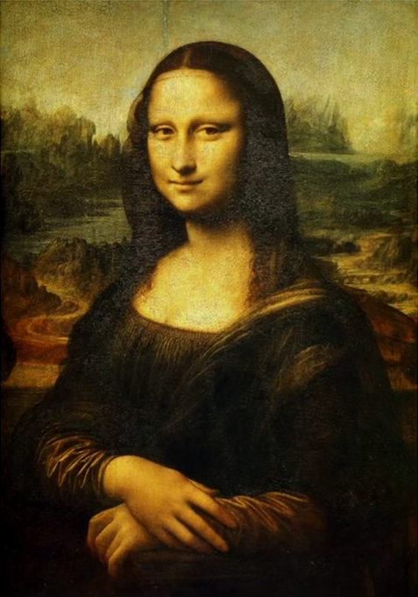
Figure 1: “The Thinker” by Auguste Rodin | Figure 2: “Mona Lisa” by Leonardo da Vinci

Here’s a more plausible example: Rodin’s famous sculpture, “The Thinker,” was created in 1902 – and thus (as we will see) is no longer subject to copyright protection. Suppose that you make a perfect replica of The Thinker. Do you have a copyright in your replica? In other words, if someone copies your replica, do you have a legal claim against the copyist? No. The same principle applies – certainly in the US and probably in other countries – if you take a photograph of an old painting, like the Mona Lisa, trying to recreate the painting exactly. This is not a hypothetical example. A few years ago, there was a sharped-edged controversy between the National Portrait Gallery in England and one Derrick Coetzee, who uploaded to Wikipedia some 3000 high-resolution photos, taken by the Portrait Gallery, of old paintings in its collection. Coetzee invoked this principle when resisting, successfully, the Gallery’s copyright claims: because the photos lacked originality, they were not shielded by copyright.
As we will see later, the question becomes more complicated if your replica or painting of a public-domain work is not perfect – in other words, if you have made changes to The Thinker or altered the colors of the Mona Lisa. But if your replica is verbatim, you have no rights. So, to repeat, the first of the two requirements encompassed by the term originality is independent creation. The second requirement is creativity. To be entitled to copyright protection, a work must embody a modest amount of creativity. Not much, but some. This is the more interesting and subtle of the meanings of originality, and we’ll spend a fair amount of time exploring it. Before doing so, however, we need to identify some related characteristics that are not required for copyright protection – and consider why not. Once we have cleared away this underbrush, we’ll return to the question of creativity.
The first thing not encompassed by the originality requirement is novelty. To be protected in the United States, a work does not have to be new. In this respect, copyright law is very different from patent law. To be patentable, an invention must be new. To be protected by copyright, a literary or artistic work need not. The classic statement of this principle in US law appears in the Sheldon case, decided by the Second Circuit Court of Appeals. Here is what Judge Hand said:

Borrowed the work must indeed not be, for a plagiarist is not himself pro tanto an “author”; but if by some magic, a man who had never known it were to compose anew Keats’s Ode on a Grecian Urn, he would be an “author,” and, if he copyrighted it, others might not copy that poem, though they might of course copy Keats’s.

In other words, if your creation is identical to an already existing work, but you are genuinely unaware of that existing work, your creation is original, and you get the benefit of copyright protection. Novelty is not necessary.
To be sure, as Professor Paul Goldstein observes, lack of novelty, though not itself fatal, may sometimes be introduced in litigation to undermine other aspects of a plaintiff’s case. For example, it can be used to rebut a presumption that the plaintiff’s work was independently created – which, as we’ve seen, is required for copyright protection. Or a defendant can sometimes use the fact that the plaintiff’s work is not novel to argue that the defendant did not copy the plaintiff’s work, but instead copied the preexisting work. That’s the import of the last clause in Judge Hand’s statement – “though they might of course copy Keats’s.” If true, that would get the defendant off the hook. The upshot is that, in practice, novelty helps a plaintiff, and lack of novelty can hurt. But strictly speaking, novelty is not required for copyright protection.
Another thing that is not required for copyright protection – at least in the United States – is intent to be original. To get the benefit of copyright protection, it’s not necessary that you, the author, try to create something of your own. It’s only necessary that you do so. The classic statement of this principle in US law comes in an opinion by Judge Jerome Frank in the 1951 Alfred Bell case, which held that, even if mezzotint engravings of old (public-domain) paintings differed from the originals only inadvertently, they were still copyrightable. “A copyist’s bad eyesight or defective musculature, or a shock caused by a clap of thunder, may yield sufficiently distinguishable variations. Having hit upon such a variation unintentionally, the ‘author’ may adopt it as his and copyright it.” As you might imagine, this issue doesn’t arise often, and one can find some judicial opinions that seem to cast doubt upon it. But the principle expressed by Judge Hand is the canonical view in the United States.
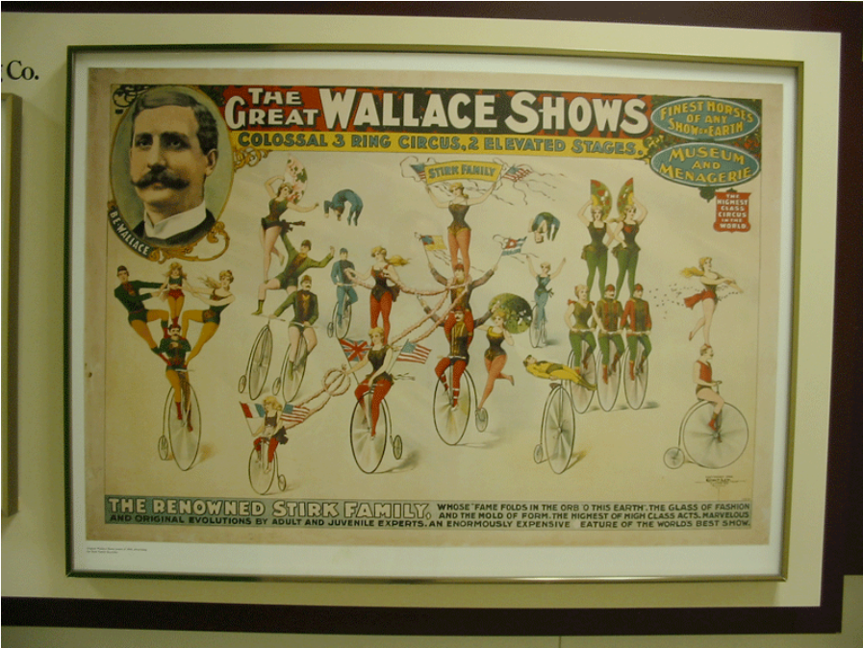
Figure 3: A poster advertising the Great Wallace circus

A third thing not required for copyright protection is that the work in question be artistic. If your creation is bad art – or not art at all – you still get a copyright in it. The classic statement of this principle comes in the 1903 Bleistein case, which involved a copyright claim to three circus posters, one of which is shown in Figure 3. In some famous passages in the majority opinion in that case, Justice Holmes rejected the defendant’s argument that these posters did not enjoy copyright protection because they did not constitute “fine art.” In US law, Bleistein has come to stand for the principle sometimes referred to as “aesthetic neutrality.” When applying copyright law, the quality or artistic character of both the plaintiff’s work and the defendant’s work are said to be irrelevant. A child’s finger paintings are as deserving of copyright protection as the Mona Lisa. Why? What might justify this stance of strict aesthetic neutrality? Defenders of this principle commonly make four arguments. The first is that judges (or juries) who would be called upon to assess the merit of either the plaintiff’s or the defendant’s works lack the expertise to do so. Justice Holmes emphasizes this point in Bleistein:
It would be a dangerous undertaking for persons trained only to the law to constitute themselves final judges of the worth of pictorial illustrations, outside of the narrowest and most obvious limits. At the one extreme, some works of genius would be sure to miss appreciation. Their very novelty would make them repulsive until the public had learned the new language in which their author spoke. It may be more than doubted, for instance, whether the etchings of Goya or the paintings of Manet would have been sure of protection when seen for the first time. At the other end, copyright would be denied to pictures which appealed to a public less educated than the judge.

The second argument, latent in the last sentence of Holmes’ passage, is fear of elitism – worry that an upper class would use the opportunity to assess artistic quality to impose their tastes on the rest of the population. The third, related argument is fear of paternalism – or what has come more recently to be called parentalism. This argument is tied to the political theory of liberalism, which continues to have considerable sway at least in western democratic societies. The basic idea is that governments should not impose on their citizens any particular conception of the good – or the good life in particular – but rather should create conditions in which people are free to formulate and pursue their own conceptions of the good. One implication of that idea, it is sometimes argued, is that the law – specifically copyright law – should not promulgate a particular conception of what counts as worthy art. In the United States, this attitude finds expression in periodic campaigns to abolish the National Endowment for the Arts, which distributes government funds to artists. Most other countries are less hostile to government support for the arts.
The final argument in favor of the principle of aesthetic neutrality is that to decide what constitutes good art, one needs to know what art is, and there’s deep disagreement on that crucial question. As Professor Fred Yen has pointed out, at least three different meanings of art are in widespread circulation. Formalism, exemplified by the work of Clive Bell, defines art as things capable of provoking in sensitive people the aesthetic emotion. Some objects have formal qualities that enable them to cause this reaction while others don’t. Only the former count as art. By contrast intentionalism, exemplified by the work of Monroe Beardsley, defines art as “something produced with the intention of giving it the capacity to satisfy the aesthetic interest.” So, for example, whether people moving in a circle are engaged in a form of art depends on the nature of their motivation. Their purpose might be religious (as in a ceremony), it might be political or economic (as in a picket line), or it might be artistic (as in the dance). Only if their intention falls into the last category does their behavior constitute art. Finally, institutionalism, exemplified by the work of George Dickie, emphasizes the role of the “art world” – ““[t]he broad social institution in which works of art have their place.” The members of this world include artists and viewers who participate in the traditional social practice of creating, presenting, and appreciating art. Against this backdrop, “objects become art when someone who believes that he is a member of the art world invites others to view the object aesthetically.” In the simplest case, an object constitutes art if a museum chooses to display it. These three approaches – formalism, intentionalism, and institutionalism – are in obvious tension. Some objects or activities qualify as art under one approach, but not under others. If aesthetic theorists cannot resolve this crucial question, surely it would be foolish for the law to attempt to do so. So, those are the four arguments commonly deployed in support of the principal of aesthetic neutrality. Lack of expertise, unease about elitism, hostility to governmental involvement in art, and uncertainty concerning what constitutes art in the first place. However, as we will see, the principle of aesthetic neutrality is frequently violated – tacitly and occasionally expressly – even in the United States, which purports to adhere to the principle most faithfully. Judges and juries find ways to favor plaintiffs who have created what they consider meritorious works, and to disfavor plaintiffs who have created what they consider bad or unimpressive material. On the other side of the ledger, judges and juries find ways to penalize defendants whose work seems poor, and to give extra latitude to defendants whose work seems worthy of respect.
Professor Yen and others argue that, if judges and juries are going to be making such judgments, they should do so expressly-and should be obliged to justify their judgments. This is a fairly fundamental issue, on which, as we will see, countries differ sharply. By the end of the series of lectures, I hope you are in a position to form your own opinion concerning the scope and merits of the principle of aesthetic neutrality.
Yet another characteristic not required for copyright protection is that a work be noncommercial. This is not quite as obvious as it might seem. For example, Justice Harlan, in a dissenting opinion in the Bleistein case, suggested that advertisements will be produced in at least optimal quantities, regardless of whether they are protected by copyright. In other words, copyright protection for ads is unnecessary. Whatever the merits of Harlan’s position, it has been rejected. Today, advertisements definitely enjoy the protection of the copyright law.
A final characteristic not required for copyright protection in the United States is that the content of a work be lawful. So, for example, it’s now reasonably clear that, in the US, obscene, libelous, or fraudulent material enjoys copyright protection. In this respect, US copyright law differs sharply from US trademark law, which denies protection to immoral or scandalous marks. Copyright law purports to have no such exclusions.
Having listed the things that copyright does not require, let’s now return to what it does require. As I mentioned earlier, to satisfy the requirement of originality, a work must pass two tests: it must be independently created, and it must embody some degree of creativity. The more important and slippery of these tests relates to creativity. How much do you need? In the United States, very little. In its 1991 decision in the Feist case, the Supreme Court put it this way: A work must possess “at least some minimal degree of creativity. To be sure, the requisite level of creativity is extremely low; even a slight amount will suffice. The vast majority of works make the grade quite easily, as they possess some creative spark, ‘no matter how crude, humble or obvious’ it might be.” As the Court notes, it’s pretty easy to pass the test formulated in this way. Take photographs, for example. In 1884, the Supreme Court ruled that this staged studio photo of Oscar Wilde (Figure 4) enjoyed copyright protection, emphasizing the many forms of creativity that went into setting up and producing the photo. Today, it’s clear that nothing so elaborate is necessary. In the US, a snapshot taken with a modern automated point-and-shoot camera contains enough creativity to satisfy the Feist standard. The modest creativity involved in deciding what to point the camera at, and when to activate the shutter, is enough.
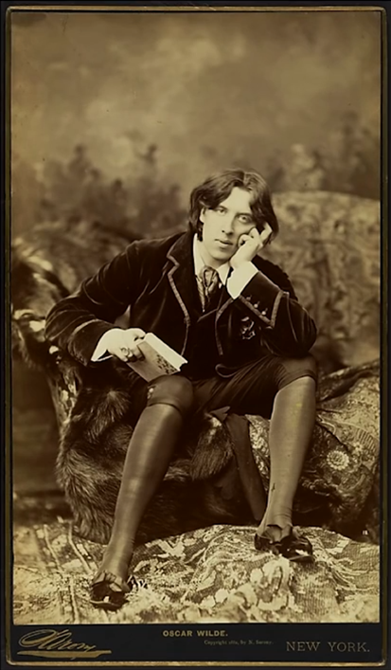
Figure 4: Studio photograph of Oscar Wilde taken by Napoleon Sarony, the subject of Burrow-Giles Lithographic Co. v. Sarony 111 U.S. 53 (1884)

But some degree of creativity is necessary. The most important effect of this requirement is to withdraw copyright protection from works whose form is entirely conventional, even if they required lots of effort and/or skill to create. At one point, courts in the US (and in other common-law countries) extended copyright protection to such works under the auspices of the so-called “sweat of the brow” theory. Since the 1991 Feist decision, that doctrine has been formally rejected by US courts. I hasten to add that, in practice, it’s not so clear that a plaintiff’s labor does him no good when seeking copyright protection. Despite the formal repudiation of the sweat of the brow theory, in borderline cases, some courts still pay attention to the effort that authors have invested in their works. Again, this is a general theme we’ll return to in lecture #2, when we take up the Fairness and Personality Theories of Intellectual Property.
Thus far, I have confined my attention to the interpretation of the originality requirement in the United States. Now let’s examine some other jurisdictions. Today, every country in the world treats originality as an essential requirement for copyright protection. But not all define “originality” the same way. A few decades ago, countries’ disagreement on this issue was sharp. Generally speaking, countries influenced by the common-law tradition set the bar very low, while countries influenced by the civil-law tradition were more demanding. The two fields where this disagreement mattered most were photography and software. As mentioned above, in the US and its cousins, virtually all photos taken by people have long enjoyed copyright protection. By contrast, as Roman Heidinger has observed, in Austria photographs were given copyright protection only if they differed substantially from pre-existing photographs. Applying that standard, a conventional photo showing some bikers in a landscape failed to qualify. Likewise, as we will see in Lecture #3, software programs received generous protection in the US and its cousins. In Germany, by contrast, software programs were accorded copyright protection only if they embodied degrees of creativity greater than that exercised by average programmers. Recently, the divergence among countries on these and related issues has decreased. As you can see from the map, most common-law countries have now repudiated the permissive “sweat of the brow” approach and adopted stances similar (though not always identical) to the approach taken by the US Supreme Court in Feist.
Meanwhile, harmonization within the European Union has resulted in a modest softening of the requirements that some of the member countries previously enforced. In a series of decisions, the European Court of Justice has announced and then refined a new, general definition of originality. Under this new approach, two related things (in addition to independent creation) seem both necessary and sufficient: the creation reflects the author’s personality; and the author, when creating the work, was able to express her creative ability by making unconstrained choices and thus impressing her personal touch on the work. The articulation of this standard by the European Court of Justice has caused courts in several of the member countries of the EU to adjust their originality thresholds – in most cases downward. In Austria, for example, it’s now easier to secure copyright protection for modestly creative photos than it used to be. And in Germany, a larger set of software programs are now eligible for copyright protection; the only things now excluded are simple, routine programs that ordinary programmers would write the same way. In combination, the harmonization process in Europe and the trend among common-law countries to abandon the sweat of the brow theory has reduced the divergence among the countries of the world concerning the meaning of originality. But some divergence remains. For example, the European standard alludes to a theme that US lawmakers generally ignore – namely, the degree to which a work reflects the personality of the creator – a topic we’ll return to in the next lecture. And there remain outlier countries. For example, South Africa and New Zealand still seem to adhere to the sweat of the brow approach. At the other extreme, courts in Switzerland pay attention, when considering originality, to the degree of “statistical uniqueness” of the work in question – an approach that suggests concern with the novelty of the work, a consideration ignored in the overwhelming majority of countries. The upshot is that some works are more likely to secure copyright protection in some countries than in others.

The Idea/Expression Distinction
We turn now to the second of the foundational doctrines in copyright law: the idea/expression distinction. Every system of copyright law contains some version of this distinction. In US law, its statutory locus is section 102(b) of the Copyright Act, which provides “in no case does copyright protection for an original work of authorship extend to any idea, procedure, process, system, method of operation, concept, principle, or discovery.” (Some scholars, such as Professor Pam Samuelson, argue that this provision reaches more broadly than the idea/expression distinction, but I’ll put that controversy aside for the time being.) In the Eldred case, which we will consider in a subsequent lecture, the United States Supreme Court suggested that the idea/expression distinction is necessary in order to reconcile copyright law with the principle of freedom of speech embodied in the First Amendment of the federal Constitution.
Lots of other examples of this distinction can be found in the law of other countries. So, what exactly is this famous, fundamental distinction? It’s easy to state, but surprisingly hard to apply. The key concepts are clear enough: neither ideas nor facts are protected by copyright law; only the way in which an author expresses ideas or facts is protected. Simple enough. Unfortunately, the key terms – idea, fact, expression – are all ambiguous and contested. To figure out what they mean, you need to examine some applications of the principles.
Here’s a general guideline: when interpreting and applying the idea/expression distinction, try to avoid attributing to those terms their ordinary meanings. Think of them rather as “terms of art”: shorthand references to loose clusters of things that, for policy reasons, the law includes in – or excludes from – copyright. Against this backdrop, let’s consider some of the contexts in which the idea/expression distinction arises. The first such context is known as the merger doctrine. Suppose there is only one set of words that accurately conveys a particular idea. In such a situation, the principle that ideas are unprotected and the principle that expression is protected clash. Which prevails? The principle that ideas are unprotected. So, anyone else is free to use that uniquely appropriate set of words with impunity. Such situations arise more often than you might think-particularly the context of computer software. But we will wait to take up those illustrations until lecture three, when we will consider the various kinds of works that copyright covers.
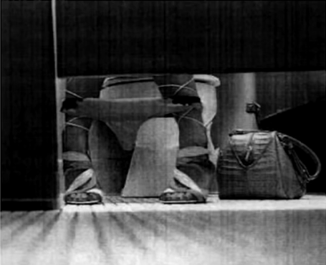

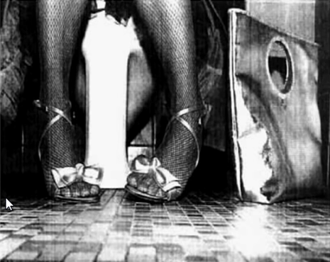
Figure 5: Bill Diodato Photography v Kate Spade – original photograph (top) and accused photograph (bottom)
The second context is known as the scenes a faire doctrine. The 1978 case of Alexander versus Haley provides a good illustration. The basic facts of that case were as follows: prior to the publication of Alex Haley’s book Roots, the plaintiff wrote a similar book about the history of her own family during slavery and about her own gradual awakening to the importance of her heritage. When Roots was published, and became famous, the plaintiff brought a copyright infringement suit against Haley. In support of her claim, the plaintiff provided a long list of parallels between her book and Roots, arguing that Haley had copied heavily from her. The court eventually ruled that, despite the large number of similar scenes, Haley had not engaged in copyright infringement. One of the grounds on which the court rejected many of the plaintiffs’ assertions is that they involved so-called scenes a faire. Here’s the language in which the court expresses this judgment: “These are incidents, characters or settings which are as a practical matter indispensable, or at least standard, in the treatment of a given topic. Attempted escapes, flights through the woods pursued by baying dogs, the sorrowful or happy singing of slaves, the atrocity of the buying and selling of human beings, and other miseries are all found in stories at least as old as Mrs. Stowe’s. Other examples include scenes portraying sex between male slave owners and female slaves and the resentment of the female slave owners; the sale of a slave child away from her family and the attendant agonies; the horror of punitive mutilation; and slave owners complaining about the high price of slaves.” All of these images, the court ruled, constituted unprotected ideas, because they were standard vignettes in the genre of US slave narratives.

Figure 6: Gentieu v. Tony Stone Images/Chicago Inc. et al (2003) – Gentieu’s photograph (left) and accused photograph (right)

Some more recent, and perhaps surprising, applications of this doctrine of scenes a faire involve photography. Here too, courts refuse to grant copyright protection to images that they conclude are standard or typical of a particular genre. For example, in the 2005 case of Bill Diodata Photography versus Kate Spade, the plaintiff contended that the photograph on the left of Figure 5, which appeared in an advertisement for women shoes, was infringed by the one on the right. The court rejected the argument, arguing that the positioning of a model sitting on the toilet with her feet angled inward, though “seemingly unnatural,” was a common trope; photographing stylish women in this pose to showcase fashion accessories was an idea “used often in popular culture.” Similarly, in the 2003 Gentieu case (Figure 6), the photograph on the right side was held not to infringe the copyright in the photograph on the left side, because, even if one photographer had been imitating the other, the compositional elements they had in common were “standard photographic conventions or devices” and thus not copyrightable.
Here’s a more straightforward application of the same general principles. Suppose I write and publish a cookbook – a collection of recipes of a particular sort. Suppose further that I created some of those recipes myself. You copy some of my recipes and include them in your own cookbook. Have you engaged in copyright infringement? If the recipes that you copied contain nothing more than descriptions of ingredients, quantities, ways of combining things, cooking times, and so forth – in other words, instructions for creating the dishes in question – then the answer is no. The reason is that unadorned recipes are said to be ideas or “methods of operation” and thus not subject to copyright protection. By contrast, if the recipes you copied included expressive embellishments – for example descriptions of how the dishes taste or suggestions concerning social circumstances for which they would be appropriate – then you would be in trouble, because such things are considered expression.

Figure 7: Screenshot of Google Maps showing the sector of Cambridge, Mass., that includes Harvard University

Maps have been protected by copyright law for a very long time. But not all components of maps enjoy copyright protection. For example, the location of roads, mountains, rivers, and political boundaries; the names of cities and towns; are all excluded from copyright protection. Thus, you can copy such things from someone else’s map onto your own without running afoul of the law. This shouldn’t be terribly surprising. More interesting is the fact that newly coined place names are not shielded. Suppose, for example, an explorer surveys a remote mountain range, selects names for the hitherto nameless peaks, and draws up a map that includes those new names. Another cartographer copies those features and those names into his own map. Copyright infringement? No. It’s sometimes said that the newly applied names, although created by the Explorer, become facts once applied to features in the world. But that can’t be right. By the same logic, the text of my novel becomes a “fact” once it’s published, and I lose copyright protection for it. A more plausible reason is that to recognize copyright protection for newly created place names would frustrate important public policies – concerning communication of geographic information. Latent in that rationale is the seed of a much more general principle that will flower in subsequent lectures. So, what aspects of maps do enjoy copyright protection? The answer is original selection, arrangement, or presentation of individually unprotected elements. The net effect is that entirely conventional maps receive no protection whatsoever. Consider, for example, the screenshot (Figure 7) of a map created by Google of the sector of Cambridge, Mass., that includes Harvard University. If I copy it without permission, as I have done for the purpose of this slide, have I engaged in copyright infringement? Probably not, because it’s difficult to locate in the Google map any unconventional selection or presentation element.
We come, finally, to the tricky case of history. Perhaps the most striking effect of the idea/expression distinction is the limited legal protection enjoyed by works of history. Suppose I spend years investigating the life of a little-known politician, and then write and publish a biography of him. You read my book, and then, relying on it, quickly write your own biography of the same politician. You’re a better writer than I am, so your book sells better. I’m angry. I point out that you could not have written your book without mine, and that most of the story I told, and most of the arguments I made, in my book can be found in yours. Do I have a copyright claim against you? If the things you lifted from me consists of facts about the life of the politician, then the answer is no – no matter how much time and pain it took me to ferret them out. This principle governed the outcome of the litigation between two historians, arising out of the close similarity between two biographies of the Rosenbergs, who were tried for treason in 1953. Because all of those similarities were deemed to involve facts, the defendant escaped liability.
What if I included in my biography some speculations, and the same speculations appear in yours? If I have represented my speculations as facts, then they too are unprotected. The rule underlying this outcome is known as copyright estoppel. Having depicted an assertion as a fact, I am said to be estopped from subsequently re-characterizing it. So, for example, in the Nash case, the Court of Appeals ruled that the plaintiff’s contention in his book the John Dillinger had not been killed by the FBI at the Biograph Theater but had lived on in California was not protected by copyright, because the plaintiff had offered that contention as a fact. What if you lift from my biography, not a factual contention, but an historical theory? Once again, I will lose, but for a different reason: historical theories are considered ideas – and thus unprotected. So, for example, in the Hoehling case the Court of Appeals held unprotected the plaintiff’s assertion that the Hindenburg dirigible had been destroyed by a member of its crew in an effort to discredit the Nazis. The bottom line is that an historian should not expect to get much protection from copyright law. If a second historian copies significant hunks of her prose, or closely tracks original ways in which she has expressed arguments, she will have a claim. But if, as in the usual case, a second historian free-rides on her research and lifts facts or ideas from her books, she has no recourse.
These examples surely do not exhaust the various contexts in which the idea/expression distinction has been applied to limit the scope of copyright – but they should suffice to give you an overall sense of the law in this area.

The System of Multilateral Treaties
This is the final segment of the first lecture in a series of lectures on copyright. In this segment, I’ll examine the system of multilateral treaties that bind most countries in the world. A word of warning: This material is intricate. You are unlikely to retain all of it right now. Several times during the remainder of this lecture series we will return to these themes. By the end of the series, you should feel comfortable with this important dimension of copyright law.
Each country in the world creates, interprets, and enforces its own copyright laws. With minor exceptions that we’ll consider in a minute, the force of those laws reach no further than the country’s borders. To put the same point a bit more formally, copyright law has no extraterritorial application. It controls conduct only so far as the nation’s edge. Suppose, to illustrate, that I’m an American musician. I write and record a song in the United States. You’re a French musician, in the United States on vacation. You hear the song broadcast on the radio. You like it. You return home. Without my permission, you make your own recording of the song in France and sell copies of that recording in France, or you perform the song in a public venue in France. US copyright law will not reach your behavior, because none of the acts that might violate my exclusive rights under US law occur in the United States. French copyright law might, because the acts at issue occurred in France, but only if French law shields US composers, like me. In any event, US copyright law won’t apply to your behavior, because it has no grip outside US territory. As I mentioned earlier, there are some minor exceptions to this principle – a few of them noted below.
- The so-called “predicate act” doctrine enables US copyright law to reach acts commenced in the US that are completed outside the US.
- When a defendant engages in infringing behavior in the US, that enables him to earn profits outside the US, courts will permit the copyright owner to recover those profits in US courts.
- For a while, some courts took the position that if a defendant in the United States “authorized” behavior outside the US, he would violate US copyright law if the behavior at issue would have been unlawful if it happened here. The Court of Appeals for the Ninth Circuit reconsidered this issue in a case involving the distribution outside the US of videocassettes of the classic Beatles movie, “Yellow Submarine.” The outcome of the case is that the court rejected its earlier position, finding authorization of extraterritorial behavior insufficient to trigger a violation of US law. There has been some grumbling about this stance among lower courts in other circuits, but for the most part the judgment of the Ninth Circuit seems to have held up.
Troublesome edge cases of this sort are likely to multiply in the future, as technology blurs national boundaries. For example, which country’s laws apply when a radio or television broadcast containing copyrighted material originates in country #1 but is then received and watched by viewers in country #2? A pair of judicial decisions in the United States take the position that such acts are governed by the law of country #2 – and thus that a Canadian broadcast received by US viewers is subject to US law. The Internet will surely generate many more worrisome problems of this sort. But the presence of these difficult edge cases should not cause you to lose sight of the basic, fundamental principle: each country adopts its own copyright laws, and those laws only apply to acts in that country.
When a country develops its own copyright law, may it discriminate in favor of its own citizens or residents? In other words, may it disfavor foreign authors? For a long time, the answer was yes. Indeed, until the late 19th century, it was common for countries to deny copyright protection altogether to foreign authors. For example, until 1891 works by foreign authors first published outside United States received no copyright protection at all in the United States. Foreign authors (most famously, Charles Dickens) and some US authors denounced this practice and sought reform of US copyright law, but to no avail. What underlay this practice? What would prompt a country, like the United States, to discriminate against foreign authors? Several forces seem to have been at work. Simple nationalism is part of the explanation. A more complex explanation is that copyright protection is often thought of as a tax on consumers. By granting an author exclusive rights, copyright law enables the author to raise the price of copies of his or her work – or to charge more for admission to performances of those works – thereby forcing consumers to pay more for those copies or performances. The rationale of that price increase, of course, is to provide a reward or incentive for creativity – a rationale that we will examine in much more detail in subsequent lectures. For present purposes, the crucial point is that copyright protection causes price increases. Historically, many nations were reluctant to force their own residents to pay those increased prices if the monies raised thereby were to be paid to authors in other countries, even (or especially) if the result would be to stimulate creativity in those other countries. Attitudes of these sorts help to explain the origins of the practice of discriminating against foreigners. Perpetuation of that practice, however, is probably better explained by interest-group politics. For example, as Bill Patry has shown, in the United States during the 19th century, many businesses came to depend financially upon their privilege to print and distribute inexpensive copies of British books. Such businesses included publishers, printers, and bookbinders. Not surprisingly, when legislative proposals to end the discrimination against foreign authors arose, the interest groups that would have been hurt by the change lobbied against it. They were successful until 1891. Indeed, when the law was eventually changed, the publishers and printers were able to secure an important qualification: copyright protection was extended to nonresident foreign authors (more specifically, to foreign authors from countries offering similar protection to US authors), but only if copies of their works were manufactured in the United States. This protectionist measure, known as the “manufacturing clause,” was eliminated with respect to foreign authors in 1955 and eliminated for US authors in 1986. Its significance in the present context is that it illustrates the ways in which the financial interests of an industry often congeal around a particular set of copyright laws – and then retard any modification of those laws. We’ll see several other examples of that dynamic later in these lectures.
Let’s return to the main theme: As we have seen, one byproduct of the principle that copyright protection is nation-specific and has no extraterritorial application is that countries could, and for a long time did, discriminate against foreign authors. Another important byproduct is that, historically, copyright laws in different countries differed dramatically. Here’s an illustration to which we’ll return frequently in this course: countries in continental Europe have long accorded generous protection to what is referred to as “droit moral” – loosely translated in English as “moral rights.” These are said to be noneconomic rights; they shield the personal or personhood interests of authors and artists, rather than their interests in making money. For example, moral rights forbid the purchaser of a painting from defacing it or obscuring the identity of the artist who painted it. Such acts might not damage the artist financially, but they threaten the bond between the artist and her creations. By contrast, countries whose legal systems were primarily influenced by Great Britain have long been more skeptical of these moral rights. Such countries include the United States, Australia, New Zealand, and so forth. The upshot is that the existence or force of moral rights traditionally varied sharply across the world. The more general point is that, historically, the entitlements enjoyed by authors and artists were quite different in different countries. That’s where things stood in the late 19th century: widespread discrimination against foreign authors, and wide divergences among the laws in different countries. There then began a long process, which continues to the present day, of convergence of national copyright laws. Convergence has encompassed three intertwined trends: first, the elimination of discrimination against foreigners. Second, the mitigation of variations across countries – exemplified by the reduction in the divergence among countries concerning the meaning of originality, discussed earlier in this lecture. And third, a steady increase in the scope, strength, and duration of copyright protection in all countries. These are important, so I’ll repeat: first the elimination of discrimination against foreigners. Second the reduction of variations across countries. And third, an increase in the scope, strength, and duration of copyright protection. There’s no logical link between those three dimensions. For example, you could imagine harmonization having been achieved through universal adoption of the least common denominator – the laws of the least protective country. In other words, we could have seen a leveling down, rather than a leveling up. How and why the three trends nevertheless have been linked historically is one of the major issues in the legal history of copyright. I hope, by the end of these lectures, you’ll have a better sense of the possible answers.
The primary vehicles of this process of convergence were a series of multilateral agreements – treaties or analogous deals among many countries. Since the late 19th century, there have been seven major multilateral agreements implicating copyright law.
- The Berne Convention;
- the Universal Copyright Convention;
- the International Convention for the Protection of Performers, Producers of Phonograms and Broadcasting Organizations, commonly known as the Rome Convention;
- the “Agreement on Trade-Related Aspects of Intellectual Property Rights,” commonly known (confusingly) as TRIPS;
- the 1996 treaty adopted under the auspices of the World Intellectual Property Organization, commonly known as WIPO Copyright Treaty;
- the contemporaneous WIPO Performances and Phonograms Treaty;
- and the recently concluded Marrakesh Treaty for the Visually Impaired.
All of these agreements are complex. I’m not going to attempt here to walk you through all of their various provisions. Instead, in this lecture, I will identify the most important general themes of these agreements. In subsequent lectures, when addressing specific sets of legal rules that have been shaped or constrained by these treaties, we will return to the relevant treaty provisions.
The two most important agreements are the Berne Convention and the TRIPS agreement, so we will spend most of our time on those. The Berne Convention is the grandparent of these multilateral agreements: it was the first to be adopted. The negotiations that resulted in the Berne Convention began in 1858 and finally culminated in 1886, with the adoption by 10 countries of the original version of the convention. Since then it’s been revised seven times. If you click on the icon associated with the “History” subtopic in the map, you’ll find a series of slides that provide details concerning the evolution of the Berne Convention – when different provisions were added, and how many countries signed on to each version. Today (meaning, as of January 2016), the Convention has been joined by 168 countries, extending its reach over most of the world. Figure 8 is a map showing its coverage.
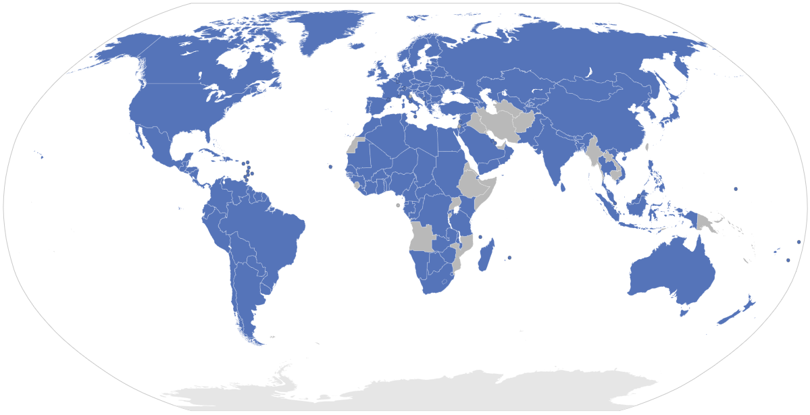
Figure 8: A maps showing the Berne Convention signatory countries (as of January 2016)

Three dimensions of the current version of the Berne Convention are crucial. The first is the so-called national-treatment principle. Prior to the Berne Convention, some countries had been chipping away at the widespread practice of discrimination against foreign authors through adoption in bilateral treaties of the so-called reciprocity principle. As its name suggests, the reciprocity principle depends upon two or more countries each extending rights to the residents of the other(s). Country number #1 agrees to grant copyright protection to the residents of Country number #2 if and only if Country #2 grants copyright protection to the residents of Country #1. The Berne Convention – and, as we will see, all subsequent multilateral agreements – repudiate the reciprocity principle in favor of the simpler and more powerful national-treatment principle. The key idea in national treatment is that country #1 must grant to the residents of country #2 the same rights it grants to country #1’s own residents. To illustrate, today French authors are given the same rights in the United States as are given to US authors, and US authors are given the same rights in France as are given to French authors. The application of this principle in the Berne Convention is actually somewhat more encompassing than I have thus far suggested. As the map indicates, the Berne Convention requires each signatory country to grant to “protected authors” the same rights it accords its own nationals. If you follow the links in the mind map, you will see that the term “protected authors” is capacious. The net effect is to require all member countries to extend the benefits of their copyright laws quite broadly. In one respect, however, the application of the national-treatment principle in the Berne Convention is less encompassing than I have thus far suggested. Specifically, the Berne Convention does not apply to what are called “neighboring rights.” This is the term used in many countries to describe the legal rights of performers and producers. They are said to be “neighboring rights,” because they are adjacent to copyrights but not true copyrights. Such neighboring rights are governed, not by the Berne Convention, but by the Rome convention. The geographic coverage of the Rome convention is substantially smaller than that of Berne. As of today, 91 countries have joined. Among the major countries not participating is the United States. We will return later in this series of lectures to the ways that the Rome convention affects the definition and scope of rights of public performance. For present purposes, the crucial point is that members of the Rome convention are permitted to discriminate against the residents of nonmember countries – including US nationals. And they do. Here’s an example: France imposes a levy on sales of blank tapes. The money raised to that levy is distributed as follows: 25% is devoted to French cultural purposes; 25% is paid to the composers of the musical compositions recorded on those tapes; 25% goes to the performers of the recordings of the songs recorded on the tapes; and 25% goes to the producers of those recordings. US composers get a share of the 2nd slice, because musical compositions are governed by the Berne Convention, and thus France may not discriminate against US authors. By contrast, US performers and producers are excluded from the 3rd and 4th slices, because their interests are not governed by the Berne Convention. So, to review, the first key dimension of the Berne Convention is national treatment – the principle that each member country must extend to the residents of other member countries the same rights it extends to its own residents.
The second of the three major dimensions of the current version of the Berne Convention is the prohibition on formalities. As the map indicates, the key idea here is that member countries may not impose upon protected authors any administrative obligations that they have to satisfy in order to acquire, enforce, or maintain their copyrights.
Curiously, member countries may impose such obligations on their own nationals – and occasionally they do so – but as one might imagine, discrimination against one’s own citizens is rare. This prohibition on formalities creates a sharp contrast between copyright law and patent law. Roughly speaking, while copyright law protects works of authorship, patent law protects inventions. To obtain a patent, an inventor must comply with myriad administrative requirements. Typically, he or she must apply for a patent within a limited period of time, and must demonstrate to the satisfaction of a patent examiner that his or her invention is useful, novel, and nonobvious. Most patent applicants eventually succeed, but not all. And compliance with these requirements is costly. Copyright law, in the overwhelming number of countries that adhere to the Berne Convention, is radically different. In those countries, there are no administrative preconditions to the acquisition or enforcement of copyright. So, for example, if you happen to be taking notes while watching this lecture, and (as we discussed previously) your notes contain a bare minimum of creativity, then you have acquired a copyright in your notes. Similarly, if you take a snapshot of your family, and that photograph is minimally creative, then you acquire a copyright in the photograph. No formal grant, no governmental imprimatur is necessary.
Historically, what underlay this hostility to formalities? The traditional explanation is that the countries most influential in the shaping of the Berne Convention subscribed to the so-called “natural rights” theory of copyright. If an author’s control over his or her creations is a natural right, then the interposition of governmental formalities would seem unacceptable. Professor Chris Sprigman, who has written most insightfully about this issue, persuasively argues that this traditional explanation is unconvincing. It’s more likely that the drafters of the Berne Convention provisions pertaining to formalities believed that disparate administrative requirements in different countries would frustrate authors’ ability in practice to secure global protection for their works. Whatever the reason, the current draft of the Convention is firmly set against formalities. This issue might seem technical and unimportant, but for two reasons it’s not. First, lawmakers in some countries have long been hostile to the Berne Convention’s prohibition on formalities. The premier example is the United States, which, as we will see, retained many formal requirements for copyright protection until late in the 20th century. Reluctance to surrender those requirements helps to explain why the United States did not join the Berne Convention until 1989. The second reason is that an unexpected byproduct of the absence of formalities is that our social environment is increasingly clogged with billions of modestly creative cultural products over which someone enjoys copyright protection, but persons who wish to make use of those products have no effective way of ascertaining the identity of the owners of those copyrights. Copyrights, as you will soon see, are everywhere, but identifying the persons to whom they belong is often infeasible. As a result, some scholars and lawmakers advocate the reinstatement of formal requirements for copyright protection. The result would be to reduce sharply the number of copyrighted works and thus the density of the legal soup through which we daily move. The principal impediment to such a reform is the Berne Convention.
The third of the three main dimensions of the Berne Convention consists of a set of obligations, imposed on all member countries, to establish minimum levels of copyright protection. For example, member countries must extend copyright protection to certain kinds of works, must grant the authors of those works specific exclusive rights, must allow those rights to continue for specified periods of time, and so forth. The details of those minimum standards will be examined in subsequent lectures. For present purposes, the main point is that, although the Berne Convention has lots of such requirements, it contains no effective mechanism for punishing member countries when they fail to comply with their duties in this regard. As a result, countries that want the benefits of the Berne Convention, but don’t want to comply with all of its obligations, are free as a practical matter to join up – and then delay or refuse to comply with the provisions that they find unattractive. The United States between 1989 and 1994 definitely fell into this category.
The posture of the United States changed substantially with the adoption of the TRIPS agreement. The history of the negotiations that resulted in the TRIPS agreement is intricate – much too intricate to be explored here. If you’re curious, the chronology is reviewed in the series of slides that can be accessed through the link associated with subtopic “origins.” Today, the geographic coverage of the TRIPS agreement rivals that of the Berne Convention. All member countries of the World Trade Organization – as of January 2016, 162 nations – are subject to the agreement. In important respects, the TRIPS agreement parallels the Berne Convention. Like Berne, TRIPS adheres to the principle of national treatment. Also like Berne, TRIPS imposes on member countries the obligation to establish certain minimum levels of copyright protection. As the map indicates, these obligations pertain to: – the kinds of works that are subject to copyright protection (including, for example, computer software); –the entitlements that copyright owners must be given; –the duration of copyrights and so forth. We will return to the details under these headings in subsequent lectures. That said, TRIPS differs from the Berne Convention in three major respects. First, it imposes upon member countries obligations, not merely to establish legal rights, but also to establish effective remedies when those rights are violated. Some of those remedies – for example, pertaining to the availability of preliminary injunctions – were more expansive than some member countries had previously adopted and so required the adoption of new laws. Second, the TRIPS agreement, because it is part of the General Agreement on Tariffs and Trade, has (unlike the Berne Convention) a mechanism for compelling member countries to comply with their obligations. Specifically, the GATT contains a dispute-resolution procedure that enables a member country to initiate a complaint against another member country that has failed to live up to its TRIPS obligations. Details concerning the handling of such disputes can be found by pursuing the links in the map. The principal penalty imposed upon a country found to have failed to comply with its obligations under the agreement is so-called “cross-sectoral” retaliation. In other words, the complaining country is permitted to impose trade sanctions on other goods. This process is far from perfect, but it does have teeth.
The third of the three respects in which the TRIPS agreement deviates from Berne is related to those teeth. As you can see from the map, the TRIPS agreement incorporates by reference all of the obligations imposed on member countries by the Berne Convention except one: article 6bis. What’s that? That article, it turns out, is the provision of the Berne convention that covers moral rights. Recall that moral rights have a lower status in common-law countries than in civil-law countries. The result of the exclusion of article 6b is that countries such as the United States, reluctant to adhere fully to the Berne Convention obligations with respect to moral rights, are still able to give them short shrift without running the gauntlet of WTO dispute-resolution proceedings. The TRIPS Agreement is the most controversial aspect of copyright law – and indeed, of the law of intellectual property as a whole. Debate concerning the merits and demerits of TRIPs – and, in particular, whether it’s been good or bad for developing countries – has been intense since the agreement was first adopted. If you follow the link associated with the subtopic, “Merits and Demerits,” you will find a few slides, summarizing the principal contending positions on this issue. Later in this lecture series, once we have on the table more information concerning the actual impact of TRIPS, we’ll return to this fundamental issue. We come next to two 1996 treaties, both of them negotiated and administered by the World Intellectual Property Organization. They have almost identical geographic coverage; currently, 93 and 94 countries respectively. The first requires member countries to expand somewhat the rights of authors; the second requires member countries to expand the rights of performers and producers. The most novel and important provision in both of these treaties is the obligation imposed on member countries to reinforce technological protection measures. Specifically, both require member countries to penalize in some way the circumvention of encryption systems or the removal of information contained in copies of copyrighted works that identify the copyright owners. A major branch of copyright law has grown out of these treaty provisions. We will consider that branch in lecture eleven.
The most recent of the seven multilateral treaties is the Marrakesh Treaty on Exceptions for the Visually Impaired, which was wrapped up in Morocco in July of 2013. There are over 300 million visually impaired people in the world. Their ability to gain access to copyrighted material in formats that they can apprehend has long been curtailed by the combination of copyright law and the reluctance of copyright owners to grant permission for the creation of digital versions of their works that, if they escaped into the wild, could corrode their primary markets. The Marrakesh Treaty attempts to overcome that impediment by requiring member countries to adopt laws that permit the reproduction and distribution of published works in formats accessible to the visually impaired and then to permit organizations that serve the visually impaired to take them from one country into another. The hope is that this new regime will eventually result in the standardization of accessible formats – thus increasing the set of materials available everywhere and saving money. The Marrakesh Treaty is unique among the 7 multilateral agreements in one important respect: it’s the only one that requires member countries to limit the scope of copyright, rather than requiring member countries to create minimum levels of protection.
Overlaid on the pattern of obligations created by these multilateral agreements are a few regional agreements, which further constrain the freedom of member countries to shape their national copyright systems. The most prominent of the regional organizations that generate such agreements is the European Union. Several EU directives listed in the map oblige countries within the Union to manage their copyright systems in particular ways. Less well known is the African Intellectual Property Organization (commonly known as OAPI), the members of which are subject to similar obligations. We’ll take up the details of these regional directives later. The framework created by this welter of multilateral and regional agreements is not stable. On the contrary, countries – and major interest groups within countries – struggle constantly to tilt the framework in their favor. Sometimes the struggle involves interpretation of existing provisions. One of the most important of those provisions is known as the three-step test. This is not a separate treaty. It’s rather a recurring principle, variants of which can be found in most of the treaties we’ve already reviewed. These variants are not identical, but they’re similar. Shown on the screen is the version contained in the Berne Convention-specifically in article 9(2) of the Convention. I’ve inserted, in brackets, letters that divide the so-called 3 steps. With those insertions, the provision reads: “It shall be a matter for legislation in the countries of the Union, to permit the reproduction of such works a in certain special cases, provided that such reproduction does not conflict with a normal exploitation of the work and does not unreasonably prejudice the legitimate interests of the author.” The TRIPS Agreement contains a similar provision – although note that the TRIPS version, unlike the Berne version, applies to all “exclusive rights” enjoyed by copyright owners, not merely to the right of reproduction. Analogous provisions can be found in other treaties.
What’s going on here? What these provisions are designed to curb is the impulse of some countries to limit the scope of copyrights by granting exceptions or privileges to users who wish to employ copyrighted works in ways that would otherwise be illegal. The basic idea underlying the three-step test is that such exceptions may not cut too deeply into the rights of owners. But how deep is too deep? The language of the treaty provisions is notoriously vague on that crucial point. As a result, many different interpretations of the so-called three-step test have proliferated. Some are quite strict. If widely adopted, they would require the United States, for example, to abandon or at least to curtail significantly its fair-use doctrine – which we will consider in detail in lecture #9. Others are substantially more permissive. An intermediate position on the spectrum of interpretations, which has much to recommend it, is the interpretation offered by Professors Berndt Hugenholtz and Ruth Okediji, set forth on the map: “Limitations and exceptions that (1) are not overly broad, (2) do not rob right holders of a real or potential source of income that is substantive, and (3) do not do disproportional harm to the right holders, will pass the test.” The debate concerning the meaning of the three-step test will likely continue for quite a while. Another source of instability in the International Framework is that countries – often nudged by interest groups – are constantly attempting to supplement the treaties we have considered with additional bilateral or plurilateral agreements. Three ongoing efforts of this sort are listed in the map. The AntiCounterfeiting Trade Agreement – commonly known as ACTA – has been under negotiation since 2006. It differs from all of the treaties we’ve considered thus far, both in the small number of countries that were involved in the negotiations, and even more importantly in the fact that those negotiations were conducted largely in secret. Despite considerable resistance to that secrecy and to some of the substantive provisions that emerged from the negotiations, ACTA looked well on its way toward ratification and adoption until July of 2012, when the European Parliament, responding in part to growing public outcry, balked – refusing its consent to the agreement by a vote of 478 to 39, with 165 abstentions. It is now unlikely that ACTA will ever enter into force.
Next in line is the Trans-Pacific Partnership Agreement or TPP. This too was negotiated by a small group of countries (shown on your screen) in a series of confidential meetings. The final draft was released to the public in November of 2015. The legislatures of the participating countries ??? including Congress in the United States – are currently considering whether to approve the agreement. The outcome of their deliberations is far from certain. If it is approved by the requisite number of countries and enters into force, the TPP will lead to some medium-sized changes in the global copyright system. Copyright law in the US will change very little. However, some of the other participating countries (and countries that later join the group) will have to adjust their laws. Three such adjustments are particularly significant. First, roughly half of the participating countries will be obliged to increase the duration of copyright protection – from the life of the author 50 years to the life of the author 70 years. Second, some countries will be obliged to enhance their prohibitions on circumvention of technological protection measures. Finally, some may be obliged to adopt or modify statutory provisions permitting successful plaintiffs to recover so-called statutory damages – although their duties in this regard are less severe than they would have been if the original draft of the TPP had survived. Whether these three changes are good or bad, we will consider in Lectures 6, 11, and 12 respectively.
More modest in ambition and thus less controversial is the Beijing Treaty on Audiovisual Performances, which, if it comes into effect, will expand the moral rights of actors and other audiovisual performers. We will discuss those rights in lecture #8. The general point is that, while the broad contours of the International Framework are firmly in place, many important details are in continued flux. Typically, the representatives of major institutional holders of copyrights and other intellectual property rights push for treaty provisions that require member countries to increase the scope of their rights, while public-interest organizations play defense, resisting reform. With the exception of the Marrakesh Treaty, the public-interest organizations rarely offer treaty provisions of their own.
This concludes our preliminary review of the structure of the international framework of copyright law. To repeat, my ambition in this section of the lecture has not been to itemize all of the features of that framework. That would be impossible in a single lecture – or even an entire course for that matter. Rather my goal has been to convey to you the key principles and trends – and to mark the locations of the treaty provisions to which we will return when examining specific features of copyright law. Next week, we will focus, not on copyright law, but on theory. We will begin our examination of the questions: What concerns or values underlie copyright? And how might copyright law be reshaped to advance those concerns or values more effectively?

Fairness and Personality Theories

Introduction
This second lecture turns from copyright law to copyright theory. By theory, I mean arguments concerning when and why copyrights should be created, and what the scope or limit of those rights should be. Next week in the third lecture, we’ll return to the law of copyright. Specifically, I’ll examine the rules in the United States and in other countries that determine what kinds of works fall within the zone of copyright protection.
Before zeroing in on the specific theories that will occupy us during this lecture, I should say a bit more about what these theories do and why they matter.
Here’s the first and most obvious role of theory. As you might expect, when expanding or revising copyright law, lawmakers frequently deploy arguments concerning how much legal protection creative works ought to get. When engaged in debates of these sorts, lawmakers, or their advisers, sometimes advert directly to formal theories developed by economists, political theorists, and philosophers that address that issue, and even more often to less formal variants of those theories in general circulation in popular discourse. The result is that, in order to understand how copyright law has assumed over time its current form and how it’s likely to evolve in the future, you need to know, among other things, the content of the theories that the lawmakers in practice attend to.
The next role of theory is more instrumental. As you saw in the last lecture, and as you will see frequently in future lectures, crucial doctrines in copyright law remain ambiguous. As a result, lawyers, arguing for their clients, frequently are obliged to make normative arguments about what the law should look like. Consequently, to be an effective advocate, or an informed litigant, again you need to know the contents of the available theories that pertain to the appropriate scope of copyrights. It’s not enough to know what the law is. You have to be able to argue effectively about what it should be.
The third role of theory is, in my view, the most important. My goal is to help you make your own informed judgments concerning the respects in which our current copyright system is socially beneficial or pernicious and where the law should go tomorrow. This is a subject that everyone has a stake in, not merely lawyers. Copyright law is changing very rapidly. Its impact on the economy and culture is large. Public debate, concerning its appropriate ambit, is increasingly intense. My hope is that by the end of this course, you will be able to participate in that debate, intelligently and effectively. To do so, you need to know some theory.
Historically, there have been four main clusters of copyright theories. Theories of the first type focus on fairness. They argue that the law should be crafted to give authors what they deserve. In other words, the rights or rewards to which authors are morally entitled, either because they worked hard or because they have contributed importantly to our culture. Theories of this sort tend to be somewhat more popular and influential in common law countries, such as Great Britain and the United States, but they have grip everywhere. Theories of the second type focus on personality. They argue that the law should be crafted to give people the rights or powers or protections they need in order to fully realize or enjoy personhood. These theories tend to be somewhat more popular in civil law countries. But they have increasing influence in other jurisdictions, including the United States.
Theories of the third sort focus not on the interest or moral entitlements of individual creators, but on the welfare of society at large. They contend that copyright laws can and should be crafted to produce the greatest good of the greatest number. The way that familiar utilitarianism criterion is usually translated is that the law should create a system of incentives that will induce potential authors to generate works from which we will all benefit, and then make the fruits of those efforts widely available. In other words, the law should combine in an optimal mixture. On the one hand, stimuli for creativity. And on the other, mechanisms for distributing creative works to consumers.
Theories in the fourth cluster similarly look to the well-being of society at large, but define that well-being more capaciously. They contend that the law should be crafted so as to foster a just and attractive culture. In determining what a just and attractive culture would be, these theories do not limit themselves to aggregate consumer welfare measured by what consumers themselves currently want, but instead seek to identify and cultivate conditions that will support widespread human flourishing.
So, those are the four approaches. The labels that we will use for the four clusters are fairness, personality, welfare, and culture.
All four of these theories, as we will see, are branches or variants of broader theories dealing with intellectual property rights as a whole, which in turn are branches of even more general arguments dealing with property rights of all kinds, including property and land – commonly known as real property – and tangible personal property.
The roots of these four arguments, as we will see, are old, extending back at least as far as the 17th century. But many of the applications of those theories to intellectual property – and specifically to copyright – are quite recent.
I’ve been using the term cluster deliberately. It’s a mistake, as I’ll try to show you, to think of these theories as unitary and determinant. It’s an understandable mistake, because some of the theorists themselves claim to have identified the one true theory and to be capable of generating, from their preferred approach, unique correct answers to every specific issue that arises in the law. That’s a very ambitious contention. And in my view, it doesn’t hold up. But the element of openness, or indeterminacy, in each of these theories does not mean that they are pointless. Rather, each one offers a set of concerns or issues that merit attention and deepens our analysis of those concerns and issues. This power to set agendas and to guide and enrich analysis – I’ll try to show – can be extremely helpful. So, with those cautionary words in mind, let’s wade into the first of the approaches.

Fairness
In 1783, the author Joel Barlow wrote a letter to the Continental Congress in the United States urging the adoption of copyright legislation. Here’s the heart of his letter.

There is certainly no kind of property in the nature of things so much his own as the works which a person originates from his own creative imagination. And when he has spent great part of his life in study, wasted his time, his fortune, and perhaps his health in improving his knowledge and correcting his taste, it is a principle of natural justice that he should be entitled to the profits arising from the sale of his works as a compensation for his labor in producing them, and his risk of reputation in offering them to the public.

This letter was both influential and typical. 12 of the 13 American states adopted copyright statutes, moved in large part by sentiments of the sort expressed in Barlow’s heartfelt letter. Since then, authors, lobbyists, legislators, and judges have frequently invoked similar arguments to justify or expand copyrights. An excellent collection of examples can be found in a 1996 article by Stewart Sterk. Here are a few. In 1906, the famous composer John Philip Sousa sent a telegram to the chairman of the congressional committee considering legislation that would have expanded public performance rights, in which Sousa argued as follows.

Earnestly request that the American composer receives full and adequate protection for the product of his brain. Any legislation that does not give him absolute control of that which he creates is a return to the usurpation of might and a check on the intellectual development of our country.

An expansive declaration of this general sort of comes in the 1954 decision of the United States Supreme Court in the case of Mazer versus Stein.

Sacrificial days devoted to such creative activities deserve rewards commensurate with the services rendered.
The most general idea, latent on all of these passages, is that a person who works hard deserves to be compensated, and that the law should be crafted to ensure that he or she receives that compensation. Stating this broadly, the idea enjoys very wide public support, at least in Western democratic societies. Social psychologists tell us that most people tacitly subscribe to what the psychologists sometimes call equity theory. The central principle of equity theory is that justice entails giving each person in a collective enterprise a share of the products of that enterprise proportional to his or her contributions to it. A more specific and controversial variant of this general attitude is that a person who works hard deserves to control the fruits of her labor. In other words, she should not only be compensated appropriately. She’s entitled to a property right in her creations, the right to do with them what she wishes. When seeking support for that idea and guidance in construing it, lawmakers and scholars commonly looked at the political theory of the 17th century British philosopher John Locke. Locke’s writings are attractive for at least two reasons. First, his ideas have been highly influential in Anglo-American political culture, although to a lesser extent in continental European political culture. Thus, if one can ground a policy argument in Locke’s work, the stature of that argument increases. Second, Locke did not offer an unqualified defense of property rights. Rather, he offered an influential justification of private property balanced by various analytical devices meant to ensure that the interests of the public at large would not be impaired by private property rights. To most modern writers who seek similar balances, Locke’s complex approach is intriguing and inspiring. I’ll spend a few minutes now summarizing the main features of Locke’s general theory of property rights. This argument is likely to be familiar to many of you, but not to all. Once we’re done, we’ll consider the application of Locke’s argument to intellectual property, and to copyrights in particular.
Most of Locke’s theory is distilled in chapter five of his Second Treatise of Government. The heart of that chapter is a generative vignette, an evocative story. In that story, a person – for Locke, that person is a man – comes upon a parcel of land that no one yet owns, or, more precisely, that is held in common. The man works hard to make the land productive. How? Well, he doesn’t say precisely, but you can imagine him removing the trees and the large rocks, breaking open the soil, ensuring that it’s adequately irrigated, and so forth. He then plants seeds, which grow into plants, which, properly tended, produce fruits and vegetables. Engaging in these activities, Locke argued, the man acquires a natural property right, not merely to the crops but to the land used to grow them. Here’s the key passage.

Though the Earth and all inferior creatures be common to all men, yet every man has a property in his own person. This, nobody has any right to but himself. The labor of his body and the work of his hands, we may say, are properly his. Whatsoever, then, he removes out of the state that nature hath provided and left it in, he hath mixed his labor with and joined to it something that is his own, and thereby, makes it his property. It being by him removed from the common state nature placed it in, it hath, by his labor, something annexed to it that excludes the common right of other men, for this labor be the unquestionable property of the laborer. No man but he have a right to what that is once joined to, at least where there is enough and as good left in common for others.

All of this happens, Locke argued, in a state of nature. In other words, the farmer’s rights are natural rights, not dependent upon state recognition. But once a state is formed, it has a duty to recognize and enforce natural rights acquired in this fashion. According to Locke, the ability of a person to acquire natural property rights in this fashion is, however, limited in three ways. These limitations are commonly known as provisos.
The first is known as the sufficiency proviso. According to Locke, the acquisition of natural property rights by the farmer only occurs if he has left, as you’ll recall, as much and as good for others. This restriction is analytically very important, as we’ll see. But to Locke, it did not seem especially problematic because, at the time he wrote, the world contained lots of what Locke thought of as unowned land, most notably in North America. Today, of course, the sufficiency proviso would impose much stricter limits on the ability of a person to acquire real property through labor.
The second proviso is known as the spoilage proviso. According to Locke, if the farmer has grown so many crops that he’s unable to consume them and they rot in his barn, he not only forfeits his right to the unused crops, but also his right to as much of the land as was necessary to grow them. In other words, his legitimate holding shrinks. Again, this restriction was not particularly important for Locke because in his view, it was rendered largely irrelevant by the invention of money. After the adoption of a medium of exchange, if you grew more crops than you could eat, you could exchange the surplus for hard currency, which you could then use to purchase other goods and services. The result? A surplus did not go to waste, and the legitimacy of your holdings was not threatened.
The third and last of the provisos, less clearly recognized in chapter five but implicit in other portions of Locke’s work, is sometimes referred to as the duty of charity. This restriction, emphasized by Wendy Gordon in a pioneering article, entails an obligation to let others share one’s property in times of great need, so long as one’s own survival is not threatened.
So, that, in brief, is the core of Locke’s general theory of private property. Many nuances and controversies lurk in this quick summary. In particular, I have not said anything about the longstanding debate concerning the extent to which Locke should be understood as an apologist for capitalism. If you’re curious about such matters, feel free to explore some of the materials listed in the bibliography, to which there’s a link on the map. But we’re going to press on to consider the application of Locke’s theory of real property to copyright.
It’s widely thought that Locke’s theory provides an even stronger justification for intellectual property than it does for property in the land. The following circumstances underlie this assumption. First, the public domain, by which I mean the large body of unowned cultural products that all authors draw upon when creating their own works, provides a plausible analogue to the land held in common that figures so importantly in Locke’s argument. Next, with respect to many kinds of intellectual property, labor seems to provide a disproportionately large source of its value. To create a novel, a writer, of course, needs a few tangible, raw materials – some paper, some pencils, nowadays a laptop computer, and so forth. But much more of the value of the novel derives from the writer’s work than from those materials. Consequently, it seems more appropriate to confer on her ownership of the novel than it does to confer ownership of the land upon Locke’s homestead farmer. Finally, in ways that will gradually become more obvious as we proceed through these lectures, Locke’s famous provisos seem to align in a suggestive fashion with several of the so-called exceptions and limitations that copyright law imposes upon the rights of authors.
For all these reasons, Locke’s theory of property seems to many observers to provide both a potent justification for the system of copyright law and, equally important, a guide when determining how far that law should reach. That widespread assumption turns out to be overstated. Most fundamentally, it’s less obvious than it first appears that Locke’s argument has any bearing at all on intellectual property. Even if one can get past that initial hurdle, it turns out that key features of Locke’s argument contain ambiguities that blur its application to the kinds of issues that arise in the copyright context.
Explanations for why labor upon unowned land generates natural property rights
- Necessary to effectuate right to means of subsistence
- Religious obligation to subdue the earth and cultivate it for benefit of life
- Intuitions regarding self-ownership
- Moral value of work
- Intuitions regarding proportionality
- Imagery of beneficial transformation
Let’s take up the threshold difficulty first. In a shrewd article, Seana Shiffrin points out that one can find in chapter five of the Second Treatise six different explanations for why labor upon unowned land generates natural property rights. Those six rationales are summarized in the map in front of you. First, natural reason, Locke argued, informs us that people have “a right to their preservation.” And the only practical way of effectuating that right is by appropriating – in other words, owning – the materials we need for food and shelter. This is more than a right, in Locke’s view. It’s a duty. We have a religious obligation to preserve ourselves. More broadly, God commanded us to subdue the Earth, specifically to “improve it for the benefit of life.” And the only way to do that is to labor upon it and then, again, appropriate the fruits of that labor. Next, Locke argued that our intuitions tell us that a person has a “property in his own person,” including, as we saw in the passage I read earlier, “the labor of his body and the work of his hands.” When we mix the work of our hands, which we own, with unowned raw material, it seems natural, he argued, that the former should color the latter.
Locke’s fourth argument is that work is virtuous. God gave the world, he argued “to the industrious and rational, not to the fancy or covetousness of the quarrelsome and contentious.” Virtuous workers deserve rewards. Fifth, it seems natural, Locke argued, that ownership of a finished product should track ownership of the most valuable component thereof, which he argues is typically labor. Sixth, and finally, Locke throughout chapter five draws sustenance from the language of transformation. He depicts the homestead farmer’s activities as attractive, in part because of the way they alter the landscape from wild to domestic, from raw to cultivated, from chaotic to ordered, and from nonproductive to productive. All of these changes seemed to Locke self-evidently worthy of commendation.
Once one has catalogued the foundations of Locke’s theory of real property, it becomes much less clear that his argument has force in the context of intellectual property. In particular, as Shiffrin points out, only the fourth and fifth of the six rationales seem to provide clear-cut justifications for a novelist’s acquisition of a property right in her novel. Presumably, the novelist owns the work of her hands, just as much as the farmer, and her labor is just as virtuous. But her survival is not dependent on controlling her novel, nor does a novel seem pertinent to her religious obligation to subdue the Earth. The relevance of the other two arguments is uncertain. In short, there’s trouble at the threshold. But let’s assume that rationales four and five – the moral value of work and intuitions regarding proportionality – are indeed adequate to launch a Lockean justification for copyright. We can thus move on to more detailed questions concerning the implications of Locke’s approach for the law.
Quickly, we encounter other difficulties. Perhaps the most fundamental is what sort of labor is deserving of a reward? What counts, more specifically, as virtuous intellectual work? There are at least four possibilities, again listed in the map. The first, which seems closest to Locke’s original understanding, is that labor consists of time and effort – hours spent in a chair, typing, or standing in front of an easel, painting. But as Justin Hughes has shown, we often speak of meritorious work in other terms, tacitly defining it as something you’d rather avoid doing or as something that creates social value. Finally, as Lawrence Becker suggests, we sometimes speak and act as if creative labor is more meritorious than mechanical or drudge labor. These differences matter for copyright. Suppose, for example, that a particular writer or a particular class of artists love their work and would rather do it than anything else. The avoidance theory of labor – in other words, the interpretation that defines labor as something you’d rather not do – would suggest that writers of this sort should not be given copyrights in their creations, whereas the other interpretations would confer upon them legal protection. Perhaps poets, who seem especially passionate about their work, should be denied copyrights. Another example – suppose you work hard, but you’re bad at what you do. Indeed, your labor reduces rather than enhances the social value of the materials you labor upon. To take a classic hypothetical example, you find a beautiful piece of naturally sculpted driftwood on the beach, and you paint it pink, reducing its beauty. Do you deserve a copyright in your sculpture?
Here’s another challenge. An important dimension of Locke’s argument is that the magnitude of the reward – or the property right – acquired by our laborer should be proportional to the amount of labor he or she has invested. But how do you decide how large a reward or property right is appropriate?
An illustration – Scott Lieberman is a cardiologist who lives in Tyler, Texas. He’s long been fascinated by the space program and is an avid amateur photographer. On February 1, 2003, Mr. Lieberman figured out that the space shuttle Columbia would pass over his home in East Texas around 9 o’clock in the morning on its way to a landing in Florida. He and his wife went out into the yard and pointed their cameras at the sky. As it happened, this was just the moment when the Columbia began to break apart. One of Lieberman’s images captured that horrific incident. He submitted the photo to the local newspaper, which, in turn, forwarded it to the Associated Press. By the next afternoon, Lieberman’s photo was on the cover of Time Magazine. As you know from the first lecture, as a matter of copyright law, Lieberman surely is entitled to a copyright in his photograph, so the AP and Time needed Lieberman’s permission to print and publish the photo. But what is the magnitude of the appropriate or, in Lockean terms, proportional reward to which Lieberman is entitled? He himself seems not to have been mercenary, but he could have demanded quite a large fee from the AP. Should he have been able to do so? Locke’s theory points us in the general direction by emphasizing the principle of proportionality, but it doesn’t give us much guidance in determining what, exactly, proportionality means in cases like this.
The way in which the issue is framed matters quite a lot. If you focus on the amount of effort that went into pressing the shutter at the moment the space shuttle passed overhead, then it might seem that Lieberman is morally entitled to only a small reward. By contrast, if you take into account the cost of his equipment, his years of self-training, and so forth, then the appropriate reward might be much larger. But putting that important nuance to one side, it’s apparent that the largest source of the value of Lieberman’s photo arises from luck – being in the right place at the right time. What’s an appropriate – in other words, proportional – reward for that? Yet another difficulty – how exactly should one construe the Lockean concept of the commons? Various options are listed on the map. One possibility would be to treat the concept of the commons as equivalent to the idea/expression distinction that we discussed in the first lecture. As you’ll recall, copyright law in all countries excludes from protection facts or ideas. Only an author’s distinctive expression of facts or ideas is shielded. Perhaps the root of that doctrine is the Lockean proposition that facts and ideas constitute part of the commons, upon which authors apply their labor. But this, an initially attractive interpretation, quickly crumbles. For one thing, an author’s ideas, if they’re original, don’t seem to be part of the commons, the existing stock of cultural materials, yet they cannot be owned. Another problem arises out of the fact that, for Locke, labor upon a tract of land held in common resulted in ownership of that tract. By contrast, labor upon facts and ideas does not, as we’ve seen, result in ownership of those facts and ideas. In short, Locke’s theory doesn’t seem to fit well, the way the copyright law is currently organized.
Last but not least, the application of the provisos – the famous three Lockean provisos – to copyright law is tricky. Scholars wrestle over the best interpretation of those provisos and over the proper application of each interpretation to intellectual property. Part of the problem arises from the ambiguity of the provisos themselves. For example, should the sufficiency proviso be construed to prevent the acquisition of property rights, when the result would be to leave unowned raw materials in sufficient amount for others to appropriate? Or rather, should it be construed more broadly to prevent the acquisition of property rights only when the overall welfare of other people is impaired? The answer makes a big difference to copyright law. In other cases, the proviso itself seems reasonably clear cut, but its application to intellectual property is unclear. For instance, although most scholars think that the spoilage proviso is irrelevant in the context of copyright because novels don’t rot, Benjamin Damstedt has argued plausibly that when an author or an inventor secures an intellectual property right over a socially valuable innovation but then refuses to make it widely available to consumers, the result is a kind of spoilage, and the law should devise some mechanism to override the creator’s selfish choice.
Scholars are likely to continue to wrestle with these puzzles. My own sense is that it’s unlikely that any scholar will succeed in identifying a unique, true, or best interpretation of Locke’s original theory in the context of copyright. Locke himself supported literary property but had relatively little to say about why, and his highly influential remarks about property and land contain too many ambiguities to provide crisp answers to the kinds of questions we must resolve today in the context of art, literature, architecture, software, and so forth. This should not be terribly surprising, nor should it be terribly disturbing. The real value of Locke’s theory is not that it gives us definitive answers, but that it encourages us to ask particular kinds of questions. What resolutions to particular disputes over IP, or over the rules governing kinds of disputes, would treat the parties most fairly? In other words, what would give them what they deserve? Locke’s original writings and the many layers of commentary upon those writings sensitize us to some of the considerations that seem relevant to answering those questions. Most importantly, they urge us to be attentive to the role of labor in creating intellectual products, and to give the laborers the rights they deserve, while insuring that the public at large is not disadvantaged. But what that guideline means in particular contexts is largely up to us. Set forth on the map are a few of the issues to which fairness theories direct our attention.
How can we ensure that the many contributors to composite intellectual products are fairly rewarded? A premier example consists of films, which arise out of the creative contributions of many different people – screenwriters, actors, directors, set designers, costume advisers, camera operators, and so forth. As we’ll see, the copyright systems of different countries handle the rights for those various contributors in quite different ways. When we get to that doctrine, we should and will ask which, if any, of the national systems fairly compensate all of the contributors to a film? Another variant of the same general question – at the end of this lecture series, we’ll consider the shifting rules governing so-called traditional knowledge. These are the cultural products of indigenous groups. When we do so, one normative issue will be what system of rules, if any, takes appropriate recognition of the fact that traditional knowledge typically results from the intellectual labor of many generations of people?
The issue of proportionality will also come up frequently in this course. Here’s just one context. The value of many copyrighted works derives, in part, from the labor of the copyright owner, but also, in part, from materials taken from the public domain. Classic examples include Disney’s animated versions of folktales, such as Snow White or Cinderella, or historical narratives, such as Pocahontas. Should the scope of Disney’s copyrights in such adaptations of traditional materials be smaller than the scope of copyrights and films incorporating more original plots? The kinds of considerations that Lockean scholars attend to suggest that the answer is yes, but it’s hard to determine how, exactly, one would implement that guideline.
Another example – should considerations of the sort highlighted by fairness theory prompt us to reconsider the absence of copyright protection for factual works, many of which require considerable effort and investment to produce? As we’ll see, European countries currently offer reasonably generous copyright-style protection to databases, which are compilations of factual materials. The United States is much less generous. In this respect, is Europe right and the United States wrong? In the same vein, should the writers of autobiographies have more control over the narratives of their own lives than they currently do under contemporary copyright law?
Ensuring that people who engage in creative labor are fairly rewarded creates a presumption that the answer to each of these questions is yes. Whether that presumption is overridden or trumped by other considerations, we’ll take up in future lectures. So, here’s one last, crucial issue. Does fairness require only giving authors appropriate monetary rewards, or does it also require giving them control over the physical embodiments or performances of their works? Rob Merges, a leading IP scholar and a founder of the Berkeley Center for Law and Technology, has recently argued for the latter position.
Merges’s stance in these debates is interesting. For most of his career, Merges approached difficult policy questions involving the law of intellectual property from the perspective of utilitarian theory, the approach that we’ll take up in lecture number four. In other words, he sought to identify the set of rules that would be socially optimal in each situation. Eventually, however, he became convinced that utilitarian theory is inadequate. In particular, it’s incapable, he now believes, of generating a solid justification for the entire intellectual property edifice. So, here’s a passage, in which he expresses this disillusionment.

In my research, I’ve become convinced that with our current tools, we will never identify the optimal number of patented copyrighted and trademarked works. Every time I play the archaeologist and go looking for the utilitarian footings of the field, I come up empty. Try as I might, I simply cannot justify our current IP system on the basis of verifiable data showing that people are better off with IP law than they would be without it. Maximizing utility, I’ve come to see, is not a serviceable first-order principal of the IP system. It’s just not what IP is really all about at the deepest level.

Now, Merges has not abandoned his utilitarian calculator altogether, but he has relegated it to what he calls a middle – intermediate – layer in his theory of intellectual property. For deep-level inspiration and guidance, he now relies on the writings of Locke and Kant. One of the lessons that Merges derives from his explorations of those writers is that monetary compensation for deserving authors is inadequate, that respect for their work and their autonomy necessitates giving them property rights over their creations. Decades ago, Merges had advocated the same position from the standpoint of cost/benefit analysis. Now he offers an alternative, non-consequential justification.
Much later in this series of lectures, we’ll take up the question of what, if anything, should be done to alleviate the ongoing crisis in the entertainment industry resulting, in part, from the ubiquity of peer-to-peer copying. At that point, Merges’s argument concerning whether compensation is adequate or whether property rights are essential will become relevant. We’ll see whether his contention holds up. This concludes our review of the cluster of arguments known as fairness theory. We’ll now turn to the second of the four clusters, commonly known as personality theory.

Personality
The famous architect Meinhard von Gerkan designed the striking building shown in Figure 9. It serves as a train station in Berlin. It stands on an historically important spot, in what we used to be No Man’s Land between East and West Germany. As you can see, it’s quite a remarkable structure. It was also expensive to build. It took eight years and cost 700 million euros. To cut costs, Deutschebahn, the German railway company that owns the station, decided not to install the cathedral-like vaulted ceiling that von Gerkan originally designed, but instead installed a cheaper, flat metal ceiling designed by another architect. Outraged, von Gerkan brought a lawsuit. Altering his plans, he insisted, was equivalent to “ripping pages out of a novel.” The court agreed that his original design had been defaced, and consequently, that his rights had been violated. On that basis, the judge ordered the ceiling rebuilt, even though it would reportedly cost 30 million euros. Here’s another case. The Canadian sculptor Michael Snow created this sculpture of a set of 60 realistic flying geese, which hangs in Toronto’s Eaton Center, which is a shopping mall. During Christmas season in 1982, the mall decided to hang a red ribbon around the neck of each goose as part of its Christmas display. Snow found the ribbons, as he said “ridiculous.” They undermined his intention, which had been to create a naturalistic image of birds in flight. Snow sought an injunction, compelling them all to remove the ribbons. Judge O’Brien of the Ontario High Court of Justice agreed with Snow’s position. An artist’s subjective intent concerning the purpose and character of his work of art deserves weight, the judge concluded, so long as it’s reasonable, and Snow’s intent was. The judge ordered the ribbons removed.

Figure 9: Berlin Hauptbahnhof, designed by Meinhard von Gerkan
The moral intuitions that underlie these and other rulings are different from the intuitions that underlie what we have called Fairness Theory. They’re less concerned with rewarding labor and more concerned with respecting and protecting a special kind of emotional or psychic bond between artist and creation. Both von Gerkan and Snow had been well compensated for their efforts. In that sense, they’d already been rewarded appropriately. But morality, and consequently, law, many people believe, should go further, should recognize an artist’s continuing control over his creations. To do otherwise would be to cut at the artist’s soul.
The source and political philosophy of this approach is not Locke, but Kant and Hegel. I mean that in a special sense. As Cyrill Rigamonti has argued, it’s not clear that the legal doctrines underlying the cases that I just described were, in fact, influenced by either Kant or Hegel. Rather, when contemporary scholars and lawmakers look to philosophy for sustenance and guidance when filling out their moral intuitions, they look to Kant and Hegel, and more broadly, to the personality theory of real property with which Kant and Hegel are commonly associated. As I did with the fairness approach, I’ll begin with a brief review of the underlying theory of real property and then consider its implications for copyright. The heart of personality theory is the proposition that certain kinds of bonds with objects are crucial to human flourishing, and consequently, that the law should respect those bonds by creating and enforcing private property rights. Arguments of this sort come in many flavors. Put differently, over the centuries, different philosophers have identified a wide variety of ways in which private property rights can contribute to human flourishing.
The first of these is peace of mind. This is emphasized by Charles Fried in this book Right and Wrong. Awareness that, by using resources, you are disadvantaging countless other people, some of whom are desperately poor, can be morally exhausting, Fried contends. Private property rights, by assuring you that you own those resources, provides relief from that painful and perhaps disabling emotion. The second argument, highlighted by Jeremy Waldron in his justly famous book The Right to Private Property, is privacy. One of the functions of a property right is to provide you a place where you can either be alone or enjoy intimacy with others. The home, protected by private property rights, is a haven in a heartless world. The kind of control over information enabled by copyright can also help shield privacy, as it has done, for example, for the reclusive but litigious author JD Salinger, who aggressively pursues other writers who encroach on his informational and artistic domain, for example, by quoting his letters in a biography, or more recently, writing a sequel to one of his novels. The third theme, explored in detail by John Stuart Mill and Abraham Lincoln, is autonomy. The ability, provided by property rights, to control resources is necessary, so the argument goes, to enable persons to become independent and self-directing. The fourth, emphasized by the legal scholar Carol Rose, is that property rights facilitate self-realization as a social being. By owning and trading things, people help shape their social environments and establish their places in communities. Commerce, Rose contends, is humanizing, not dehumanizing.
Ways in which private property rights can contribute to human flourishing
- Peace of mind
- Privacy
- Autonomy
- Self-realization as a social being
- Self-realization as an individual
- Security and leisure
- Responsibility
- Identity
- Citizenship
- Self-expression
The fifth is perhaps the most famous and, in current scholarship, the most influential of the variants. It contends that property rights are crucial to self-realization as an individual, not as a social being. By owning and thus controlling objects, a person is able to assert his or her will, and thereby to be recognized as a free agent by others. Authors who, building on the work of Hegel and Kant, explore this theme in depth, include Margaret Jane Radin, Justin Hughes, and again, Jeremy Waldron. Here’s an illustrative passage from Waldron’s book.

These philosophical themes form an important part of Hegel’s conception of freedom and of the argument for private property that he develops on that basis. Self-assertion can be understood as a man’s assertion of himself against nature. Natural resources by themselves are blankly material with no point or purpose of their own. If they are to have a point or purpose, they must be given one by being occupied by human goals and purposes. By investing a natural object with purpose, an individual becomes aware of the priority of will in a world composed largely of objects that cannot actively possess it. Thus, he ceases to regard himself as a mere animal part of nature and begins to take seriously the special and distinctive features of rationality, purpose, and will.

The sixth argument is that property rights afford people security and leisure, thereby freeing them from the mind-numbing obsession with obtaining the means of survival and enabling them to pursue artistic and cultural callings. Waldron and George Fitzhugh fill out this theme. The seventh variant, explored by the British philosopher TH Green, in addition to Mill, emphasizes the importance to human flourishing of responsibility. Ownership and management of property cultivates virtues like prudence and foresight, which, in turn, are tied to full personhood. The eighth, which figures prominently in the writings of Radin, centers on identity. Selfhood, Radin contends, depends in part upon the ability to project a continuing life plan into the future, which, in turn, is fostered by property rights. You can readily see how this theme might arise with respect to artistic creations, at least unique artistic creations. Destruction or modification of those creations might well threaten the author’s means of maintaining an identity, not just a reputation, but a sense of self. The ninth theme is not prominent in contemporary scholarship, but was once very important. The central idea here is that property rights enable owners to become virtuous citizens, to participate in political deliberation responsibly and selflessly. Civic virtue, in turn, is central to personhood. This idea loomed large in the writings of classical Republican political theorists, including many of the people who contributed to the founding of the United States. Finally, control over resources, and in particular, control over one’s own creative products, may facilitate self-expression, which, in turn, is necessary for self-fulfillment. This idea can be found in the writing of some philosophers, like TH Green, and also in the work of many artists themselves. Here’s an example.

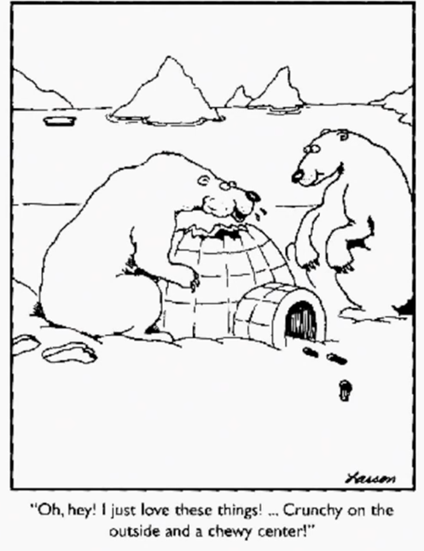 | 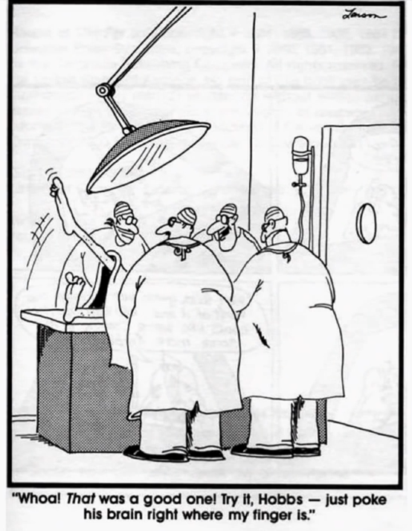
Figure 10: Two cartoons by Gary Larson

Gary Larson, as many of you know, is a famous cartoonist with a distinctive drawing style and an irreverent, even macabre, sense of humor (examples of his work are shown in Figure 10). The first major paper to carry his cartoons, the Seattle Times, dropped them because some readers denounced them as sick and offensive. Fortunately, the San Francisco Chronicle picked up the series, and the rest is history. Despite his iconoclasm, Larson was a strong defender of a particular conception or kind of copyright. His stance is well expressed in an open letter he wrote, criticizing his fans for copying his cartoons and posting them on their home pages.

Years ago, I was having lunch one day with a cartoonist, Richard Guindon, and the subject came up how neither of us ever solicited or accepted ideas from others. But until Richard summed it up quite neatly, I never really understood my own aversions to doing this. “It’s like having someone else write in your diary,” he said. And how true that statement rang with me. In effect, we drew cartoons that we hoped would be entertaining, or at the very least, not boring. But regardless, they would always come from an intensely personal, and therefore, original perspective. To attempt to be funny is a very scary, risk-laden proposition. Ask any stand-up comic who’s ever bombed on stage. But if there was ever an axiom to follow in this business, it would be this – be honest to yourself, and most important, respect your audience. So, in a nutshell – probably an unfortunate choice of words for me – I only ask that this respect be returned. And the way for anyone to do this is to please, please refrain from putting The Far Side out on the internet. These cartoons are my children of sorts. And like a parent, I’m concerned about where they go at night without telling me. And seeing them at someone’s website is like getting the call at 2:00 in the morning that goes, “Uh, dad, you’re not going to like this much, but guess where I am.”

Two aspects of this letter bear emphasis – first, the contention that public self-expression is very scary and risky, and the law should help create conditions that enable and encourage it; and second, the conception of one’s artistic creations as one’s children. The need to control those creations, Larson argues, is like the need to keep track of one’s kids. When we examined Locke’s theory of property, we saw that only some of the ways in which he fleshed out his arguments seemed germane to intellectual property. The same is true here. In my tour of the 10 variants of personality theory, I’ve tried to flag those that seemed most relevant to the interests of artists. I hope, by now, it’s clear that those are numbers 2, 5, 8, and 10. To review, maintenance of artists’ ability to control, at least in some ways, their creations is arguably necessary to respect, first, their privacy; next, their capacity to achieve individual self-realization; next, their identities; and finally, their opportunities for self-expression. The countries where belief in these connections had the greatest influence are located in continental Europe. Not surprisingly, those same countries have the legal systems that are most protective of artists. More specifically, in those countries, artists enjoy a set of entitlements, commonly referred to as moral rights.
Moral rights of artists
- Right of attribution
- Right of integrity
- Right of disclosure
- Right of withdrawal
- Right against excessive criticism
- Droite de suite
In its full-blown version, the concept or system of moral rights encompasses six distinct entitlements. The first is the right of attribution, which is the right to be given credit for things you have created and not to be given credit for works that you did not create. The second is the right of integrity, which is the right to prevent the destruction or mutilation of one’s creations. This is the best known and probably most important of the rights. It underlaid the von Gerkan and Snow cases we discussed at the outset of this section. The right of disclosure is the right to decide if and when to make one’s works public. Suppose, for example, that a painter has been commissioned to create a portrait of a particular subject and has already been paid the contract price. The painter paints the portrait, but is unhappy with it. The subject demands that it be delivered. May the painter refuse? In jurisdictions that respect the right of disclosure, the answer is yes. The painter will have to indemnify the person who commissioned the painting, perhaps by returning the contract price, but does not have to turn over the painting itself. The right of withdrawal, rarely exercised, is the right in principle to demand that works one has come to regret be returned. Suppose, for example, that Picasso came to regret his Blue Period. He could demand that their current possessors return all of those paintings. Again, an artist exercising this right would have to indemnify, in advance, the persons obliged to relinquish the works in question.
The right against excessive criticism, also rarely exercised, in principle enables an author or artist to recover against a critic who abuses him or her. Finally, the droit de suite is the right to collect a fee when one’s works are resold, for example, when the current owner of one of your paintings resells it to another collector.
Now, here’s a brief reminder of ground we covered in the first lecture. As we discussed there, the Berne Convention purports to require member countries to recognize two of these moral rights – specifically, the right of attribution and the right of integrity. But as we saw, the Berne Convention lacks teeth, and the TRIPS Agreement, which does have teeth, does not incorporate the provision of the Berne Convention pertaining to moral rights. The net effect is that countries, like the United States, that are reluctant to recognize moral rights are, as a practical matter, free to evade their treaty obligations. Late in this lecture series, we’ll examine what’s known as the Visual Artists Rights Act, which is the provision of US copyright law that implements a quite truncated version of moral rights. For the time being, we’re concerned not with the contours of the law, but with the theory that provides the best support for the moral rights system. And that theory, as I’ve suggested, is the personality theory
Scholars who follow this line contend that intellectual products are manifestations or extensions of the personalities of their creators. An artist defines herself in and through her art. The artist, consequently, is morally entitled to considerable control over her works. Why, exactly? Partly because those injuries result in corresponding impairment of the creator’s self, and partly because maintaining a connection to and control over her works is one of the ways in which an artist establishes and sustains an identity. The classic version of this argument focused on the interests and rights of the lone artist or author. Historically, the strongest version of personality theory was associated with romanticism, which celebrated solitary artistic geniuses – the novelist or painter in the garret projecting his or her vision onto paper or canvas. Nowadays, it is widely, although not universally, recognized that that conception of creativity is unrealistic or at least rare. Awareness that creativity is more often collaborative and that many artists incorporate not merely the ideas of their predecessors, but some of their predecessors’ materials, has prompted some scholars, writing in the vein of personality theory, to argue for important adjustments to its doctrinal implications. Most importantly, if we wish to ensure that all persons have opportunities to engage in self-fulfilling creative activities, we may need to liberalize the rules governing their transformative uses of already existing artistic products. When we discuss the efforts of scholars to adapt Locke’s labor-desert theory of real property in the context of intellectual property, I suggested that those scholars confronted serious difficulties, arising out of the ambiguity of key concepts in Locke’s approach. The same is true of personality theory. Listed on the map are a few of the difficulties the scholars working this vein face.
At the most primary level, it’s not obvious whether an artist who invests herself in a work of visual art should be able to prevent others from imitating her creations. Some commentators, emphasizing the self-expression inherent in the making of the imitation, argue no. Others disagree. For obvious reasons, this goes to the heart of copyright law. Assuming that an artist has the right to control copying of her creations, may she alienate that right? For example, may a composer assign to a music publisher all of her rights in her composition? As we’ll see, this is conventional in most jurisdictions. Is it legitimate? Some scholars, purporting to draw on the writings of Kant, argue no. Others, seeking guidance from Hegel, argue yes.
Here’s a more specific contemporary question. In many American states, celebrities enjoy the right to control, and therefore, the right to charge for, commercial uses of their identities. Shown in Figure 11 is one of a series of advertisements that provoked a famous application of that principle. In the late 1980s, the consumer electronics company Samsung introduced a set of what were intended to be humorous ads, ostensibly set into the future, each of which juxtaposed a hypothetical news headline with the depiction of a durable Samsung product.
The right-hand side advert in Figure 11 is the one that got Samsung into trouble. The hypothetical news story, which appears at the top of the ad, suggested that the game show Wheel of Fortune would still be broadcast in 2012. However, the letters on the game board would be turned not by Vanna White, the actress who had become famous in this role, but by a robot, which would literally take White’s place.
The right-hand side advert in Figure 11 is the one that got Samsung into trouble. The hypothetical news story, which appears at the top of the ad, suggested that the game show Wheel of Fortune would still be broadcast in 2012. However, the letters on the game board would be turned not by Vanna White, the actress who had become famous in this role, but by a robot, which would literally take White’s place.
 | 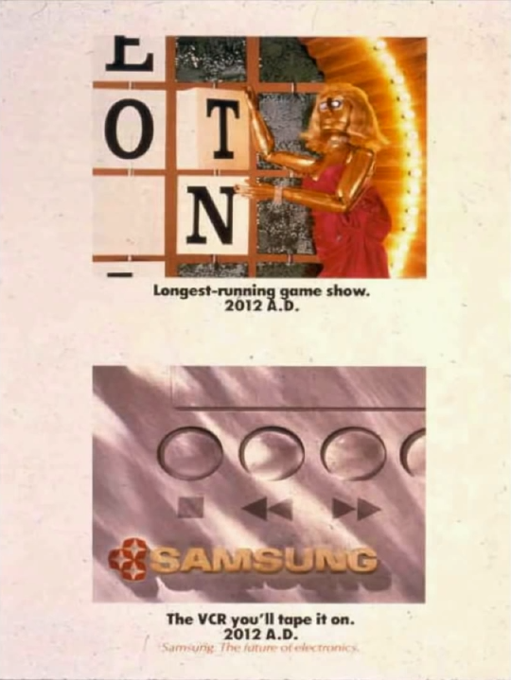
Figure 11: White v. Samsung Electronics America, Inc. (1992) – magazine adverts run by Samsung; the one in the top right was the subject of the lawsuit

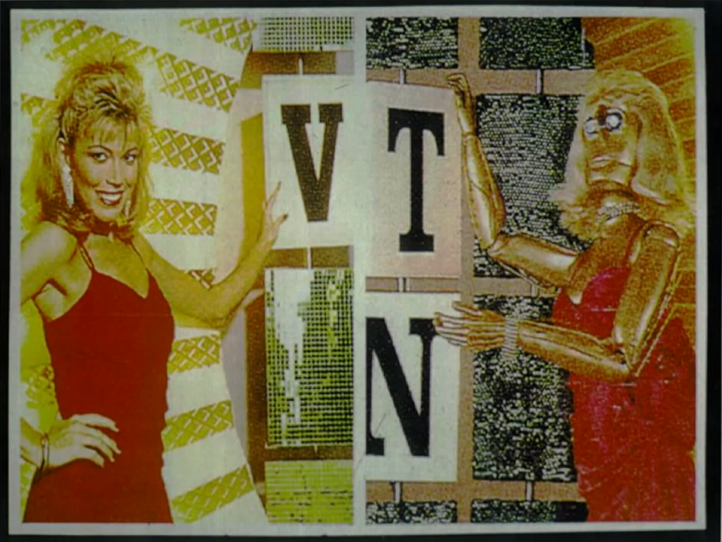
Figure 12: The real Vanna White and the image of the robot in the Samsung advert

Shown in Figure 12, on the left side is the real Vanna White, and on the right side, a blow-up of the image of the robot that appeared in the Samsung ad. White argued plausibly that the color of the robot’s hair, the color and style of its dress, and above all, its pose, was intended to evoke her. She brought a lawsuit, arguing that the advertisement constituted a commercial appropriation of her identity. And she prevailed. The theoretical question posed by this case and many similar cases is whether a celebrity’s persona is a sufficiently important embodiment of personhood that it, like a painting, should be shielded against non-permissive uses. Some scholars argue yes, indeed regard the answer as self-evident. Others, like Michael Madow, disagree, contending, among other things, that a celebrity’s fame typically owes as much to the media and the audience as it does to the creative contributions of the celebrity herself and thus should not be analogized to works like von Gerkan’s train station or Snow’s geese. These are hard questions. As I suggested when we were discussing the application of Locke’s argument to copyright, it’s very unlikely that the answers to such questions can be derived from a careful reading of the canonical texts in this theoretical tradition, namely the writings of Kant, Hegel, and so forth. The value of personality theory, I suggest, is not to provide us determinate answers to modern problems, but rather to sensitize us to and to help us reflect upon the ways in which control over intellectual products can influence opportunities for individual or group self-fulfillment. In that spirit, here are a few additional ways in which personality theory has been or might be applied to suggest ways of thinking about specific issues that arise in contemporary copyright law.
How long should a copyright last? The duration of a patent, as many of you know, is quite short – 20 years from the date of the patent application. As we’ll see in most countries today, copyrights last much longer – typically for the life of the author plus 70 years. If the principal function of a copyright is to reflect and protect an author’s personhood interests in his or her creations, perhaps that term is too long. Perhaps it should last for no more than the life of the author. Or more narrowly, perhaps moral rights should expire with the death of the author. Another example: as we’ll discuss in later lectures, many jurisdictions, including the United States, have rules that confer upon employers the copyrights in the works prepared by their employees. These rules are highly controversial. One ground in which they are commonly criticized is that they fail to respect the employee’s personhood interests in their creations.
A related criticism of contemporary copyright law that arguably is also fueled by personality theory is that several doctrines in combination inhibit the ability of creative people to remain economically independent and thus in control of their creative activities and products. Copyright law, in other words, is biased toward the interests of companies and fails adequately to support intellectual entrepreneurs. One of the sources of that bias, so it’s argued, is the set of procedural rules that govern copyright lawsuits and the remedies available to successful litigants. Those rules operate, as we’ll see, to the advantage of parties with deep pockets and emotional fortitude, neither of which is typically true of the kind of autonomous artists that are celebrated by personality theory.
Another example – it’s widely thought that, in general, artists are not good at business and thus tend to sign away their rights too quickly or for too little money. Most copyright systems contain some rules designed to protect artists or their families against the consequences of their folly or ignorance. Some scholars, drawing in part on personality theory, argue that those protective devices are insufficient and should be strengthened. Finally, as I suggested a minute ago, some scholars contend that, if all persons are to have opportunities for self-fulfillment analogous to those enjoyed by a Picasso or a Wordsworth, copyright law should be amended to increase people’s freedom to make derivative uses of existing creative works, such as photographs, films, and sound recordings. This might be achieved through adjustment of one of the major defenses to copyright infringement, namely the doctrine of fair use or fair dealing, which will be considered in detail late in the course. In countries like the United States that currently provide expansive protection for moral rights, the same adjustment might require some curtailment of the famous right of integrity. This last possibility is perhaps the most counterintuitive and eye-opening of the reform proposals we’ve considered thus far. It entails invoking personality theory to qualify one of the primary conventional doctrinal embodiments of that same theory. By the end of this series of lectures, I hope you are in a position to make your own judgment concerning the persuasiveness of this proposal.
So, that’s it. That concludes our examination of the first two of the four theories of copyright, namely fairness and personality-based theories. In the next lecture, I’ll discuss the subject matter coverage of copyright, what kinds of creations are protectable and what kinds are not. Then, in the lecture after that, I’ll return to copyright theory and take up what has become the most influential of the four approaches, namely the utilitarian-based welfare theory. This, as we’ll see, looms even larger in policy and law than the arguments we’ve addressed today.

The Subject Matter of Copyright

Literature (and Software)
In this lecture, I put theory to the side and return to the law, focusing on the subject matter of copyright, the kinds of things that copyright law applies to.
There are two main themes to this lecture. First, the subject matter coverage of copyright law has grown dramatically over the years, and is now a good deal larger than you might think. Certainly, it reaches far beyond its core, namely fine art and literature. Second, copyright law is not unitary or homogeneous. Rather, the rules governing the different kinds of things now subject to copyright protection vary considerably. Partly as a result, the business models associated with the different kinds of works also vary. This second theme I refer to as the disaggregation of copyright. I’ll begin to develop it in this lecture, but it will figure in future lectures as well.
I’ll begin with a brief overview of the history of the subject matter coverage of copyright, and then start over and examine each of the sectors in more detail.
US copyright law originates in a 1790 federal statute. Only three kinds of works were protected under the original statute – books, maps, and charts. Over the course of the 19th and 20th centuries, Congress and the courts cooperated in expanding the set of protected creations. Prints were added by statute in 1802. Musical compositions added in 1831. Dramatic works, in effect, were added to the cluster by an 1856 statute which granted the owners of copyrights in books the right to control public performance of their works, which is the only form of protection truly valuable to playwrights. This extension was confirmed by subsequent statutory amendments. Photographs were added by statute in 1865, as we saw in the first of the lectures in this series. In 1883, in the Burrow-Giles case, the Supreme Court rejected a constitutional challenge to the addition of photography, but only because this posed studio photo of Oscar Wilde was, in the court’s judgment, a quote “useful, new, harmonious, characteristic and graceful picture”. Gradually, the aesthetic requirement implicit in this ruling was softened, and copyright protection was tacitly extended to photographs of all sorts.
Paintings and drawings were added to the set of protected works in 1870, as were statues – meaning three-dimensional works of fine art – a type of work later subsumed into the broader category of works of art and reproductions of works of art. Around the turn of the century, advertisements were accepted into the fold. During the 19th century, courts had generally been hostile to the extension of copyrights to ads, on the ground that they did nothing to “stimulate original investigation, whether in literature science, or art, for the betterment of the people”. This skeptical position was rejected by Justice Holmes in the Bleistein case, which was also discussed in lecture number one. Bleistein, as you’ll recall, extended copyright protection to a circus poster. Holmes reasoned “a picture is nonetheless a picture, and nonetheless a subject of copyright, that it is used for an advertisement”.
Motion pictures were invented by Thomas Edison and his assistant William Dixon in the 1890s. Figure 13 is a photo of one of the first machines that they developed to view their primitive movies. By 1903, an intermediate appellate court had recognized movies as copyrightable subject matter, a position later confirmed by Congress. Lectures, sermons, and addresses were added to the list of copyrightable materials by statute in 1909. Subsequently fictional characters and plots were recognized by judicial decisions as objects of protection. This, as you might imagine, is a tricky subject to which we’ll return shortly. A complex series of steps between 1909 and 1954 had the overall effect of extending copyright protection to some useful articles. Which ones, we’ll consider in a moment. Sound recordings, as distinct from the compositions they embody, were added to the fold in 1972. Pantomimes and choreographic works were added as part of the 1976 general reform of the copyright statute. Software was formally added in 1978, although, as we’ll see, early forms of protection for software occurred in the 1960s. Last but not least, architecture was grudgingly given special protection by statute in 1990 in response to the United States’ belated accession to the Berne Convention. Figure 14 shows all of these elements and the order in which they were added to copyright law over time.
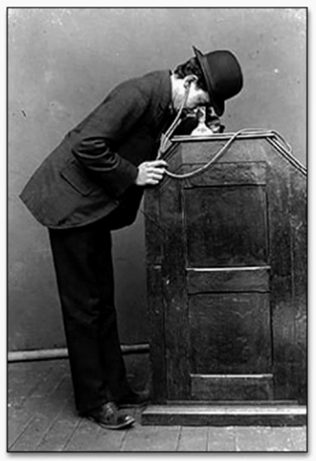
Figure 13: The Dickson-Edison Kinetoscope
That’s where things stand today. Two gradual, intertwined conceptual shifts underlie this steady expansion of the zone of coverage. The first, which is nicely traced by Oren Bracha, is a movement from a conception of copyright as trade-specific regulation to a conception that sees copyright as founded on the general principle of the right of creators to control their original works. This change was partially completed in the 1909 general reform of the copyright statute, and fully completed in the 1976 reform. The second of the overall changes, emphasized by Peter Jaszi, is a shift in what copyright is thought to protect, from the text to the work. At the start of the 19th century, lawyers and judges thought that copyright law protected the sequence of words used in a book – in other words, the text alone – against verbatim reproduction. By the early 20th century, by contrast, they thought it shielded the market value of the underlying work, no matter how it was expressed. As we’ll see in lecture number seven, the effect of this reconceptualization was to render illegal, for the first time, many forms of unauthorized use, including translations, abridgments, and, perhaps most importantly, motion picture adaptations.
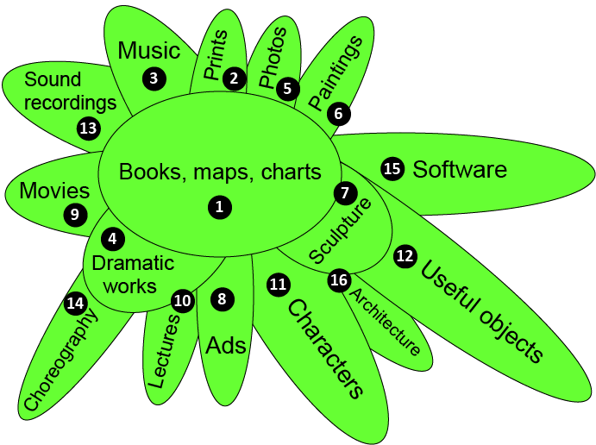
Figure 14: The growth of US copyright law

Now that we’ve completed a brief historical overview of the growth of US copyright law during the last two centuries, let’s go back and examine in more detail each of the sectors of copyrightable subject matter. For this purpose, we’ll be using the map on copyright law, which I hope is by now familiar to you. As I mentioned, during this survey I’ll highlight the ways in which the rules governing the different kinds of things now subject to copyright protection vary, and how, as a result, the business models associated with those types of works also differ. The underlying thesis, to repeat, is that the copyright system is disaggregated.
As the map indicates, the statutory basis for the subject matter coverage of copyright is Section 102 of the federal statute. In the first lecture in this series, we discussed subsection 102(b), which embodies, as we saw there, the idea/expression distinction, and related grounds for excluding work from copyright protection. We now focus on 102(a), which details the kinds of things that copyrighted law includes. As you can see, the language of 102(a) is capacious. It itemizes various kinds of things that are subject to copyright protection, but it also includes a blanket clause indicating that quote “original works of authorship, of any sort, can be protected”. In other words, the itemized list below is non-exhaustive.

17 USC § 102 Subject matter of copyright: In general
(a) Copyright protection subsists, in accord­ance with this title, in original works of authorship fixed in any tangible medium of expression, now known or later developed, from which they can be perceived, reproduced, or otherwise com­municated, either directly or with the aid of a machine or device. Works of authorship include the following categories:
(1) literary works;
(2) musical works, including any accompany­ing words;
(3) dramatic works, including any accom­panying music;
(4) pantomimes and choreographic works;
(5) pictorial, graphic, and sculptural works;
(6) motion pictures and other audiovisual works;
(7) sound recordings; and
(8) architectural works.
(b) In no case does copyright protection for an original work of authorship extend to any idea, procedure, process, system, method of operation, concept, principle, or discovery, regardless of the form in which it is described, explained, il­lustrated, or embodied in such work.

The first entry in the itemized list consists of literary works. Such works are often thought to be the heart of copyright protection. Included in this category are many things you would naturally think of as literary – for example, novels, short stories, poems, newspaper or magazine articles, and so forth. Also included are some less obvious things, such as catalogs, and, as we saw earlier, advertising copy. Last, but not least, the term “literary works” is now construed to incorporate computer software. The history and economic implications of this highly counter-intuitive interpretation are very complicated.
Here’s a brief introduction to the topic of software, a subject to which we’ll return several times. Before plunging into the details of the law, it’s important to differentiate the kinds of activities that some – not all – software firms hope to curb.
The first consists of consumer reproduction of object code. By object code, I mean the collection of ones and zeros that embody the working version of the program. By consumer reproduction, I mean the behavior of individual software users. So, for example, if I borrowed a disc that you had purchased containing PowerPoint or Final Cut Pro and made a copy of one of those programs onto my own laptop hard drive, my behavior would fall into this first category. Commercial reproduction of object code consists of the same conduct on a commercial scale. The vendors on the streets of Beijing or Rio selling discs containing pirated versions of the Microsoft Office Suite are engaged in commercial reproduction of object code. Much different is the activity of incorporating parts of the source code of a software program into a new program. Source code is the version of the program in a human-readable language, typically the language which was originally written before it was converted or compiled into object code. Copying portions of the source code is sometimes known as follow-on copying. This behavior includes a wide range of behavior, from the creation of modestly improved versions of existing programs, to the creation of radically new programs that incorporate small bits of existing programs. Fourth and finally, some developers – not all – wish to prevent what is sometimes referred to as “non-literal” copying. This consists of the creation of new programs that have the same structure, sequence, or organization as existing programs, but use none of the code of the existing programs. Suppose, for example, that I created a program that worked exactly like Photoshop, enabling me to compete with Adobe, but I wrote my own code from scratch, my conduct would fall into this fourth category. The reason for differentiating these four categories is that, as we’ll see often during this course, both the legal doctrines and the policy issues that they raise differ considerably.
Activities that some software firms hope to curb
- Consumer reproduction of object code.
- Commercial reproduction of object code.
- Incorporation of parts of source code in new programs (AKA “follow-on copying”).
- “Nonliteral” copying.
Now let’s turn to the law. The history of efforts to use law to discourage or penalize the behaviors I just summarized proceeded roughly as follows. In the 1950s and ‘60s, when the computer industry was just getting off the ground, a few integrated firms provided – typically industrial – customers both hardware and associated software. These products typically were task-specific, and thus were often customized for each client. The sellers and buyers of software were usually – though not always – in contractual privity. Under this combination of circumstances, the existing law of trade secrecy provided reasonably good protection against competitors. Typically, the software and hardware firms would provide their customers copies of the object code of their programs while retaining the source code. US courts ruled that public distribution of object code did not result in forfeiture of trade secrecy protection, so long as the source code was kept secret and was reasonably hard to reverse engineer. The combination of trade secret law and the concentrated structure of the software industry made non-permissive copying rare. Gradually, however, the effectiveness of trade secrecy protection diminished. Several factors were at work. They included the gradual improvement of decompilers, which facilitated reverse engineering, the increased demand from customers for access to source code, and the fact that, in any event, trade secrecy does not inhibit verbatim reproduction of object code which is made public. Some firms responded to these changing conditions by increasing their reliance on the law of contracts. They began to demand that their customers agree to various contractual restrictions on their ability to reproduce, modify, or redistribute the programs provided to them. This strategy also worked reasonably well for a while, but its effectiveness was undermined by two circumstances. First, the firms came increasingly to depend not upon expressed voluntary acceptance of contractual terms by their customers, but instead upon so-called “shrink wrap” or “click-through” licenses. The phrase “shrink-wrapped license” refers to, ostensibly, contractual commitments that were printed on the outside of the boxes that were sold to customers. A common term provided that, by breaking the cellophane that enclosed the boxes, the buyer agreed to all the other provisions. The validity of such commitments was far from certain. A decades-long struggle to settle this question was, in the end, inconclusive. If you’re curious about the details of that struggle, including the efforts of a group of academics to prevent the modification of the Uniform Commercial Code that would have resolved the matter in favor of the software firms, follow the link in the map associated with the topic Contracts.
The second limitation of contracts, from the standpoint of the software firms, grows out of the peculiar structure of the law of federalism in the United States. Briefly, contract law is state law, whereas copyright law is federal law, and under some circumstances, federal law will trump or preempt state law. Skeptics of contractual limitations on modifications or redistribution of software sometimes challenge those limitations on the grounds that they were preempted. Another struggle, this time over the scope of copyright preemption, ensued. Most of the cases that were fought over this issue eventually upheld contractual limitations against preemption challenges, but the controversy undermined the overall effectiveness of this approach.
By the late 1970s, the structure of the software industry was changing fast. The increased use of integrated circuits and microprocessors made the price of microcomputers drop rapidly. No longer was software produced and sold primarily by the hardware manufacturers. Instead, separate software firms began manufacturing and distributing both operating systems and application programs designed to run on devices produced by other firms. These changes, combined with increased dissatisfaction with trade secrecy and contracts – the reasons I just suggested – prompted some software firms to seek increased protection from the law of copyright.
Initially, copyright law was not very hospitable. To be sure, as early as 1964, the register of copyrights in the United States had expressed a willingness to register copyrights in software, but several uncertainties in the relevant law and procedural hurdles limited usage of this option. As of 1977, a total of only 1,200 programs had been registered, 80% percent of them by either IBM or Burroughs. In 1974, as part of the long ramp-up to the ’76 general reform of the copyright statute, Congress created a commission known as CONTU to consider the extent to which copyright protection for software should be clarified and expanded. The 1976 act itself recognized copyright protection for software, but did not settle all issues. CONTU’s 1978 report, which was adopted and implemented by Congress in 1980, cleaned things up. The net result was that software developers came to enjoy, in the United States, all of the entitlements enjoyed by authors of other, more traditional works. Europe soon followed suit. And finally, copyright protection for software was mandated by the TRIPS Agreement, and is, thus, now close to universal. This is not the end of the story, however. Copyright protection to not proved to be a panacea, partially confirming the arguments raised by CONTU’s critics, who thought copyright protection for software was a bad idea from the beginning. The limitations of copyright prompted a subset of software firms to press for patent protection, first in the United States, then in Europe. They met with only mixed success. How and why copyright law proved less than ideal is a large and important question, which we’ll take up in another lecture.
Figure 15 is a timeline showing when the various forms of intellectual property for software were introduced into law.
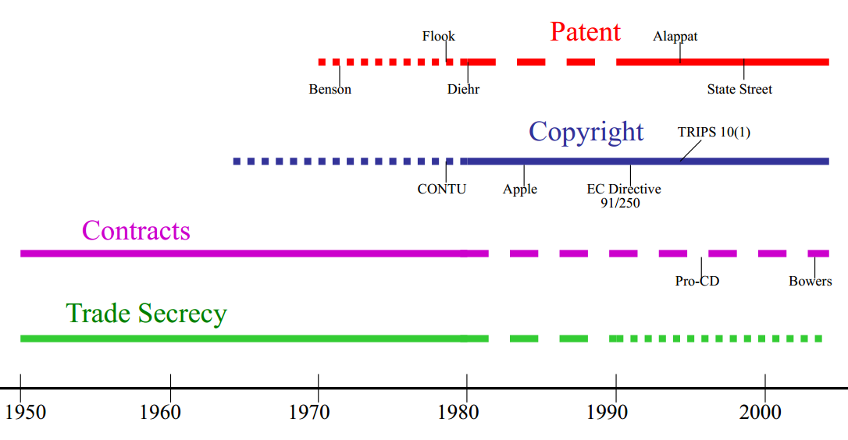
Figure 15: A timeline of the creation of forms of intellectual property for software

Drama and Choreography
Dramatic works are almost as close to the heart of copyright law as literary works. The premier example of a dramatic work is, of course, a play. As you might expect, you may not reproduce the script of a play without the permission of the owner of the copyright in it. Nor may you publicly perform the play without the owner’s permission. This rule is not always honored, but the rule itself is clear enough.
Choreography is a much more recent addition to the catalog. One of the reasons for its late arrival is that the particular dances whose status was considered in some of the early litigated cases happened to offend the judges making those decisions. For example, in the Dane case, which was decided by the New York Supreme Court in 1963, the work at issue was a mock strip tease that the plaintiff developed and then performed during an audition for the musical Gypsy. The court refused to extend copyright protection to this routine, reasoning,

The words dramatic or dramatico-musical composition as used in the statute must be held to include only those representations and exhibitions which tend at least to promote the progress of science and the useful arts. Where a performance contains nothing of literary dramatic or musical character which is calculated to elevate, cultivate, inform, or improve the moral or intellectual natures of the audience, it does not tend to promote the progress of science or the useful arts. Thus, not everything put on stage can be subject to copyright. While the plaintiff’s performance was no doubt amusing and entertaining to many, it does not fall within the purview of the statute as a production tending to promote the progress of science and the useful arts

Recall our discussion in lecture number one of the principle of aesthetic neutrality, which is commonly traced in the 1903 Bleistein case. The passage I just read is one of the many examples of judges ignoring that ostensible principle altogether. The unfortunate effect of such cases is that some famous and deserving choreographers were left out in the cold. For example, Agnes de Mille choreographed Oklahoma, which was – and deserved to be – one of the most popular musicals of all time. Her dances – in particular, the dream ballet – contributed importantly to the plot of the play. She was paid a modest contract price by the producers, reportedly $15,000. However, unlike Rogers and Hammerstein, who composed the musical score for the play, de Mille received no royalties when it was produced, because her choreography, unlike their musical compositions, enjoyed no copyright protection. The gap in the law – the absence of protection for choreography – was filled as part of a comprehensive 1976 reform, which became effective the start of 1978. The result is that today, choreographers enjoy the same copyright protection as do playwrights. Unfortunately, it’s not always clear what constitutes choreography. What about figure skating routines, for example? The statute itself does not define the term. The Copyright Office has developed its own definition:

Choreography is the composition and arrangement of dance movements and patterns, usually intended to be accompanied by music. As distinct from choreography, pantomime is the act of imitating or acting out situations, characters, or other events. To be protected by copyright, pantomimes and choreography need not tell a story or be presented before an audience.

Courts, when construing the copyright statute, are not bound by this administrative decision. But they tend to give it weight. As dance and performance art continue to evolve in the future, tricky questions concerning the scope of this definition are likely to arise with increased frequency.
In the United States, choreographers face one more hurdle if they are to secure copyright protection for their works. They have to capture their routines in some stable medium. As you can see from the language of section 102a, copyright in the United States extends only to works that are “fixed in a tangible medium of expression”. This so-called fixation requirement is peculiar to the US. Most countries have no such rule. So, what does fixation mean? The term is defined in Section 101.

A work is fixed in a tangible medium when its embodiment in a copy or phono record by or under the authority of the author is sufficiently permanent or stable to permit it to be perceived, reproduced, or otherwise communicated for a period of more than transitory duration. A work consisting of sounds, images, or both that are being transmitted is fixed for the purposes of this title if a fixation of the work is being made simultaneously with this transmission.

The overwhelming majority of works for which authors might seek copyright protection easily satisfy this standard. Novelists typically write their novels down. Photographers capture their images in negatives, prints, digital files, and so forth. However, on occasion, potentially copyrightable works fail to qualify for protection because their creators neglect this requirement. So, for example, if a jazz musician in a live, unrecorded performance improvises in an original way on a classic public domain composition, that musician will get no copyright protection in his innovation. As a matter, this means that a member of the audience, after hearing the performance, is free to perform or record it himself without fear of copyright liability.
Here’s a hypothetical case that may suggest the scope of the fixation requirement. A mandala is a highly-detailed painting typically made out of fine-grained colored sand by Buddhist monks or priests. Mandalas represent the dwelling spaces of tantric deities. Most are elaborate, and require a long time to create, but they don’t last long. If they’re jostled, they disappear. More importantly, it’s conventional, after completing a mandala, to undo it by pouring the sand into a body of water, often a river. Among other things, this custom emphasizes the impermanence of possessions and the importance of not being too attached to them. Traditionally, mandalas were created and dissolved in private religious ceremonies. Recently, however, the Dalai Lama has encouraged monks to create them in public, in part to educate people about the culture. Some have been created, briefly, in the United States. In the unlikely event that a creator of a mandala sought copyright protection in it, would he trip over the fixation requirement? In other words, would he lose because this work was not fixed in a tangible medium of expression? Probably not. A mandala is not fixed in the ordinary sense, but it would seem to qualify under the statutory definition. Its embodiment in sand is “sufficiently stable to permit it to be perceived or reproduced for a period of more than transitory duration,” as is evidenced by the existence of the photo above. Parenthetically, the monk might trip over a separate requirement for copyright – namely, the originality requirement discussed in lecture number one. The reason is that the mandalas created by monks typically replicate traditional designs. But the fixation requirement would probably not be a problem.

Figure 16: Buddhist monks from the Namgyal Monastery creating a sand mandala

Returning to the topic at hand. The primary form of creative work that with some frequency does run afoul of the fixation requirement is choreography. The reason is that choreographers commonly fail to write down their innovations. In part, this is because it used to be difficult to do so. Dance notation has existed for a long time, but it’s cumbersome and incomplete. Nowadays, it’s easier to fix a choreographic work. The standard method is to videotape a rehearsal. Nevertheless, some choreographers still forget this. In the United States, the result is that they forfeit copyright protection.
Stepping back from this example. What underlies the fixation requirement in general? There are two standard answers, but neither is particularly persuasive. The first answer is that the language of the constitutional provision that, in the United States, underlies copyright law, limits its scope to “writings.” An ephemeral work, it is sometimes said, does not qualify as a writing. In light of how broadly the term writing is construed in other contexts – to incorporate, as we’ve seen, software and photos, for example – this textual argument seems weak. The second explanation is that there’s an important policy underlying the requirement of fixation – namely, that it serves an evidentiary function. Supposedly, it forces authors and artists to write down their works and the result is to provide judges and juries who are called upon to resolve subsequent disputes good information concerning what exactly those works contained.
This argument is a branch of a policy argument one finds in many fields of the law. The basic idea is that formalities have important social functions. So, for example, the rule found in many jurisdictions that a will indicating who gets your property on your death must be written down and signed by two disinterested witnesses serves to caution people concerning the importance of what they’re doing when they create wills, channels their behavior into standard forms that are more easily implemented, and, again, provides good evidence concerning what they intended. The conventional justification of the fixation requirement in copyright law fits easily into this family of policy arguments. That conventional justification is also, however, vulnerable to the standard retort – namely, that formalities are largely ineffective if people are unaware of them, which tends to happen when people are not “repeat players.” If many artists – and many choreographers in particular – are unaware the fixation requirement, it’s unlikely to have a socially beneficial disciplining effect. A further indication that the fixation requirement is unnecessary can be gleaned from the fact that most countries apparently get along just fine without it.

Music
Copyrights in music differ from copyrights in literary and dramatic works in several ways. Perhaps the most important is that there are two different kinds of copyrights that involve music. The more traditional of the two are copyrights in musical compositions. As you can see, section 102 (a), refers to these as copyrights in musical works, including any accompanying words. These have been around for a very long time. The second type, which was added to the federal copyright statute only in 1972, consists of copyrights in sound recordings. As I mentioned earlier, in most countries legal rights to sound recordings are known as neighboring rights. In the United States, however, they are referred to as copyrights.
The legal rights associated with these two types of copyrights and the complex business models that capitalize on those rights are perhaps best seen by tracing the life history of a typical piece of popular music. I’m going to tell this hypothetical story using a diagram (Figure 17). As you’ll soon see, the narrative is complicated. Don’t be discouraged if not all features of the story are clear right now. We’ll return to it several times during this lecture series.
Imagine that I’m a pretty good composer, but not much of a musician. I compose a song. It has a memorable melody and some conventional sentimental lyrics. I wrote it down on some sheet music, so I satisfy the fixation requirement. I thereby, as you know, acquire a copyright in my composition. I could if I wanted retain ownership of my copyright, but as a typical composer I lack the business skills or time necessary to exploit it effectively. So instead, as is now customary in the United States, I sign all of my rights to a music publisher. There are tens of thousands of these in this country. From this point forward in the story, the publisher will retain the copyright and the composition. In other words, the publisher will not assign it further. Rather, the publisher will make money for itself and for me by issuing licenses to a variety of other organizations – in other words, permissions to engage in activities that otherwise would violate copyright. The most important of these licenses consist of the right to make so-called mechanical copies of the composition. Typically, such a mechanical license will be issued to a record company, which is interested in making and selling sound recordings of my composition. The independent rights of the musician who actually makes that recording we’ll discuss in a minute. Back to the narrative, the publisher could in principle enter into such a license with the record company on its own, but it’s customary in the United States to use the services of an intermediary, namely the Harry Fox Agency.
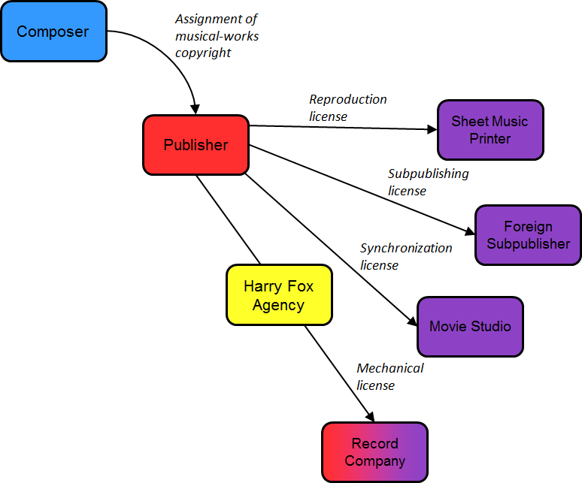
Figure 17: Parties involved in the copyrighting and licensing of music works (compositions), and their interactions

If the CD and other products embodying the recording of my song are commercially successful, the music publisher, who as we saw now holds the copyright in it, will begin to exploit other licensing opportunities. For example, the publisher will likely issue a reproduction license to one of the four major sheet music printers in the United States, which will then print and sell sheet music, which in turn will be purchased by amateur guitarists who want to learn how to play my song. If the song is sufficiently popular and evocative that a movie studio wants to include in the soundtrack of a movie, then the music publisher and the studio will negotiate a so-called synchronization, or sync, license. If there’s demand for my music in other countries, the publisher will likely issue a so-called sub-publishing license to a similar publisher in one or more other countries. The terms of these several contracts will vary, but it’s typical for the music publisher to turn over to me half of the license revenues it earns from these various sources, keeping the remainder, of course, for itself.
So now let’s return to the musician, the performer, whose recorded rendition of my song is crucial to the success of my composition (refer to Figure 21). As I mentioned earlier, the creative contributions of the performer will generate a second independent copyright in the sound recording. It’s possible that the performer will have to share that copyright with a sound engineer, but we’ll put that nuance to one side. As was true of the composer, it would be possible for the performer to retain that copyright, but at least until quite recently, it was customary for performers to enter into so-called recording contracts with record companies. Such recording contracts also have many complex terms, some of which are likely to be onerous which we’ll discuss in a few weeks. The central term, however, is straightforward. The performer assigns his copyright in the sound recording to the record company. By now I hope the color scheme of this chart is apparent. The blue figures represent artists, the people who make creative contributions to the finished product. These are the folks who, in the rhetoric of copyright law, are commonly referred to as creators. Red designates an assignee of a copyright. Purple designates a licensee, and yellow designates an intermediary. Arrows signify transfers of legal rights. As you can see, the legal position of the record company is the most complex. For the reasons I’ve sketched, the record companies occupy two legal positions – it’s the assignee of the sound recording copyright and one of the licensees of the musical composition copyright. That’s why it’s shown in the chart as half red and half purple.
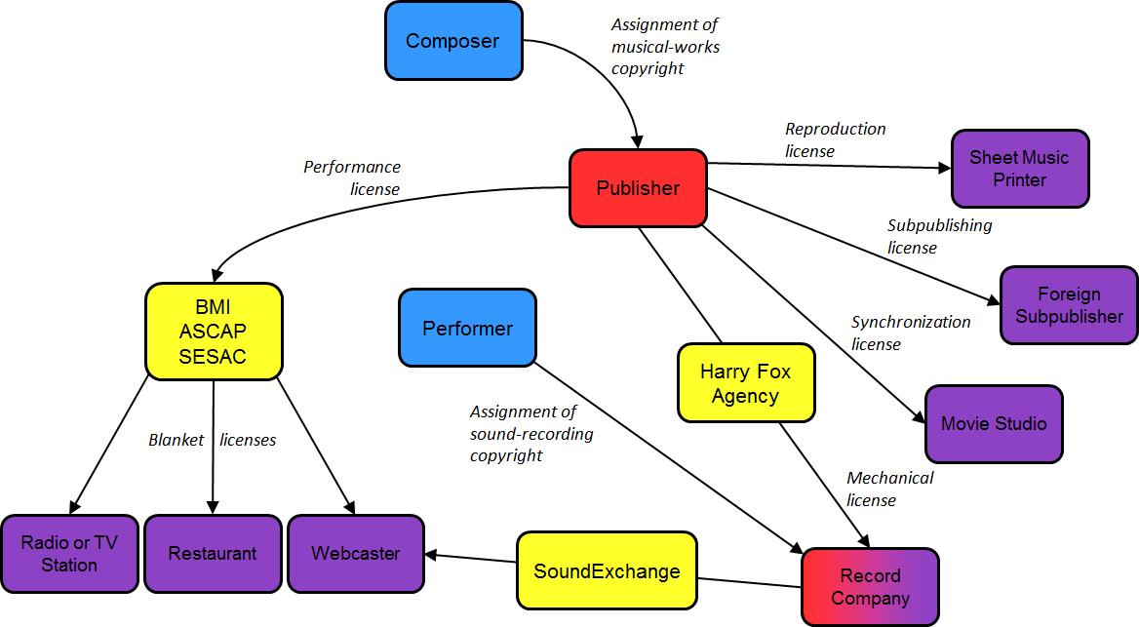
Figure 18: Parties involved in the copyrighting and licensing of sound recordings, and their interactions

We’re not done yet, however. The music publisher, which, to repeat, holds the copyright in the original composition, enjoys one additional valuable entitlement, namely the exclusive right to authorize so-called “public performances” of the composition. Such performances include playing the song at a park or a theater and more importantly, broadcasts of recordings of the composition.
If the recording distributed by the record company is popular, several companies are likely interested in making such public performances. They include radio stations, perhaps television stations, restaurants that play music in the background, and nowadays webcasters.
The publisher could in principle negotiate individual licenses with these companies, but that would be time consuming and inefficient. So instead, the publisher will almost certainly use an intermediary to manage its public performance rights. In most countries there’s only one such intermediary, but in the United States there happen to be three. They are known as BMI, ASCAP, and SESAC. They’re called Performing Rights Organizations, or PROs. Whichever PRO the publisher selects will issue so-called blanket licenses to all of the companies that I mentioned earlier. The reason these are called blanket licenses is that instead of paying a small fee for each song it plays, the licensee pays a flat fee – typically a small percentage of its gross revenues – to perform any of the compositions in the PRO’s repertoire. The PRO then pays to the music publisher a slice of the total amount of the license fees it collects, a slice roughly proportional to the relative frequency with which my song is played. And the publisher in turn gives half of that slice to me. The net result – the more popular a song, the more money flows to the publisher and to the composer. Notice again the color scheme. Yellow indicates an intermediary. Purple indicates a licensee.
Do the radio and television stations, restaurants, and webcasters shown in the lower left of this chart have to pay license fees not just to the music publisher at the top but also to the record company in the bottom right? In most countries, the answer would be yes. After all, a radio station when it plays a song is performing not just the composition whose copyright is held by the publisher, but also the recording of a particular rendition of the song whose copyright, otherwise known as a neighboring right, is owned by the record company. It would seem to make sense for the radio station to pay both copyright owners, and in most countries it must. Nevertheless, in the United States radio stations engaged in traditional analog broadcasting do not make such payments. The reason is that in the United States, the owner of a copyright in the sound recording, unlike the owners of copyrights in other sorts of works, does not enjoy an exclusive right of public performance.
You’ll recall that I discussed this unusual feature of US law briefly in lecture number one and the tensions it creates between the United States and the member countries of the Rome Convention. The principal reason for the anomalous position of the United States on this issue is that in 1972, when sound recordings were first given federal copyright protection, broadcasters in the United States had considerable lobbying power, and they successfully blocked adoption of a public performance right for sound recordings. That political explanation is buttressed by a plausible policy argument. The broadcasters argue that they shouldn’t have to pay license fees to the record companies because they argue broadcast of songs help the record companies by bringing those songs to the attention of potential purchasers of records, CDs, and so forth. In other words, the promotional benefit of broadcast substitutes for a license fee. Record companies, not surprisingly, disagree.
In 1996 and 1998, the record companies succeeded in obtaining from Congress a partial modification of this longstanding rule, specifically by securing an amendment to the copyright statute that gave them public performance rights for their sound recordings. However, that amendment was limited to performances that occurred in the form of a digital audio transmission. The upshot is that today, when webcasters perform recorded music digitally over the internet they must pay license fees to the record companies. How those license fees are calculated we’ll discuss in lecture number eight. For the time being, you need to know only that this legal relationship is managed by yet another intermediary, the organization SoundExchange. Record companies have not been satisfied by this adjustment to the statute. They want full-blown public performance rights, which would enable them to charge traditional radio stations, large restaurants, and so forth who make use of their recordings. Congressmen sympathetic to their position periodically introduce bills that if adopted would have that effect. The name of the most recent version of this proposed legislation is the Performance Rights Act. Shown in Figure 19 is the press release by the trade association of the recording companies welcoming the introduction of this legislation. Notice the reference to the difference between the situation in the United States and the situation in most countries.
Figure 19: Press release by the Recording Industry Association of America (RIAA) welcoming the introduction of the Performance Rights Act | 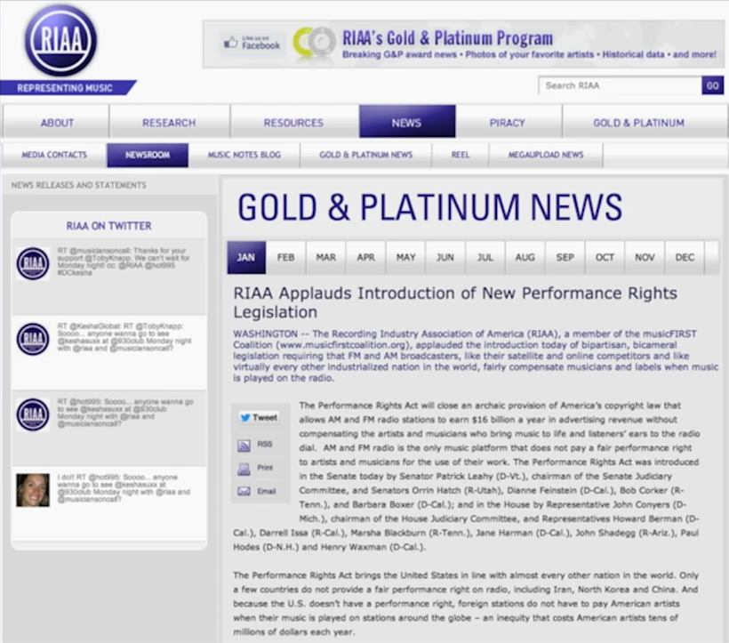

RIAA Applauds Introduction of New Performance Rights Legislation
WASHINGTON – The Recording Industry Association of America (RIAA), a member of the musicFIRST Coalition (www.musicfirstcoalition.org), applauded the introduction of bipartisan, bicameral legislation requiring that FM and AM broadcasters, like their satellite and online competitors and like virtually every other industrialized nation in the world, fairly compensate musicians and labels when music is played on the radio.

The broadcasters, for their part, continue to push back. Set forth in Figure 20 is their own summary of their stance. Notice that they continue to emphasize the “free promotion” that they’re providing record companies. And notice also their strategic characterization of the proposed legislation as a tax. Finally, you’ll see that they too have a group of sympathetic congressmen.
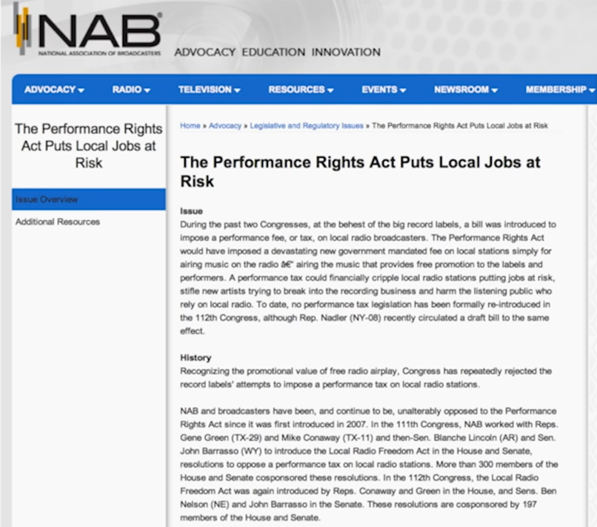 | Figure 20: Press release by the National Association of Broadcasters (NAB) opposing the introduction of the Performance Rights Act

A Performance Tax Puts Local Jobs at Risk
Issue
During the past two Congresses, at the behest of the big record labels, a bill was introduced to impose a new performance fee, or tax, on local radio broadcasters. The Performance Rights Act would have imposed a devastating new government mandated fee on local stations simply for airing music on the radio – airing the music that provides free promotion to the labels and performers. A performance tax could financially cripple local radio stations putting jobs at risk, stifle new artists trying to break into the recording business and harm the listening public who rely on local radio. To date, no performance tax legislation has been formally re-introduced in the 112th Congress, although Rep. Nadler (NY-08) recently circulated a draft bill to the same effect.

For better or worse, this is a reasonably good illustration of the way in which lobbying over copyright typically works. For more details concerning the still ongoing negotiation over this particular issue, follow the link shown on the left-hand side of these two slides.
So, that in brief is the pattern of legal rights in the US recorded music industry. The arrows, as I’ve indicated, show transfers of legal entitlements. For the most part, money flows between organizations through the channels cut by the legal rights (see Figure 21), with one exception. For a long time, record companies have paid radio stations significant amounts of money, known informally as payola, to induce them to play the record company’s recordings over the airwaves, lending credence to the broadcasters’ contention that radio play serves as an effective form of advertising. At its peak, roughly $100 million a year flow through this channel. Legal impediments to such payments have been slowly increasing for decades, and enforcement of those legal impediments has also been increasing. For a while, record companies evaded these tightening rules by using third-party intermediaries, known confusingly as indies, to make their payments, but this loophole is also shrinking. Today much less money is flowing through this channel than was true 40 or even 10 years ago, but the river has not dried up completely.
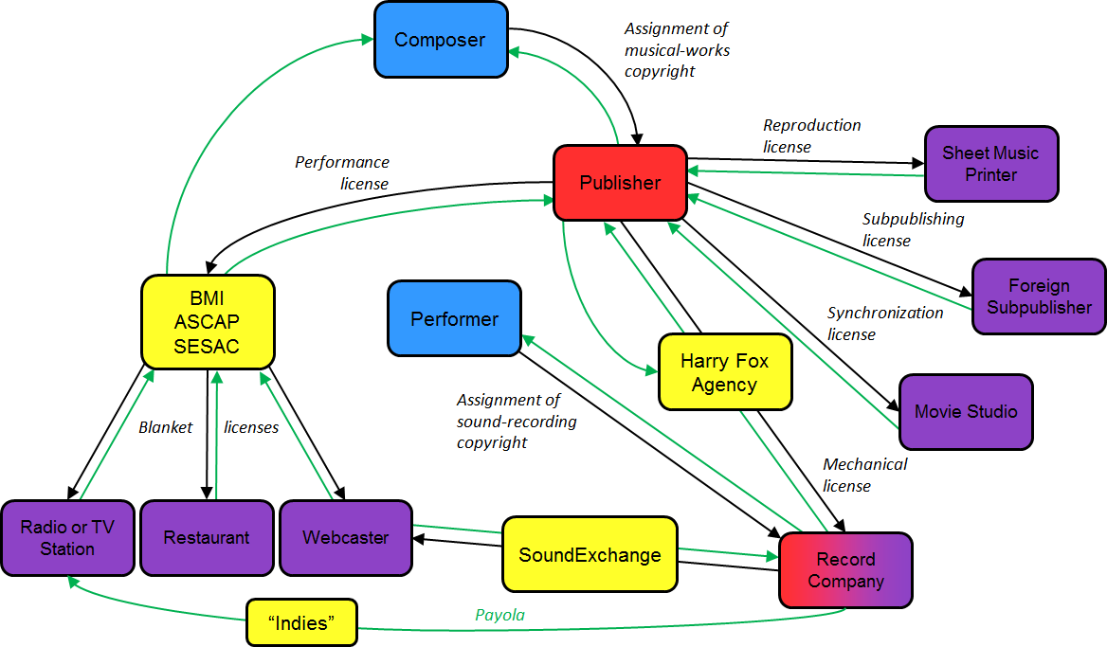
Figure 21: Parties involved in the copyrighting and licensing of sound recordings and the payments between them (in green)

One final dimension of this legal and financial system merits emphasis. I mentioned earlier that the most important of the licenses issued by the music publisher is the so-called mechanical license that it grants to the record company. Suppose, to return to our story, that the first commercial recording of my song proved so popular that a second musician affiliated with a different record company wants to do a cover of the song, meaning a new rendition of it. Does the second record company have to obtain a separate mechanical license from the publisher? The answer is, you might suppose, yes. However, the second record company is not obliged to negotiate a voluntary license with a music publisher. Rather, so long as the second record company pays a modest fee just set by the government, it’s free to make and distribute a new recording, and neither I nor the music publisher can object. Currently that fee is about $0.09 per copy sold of the new recording, more if it’s a long song. Separate fees apply to ringtones and recordings delivered to customers through interactive streaming.
This is the first example we’ve seen in this series of lectures of a so-called “compulsory license”. We’ll see several more in future lectures. Not surprisingly, the central feature of a compulsory license is that the copyright owner is compelled to issue it. It has no choice but to accept the governmentally set fee. Typically, that fee is lower than the amount the owner would demand if the license were voluntary. Equally important, a compulsory license deprives the copyright owner of creative control. Suppose, for example, that I or the music publisher acting on my behalf don’t like the second sound recording artist and think he will butcher my song. As a result, I’d prefer not to grant him a license of any sort. Nevertheless, neither I nor the publisher can refuse.
To be sure, the statutory provision that creates this rule contains a few limitations, one of which is that the second recording artist may not “change the basic melody or fundamental character of the work”. But that restriction is construed very leniently. Here’s an example that illustrates the application of this rule and its cultural impact. In 1967, Jimi Hendrix composed the song “Little Wing.” He and his group, The Jimi Hendrix Experience, recorded the song on their 1967 album, “Axis: Bold as Love”. In terms of our diagram, Hendrix occupied both of the blue zones because he was both the composer and the performer of the song. This is reasonably common in rock music. Compositions that fit this pattern are known as controlled compositions. The contracts typically used to handle them differ modestly from the contracts we’ve discussed thus far, but not in ways that merit our attention right now. I’m going to play the famous opening segment of Hendrix’s composition, so listen carefully.

[Music: Jimmy Hendrix, “Little Wing”.]
(Lyrics) Well she’s walking through the clouds with a circus mind that’s running wild.

This song has inspired generations of musicians. A few of the many commercially distributed covers are shown in Table 2. Some of these covers could fairly be described as faithful adaptations that preserved the essential character of Hendrix’s original. An example might be the version by Santana and Joe Cocker. Here it is.

[Music: Santana and Joe Cocker, “Little Wing”.]
(Lyrics) Well she’s walking through the clouds with a circus mind that’s running wild.
Table 2: Selected “Covers” of Hendrix, Little Wing
- Allman Brothers  - Eric Clapton  - Sting  - Steve Ray Vaughn  - Nigel Kennedy  - The Corrs  - Laurence Juber  - Santana & Joe Cocker | - Def Leppard  - Kirk Hammett (Metallica)  - Tuck & Patti  - Stanley Jordan  - Divididos  - John Mayer

Hendrix himself might also have been pleased by the extraordinary instrumental recording of the song by Stevie Ray Vaughan, one of the few guitarists better than Hendrix himself. So, if you don’t know the recording, pay close attention because this is one of the best guitar solos of all time. [Music: Stevie Ray Vaughan, “Little Wing”.] Not all covers come as close to Hendrix’s original vision. Some would likely have set his teeth on edge. Examples include Laurence Juber’s acoustic rendition, which is technically very impressive but suburban or new age in mood, or The Corrs’ pop rendition. Here’s a slice of the latter.

[Music: The Corrs, “Little Wing”.]
(Lyrics) Now she’s walking through the clouds with a circus mind that’s running wild.
Butterflies and zebras, moonbeams and fairy tales. All she ever thinks about is riding with the wind.

I hope you’ll recall from the last lecture our discussion of the powerful bond that many artists feel with their creations. That bond, you’ll remember, prompted the sculptor Michael Snow to object when ribbons were hung on the necks of his geese and underlay Gary Larson’s plea to his fans not to use his cartoons in their websites. The law, as we saw, often comes to the aid of such artists, particularly in countries that recognize strong versions of moral rights. By contrast, the law, and consequently the culture, of the music industry is radically different. Composers know that once they have authorized the commercial distribution of one recording of their composition they could no longer enjoy what in moral-rights terms is referred to as a right of integrity. In other words, they can’t prevent other musicians from altering their creations by making and distributing covers, some of which will be very different from the versions the composers had in mind. Nor may the first recording artist object when a second recording artist makes a cover. Interestingly neither composers nor performers seem especially troubled by this prospect. And the legal privilege of making covers has an important cultural benefit. Each generation of musicians can test their skills, can show their chops, by attempting their own recorded renditions of the classic works of their predecessors. Now to be sure, they have to pay a modest fee when they sell recordings of their adaptations, but they don’t have to ask permission.
Does this seemingly fundamental difference between music on the one hand and other fields of art reflect differences in the nature of the cultural products in question? For example, the fact that most sculptures are unique, whereas sound recordings can be replicated indefinitely. Alternatively, have the feelings and expectations of composers and musicians evolved in response to the relatively unprotective rules that govern – at least in the US music industry? These are hard questions, and I don’t know the answers. The answers matter. For example, if the first explanation is right, we should probably reexamine the contention of the directors of black-and-white classic movies that they should be able to block colorization of their masterpieces, a contention that some countries, not including the United States, currently respect. By contrast, if the second explanation is right, we may need to reconsider just how deep are the psychic bonds celebrated by the personality theory of copyright.

Audiovisual Works
The next type of copyrightable work on the list consists of motion pictures and other audiovisual works. A motion picture is defined in the statute as an audiovisual work consisting of a series of related images, which, when shown in succession, impart an impression of motion, together with accompanying sounds, if any. Some audiovisual works, such as film strips or sets of slides, don’t fit this narrow definition. But that doesn’t make much difference in practice, because the copyrights in all audiovisual works are handled in basically the same way.
Fortunately for our purposes, the legal rules governing copyrights in motion pictures are simpler than the rules governing copyrights in music. But the business models that depend upon motion picture copyrights are at least this intricate. Again, I’ll use a diagram to sketch the main features of those rules and models. In this lecture, I’ll give you a quick overview of the structure. Then, in subsequent lectures, we’ll return to specific sectors of this structure, and discuss the rules and controversies that have arisen in those sectors.
As we saw, a typical piece of recorded music implicates two copyrights – the copyright in the musical composition and the copyright in the sound recording. Much of the complexity in the music industry arises out of the complex relationship between those two rights. By contrast, in the typical film, there exists only one copyright – in the motion picture itself. In the United States, this copyright is ordinarily owned by the producer of the film (refer to Figure 22). Sometimes that producer will be an individual person. More often, the producer will consists of a company, which creates the film, aided by a motion picture studio, which typically finances and distributes it. Finally, the producer is sometimes a branch or subsidiary of the studio itself. In this presentation I’ll assume the producer is an independent company.
To create the film, the producer, of course, needs the assistance of myriad artists – screenwriters, actors, directors, and so forth. Do those artists share in the copyright in the film? In some countries, the answer is yes. And then complex contractual arrangements are necessary to acquire all of their rights. In the United States, by contrast, the answer is no. Copyright in the film is owned by the producer, which hires the various artists. The character of the deals used by the producer to assemble the creative contributions of the artists vary. Suppose, for example, the producer wishes to adapt an already-existing novel. The producer might negotiate an assignment of the copyright in the novel – indeed, we’ll see an example of this in a minute – but that’s rare. It’s much more likely that the producer will obtain a license to make a so-called derivative work based upon the novel, leaving the copyright in the hands of the novelist.
What about the screenwriters, actors, director, and composer, whose work is, of course, essential to convert the novel into a motion picture? Decades ago, it was common for the producer or studio to hire such people as long-term employees, in which case their creative contrib utions would belong to the producer or studio. Today, by contrast, these relationships are more likely to be arm’s-length, but the legal outcome is similar. The way in which this is achieved today is uthori h so-called work-for-hire agreements, which we’ll examine in detail in lecture number five. If the movie is filmed on site, rather than in a studio lot, the producer customarily obtains – and pays for – releases from the owners of the buildings that will appear in the background of the scenes. It’s far from clear that such releases are legally required. Lawyers for the producers typically take the position that the owners of the buildings have no enforceable rights, and, thus, that the producer could, if it wished, make and show the film without paying them anything. However, the insurance companies that provide the producers’ so-called errors and omissions insurance tend to be highly risk-averse, and demand that the producers obtain these releases. If the producer wishes to include an existing sound recording in the soundtrack of the movie, the producer will obtain a so-called master use license from the record company that owns the copyright in the sound recording, and a synchronization license from the music publisher that, as we saw, owns the copyright in the composition embodying the recording.
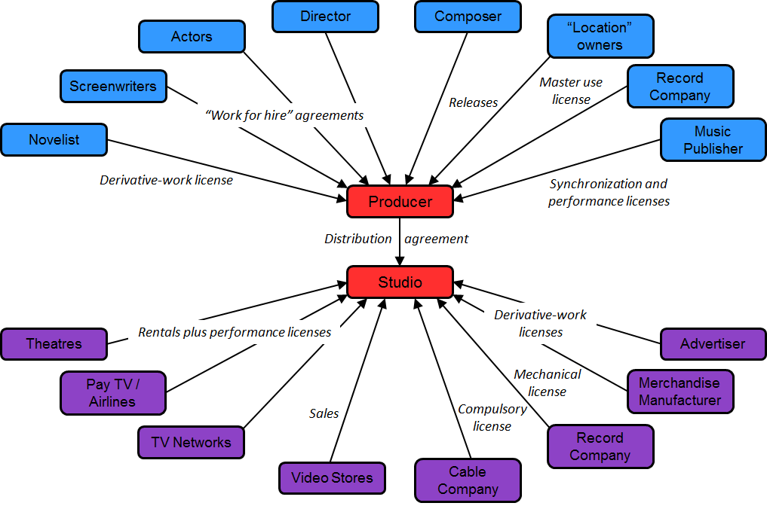
Figure 22: Parties involved in the copyrighting and licensing of movies, and their interactions

What do these various artists and copyright owners obtain in return for entering into these contracts and licenses? In most cases, they’re paid a negotiated flat fee. However, a few of the most important contributors – for example, the key actors and perhaps the director – may negotiate a share of the back-end profits generated by the film. So, to return to our story, the producer, which now owns the copyright in the completed film, typically enters into a perpetual worldwide – sometimes universewide – distribution agreement with a major motion picture studio. Like the music publisher, who figured so prominently in the previous section of this lecture, the studio then typically makes money by issuing a series of licenses to companies that wish to present the film to consumers in one way or another. Typically, the first set of such licenses is granted to theaters, which then show the film to their patrons, collecting box office revenues. The terms of the deals between the studios and the theaters have changed dramatically over time. Nowadays, when the dust settles, typically between 40% and 50% of the revenues collected by the theaters are paid to the studios. When attendance in theaters begins to decline, the studio is likely to enter into similar licenses with pay TV companies, airlines, and so forth, permitting them to show the film to their subscribers or passengers. Next, the studio will probably grant a similar license to a television network, which will broadcast the film – leavened, of course, with advertisements – to the public at large. Cable companies may pick up the network signals, and relay the broadcast to their own customers. When they do so, they have to pay the studios fees. But the amounts of those fees are governed by another compulsory licensing system of the sort we discussed in connection with the music industry. More on this later.
The studio then may begin to exploit ancillary sources of revenue, which are increasingly valuable. For example, it may issue a mechanical license to a record company, which will produce CDs and other products containing the recording of the soundtrack of the movie. The studio may authorize a merchandise manufacturer to make and sell dolls, lunch boxes, backpacks, and other products, based upon the characters or plot of the movie. Sometimes, advertisers will pay to use components of the film in their ads.
Last, but not least, the studio will likely authorize sales of copies of the film to video stores and, now, online distributors, which will make them available, either by sale or rental, to customers.
We’ll return later to several litigated cases that implicate one or another part of this overall business model.

Fictional Characters
A relatively recent addition to the set of copyrightable works consists of fictional characters. A character described in a larger fictional work, such as a novel or a movie, now enjoys copyright protection independent of the work in which he or she appears. The primary practical implication of this principle is that no one without permission may write a sequel to a fictional narrative that includes one or more of the characters who appeared in the original. To be sure, not all fictional characters get this protection. To qualify, a character must be important.
US courts have articulated two different tests for determining which characters are shielded. The first test, commonly known as the Sam Spade Test, was announced long ago by the Court of Appeals for the Ninth Circuit. To be protectable under this approach, a character must, “constitute the story being told.” The facts of the case that prompted the Ninth Circuit to adopt this restrictive approach were as follows: Dashiell Hammett, the author of the classic detective story, The Maltese Falcon, assigned the copyright in the story to Warner Brothers, which made a film based on the book. Subsequently, Hammett granted the copyright to the Sam Spade character, older than his incarnation in The Maltese Falcon, to CBS. Warner Brothers brought suit, contending that Sam Spade already belonged to Warner Brothers. The Ninth Circuit eventually rejected this argument, announcing the Story Being Told Test and suggesting that Sam Spade did not satisfy it. So that’s the first approach. The Ninth Circuit has never expressly repudiated it; however, in several recent opinions, the court has implicitly distanced itself from that approach, moving toward the rule applied in all other US jurisdictions, which is simpler and more lenient. Under the second approach, a character is protected under copyright law so long as he or she is well delineated.
Here’s a relatively recent controversy that suggests the scope of this doctrine.
Sylvester Stallone, as you probably know, wrote the scripts for each of the first three Rocky movies. He then also played the role of the title character, Rocky Balboa. In each of the three movies, Rocky is depicted as an underappreciated, sullen, but heroic boxer. In 1982, Stallone and MGM were considering producing yet another, fourth, movie in the series. An unaffiliated author by the name of Timothy Anderson wrote a script for such a fourth movie. The central figure in the script was, of course, Rocky. This time, Rocky is depicted as fighting a Russian boxer in a contest with strong nationalist overtones. MGM apparently seriously considered using Anderson’s script, but eventually decided not to do so. When MGM and Stallone eventually produced their own version of Rocky IV in which Rocky is depicted as fighting a Russian, Anderson brought suit, contending that his copyright in his script was infringed by the MGM Rocky IV movie. The district court rejected Anderson’s argument on several grounds, one of which is central to the issue before us. In the court’s judgment, the character of Rocky clearly satisfied both the old Sam Spade Test and the modern Well Delineated test. Indeed, in the court’s judgment, this was obvious. The Rocky character, “has become identified,” says the court, “with specific character traits ranging from his speaking mannerisms to his physical characteristics.” Presumably, the court is here referring to Stallone’s famous physique, which is more or less the same in all four of the movies. Anderson’s script, the court pointed out, appropriated the character of Rocky without permission. Indeed, says the judge, the character was “lifted lock, stock, and barrel from the prior Rocky movies.” As a result, Anderson’s script constituted an infringing derivative work. In US copyright law, infringing derivative works are denied copyright protection, at least if the material taken from the plaintiff’s work pervades the infringing derivative. The net result was that even if the MGM Rocky IV movie closely tracked Anderson’s script, Anderson could not prevail because his script was tainted by its unauthorized inclusion of the copyrighted character, Rocky, and thus did not, itself, enjoy copyright protection.
Application of these principles is reasonably straightforward in cases like Anderson’s, in which the character at issue is stable and well-etched, and in which the defendant appropriates that character verbatim. But many monitor modern controversies don’t fit this pattern. For example, some of the most famous fictional characters evolve over the course of their commercial careers. An important example would be Superman, whose depiction in the original comic books changes as he becomes more popular, as the narrative associated with his character shifts, and finally, when he becomes associated in the minds of the public at large with the face and body of Christopher Reeve. Which, if any of the Superman incarnations, thus enjoys copyright protection? Difficult to say. Here’s another complicating factor: it’s sometimes said that a fictional character is more likely to enjoy protection if he or she is presented visually – as in a comic book or movie – than if he or she is described in prose. But this advantage could become a disadvantage if more than one actor plays the part of the character, thereby blurring the character’s characteristics. The premier example is James Bond, who has now been presented by six different actors. Tuxedos and a British accent can only go so far in obscuring the differences among these depictions.
In circumstances of these two sorts, in which the character changes significantly over time, or in which the character is associated with several different actors, does the character forfeit copyright protection? Typically, no. Modern courts are quite forgiving of indeterminacy of these sorts. Pretty much the only kind of character who will fail to qualify for copyright protection nowadays is a lightly sketched, so-called stock character. In other words, a simple or familiar stereotype. This exclusion, you will probably notice, is a cousin of the scenes a faire doctrine, which we discussed in lecture number one, which denies copyright protection to an image or scene that has become standard in a genre.
This exclusion doesn’t much matter, however, because there’s usually not much point in appropriating stock characters.
So, to return to the main line, a crucial implication of the protectability of fictional characters is that almost all fan fiction, which is increasingly common nowadays, is legally problematic. Now, I hasten to add that fan fiction may escape liability under one of the affirmative defenses to copyright infringement that we’ll discuss in detail in lecture number nine. But the fact that fan fiction almost always lifts one or more character from a famous work creates a legal risk.

Architectural Works
An important category of copyrighted work consists of works of visual art, which are known in US law as pictorial, graphical and sculptural works – sometimes abbreviated as PGS works. Included in this zone are, of course, paintings, posters, statues, and so forth. Most of the other things that fall into this category are obvious. However, two dimensions of the protection extended to PGS works are not obvious and merit closer attention.
The first is that nowadays copyright law is often used to shield the logos that manufacturers apply to consumer products. Here's an example. The Omega watch company has obtained a US copyright on the design shown in Figure 23, which it calls the Omega globe design. From lecture number, one you should remember how and why a Swiss company can get a US copyright. Omega engraves a version of this logo on the underside of its watches, which are manufactured in Switzerland. Omega then sells these watches all over the world. Typically, it sells them for lower prices in poor countries than it does in more wealthy countries. Some years ago, Costco, using an intermediary, purchased some of the watches that Omega had sold cheaply outside the United States, imported them into the United States, and began selling them in its US stores for prices lower than those used by Omega’s authorized US dealers. Omega brought suit contending that this so-called parallel importation violated Omega’s copyright in the logo – not its trademark or patent rights, but its copyright. Now, the legal rule underlying this lawsuit and the outcome of the suit we’ll consider later when we discuss the rights of distribution and importation in lecture number eight. For now, I just want to emphasize the expansive reach of the subject matter of copyright and how companies like Omega have tried to use that expansive coverage to engage in geographic price discrimination.
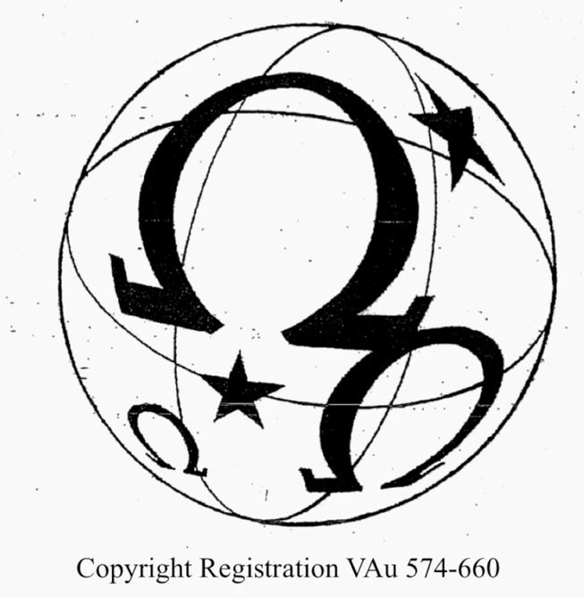
Figure 23: Omega S.A. v. Costco Wholesale Corp. – the Omega globe design

The second non-obvious dimension of the category of PGS works involves what is sometimes called applied art or industrial design. Those terms refer, roughly, to three-dimensional objects that are intended to be both useful and attractive. Objects of this sort permeate modern consumer culture. Just look around the room or space where you are located right now; most likely, you'll notice many objects that fit this general definition. Possibilities include an unusual lamp, a container of bottled water, a distinctive coffee mug, the shape of a laptop computer or tablet, your eyeglasses (if you wear them), a doorknob or window fixture, a decorative table or chair, and so forth. Each of these things combines, in some way, art and function. In the United States, three different systems of law are potentially available to the creators of new objects of this sort. Copyright law, design patent law, and the protection that trademark law extends to so-called “trade dress.” Some innovations qualify on more than one of these systems, but others may fail to qualify under any. It depends on the shape and history of the particular object and all too often on the whims of the tribunal evaluating that object. If you're curious about the potential reach of design patent law or trademark law, feel free to follow on your own the links in the relevant branches of the map using the interactive version of the map available through the CopyrightX website. For obvious reasons, I'll concentrate in this lecture on the possibility of copyright protection for objects of this sort.

The history of copyright as it pertains to three-dimensional works
1870: statute reaches three-dimensional “fine art”
Bleistein (1903): expansive, relativist conception of art
1909: statute reaches “works of art, models or design for works of art”
1910 – 1948: Copyright Office construes narrowly
Regulation § 202.8 (1948): works of art “include works of artistic craftsmanship, in so far as their form but not their mechanical or utilitarian aspects are concerned”
Mazer (1954): uphold § 202.8
1959: Copyright Office adopts § 202.10I, incorporating separability principle
Courts develop concepts of physical and conceptual separability

In the late 19th century, it was clear that copyright law did not extend to works of this sort. Three-dimensional works of fine art were shielded, but not the kind of consumer products to which I directed your attention a minute ago. Then gradually, through a series of steps itemized on the map (and above), Congress, the Copyright Office, and the courts liberalized the relevant rules in the United States. Today, the governing general principle is that copyright protection is available to so-called “useful articles” if, and only, if the aesthetic and functional features of the article at issue are separable.
The first step in applying this principle is to determine whether a particular object qualifies as a “useful article” within the meaning of the copyright statute. The reason why this initial determination is so important is that if an object does not constitute a useful article then the ordinary more lenient rules of copyright law apply, whereas if it does constitute a useful article it has to pass more stringent tests. So what does “useful article” mean? The statute defines it as follows: “an article having an intrinsic utilitarian function that is not merely to portray the appearance of the article or to convey information.” Some applications of this definition will be straightforward. For example, Rodin’s sculpture does not constitute a useful article because its function is to depict itself – to depict a thinker. By contrast, a lamp – no matter how beautiful – is a useful article because it has a function other than looking good, namely illuminating the room in which it's located. In other instances, however, application of this definition will be trickier. If a particular object is deemed to fall into this special category then its creator gets copyright protection, to repeat, only if its aesthetic and functional dimensions are separable.
How might they be separable? Traditionally there were two options. The first of these options, which arises rarely, is that the aesthetic and functional dimensions might be physically separable. For example, as the treatise writer Melville Nimmer suggests, the stylized Jaguar shape that is attached to the hood of a Jaguar automobile enjoys copyright protection because it can be physically removed from the car without impairing the car's utilitarian function. Likewise, the utilitarian components of the car can be removed from the Jaguar without impairing its aesthetic features. With respect to most useful articles, physical separability of this sort is not feasible. The creators of such objects may still obtain copyright protection, however, if they can demonstrate that the aesthetic and utilitarian features are conceptually separable. So what does that mean? The conceptual separability inquiry is the most intriguing and least satisfying aspect of this doctrine. Until very recently, the United States Supreme Court provided very little guidance concerning how this concept should be interpreted and applied. As a result, the lower courts were forced to develop their own interpretations. By the early 21st century, five distinct families of interpretations of the term “conceptual separability” had emerged.
The first of the five approaches asked whether the form of the object at issue is dictated by its function. If so, conceptual separability does not exist. This variant was emphasized by the majority of the judges in the influential 1985 Barnhardt case, which involved the two sets of mannequins shown in Figure 24, which were copied by a competitor without permission. The majority, in that case, contended the shapes of the mannequins were required by their function – namely, displaying clothes in stores – and consequently that their utilitarian and aesthetic features were inextricably combined, and thus copyright protection was unavailable.
Interpretations of conceptual separability
- Is form dictated by function?
- Which aspect of the article is primary?
- Separate concept
- Stand on its own as work of art?
- Intent of the creator
The second of the five approaches asked which aspect of the object in question is primary. So, for example, the court in the Kieselstein-Cord case concluded that the ornamental aspect of the belt buckles shown in Figure 25 was primary and their utilitarian function, namely holding pants up, was subsidiary, and thus that they did enjoy copyright protection.

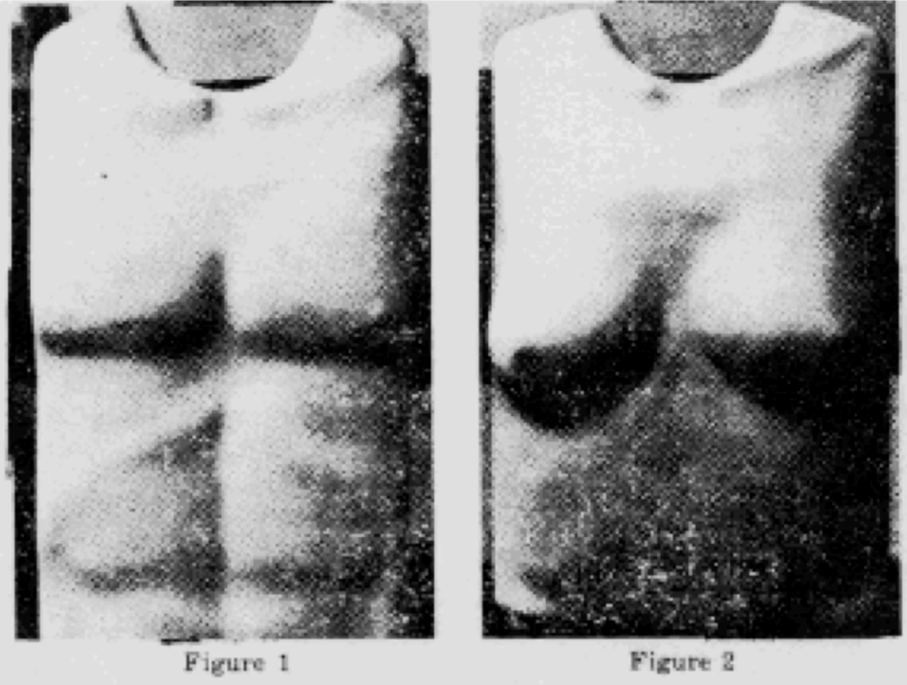

Figure 24: Carol Barnhart Inc. v. Economy Cover Corporation (1985) – mannequins

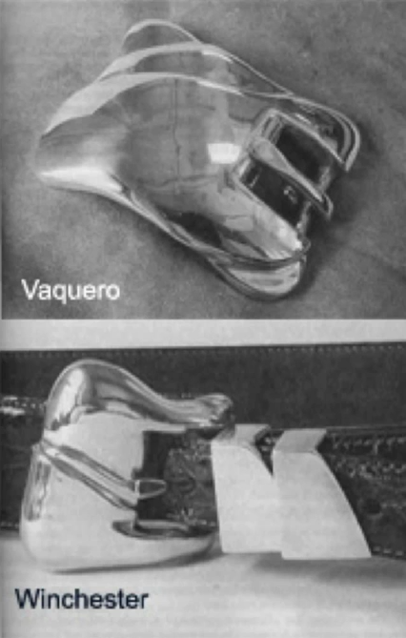

Figure 25: Barry Kieselstein-Cord v. Accessories by Pearl, Inc. (1980) – belt buckles

The third approach was made famous by judge Newman's dissenting opinion in the Barnhart case which I mentioned a minute ago. It came to be known as the “temporal displacement test.” The key question under this approach was whether the object “stimulates in the mind of the beholder a concept that is separate from the concept evoked by its utilitarian function.” If so, there is conceptual separability; if not, not. The phrase “temporal displacement” came from Newman's contention that the two concepts – utilitarian and non-utilitarian – must occur to the beholder not simultaneously but separated in time.
The fourth approach asked whether the article can stand on its own as a work of art. If so, it enjoys protection. There were two different ways of elaborating this. Paul Goldstein suggested that we inquire whether the article could constitute a work of art “traditionally conceived,” which is related he argues to whether the article would be equally useful without its aesthetic feature. The reference to art “traditionally conceived” naturally draws us back into the debate I discussed in the first lecture concerning the best way of defining art. For the reasons I reviewed there, resolving that question would be difficult, although perhaps unavoidable. By contrast, Goldstein's fellow treatise writer, Nimmer, pointed to a more empirical interpretation, asking whether a significant number of copies of the article would be purchased if it had no utilitarian use. This approach was adopted by the Court of Appeals for the Fifth Circuit in the Galiano case, which involved uniforms for employees of the Harrah’s gambling casino. Applying the test, the court concluded that the plaintiff “makes no showing that its designs are marketable independently of the of their utilitarian function as casino uniforms,” and therefore that the uniforms are not entitled to copyright protection.
The fifth and last of the approaches focused on the intent of the creator of the article – the individual designer – who determined its final shape. This approach was adopted by the Court of Appeals for the Second Circuit in the Brandir case, which involved the following facts. David Levine was playing around with some wires, making miniature sculptures in his home. Ge twisted one wire into the shape of a bicycle and another into the shape of a ribbon and placed both along with other designs on his mantelpiece. A friend of his pointed out that the ribbon shape could serve as a useful rack for the miniature bicycle. Inspired, Levine worked with a friend to refine the design and eventually begin manufacturing and selling commercial versions under the company name Brandir International. His product is depicted in Figure 26, together with another photo showing how bicycles can be locked to it. The rack proved popular and a competitor, Cascade Pacific Lumber, began producing knock-offs. Brandhir brought a copyright infringement suit against Cascade. The outcome of the case hinged on whether the ribbon rack satisfied the conceptual separability test. Relying on a 1983 article by Robert Denicola, the court announced the following test: “if design elements reflect a merger of aesthetic and functional considerations, the artistic aspects of a work cannot be said to be conceptually separable from the utilitarian elements. Conversely, where design elements can be identified as reflecting the designer's artistic judgment exercised independently of functional influences, conceptual separability exists.” Applying this approach, the court ruled against Brandir, emphasizing several ways in which Levine had modified the shape of the original abstract sculpture in order to make it durable and to accommodate as many bicycles and mopeds as possible. Because the shape of the product did not reflect “artistic expression uninhibited by functional considerations,” it could be copied by a competitor with impunity. As one might expect the result of this decision was that other companies began manufacturing and selling competing versions of the ribbon rack.

Figure 26: Brandir International, Inc. v. Cascade Pacific Lumber Co. – the Bandir ribbon rack
In 2016, the divergence of views among the various courts of appeals on the proper approach to conceptual separability prompted the United States Supreme Court to attempt to settle the matter. The case in which the court addressed the issue involved the following facts. Cheerleaders in the United States entertain the fans who attend sporting events. Typically, they wear brightly colored uniforms, perform in gymnastic maneuvers, and encourage the fans to cheer on the team hosting the event. Although the cheerleaders at college-level competitions are best known, in part because those competitions are often televised, quite young people often – though not always girls – participate in this activity. The Varsity Brands company designs, manufactures, and sells cheerleading uniforms. Two of their products are shown in Figure 27. Varsity has applied for and been granted copyright registrations on many of their designs. The drawing submitted in conjunction with five of those registrations are shown in Figure 28. The Star Athletica company also manufactures and sells cheerleading uniforms. Allegedly, Star produced and sold uniforms that incorporated these five of Varsity's designs. Varsity brought suit for copyright infringement. The crucial issue in the case was whether Varsity's sesigns qualified for copyright protection at all and that issue reduced to the issue of whether the design and function of the uniforms were separable. The trial court concluded no; the Court of Appeals for the Sixth Circuit concluded yes; and the Supreme Court, seeking to resolve the conflict among the various courts of appeals on this general question, agreed to hear the case. In the end the court, by a vote of 6 to 2, upheld the Sixth Circuit's judgment that the uniforms did enjoy copyright protection. The majority opinion, written by Justice Thomas, announced a new test for separability which will govern all future cases involving useful articles. The key components of the new test are set below.

Figure 27: Two of cheerleading uniforms offered by Varsity Brand

We hold that an artistic feature of the design of a useful article is eligible for copyright protection if the feature (1) can be perceived as a two- or three-dimensional work of art separate from the useful article and (2) would qualify as a protectable pictorial, graphic, or sculptural work either on its own or in some other medium if imagined separately from the useful article.
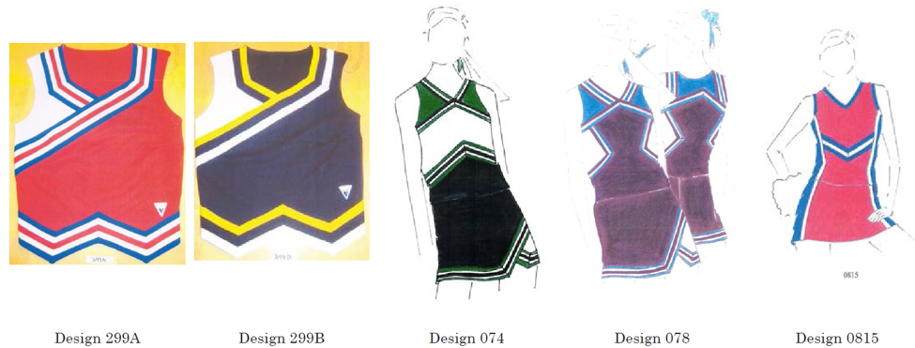

Figure 28: Five of the cheerleading uniform registrations belonging to Varisty Brand

This new test, you should recognize, is a variation on the separate concept test originally developed by Judge Newman – although, oddly, Justice Thomas did not acknowledge as much. In his justification for this approach, Thomas expressly repudiated some of the other tests. Goldstein's variant of the standalone test, Nimmer’s variant of the standalone test, and the intent of the creator test that, as we saw, drove the Brandir bike rack case. Implicit in Thomas's opinion is repudiation of the other pre-2017 approaches. The application of this new approach to the facts of the case, Justice Thomas contended, was simple: one can easily identify the decorations on the uniforms as features having pictorial, graphic, or sculptural qualities, thus satisfying test one. As to test two, if the arrangement of colors, shapes, stripes and chevrons on the surface of the cheerleading uniforms were separated from the uniform and applied in another medium, they would of course qualify as two-dimensional works of art.
We don't yet know how this new approach will be interpreted and applied by the lower courts, but already many legal commentators have weighed in and the large majority of expressed disappointment or dismay. To be sure, a few aspects of the star test have been praised. For example, by rejecting the subjective intent of the creator test, the Supreme Court has probably limited the scope of discovery in cases of this sort, thus sharply reducing litigation costs as well as curbing wasteful strategic behavior by designers. And, as Jane Ginsburg, points out the new approach has reduced to some degree the relevance of whether an artistic design is first developed in two dimensions and then applied to a useful article or incorporated in the useful article straight away. All to the good. But other aspects of Thomas's approach have been sharply criticized. Almost all commentators agree that it is distressingly vague and thus give gives poor guidance to litigants and lower courts. Some commentators contend that it is too easily satisfied and thus will expand dramatically the set of useful articles that enjoy copyright protection. Others, like Marc McKenna, lament the absence of any discussion in the court’s opinion of the policies or theories underlying the separability requirement, which in turn reduces the chances that when applied the new test will be either coherent or socially beneficial. Whether these criticisms are well-founded remains to be seen.
This leaves us with one more type of three-dimensional object that now enjoys copyright protection: architecture. Inclusion of architecture in the list was a long time coming and its implications are still not entirely clear. Here's a bit of background. The original 1886 version of the Berne Convention included architectural plans in the set of things that member countries were obliged to protect, but not architectural works per se. Application of this principle would mean that if you copied the drawings that an architect had prepared to guide the construction of a building you would be liable for infringement, but not if you were able to construct an identical building without use of those plans. In 1890, the Belgian scholar Jules de Borchgrave published an article criticizing the state of affairs and arguing that works of architecture deserve protection identical to that enjoyed by other works of art, such as painting and music. Borchgrave’s argument slowly took root in European copyright systems, first in Belgium, then in France. For a while, some European countries resisted adoption of his proposal on the ground that it could prevent replication of ordinary non-innovative buildings, but when reassured that the proposal would only apply to “original artistic work,” they acquiesced.
A key step in this campaign was the addition of architectural works to article 2(l) of the 1908 version of the Berne Convention. As you know, the United States did not join the Berne Convention until 80 years later. Until it did so, copyright protection for architecture in this country was skimpy. Again, architectural plans were shielded, as they were in most countries, so that unauthorized reproduction of such plans was unlawful; however, the majority view in the United States was that an architect whose plans were copied without his permission could not permit the construction of buildings using the infringing plans. The buildings themselves were potentially protectable as useful articles, just like the types of industrial design we have recently considered, but as such they had to satisfy the conceptual separability test. Only if the aesthetic components of a building were separable from the utilitarian features did the building enjoy protection against non-permissive copying. Rarely was this true.
When the United States did finally join the Berne Convention, Congress considered whether formally to extend copyright protection to architectural works. It initially decided not to do so, persuaded that the protections available for useful articles were adequate, but commissioned a report from the Copyright Office on the subject and that report urged that the law be modified. Congress in response adopted the Architectural Works Copyright Protection Act, which became effective in 1990. The key provisions of the new statute are set forth below.

17 USC § 102(a) amended to extend protection to “architectural works”
“An ‘architectural work’ is the design of a building as embodied in any tangible medium of expression, including a building, architectural plans, or drawings. The work includes the overall form as well as the arrangement and composition of spaces and elements in the design, but does not include individual standard features.” § 101
Limited to “buildings”
Author = architect
Infringement
Effective 1990

Notice that it's limited to “architectural works,” which are defined as “the design of a building.” Courts in the United States have construed building to be limited to freestanding structures. The most important implication of this new statute is that in the United States architectural works no longer have to run the gauntlet of the conceptual separability test in order to be protected. To be sure, like all types of copyrighted work, a piece of architecture must be original to be protectable, but as we've seen the standard for originality is very lenient.

Figure 29: The Jewish Museum in Berlin, designed by Daniel Libeskind

Here's an example of a building design that would clearly pass muster. In 1989, the Polish-born architect Daniel Libeskind won a competition to design the Jewish Museum in Berlin. Figure 29 shows a photograph of the building taken from directly above it and a second aerial photograph taken from a slight angle. As you can see, the shape of the building is unusual – a complex zigzag. Here's how Libeskind himself explained the structure.

From the Museum Website:
The new building is full of artistic expression: the architect Daniel Libeskind named it “Between the Lines” on account of two linear shapes which form its structure. The “Line of Connectedness” expressed in the window design symbolizes the cultural exchange between Jews and non-Jews and the ways in which they influenced each other. The “Line of the Voids” is a series of empty rooms, which runs in a straight but disrupted line through the building. These empty rooms represent the cultural gaps left in Germany after the Holocaust.
The groundplan has been interpreted in many different ways. Some see it as a lightning bolt striking the city of Berlin. Daniel Libeskind, the architect, likens it to a deconstructed star of David.
The Libeskind building is formed of two main lines: the line of connection, tortuous and infinite, authorized the cultural exchange between Jews and Gentiles and their mutual influences; a second line, straight but broken into discrete fragments, runs through the length of the house – it is the line of the void.

His architectural partner and wife, Nina Libeskind, emphasized the theme mentioned at the end of the second paragraph likening the shape of the building to a broken star of David. In the late 1990s, the Australian architect Howard Raggatt was commissioned to design the new National Museum of Australia to be located on a peninsula in the center of Canberra. Raggatt’s much celebrated design is shown in the aerial photo in Figure 30. Until the Australian Museum had been finished, no one, apparently, noticed the resemblance between its central building and the Jewish Museum in Berlin, but once the connection was suggested, the parallelism became unmistakable (see Figure 31).
This case never resulted in litigation. Had it done so, it most likely would have resulted in liability. Since 1968, Australian copyright law has extended to, among other things, a building or model of a building, whether the building remodel is of artistic quality or not. Certainly, if this standard is construed in the same way that current US standard is construed, Libeskind’s design would qualify for protection and the Australian building resembling it sufficient to satisfy the legal standard of substantial similarity. The fact that the case nevertheless was not litigated bears emphasis. Why not? We can't be sure, but probably two factors were at work. First, copyright litigation is very time-consuming and expensive; as a result, only a tiny percentage of potentially actionable cases ever end up in court. Second, architects – at least high-end architects – seem especially loath to rely on copyright to protect their work. As David Shipley notes, the large majority of the cases that have been brought alleging violations of the Architectural Works Copyright Protection Act involved not high-end buildings but mundane mass-produced works. The designers of noteworthy buildings by contrast seem to rely more on peer pressure and public condemnation to discourage knock-offs. Indeed, such extra-legal sanctions were deployed in this particular instance. The Libeskinds publicly expressed outrage and the press, both in Germany and in Australia, condemned what one paper called “architectural kleptomania.” The director of the Australian Museum, who apparently had not known of the relationship between the two buildings, expressed some misgivings, publicly acknowledging that “had we known we might well have asked for that particular reference not to be included.” Interestingly, however, Raggatt himself seems to have had no regrets. The overall design of the Australian Museum is postmodern in character, alluding to many other structures. Raggatt readily admitted to having been inspired by the Jewish Museum and does not seem to resist the inference drawn by many observers that he deliberately intended to analogize the treatment of Aborigines in Australia to the treatment of the Jews in the Holocaust. As one might imagine, that suggestion remains highly controversial in Australia. The more general point latent in this example is that there is no consensus, even among architects, concerning the definition and significance of copying when it comes to designs of buildings. What to one person constitutes plagiarism or theft may to another seem quotation or allusion. The law now sides with the former but is rarely invoked. What the relevant norm should be is one of the questions I hope you'll be in a position to answer.

Figure 30: The National Museum of Australia, designed by Howard Raggatt


Figure 31: Compare the National Museum of Australia (left) to the Jewish Museum in Berlin (right)

Welfare Theory

The Utilitarian Framework
Today, we return to copyright theory. I’ll be examining the third of the four general approaches to copyright law, which is known as the welfare theory. The first segment of today’s lecture will describe the overall framework of the utilitarian perspective that underlies the welfare theory. The second segment will examine how, viewed through the lenses of the welfare theory, copyright law functions. In the third and last segment, I’ll explore a few of the many applications and implications of the welfare theory. I will refer to the second of the two maps I’ve been employing in this course, which addresses theories of intellectual property.
The fairness theory, which I discussed two weeks ago, centers on the proposition that labor gives rise to a natural property right in the fruits of that labor. Somewhat more specifically, creative or intellectual labor, so the argument goes, gives rise to a natural right to a reward or a set of entitlements proportional to the amount of labor invested. Law, the argument continues, should recognize and enforce that natural right. In lecture number two, I discussed some of the implications of the labor theory and the ways in which it finds expression nowadays in many copyright systems, including that of the United States. I also discussed some of the difficulties, complexities, and ambiguities associated with the theory.
The second of the four main approaches, also considered in the second lecture, is the personality or personhood theory. Its premise is that law should provide people, especially but not exclusively artists, property rights over objects or intangibles that they need in order to fully realize their selves. This argument is grounded in the writings of Kant and Hagel. In the second segment of lecture number two, I examined some of the contemporary applications of the personality theory. In particular, the ways in which it has informed the practice in European countries of moral rights. I also discussed some difficulties for complexities associated with that argument.
We turn to the welfare theory, which has a very different heritage. The foundation of the welfare theory is, as I mentioned, utilitarianism. Its patron saints are Jeremy Bentham and John Stuart Mill, who established, starting in the late 18th century, a distinctive approach to political thought and eventually economics. The key idea of utilitarianism, undoubtedly familiar to most of you, is that government and law in particular should be organized so as to promote the greatest happiness of the greatest number. Somewhat more specifically, law should be organized to induce people to behave in ways that redound to the benefit of the public at large. How? Primarily by creating combinations of incentives and penalties to nudge people in socially beneficial directions.
Two characteristics of this orientation bear emphasis and cause it to contrast sharply with the fairness theory, its primary rival. First, the utilitarian approach is prospective in orientation. In other words, it looks forward in time. It seeks to craft the law in a way that will induce people in the future to behave in a fashion that will increase overall happiness or welfare. By contrast, the fairness theory, as we saw, is retrospective in orientation. It seeks to create rights that appropriately reward people for their conduct in the past. The second characteristic of the utilitarian approach that differentiates it from the theories we’ve discussed thus far is that it’s collective rather than individual in orientation. It focuses on the welfare of society as a whole rather than on doing justice to or serving the human needs of its individual members.
So, that’s the starting point – the foundation of this approach. The way this venerable broad perspective is brought to bear on intellectual property is through the concept of public goods. This is a phrase common in economics, although less familiar outside the field of economics. I’ll begin by defining it and then discuss its implications. A “public good”, economists tell us, is a good that has two related features – it’s non-rivalrous and nonexcludable. By way of contrast, consider an apple. An apple is said to be rivalrous because consumption of the apple by one person is inconsistent with consumption of it by a second person. If I eat the apple, there’s nothing edible left for you. Partly because it’s rivalrous in this sense, it’s naturally excludable. In other words, as long as the apple is in my possession, it’s difficult for you to gain access to it. A non-rivalrous good is one whose consumption is not inconsistent with its availability to other people. A classic example of this phenomenon that figures prominently in the literature of economics is a lighthouse or other navigation aid. Suppose that I erect a lighthouse on a rocky headland. The purpose of the lighthouse is to warn ships not to come close to the rocks, thereby enabling them to avoid catastrophe. The benefit of that warning can be provided simultaneously to a nearly unlimited number of ships and their captains. Making the lighthouse signal available to one ship does not diminish its availability or benefit to other ships. The lighthouse is for that reason said to be non-rivalrous. For a related reason, it’s also said to be nonexcludable. As should be apparent by now, it would be difficult for me, the creator of the lighthouse, having made the signal available to one ship, to prevent others from benefiting from it. Consequently, it would be very difficult for me to charge for access to the good. In theory, I suppose, I could construct a fence of some kind 10 miles out from the lighthouse – in other words, on the horizon this photo – and then charge ships who want to enter the gates. But that’s plainly impracticable.
These two characteristics of lighthouses largely explain why there are almost no privately constructed lighthouses or other navigation aids anywhere in the world. The reason is that no private party has an appropriate financial incentive to construct such a socially beneficial facility because the builder would be unable to charge the persons and organizations who benefit from it.
Navigation aids are the example of public goods most commonly deployed by economists. Here are some others. National defense. Once the benefit of an army or navy is made available to one resident of a country, it can be enjoyed by everyone else in the country. Roads can be used by a very large number of drivers simultaneously without impairing usage by others. Now, as any commuter can attest, there’s an outer limit to the number of cars that could use a road simultaneously, but short of that limit, roads function as public goods. Most important for our purposes, the kinds of things that are at issue in intellectual property, specifically inventions and reproducible art, are classic examples of public goods.
Here’s a simple illustration. Suppose that I’m a poet. I write a poem. I make it available to one poetry lover. She reads it and likes it. She’s likely to want to share it with others. Why? Well, partly, of course, because of the natural human impulse to share things. But, also, partly because by sharing it she would not be giving up anything. Even after sharing it, she could reread or recite it anytime she wants. The practical result is that I will have great difficulty charging successive readers for access to my poem. Instead, it is likely to spread from one reader to another without my knowledge or permission. Public goods, such as – as we’ve seen – lighthouses, roads, and poems, are special in a couple of ways. First, usually though not invariably, they have especially large social benefits. Second, they’re likely to be underproduced. In other words, to be generated at socially suboptimal levels. In this respect, I, the hypothetical poet, am in the same position as a private party considering building a lighthouse: recognizing the difficulty of collecting money from readers, I’m likely to be discouraged from producing the poem in the first instance, and society at large will consequently suffer. If lawmakers wish to prevent this unfortunate outcome, they have to act in some way, have to provide a special stimulus for the creation of public goods. How governments can provide such a stimulus we’ll consider in just a minute. Before doing so, however, we have to consider several circumstances that will either exacerbate or mitigate the hazard that public goods will be underproduced and thus increase or decrease the need for governmental intervention.
Circumstances that exacerbate the problem of public goods being underproduced
- High costs of creation
- High uncertainty
- Low marginal cost of production
- Ease of reverse engineering
- Positive externalities from the public good
Listed to the right are some circumstances that are commonly said to exacerbate the public goods problem. First, high cost of creation. If a public good costs a lot to generate, the risk that it will be under produced is especially serious. In the intellectual property context, the premier example is new pharmaceutical products, which, taking into account the money spent on failed experiments, cost roughly $800 million to $1 billion dollars apiece to produce. The second exacerbating circumstance – also true of the pharmaceutical industry – is high uncertainty. If a potential innovator is unsure of success, he or she is especially likely to give up at the threshold. This tendency is exacerbated in social settings where potential innovators are risk-averse. By contrast, high degrees of uncertainty are less problematic in social settings where potential innovators are risk preferers, meaning naturally inclined to gamble. This is an interesting contested theme in the context of intellectual property because some commentators – relying either on anecdotal evidence or, in a few cases, empirical work – contend that some kinds of artists are risk preferers. This matters from utilitarian standpoint because to the extent artists or authors are gamblers by temperament, we should be at least marginally less concerned with giving them strong legal protections.
A third circumstance that is said to exacerbate the public goods problem is low marginal cost of production. If it’s easy to make copies of an innovation, then the risk that it will be spread willy-nilly without any compensation to the original creator are especially high. Again, drugs provide a clear example. New pharmaceutical products, at least if they consist of so-called small molecules as opposed to biologics, are easy to replicate cheaply. As a result, the hazards of under production are high. In the copyright context, this worry is even more serious nowadays with respect to digital embodiments of recorded entertainment, sound recordings (which we discussed last week), or films. It’s virtually costless to reproduce and redistribute digital recordings. In other words, the marginal cost of the copies is close to zero. That creates well known hazards for the creators of such things, increasing the argument for some kind of governmental response.
In the same vein, ease of reverse engineering exacerbates the public goods problem. The easier it is to figure out how a particular product was created, the easier and cheaper it will be to replicate it without permission. Most copyrighted materials are highly vulnerable on the score. Reverse engineering a poem, for example, is a simple matter. There are, however, a few exceptions. I discussed one of them in the previous lecture – software. Software enjoys a modest, natural shield against some kinds of copying. After a program is written in a language comprehensible to people, it is compiled into so-called object code – the sequence of ones and zeros comprehensible to computers. Proprietary software is typically distributed to the public only in object code form. In other words, the source code, the human readable code, is not contained in the CD-ROM you purchase or the copy of a program that you download. Now, there exist things called decompilers – devices that enable one to infer source code from object code – but they remain imperfect. As a result, software developers are able, by keeping the source code secret, to discourage replication of that code. Members of the public can, of course, make verbatim copies of the object code – that’s what the term software piracy usually refers to – but they have a harder time getting at the source code, and thus a harder time modifying or adapting the program. The key to this modest amount of natural protection is the difficulty of reverse engineering.
Last, but not least, the public goods problem is especially worrisome when the product in question has strong positive externalities, meaning that it confers benefits not merely on immediate consumers, but also on third parties. The context in which this issue arises most often is with respect to informational products that have infrastructure or generativity benefits, to use terminology developed by Brett Frischmann and Jonathan Zittrain. The key example is the set of protocols that underlie the internet. The reason that such externalities matter is that would be especially tragic if the incentives for the creation and improvement of such things were insufficient to foment them.
So, to review, there are five main circumstances that can exacerbate the public goods problem and thus heightened the need for governmental intervention to overcome it. Those circumstances are high creation costs, uncertainty, low marginal cost of production of copies of an innovation, ease of reverse engineering, and strong positive externalities.
Circumstances that mitigate the problem of public goods being underproduced
- Lead time protects first mover
- Custom or extralegal norms protect first mover
- Opportunities for increasing excludability through self-help
- Alternative motivations for production
- Philanthropy
On the other side of the ledger are circumstances that mitigate the public goods problem and therefore reduce the need for governmental involvement. First, in some contexts, innovators obtain through lead time enough of an advantage over copyists to enable them to recover the costs of their innovations, thus reducing the need for a governmental stimulus. Justice Breyer of the United States Supreme Court, long ago when he was an assistant professor at Harvard Law School, wrote an article developing this argument in the context of trade books. One of Breyer’s contentions was that the writers and publishers of so-called trade books – for example, the textbooks that are used in US high schools – enjoy at least a moderate lead time advantage. It takes a while, he contended, to reproduce and redistribute books of the sort. During the window of time before competitors can enter the field, the first publisher can earn quite a bit. Perhaps enough to render uncertain the social need for copyright protection with respect to such books. Hence the title of Breyer’s famous article, “The Uneasy Case for Copyright.” Another context in which lead time may be sufficient adequately to support innovation is fashion, meaning the design of high-end clothes. At least until recently, a fashion designer enjoyed a window of time between the first introduction of a new design and the moment when knock offs became available. During that window, the designer could and did sell his or her dresses and suits for a very high price to wealthy and fashion conscious, or perhaps prestige conscious, consumers. As a result, innovation has long flourished in fashion, despite the fact that in many countries, including the United States, new clothing designers do not enjoy copyright protection or indeed any other type of intellectual property protection. Now, this argument, I hasten to add, is controversial. Some commentators and designers disagree sharply, and most commentators acknowledge that the lead time window is getting shorter as the technologies for quickly reverse engineering and replicating fashion innovations are advancing.
Another circumstance that may reduce the public goods problem and therefore reduce the need for governmental involvement is the presence of customary or extralegal norms that forbid or discourage unauthorized, uncompensated usage of the good in question. Again, trade books may be an example. If there is a custom adhered to by all of the publishers in the field not to knock off each other’s works, then the need for legal intervention diminishes and indeed may evaporate altogether. This argument may also be found in Breyer’s article. Another potential example of extralegal norms is stand-up comedy. Professors Dotan Oliar and Chris Sprigman argue in a recent article that comedians have a fairly elaborate set of customs that discourage so-called stealing jokes. Not all comedians abide by those norms – Robin Williams, for example, is famous for defying them – but most do. To the extent these customs are effective, then legal intervention may be less necessary to provide an incentive for the creation of new jokes.
A third circumstance that can mitigate the public goods problem consists of opportunities for increasing excludability through self-help. That’s a somewhat cumbersome phrase, but here’s the basic idea. In some contexts, innovators can use self-help maneuvers to prevent promiscuous reproduction – the creation and distribution of knockoffs of their innovations. Innovations in the fields of soft drinks and chocolate, for example, are usually protected by keeping the formulas for the innovations secret (think Willy Wonka). Encryption is a modern analog to secrecy. In some contexts, innovators nowadays are able to impede reproduction of copies of their innovations by encasing each copy in a technological wrapper of some kind (think Blu-ray disc). I’ll return to this strategy in just a minute.
Yet another self-help technique relies on contracts. An example: in the United States, in contrast to many other countries, the primary databases for legal materials are not free. Instead, they’re hosted by private companies, specifically Lexus and Westlaw, and those companies charge a fair amount of money for access to their databases of judicial opinions and statutes. How? How do they protect themselves from competitors who have an obvious incentive to copy their databases and make them available more cheaply? Well, for the most part, not by relying on copyright law. In the United States, in contrast to many other countries, governmental works including judicial opinions and statutes are not covered by copyright. They are in the public domain – anyone is free to copy them. The way in which Lexus and Westlaw nevertheless discourage competition and maintain their business models is by requiring subscribers to agree to limitations on copying and redistributing the materials. Violation of those agreements is not copyright infringement, but it’s actionable as a breach of contract. The net result: Lexis and Westlaw don’t need intellectual property protection to maintain their business models.
Alternative motivations for production
- Passion
- Prestige/fame
- Tenure
- Norms of science
- Advertising
- Collaborative voluntary creation

The fourth circumstance that mitigates the public goods problem is that with respect to some kinds of innovations, alternative motivations for production can substitute for governmentally organized incentives. A non-exhaustive list of such alternatives is set forth on the right. The most obvious: passion. Many artists love their work and would continue to do it even in the absence of any monetary reward whatsoever. To the extent that’s true, the utilitarian argument for intellectual property or any other governmental intervention falls away because the good in question will not be underproduced. Assume for the moment that all poets write for love, not for money. That, from the utilitarian standpoint, would provide a compelling argument for withdrawing copyright protection from poetry. Now, there are other arguments reviewed previously in this lecture series for affording poets strong intellectual property protection. But from the utilitarian standpoint, the fact, the possible fact that a particular producer is motivated by non-monetary incentives reduces the need for law.
Prestige, fame, tenure – these play powerful roles in academic communities. Most scholars make no money whatsoever from their articles. Some make money on books, but from articles, almost never. So why do scholars write them? Well, first, to get tenure. And then, in some cases, to increase their prestige or renown.
Less selfish is the next entry on the list – the norms of science. Specifically, truth seeking. This figures, at least to some degree, in all fields of scholarly endeavor. Most people who work in research universities are primarily focused on contributing to human knowledge, not on earning more money. Scholars who’ve written powerfully about the implication of this fact for patent law and about the risks we run by contaminating this ethos with monetary incentives include Arti Rai and John Golden.
Advertising – I mentioned this in a previous lecture. In some contexts, intellectual property products will be generated even in the absence of legal protection because they serve as advertising for other things. For example, it’s sometimes said controversially that sound recordings function as advertisements for performances, specifically for concerts, and thus that we should not be troubled from a utilitarian standpoint by the decline in the monies that could be earned by selling copies of the recordings themselves.
Next, collaborative voluntary creation. In some contexts, people love to contribute without monetary rewards to collective creative enterprises. A rich array of such settings is examined by my colleague Yochai Benkler in two articles. Perhaps most familiar modern example is Wikipedia, which now rivals in influence and accuracy proprietary encyclopedias like the Encyclopedia Britannica. The people who have built Wikipedia don’t make any money. So why do they do it? Well, primarily because it’s fun. It’s fun not just to contribute to knowledge, it’s fun to engage in a collaborative enterprise of that sort. Again, the general point is that to the extent such motivations are operating, the need for governmental incentives diminishes.
Finally, that need is also reduced to the extent that innovators in a particular context are supported by private philanthropy. For example, as Mike Scherer emphasizes, once upon a time, philanthropy was a main way in which musical composition was funded. Another example: in the United States today, the news, gathered and broadcast by Public Radio stations, is funded in significant part by listeners who voluntarily contribute funds. Again, to the extent that’s true, the need for governmental support is reduced.
So, to review, we’ve identified a special and especially important category of goods known by economists as public goods that are subject to a unique danger. The danger is that unless government stimulates in some way their production, they will be generated in socially suboptimal quantities. There are, with respect to some such goods, circumstances that exacerbate the hazard of under production and thus intensify the need for governmental engagement. Conversely, there are with respect to other types of public goods circumstances that reduce or mitigate the difficulty, and thereby reduce the need for governmental engagement.
So, let’s assume that we’re dealing with one of the many types of intellectual products where the public goods problem is serious. Say, full length entertainment films or new vaccines. If a government recognizes the risk that such things will be under produced and seeks to overcome it, how could it do so? Well, over the centuries, governments have attempted to resolve the public goods problem in five different ways. I’ll survey them briefly and then zero in on the one that’s most relevant to this course of lectures.
Government solutions to the public goods problem
- Government provides the good
- Government selects and subsidizes private innovators
- Government issues prizes to successful private producers
- Legal reinforcement of self-help strategies
- Government protects producers against competition
Number one – the government can provide the public good itself. Recognizing that it will be under produced by private parties, the government can produce it. An example is space research. In most advanced countries, government agencies conduct space research. In other words, governments don’t rely on private parties to do the research. Rather, governments take on the task themselves. In the United States, this approach may be corroding a bit, but it’s still the dominant one. Similarly, much agricultural research is currently conducted in government labs. Likewise, the provision of national defense is almost always done by a government. Mercenary armies are rare, at least in the modern world. The final example mentioned earlier – navigation aids. Throughout the world, almost all lighthouses and buoys and so forth are built and operated by governments. Not surprisingly, the density of those aids varies with the amount of money each government is able and willing to devote to the project. So, there are many more buoys per mile along the coast of the United States than, say, along the coast of Croatia.
Number two – instead of providing the public good itself, a government can select and subsidize private parties who are able and willing to provide the good. The premier example of this strategy in the United States is the $27 billion per year that the National Institutes of Health pay to private parties – typically universities – that, in the government’s view, are likely to conduct socially beneficial medical research. Much smaller scale is the grant program of the National Endowment for the Arts, which subsidizes some kinds of cultural production. In Europe, governments commonly subsidize private filmmakers. In other words, give them grants that supplement the money they can earn from box office revenues, performance licenses, and so forth. Where do the European governments get the money that they then pay to the filmmakers? Well, sometimes from general tax revenues. Sometimes by taxing television stations or television advertising. Implicit in this portion of the system is a controversial judgment that film is a more worthy art form than television programming. Finally, sometimes the European governments get the money through taxes on box office receipts. That at first seems very odd, until one realizes that the governments are trying in this fashion to diversify the kinds of films that are produced. In other words, a portion of the ticket prices paid by the patrons of mainstream films are used to subsidize films that are less popular, perhaps because they’re unconventional, or because they’re made by first time filmmakers. Arguably, the ultimate objective is to elevate the tastes of moviegoers. Whether the European governments are justified and successful in this regard is a question to which we’ll return later in this lecture series.
Number three – instead of giving private parties grants in hopes that they will then generate public goods, the government can offer to give the private parties prizes if they generate socially beneficial public goods. In the context of inventions, the former Soviet Union and the People’s Republic of China have pursued this strategy aggressively. In the United States, it’s used much less often, but innovations in atomic energy are stimulated by the government in this fashion. In the artistic context, the Audio Home Recording act in the United States contains a mechanism for distributing government funds to the owners of the copyrights in popular songs. Several European countries have much more extensive levee systems that work essentially the same way, all reliant prizes to induce innovation that arguably would not otherwise occur.
Solution number four consists of legal reinforcement of self-help strategies. A few minutes ago, I mentioned that in some contexts, secrecy or encryption can substitute for governmental funding and supporting innovation, specifically by providing innovators protection against competition and thus helping overcome the public goods problem. Secrecy and encryption are not perfect, however. They’re threatened by economic espionage, by faithless employees, and by encryption circumvention. So, governments can come to the innovator’s aid not by paying them money, but by establishing and enforcing penalties for evading the innovators private self-help strategies. That’s basically what trade secret laws do. It’s also the essence of the Boat-hull Protection Act in the United States, which forbids certain ways of reverse engineering the design of recreational boats. Last, but not least, this approach underlies the recent addition to the copyright universe of so-called anti-circumvention rules. In brief, these rules impose fairly strong penalties upon non-permissive trafficking in circumvention technologies, and in some cases, upon the act of encryption circumvention itself. The idea behind these rules is to buttress encryption as a strategy for discouraging non-permissive reproduction of cultural products. I mentioned these rules in the first lecture. And we’ll come back to them and examine them in detail in the 11th lecture.
This brings us finally to the fifth, and for our purposes here, the most important of the approaches. The fifth strategy for overcoming the public goods problem is that governments sometimes protect the producers of public goods against competition through law. So, here’s a quaint example. In the 19th century, governments would sometimes authorize private companies to create toll roads or bridges. In other words, to construct turnpikes or bridges over rivers, and then charge the travelers who wanted to use them. But here’s the key feature. When doing so, governments would frequently promise the companies that no competitor would be permitted to construct a rival road or bridge, at least for a certain period of time. The purpose and the effect was to enable the companies to charge high tolls, at least for a while. High enough to defray the construction costs and to make a tidy profit. Now, a footnote. The governments didn’t always make good on their promises. For example, the famous Charles River bridge case in the United States arose out of a breach of a promise of this sort. A promise to limit the set of bridges across the Charles River here in Cambridge to the first developer. Investors’ expectation that governments might renege in this way limited the effectiveness of this approach. Putting that important nuance to one side, the key point is that governments sometimes encourage private parties to make socially beneficial things not by giving them grants or offering them rewards or helping them to lock up their ideas, but by suppressing competition, giving them for limited periods of time monopolies. Intellectual property, and the law of copyright and patent, in particular, constitute an application of this approach. At least when viewed through the utilitarian glasses, the point of such laws is to give authors and inventors exclusive rights to make and distribute copies of their creations, and thereby to charge high prices for them. High enough to offset the cost of creating them in the first instance and, even more importantly, to induce creative people to become authors and inventors rather than lawyers or financiers.
In the next segment of this lecture, I’ll examine in detail how the copyright system works, how exactly it functions to overcome the public goods problem.

The Incentive Theory of Copyright
This is the second segment of a lecture on the welfare theory of copyright. In this portion, I’ll examine in more detail how copyright law works – specifically, how it functions from the standpoint of the welfare theory. Along the way, I’ll point out a few of its advantages and disadvantages, again, viewed from the standpoint of welfare. For this purpose, we’ll be using a slightly fictionalized real-world example.
Cambridge Documentary Films is a small documentary filmmaking company. It’s run by two people, Margaret Lazarus and Renner Wunderlich. It’s called Cambridge Documentary Films because it used to be based here, in Cambridge, Massachusetts, but it’s now housed in Santa Barbara, California. Cambridge Documentary Films, or as we will call them, CDF, produces very high-quality, short documentaries. One of those documentaries is Defending Our lives. It’s 30 minutes long. Its subject is the scourge of domestic violence. Domestic violence is a phenomenon that, as many of you know, is global in character. If anything, it’s increasing in severity. This film examines the subject by talking with, doing interviews with, many of the women who’ve been subjected to domestic violence. It won the Academy Award for Short Documentary in 1993. Because of the continued salience of the social problem and the quality of the film, demand for the film remains sizable and fairly constant, and as a result, CDF continues to sell copies of it.
So, that’s the real-world case. We’re going to use an adapted, simplified version of that case to explore the way in which the copyright system works. First question: suppose CDF wants to make some money by distributing copies of the film in DVD format. How much should CDF charge for each copy? To answer that question intelligently, CDF would need some more information. I’m going to supply you hypothetical, but reasonably realistic, data of the sort they would need. For simplicity and clarity, I’m going to present that information graphically. To those of you who’ve studied some economics, graphs of the sort you see in Figure 32 will surely be familiar to you. The x-axis, the horizontal axis, represents quantity – in this case, the quantity of DVDs containing the film Defending Our Lives. The vertical axis is money – we’ll use dollars, but we could use any currency – to represent first the cost of those DVDs, and then the revenue that they could generate for CDF.
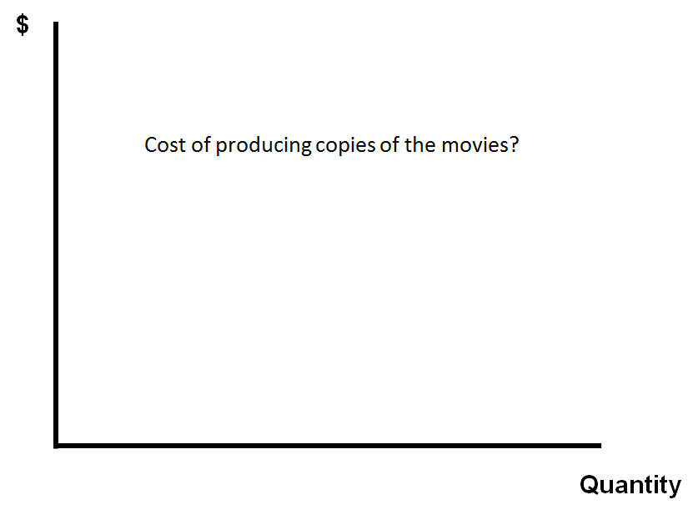
Figure 32: The basic axes

The first thing we’d want to know in order to determine how much CDF should charge is the cost of producing the DVDs. CDF surely doesn’t want to charge less than the cost of generating them. So here are some numbers. It turns out that producing and distributing a DVD is inexpensive. It costs approximately $1 to reproduce the film in the physical disc, $0.90 to package it, and $0.80 to distribute it to customers. So roughly speaking, $2.70 is the cost of making and distributing each copy of the film. That cost doesn’t vary much with how many copies you make. Expressed graphically, this means that the marginal cost of producing DVD copies of Defending Our Lives is low and flat – flat because it doesn’t change, as I indicated, materially as the total number of copies produced increases or decreases. Now, this is not true of all cultural products. With respect to some, there are economies of scale, meaning that the marginal cost of making copies of them goes down the more you produce. There may be a few types of cultural products, though examples are hard to think of, in which the marginal cost of making copies goes up if the materials used to produce them are scarce. But many, perhaps most, will have marginal cost curves that look roughly like the one in Figure 33, low and flat.
But this information actually doesn’t get us very far. As any business school professor will tell you, the seller of a commodity should be paying primary attention when pricing that commodity not to the cost of producing it, but to what potential buyers of the commodity are able and willing to pay. How would CDF get information of that sort? Perhaps through consumer surveys, focus groups, or projections on the basis of what earlier films sold for. To keep things simple, we’ll supply them with the information they are seeking. Looking at Figure 34, if CDF set the price of the DVDs up where the red dot (A₁) is located on the vertical axis, a modest number of people (A₂) would pay for it each month. The high price would keep it out of the hands of most potential customers. If, by contrast, it’s priced at a lower point (B₁), the number of people who would purchase it is larger (B₂). Still lower price (C₁), still larger a number of purchasers (C₂). And if CDF priced it at 0 (D₁) – in other words, if they just gave the DVDs away – an even larger number of people (D₂) would accept it and watch it each month. The number here is not infinite, because not everyone is interested in domestic violence. Put differently, there are other things they’d rather do with their time. But as one might expect, the total number of copies sold would be greatest if the price were 0.
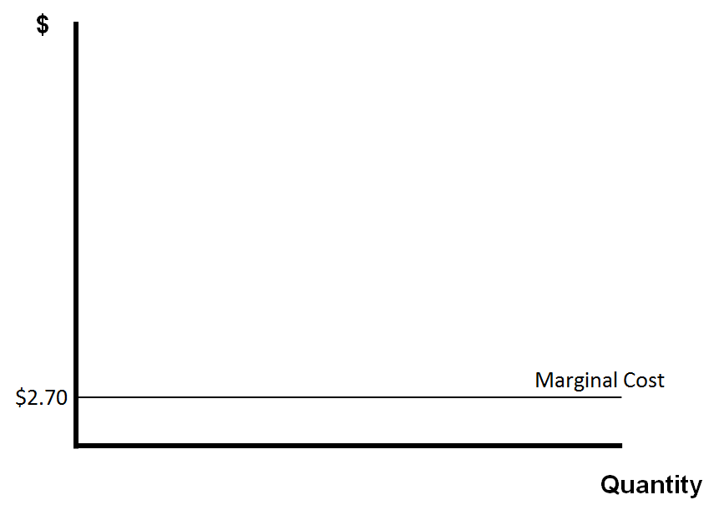
Figure 33: The marginal cost of producing a DVD

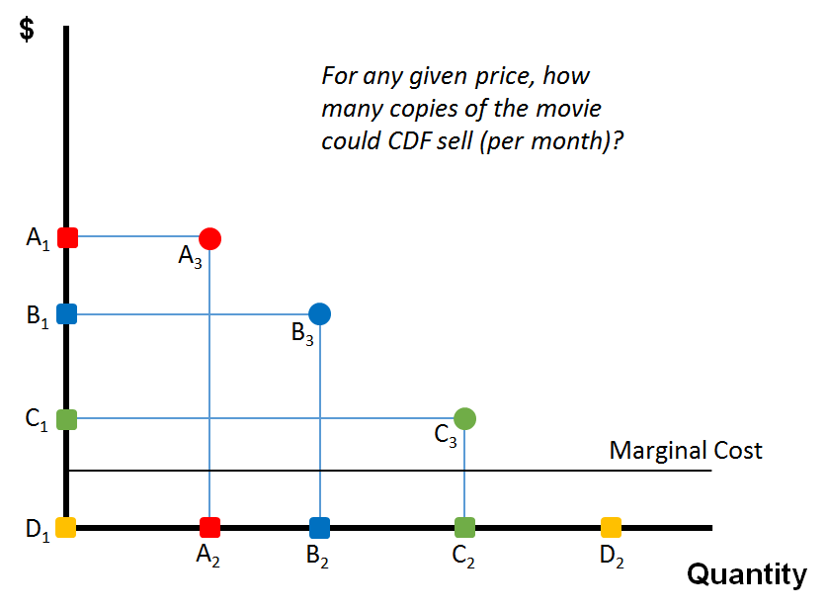
Figure 34: Plotting price vs demand

It will turn out to be helpful to plot these pairings on the two-dimensional space of the graph. A₃ is a representation of the combination of price and quantity associated with the red option. B₃, and C₃ represent the blue and green respectively. Finally, yellow is already marked at the bottom. When you connect up all these dots, the result is a demand curve (Figure 35). To keep things simple, I’ve chosen combinations of price and quantity that would generate a straight line, rather than a curve. In the real world, the shape of this line would, of course, be more complex. But a simple straight line enables us to illustrate the basic principles more clearly. The demand curve, to repeat, is merely the accumulation of many observations of the sort we just did; namely, for any given price, how many copies of the movie could CDF sell each month.
Having built the curve, we can now remove the scaffolding. OK, so against this backdrop, what should CDF charge for the DVDs? In other words, where along this curve should CDF position itself? We’ll try to answer that question first in a hypothetical environment in which copyright law does not exist, and then in a hypothetical environment in which copyright protection is available.
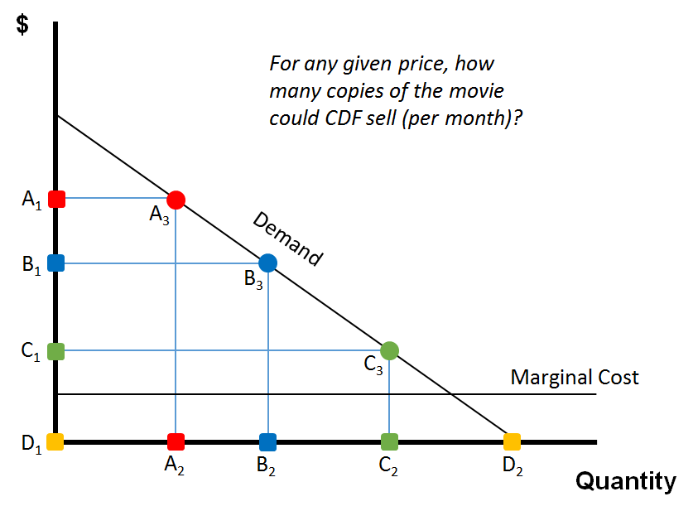
Figure 35: The demand curve
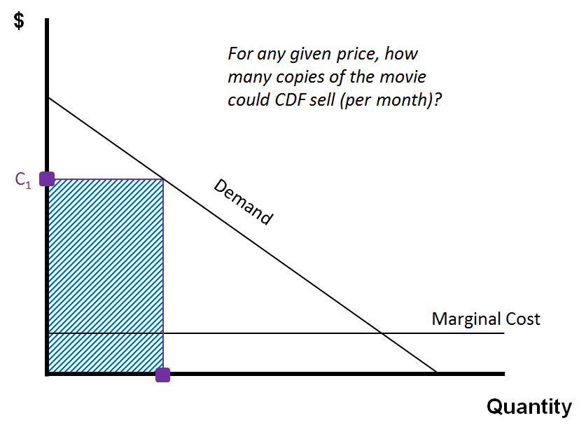
Figure 36: A possible initial price for the DVD and the resultant revenue

If copyright law does not exist, then the CDF managers will quickly recognize that, sooner or later, if they wish to sell significant numbers of DVDs, they will have to set the price very low. They could, of course, begin by setting the price up at C₁ (Figure 36). The result will be that, in the first month, they would sell a modest number of copies and earn a fair amount of money. More specifically, they would earn the amount of money equal to the number of copies sold times the price of each copy; in other words, revenue equal to the shaded area. But if they did this, CDF would very quickly face competition, because a rival would purchase one of their copies and then replicate it, selling the knockoffs for a lower price.
So, let’s suppose that this occurs in month number two (Figure 37). By choosing price R₂, the competitor would sell a much larger number of DVDs. But even more seriously, it would eliminate or largely undermine the demand for the CDF authorized version. CDF’s market would more or less go away. So, to respond, CDF would be obliged, if they wished to continue to sell films at all, to lower their price in the third month (C₃ in Figure 38). In the fourth month, the rival would respond by lowering its price (R₄), and CDF will be obliged to lower its price (C₅), and so forth, until the price of the copies of the film fell all the way down to almost the marginal cost of producing copies. The general point illustrated by this simple sequence is that, in the absence of copyright, copying and competition will drive the price down to marginal cost or nearly so.
In two related respects, this is socially beneficial. Indeed, in most contexts, antitrust law is designed to generate exactly this behavior. First, the total number of DVDs produced and distributed in this scenario is very large, meaning that a lot of people get the benefit of access to the film. Second, the consumer surplus generated by this pricing pattern is very large. Consumer surplus is just a term that represents the difference between the price that a given consumer pays for the product and the value of that product to the consumer, measured most easily by the maximum amount the consumer would be willing to spend. A rough measure of the total surplus generated by a particular marketing practice is the area between the demand curve, which represents consumers’ willingness and ability to pay, and the price of the product; in other words, the green zone in the graph in Figure 39. So, you might think, great, we hope this scenario does indeed occur. The trouble is that the CDF managers, anticipating this effect, won’t produce Defending Our Lives in the first place, because they will recognize that they will be unable even to recoup their costs. Or, perhaps more realistically, they won’t make any more of their wonderful films in the future. So, the seemingly large social benefits associated with the absence of copyright protection turn out, unfortunately, to be illusory. Very few films will be produced in this legal environment.
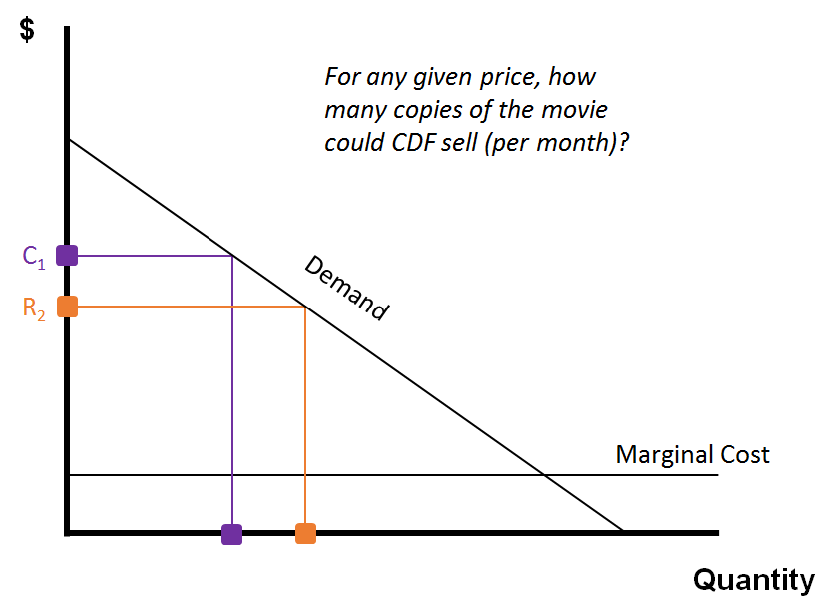
Figure 37: A rival copies the DVD and sells it at a lower price
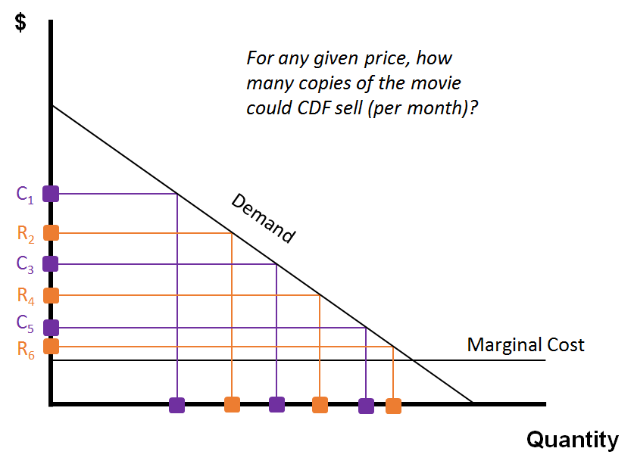
Figure 38: Competition drives the price down to (almost) the marginal cost
So, wait a minute, you may be thinking, won’t some of the alternative motivations that are sources of revenue for filmmakers that I discussed in the first segment of this lecture prompt CDF to keep making films? Perhaps, for example, CDF can get a government grant. Or perhaps private philanthropists will come forward. Maybe. But for the time being, we’re focused exclusively on the incentives that the copyright system can generate. So, ignore for the moment the possibility of other sources of funding.
Returning to our story, the purpose of copyright law is to avoid this outcome. How? By suppressing competition in the production and distribution of embodiments of the creative work; in this case, the film – in other word s, to eliminate CDF’s rivals. If the managers enjoy protection against competition, how, then, will they price the film? Well, if they have very good and detailed information concerning the ability and willingness to pay of every individual customer, plus the capacity to vary the price of the DVDs, then the managers will charge each customer the maximum amount that they can. So, for example, if the managers know that X is able and willing to spend P(X), they will charge that much. If they know that Y is able and willing to spend P(Y), they’ll charge that much. If they know that Z is able and willing to spend P(Z), they’ll charge that much. And the result is that the managers will enjoy, through this pricing strategy, monopoly profits that occupy the same area in our graph that, in the competitive model, was devoted to consumer surplus (see Figure 40).
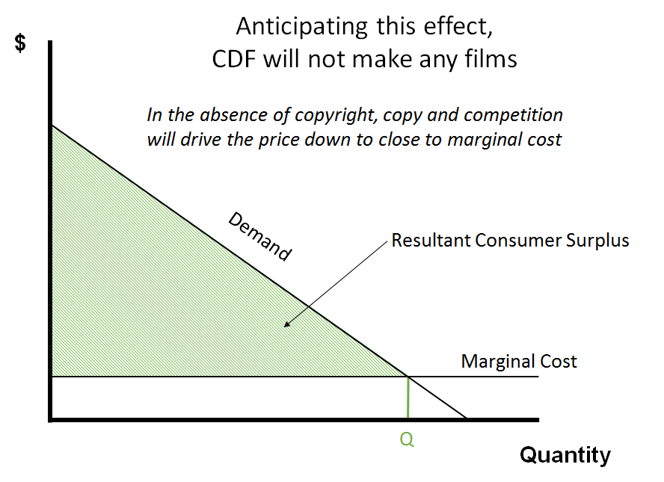
Figure 39: At marginal cost, there is a consumer surplus, but there is no incentive to make the film
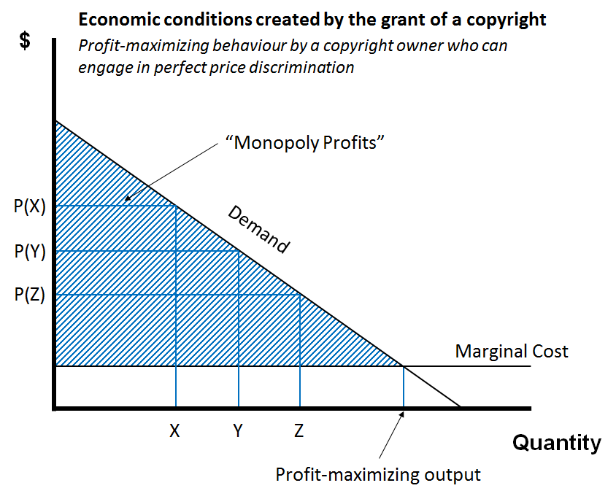
Figure 40: Perfect price discimination leads to maximum “monopoly profits”

From the standpoint of the CDF managers, this, of course, is wonderful. It gives the m a very large return on their original investment.
From a social welfare standpoint, it’s beneficial in two respects. The total output, meaning the number of consumers who get copies of the film, is maximized. And the prospect of these large potential profits will induce CDF to keep making the films from which we all benefit and will draw many other aspiring documentary filmmakers into this field. On the other hand, consumers are much less happy with this outcome, because each individual consumer has paid the most that he or she would be willing to pay.
The result: the large amount of consumer surplus, generated by the competitive scenario, has been altogether replaced here by producer surplus. In other words, all of the benefit that, in the previous narrative, was reaped by consumers, in this scenario goes to CDF, the producer.

So, what we’ve just illustrated is profit-maximizing behavior by a copyright owner who can engage in so-called perfect price discrimination – in other words, differentiate perfectly among buyers, charging each one the maximum amount that he or she would be willing to pay. Now, as you can imagine, this never happens. Perfect price discrimination is impossible. Later in this lecture series, I’ll discuss some circumstances in which, aided by copyright law, the producers of informational goods can engage in imperfect forms of price discrimination. But for now, let’s assume that CDF doesn’t have good information about their consumers and thus cannot and does not discriminate at all. In other words, we’ll assume that CDF will charge the same price for every copy of the DVD.
OK, so now how much will the managers charge? Well, they might determine the price by experimentation. Remember, the demand for Defending Our Lives is stable. So, the managers could experiment. In month one, they could set the price at p. They discover that u number of consumers buy it. They earn revenues of the amount shown in Figure 41. This is broken down into two zones (Figure 42): the cost to them of producing and distributing the DVDs, and their profit. So, they try an alternative approach. The next month, the managers lower the price slightly to q. They discover that v number of c onsumers buy it, a larger number, not surprisingly, because the price is lower. Figure 43 shows that they make more money in the second month, because they’ve sold more copies, but they also forfeit money, because they’ve had to reduce the price for everyone. But notice that the purple zone is larger than the orange zone. So, it was a good idea to have reduced the price. Put differently, the size of the monopoly profits in the second month is larger than the amount that CDF enjoyed in the first month Figure 44. Suppose that, encouraged by this beneficial price reduction, the managers lower the price more dramatically in the third month. An even larger number of people buy it. Again, the result is a revenue gain that exceeds the revenue lost (Figure 45). Once again, the profits enjoyed are larger than in the previous month. So, the managers try this strategy once more. They reduce the price of the DVD from r to z. An even larger number of people buy it. This time, the price reduction turns out to have been a mistake. The revenue gained through increased quantity is smaller than the revenue lost because of diminishing the price (Figure 46 and Figure 47).
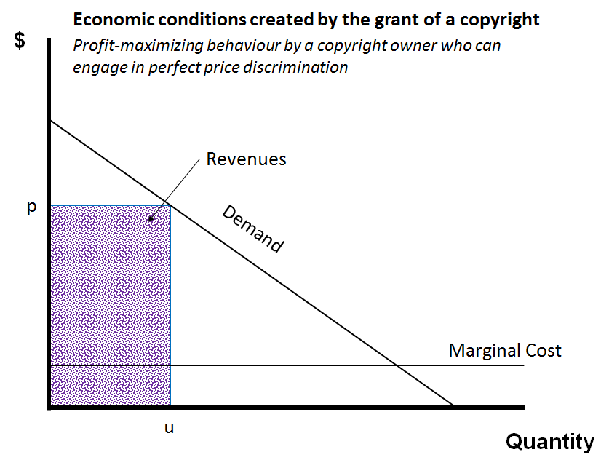
Figure 41: Price experimentation in month 1 and the resultant revenues
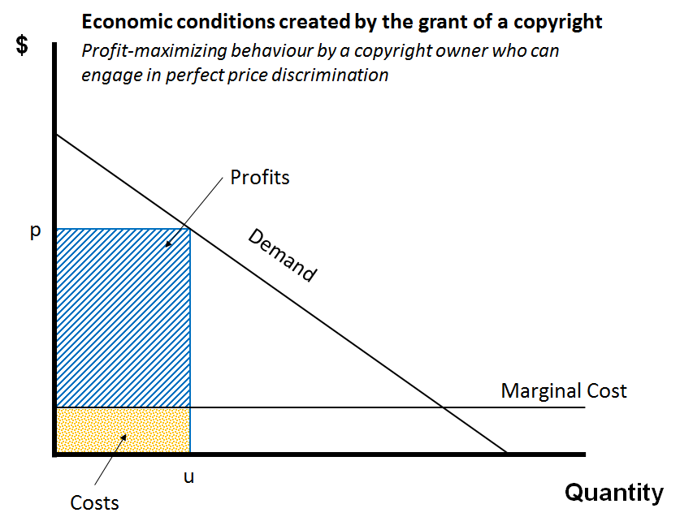
Figure 42: The month 1 revenue broken down into costs and profits

What I’ve just outlined is a possible experimental way of discovering the profit-maximizing price for copies of the film. Notice that the profit-maximizing price, when it finally emerges from this experimental process, is still well above marginal cost, but not as high as the managers might initially have been inclined to charge.
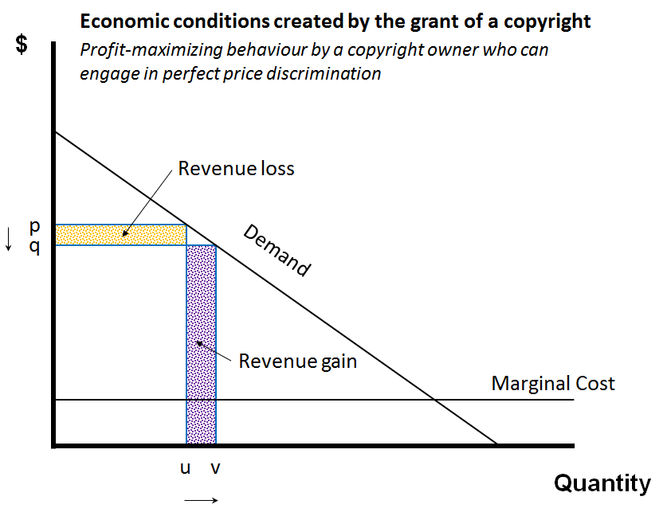
Figure 43: Price experimentation in month 2 and the resultant revenue gain and loss

Now, let’s change the assumptions once more. Suppose that the CDF managers have no practical way of differentiating among individual consumers, but on the basis of their experience making and selling other documentaries in the past, they are able to estimate the overall shape of the demand curve for Defending Our Lives. If they knew that, then they can determine the profit-maximizing price in a less haphazard, less trial-and-error fashion. They would do so by plotting the marginal revenue curve. What’s that? It’s a representation of the impact on their total revenues caused by each change in the price. Figure 48 shows what it looks like. The reason why this curve drops more steeply than the demand curve is that, as we’ve seen, each price decrease benefits CDF by expanding the set of people who purchase, but also injures CDF by forfeiting some of the profit that CDF could’ve enjoyed by targeting a smaller set of customers.
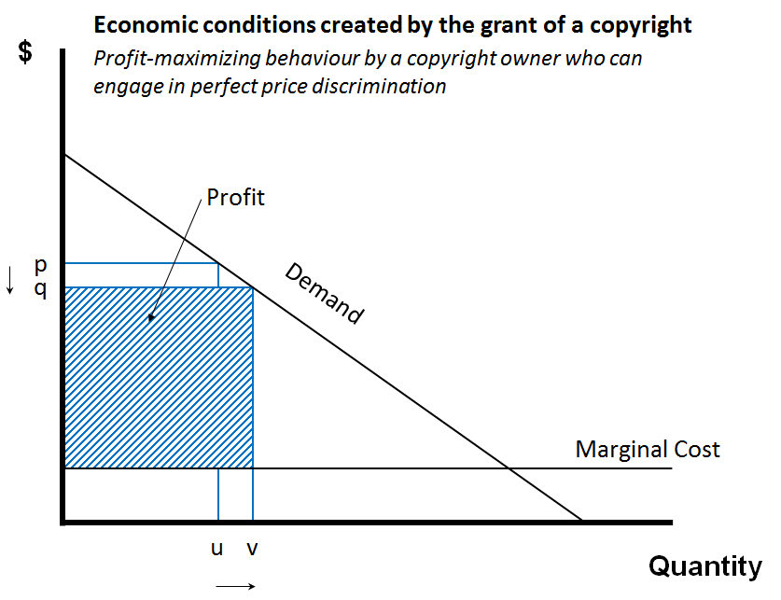  Figure 44: The total profit for month 2 | 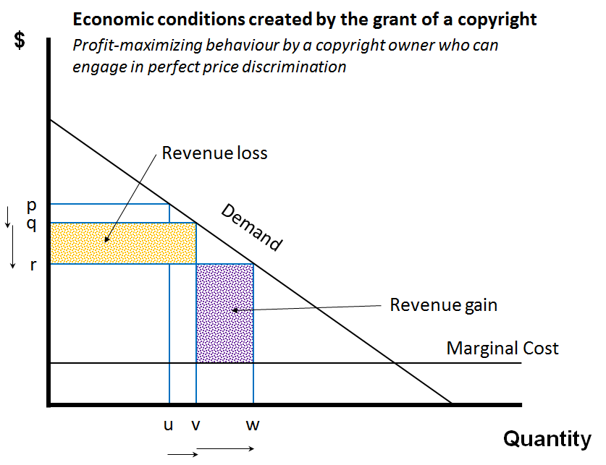  Figure 45: Price experimentation in month 3 and the resultant revenue gain and loss
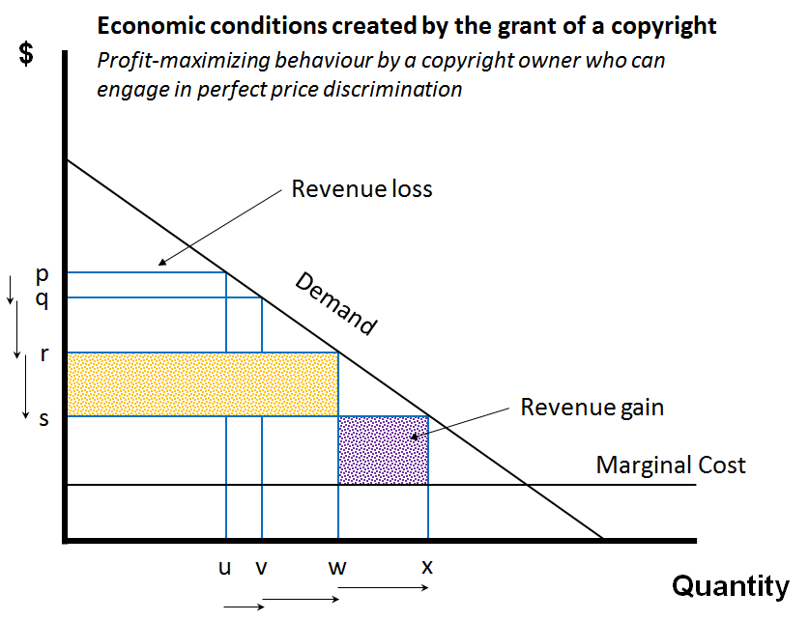  Figure 46: Price experimentation in month 4 and the resultant revenue gain and loss | 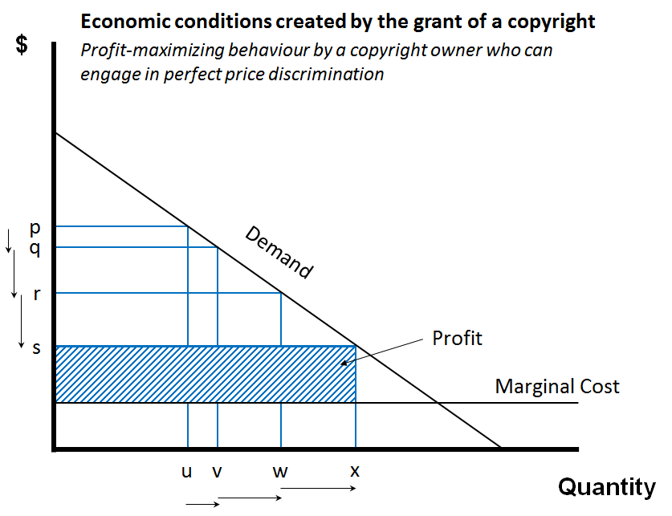  Figure 47: The total profit in month 4

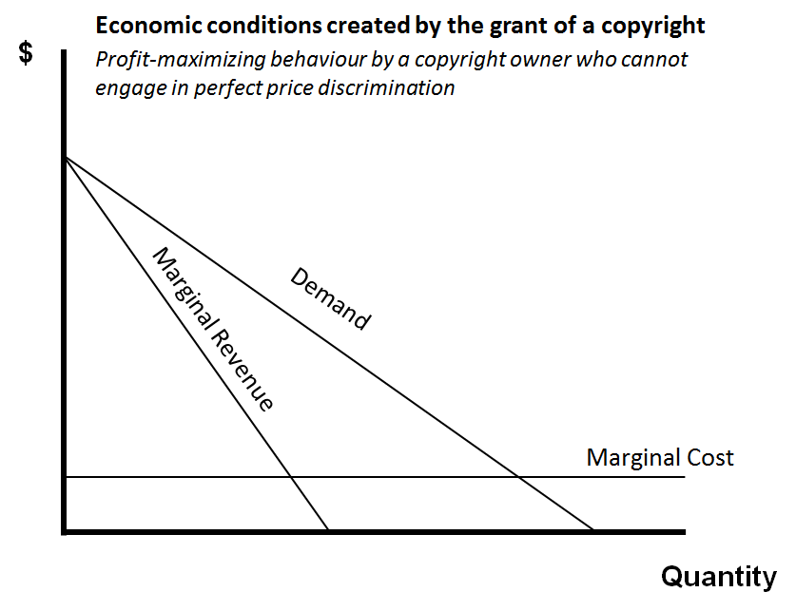
Figure 48: The marginal revnue curve

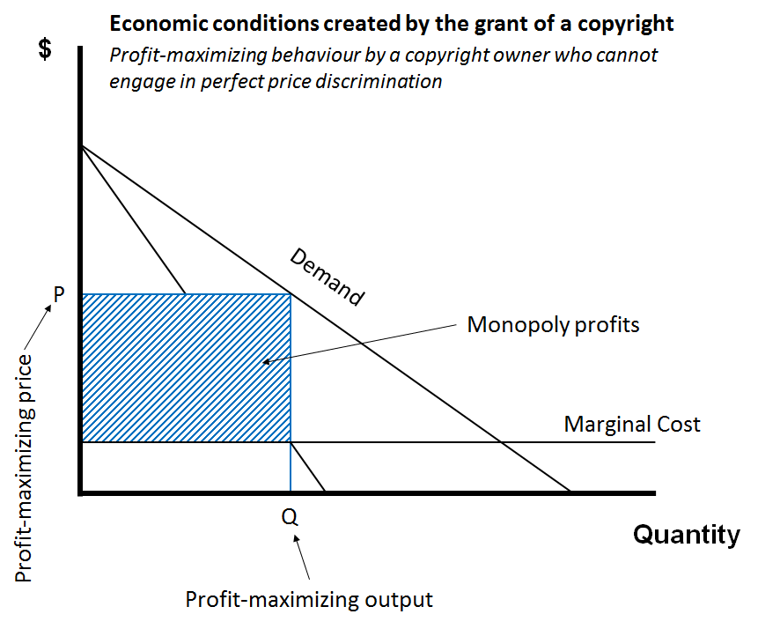
Figure 49: Using the marginal curve to find the profit-maximizing price and output, which yield monopoly profits

So, on the highly-simplified assumptions embodied in this graph, the marginal revenue curve will bisect the angle between the demand curve and the vertical y-axis. By plotting this line, the CDF managers are able to locate the place where the marginal revenue and marginal cost curves cross. They should t hen select the price for their DVDs that will reach a set of consumers that, in turn, will cause those curves to intersect. If they drop the price any further, the marginal revenue they gain through additional purchases will be less than the marginal cost of producing the additional DVDs. If they increase the price, they will forfeit in potential revenue more money than they save in costs. So, they should settle at this point. If they do, the number of consumers who purchase the DVD each month will be Q (Figure 49). P on the graph is the corresponding profit-maximizing price, and Q is the profit-maximizing output. This strategy, to repeat, will generate each month profits measured by the blue zone.
The strategy I’ve just outlined will have two crucial side effects – one of them good, the other one bad. The good one is that, unlike perfect price discrimination, this more familiar and feasible strategy will leave many consumers happy. Specifically, the people who buy the DVD at price P feel better off. Specifically, they experience pleasure measured by the difference between what they paid – that’s price P – and the maximum amount that they would have been willing to pay. The sum of all of the benefits enjoyed by all of the consumers who bought the DVD – in other words, the total consumer surplus – is represented on the graph in Figure 50 by the green zone. The bad side effect is that many of the people who would have purchased the film, had it been priced at the actual cost of making the copies, won’t, because they can’t afford price P. The result is what economists refer to as deadweight, a somewhat grim term. In this case, it refers to consumer surplus that could have been gained, but is sacrificed or foregone as a result of the pricing strategy pursued by CDF. So, the green zone is socially beneficial, while the red zone is unfortunate.
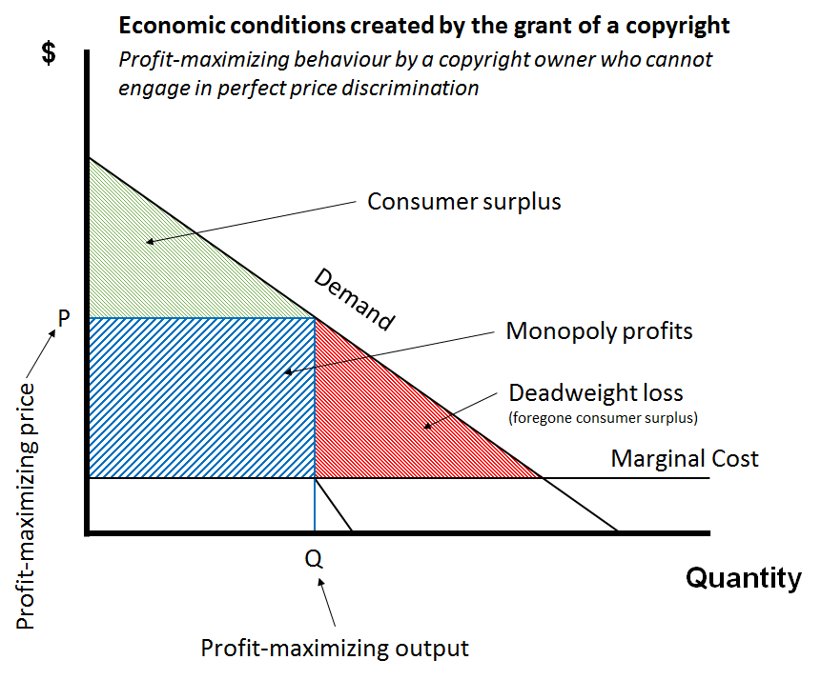
Figure 50: Price experimentation in month 4 and the resultant revenue gain and loss

Why do we tolerate the red zone? The conventional justification is that films, like Defending Our Lives, will only exist if potential creators, like CDF, are attracted by the opportunity to enjoy profits, measured by the blue zone. In short, the red zone is regrettable, but is necessary to enable us to reap the blue and green zones. That, in brief, is the core of the justification and explanation of the copyright system seen from the standpoint of welfare theory.
Now, those of you who are economists have undoubtedly recognized respects in which this scheme is oversimplified. Some of those respects I’ll address in the remainder of this lecture. Others I’ll examine in subsequent lectures in this series. And still others I won’t address at all. But this is enough to get us started. It’s very important that you feel comfortable with the primary features of this argument. To repeat one more time, the heart of welfare theory is the proposition that, unless creators can recoup the costs of their creations, their so-called costs of expression, they won’t produce those creations in the first instance. And the way that the law enables them to recoup their costs of expression is to suppress competition in the creation and distribution of their works. The absence of competition, in turn, enables the creators to price copies of their creations well above the costs of making and distributing them, which enables the creators to reap monopoly profits. That still leaves consumers who are able to purchase the goods better off than before, but has the unfortunate side effect of pricing out of the market a significant set of potential consumers. That’s regrettable, but we tolerate it in order to stimulate creativity in the first instance.
Some confirmation for this approach can be g leaned from the fact that actual pricing practices in the film industry align reasonably well with the predictions generated by this model. In Figure 51, for example, is the price on amazon.com of a DVD of Schindler’s List, which, like Defending Our Lives, won an Academy Award in 1993. Like Defending Our Lives, Schindler’s List remains popular, so there’s still considerable consumer demand for copies of it. So how was it priced? Well, as you can see, the list price is $15. Amazon sells it for $10. As you’ll recall, the cost of producing a DVD, including one containing Schindler’s List, is roughly $2.70. So, P, on the graph in Figure 50, which, you’ll recall, emerged from our analysis as the profit-maximizing price, is more or less in the zone of $10 to $15.
Now, interestingly, the film that we’ve been discussing thus far, Defending Our Lives, is not priced at $15. You can purchase the copies of the DVD from the website for Cambridge Documentary Films. On the website, you can see that CDF is selling it for $175 (Figure 52). That’s hard to explain on the basis of the analysis we’ve conducted thus far. It would seem that CDF has chosen to set the price way up at P (Figure 53). A price this high will earn CDF some monopoly profits (the blue). But the CDF managers seem to be forfeiting a large potential market (the red). So why do they do this? A clue is provided by their website, which indicates, as you can see, that the prices of their DVDs include public performance rights. To understand the significance of that statement, I need to provide you a preview of some material that we’ll discuss in much more detail in lectures number seven and number eight.
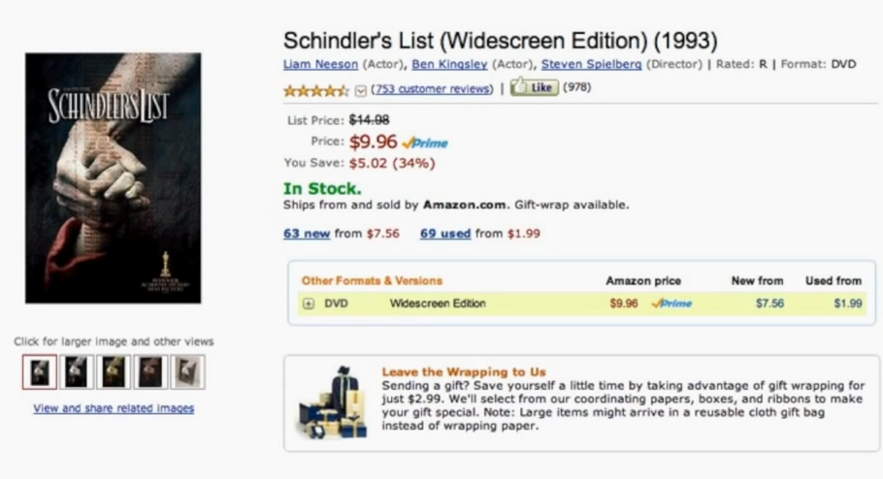
Figure 51: Pricing on Amazon for the DVD of Schindler’s List

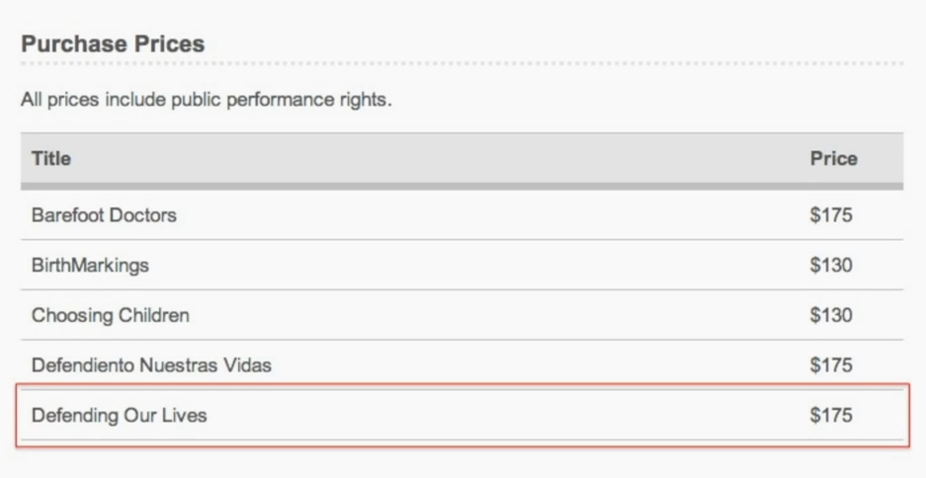
Figure 52: Purchase pricing for the short film Defending Our Lives.

When you buy a DVD, you’re permitted to do a lot of things with it, including, of course, watch it at home in your living room or den. But you’re not permitted to use that DVD to display the film on a screen in a public place. The reason is that the owner of the copyright in the film enjoys, among other rights, the exclusive right to perform it publicly. Your ownership of a copy of the DVD does not authorize you to encroach upon the copyright owner’s public performance right. So, if you want to show it to people other than your family and friends, you have to get a separate license to do so. So, what CDF is doing here is selling a bundle of two things – a physical DVD and a separate public performance license. The latter is worth much more than the former. Another inference we can draw from this somewhat unusual pricing strategy is that the customers that CDF has primarily in mind are not ordinary consumers, people who buy DVDs in order to play them on televisions in their dens. Rather, the CDF managers are aiming primarily at teachers or institutions that want to educate people about domestic violence. Put slightly differently, it seems that there are two quite different markets for Defending Our Lives – regular consumers and institutions.
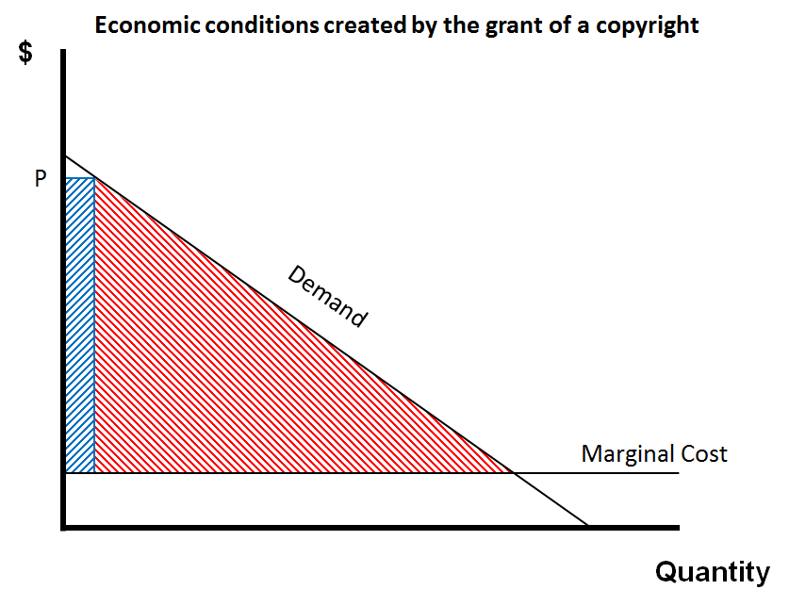
Figure 53: At a high price, CDF will earn some monopoly profit, but it will forfeit a large potential market

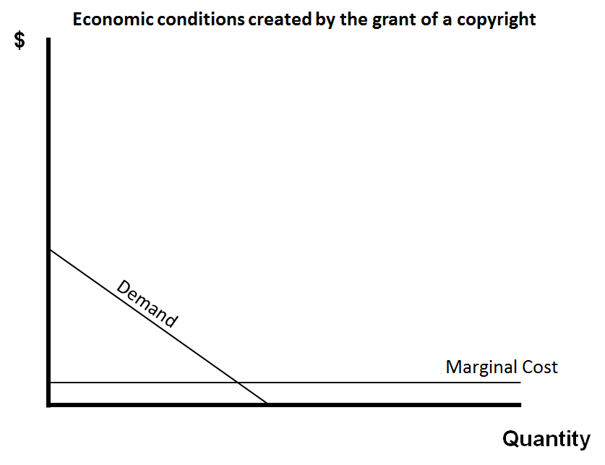
Figure 54: The first steps in showing the demand curves for regular consumers and instutions
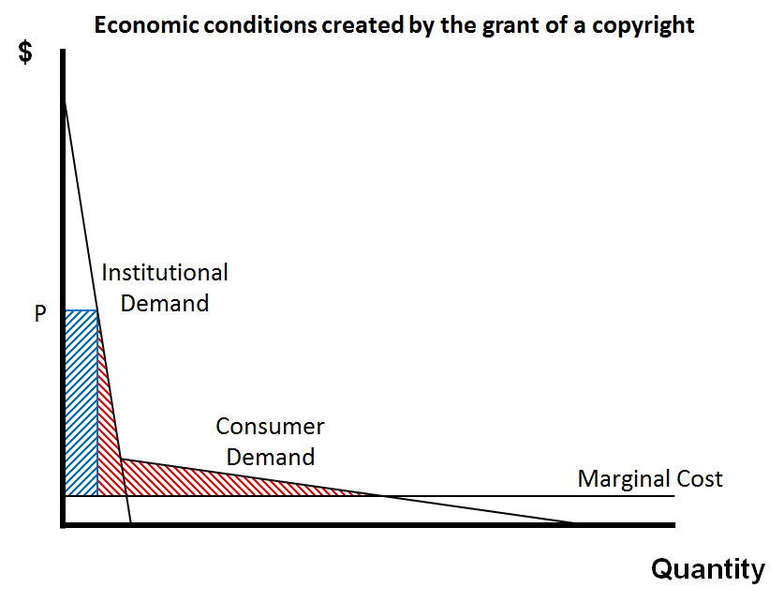
Figure 55: The instituional and consumer demand curves
To represent the two markets, I have to adjust the graph that I’ve been using, first by shrinking it and then by expanding the scales Figure 54. The institutional market for Defending Our Lives and the market consisting of ordinary consumers would look as shown in Figure 55. Why is the demand curve for the former so high and steep? Because the institutions anticipate showing it to lots of people repeatedly in educational settings, and at least some of those institutions are thus able and willing to spend quite a bit for that opportunity. Individual consumers, by contrast, are able and willing to spend much less. If CDF’s customers are clumped this way, then CDF’s pricing practice makes a lot more sense. The managers are setting the price way up at P in Figure 55. They are, to be sure, forfeiting a significant number of potential consumers, but this price is indeed profit-maximizing.
Now, there’s a nuance lurking here. Why don’t the managers separate the two markets and charge the two sorts of customers different amounts? That would represent a form of price discrimination – not the perfect price discrimination of the sort we considered before, but imperfect discrimination. It would not be as lucrative as perfect discrimination, but it would generate higher profits than flat pricing. Indeed, my brief discussion above of public performance rights may alert you to one way in which the CDF managers could separate the two markets. They could offer the DVDs with public performance rights for one price, $175, and then DVDs without such public performance rights for much less, say $10. Not only would that practice earn CDF more money, it would also be socially beneficial because more people would have access to the film. So why don’t the CDF managers do this? The most likely explanation is unenforceability. Even though copyright law, on its face, seems to give them the power to differentiate prices in the two markets by granting to some buyers public performance rights and denying those rights to others, in practice, CDF could not detect and punish violations of their public performance rights by institutions that purchase the plain DVDs. Anticipating this, some teachers would buy the inexpensive, plain copies and then unlawfully perform them for their classes. And the result would be to corrode CDF’s high-end market. The result in loss of revenue would exceed the gain that CDF gets for making the simple DVDs available to non-teachers.
Several important themes lurk in this last example – the merits and demerits of price discrimination, the marketing possibilities created by the various exclusive rights held by a copyright owner, and the limitations on those options created by the difficulty in some settings of enforcing copyrights. We’ll return to all of these themes later in the course. This concludes our initial exploration of the welfare theory of copyright. In the third and final segment of this lecture, I’ll discuss a few applications and refinements of the welfare approach and then step back from the details and ask you, through these lenses, what are the strengths and weaknesses of copyright.

Applications and Assessment
In this third and last segment of the lecture, I’ll do two things. First, I will explore a few of the many applications and refinements of the welfare theory that economists and legal scholars have developed recently. And second, I will offer a preliminary survey of the strengths and weaknesses of copyright assessed from the standpoint of utilitarianism.
The first and most general application of this theory begins with the observation that from a utilitarian standpoint, copyright is not an unalloyed good but is rather a necessary evil. Social welfare is advanced when ideas flow freely and when producers compete to satisfy consumers’ desires efficiently. Copyright impedes both of those ends. The reason that, nevertheless, the copyright system is in the aggregate of socially beneficial is that it is necessary – so the argument goes – to stimulate the creation of intellectual products from which we all benefit.
Notice that this orientation differs very sharply from the way in which copyright is seen through the lenses of the fairness theory, or the personality theory – both considered in lecture number two. Viewed through those glasses, copyright deserves our unqualified support, because copyright law tracks and enforces the natural rights, or the fundamental human needs, of artists and authors. The support provided to copyright by the welfare theory is more grudging. The conception of copyright as a necessary evil has a crucial practical implication. Copyrights should not be used in contexts in which they’re not necessary. In particular, copyright protection should not be extended to kinds of innovations that would be produced in optimal numbers without those protections.
So, what kinds of innovations might fall into this category? I mentioned a few in the first segment of the lecture, when discussing circumstances that can mitigate the public goods problem. Perhaps the most obvious candidate, already mentioned, would be advertisements. You will recall Justice Harlan’s dissent in the 1903 Bleistein case, in which he contended that advertisements should not enjoy copyright protection. A welfare theorist might agree with Harlan, not on the grounds that ads are not art, but on the ground that companies have lots of other incentives to produce and disseminate advertisements. So, if you eliminated copyright protection for ads, you would not likely see any diminution in their output.
Much the same could be said for scholarly articles, also mentioned in the first segment. Arguably, these are already produced in numbers that exceed the social optimum, but putting that source of unease to one side, the various non-pecuniary motives that drive scholars – such as tenure, reputation, fame, altruism, insecurity, boredom, and so forth – are more than adequate to incentivize the creation of those articles. A possible objection: well, maybe so, but social welfare requires more than inducing scholars to write articles; it also requires the establishment of adequate incentives to publish them. Copyright protection may not be necessary for the authors, but it is necessary for the publishers. This is a very important refinement of the welfare theory. Indeed nowadays, economists who write in this vein tend to be as or more concerned with creating optimal incentives for the commercialization of innovations as they are with creating optimal incentives for generating those innovations. However, arguably, this legitimate concern has little grip in the context of scholarly articles, at least nowadays, when the cost of publishing them has, courtesy of the internet, dropped so low.
So, here’s the general guideline suggested by these two examples. If you find the welfare theory congenial, you should be watchful as we proceed through this course for circumstances in which copyright entitlements are not necessary to stimulate creative activities or the commercialization of their products. In such circumstances, the policy argument for the elimination of the entitlements at issue is strong.
Here’s the second implication of the welfare theory. You’ll recall that in the previous lecture I discussed the disaggregation of the copyright system – the ways in which the rules applicable to specific types of innovations differ. The welfare theory offers potential justification for this disaggregation. Why? Because as we’ve seen, the severity of the public goods problem varies by type of work. In addition, the best way of offsetting the hazard of under production varies by type of work. Thus, the scope of the set of entitlements enjoyed by different creators should differ. Here’s an example: duration. Currently, both patents and copyrights last for the same period of time, regardless of the type of work they’re applied to. Patents last for 20 years from the date of the patent application, while – at least in the United States – most copyrights last for the life of the author plus 70 years. Those terms don’t change when the type of work changes. Arguably, from the standpoint of welfare theory, they should. To be sure, there are welfare-based counter arguments for the impulse toward disaggregation. Most importantly, subdividing the universe of copyrighted works into even more distinct varieties, each subject to even more customized sets of rules, would increase administrative and litigation costs. Equally serious, that the risk that the lobbying power of companies that stood to gain by tweaking the increasingly specialized sets of rules would grow, which would be good for those companies but bad for the public at large. These competing considerations are nicely explored by professors Mark Lemley and Dan Burk.
A third application of the welfare theory consists of a guideline for comparing the relative desirability of the various rights that we might give to copyright owners. Specifically, it suggests that when choosing among possible rights, we should attend carefully to the ratio between the incentives generated by each entitlement and the social welfare losses that come with it. Other things being equal, we should strive to give copyright owners entitlements that have large incentive-to-loss ratios and deny them entitlements that have low ratios. Here’s an example. Should we permit copyright owners to prevent quotation of excerpts from their works in critical reviews? Viewed from the standpoint of welfare theory, the answer is probably no. Why? Because on one hand, giving copyright owners this power would not enhance their revenue, much. On the other hand, it would lead to large social welfare losses by reducing the informational value of critical reviews, thereby diminishing the ability of customers to decide whether they want to go see a particular movie, to read a particular book, and so forth. In sum, the incentive-to-loss ratio associated with this particular potential entitlement is low. Therefore, if we are faithful to the welfare theory of copyright, we should deny this right to copyright owners. And in fact, most jurisdictions do deny it to copyright owners by creating an exception or limitation on copyright for critical reviews.
Applications of welfare theory
- IP = “Necessary Evil” (covered)
- Scope of protection: incentive/loss ratio (covered)
- Disaggregation (covered)
- Compulsory licenses
- Bounded Rationality and IP
- Product differentiation
- Price discrimination
- Patents and antitrust
- Pharmaceutical products
As you can see from the list on the right, there are many more potentially illuminating applications of welfare theory. Some of them I’ll take up in subsequent lectures.
So now, armed with these various applications and insights, let’s return to a general question I implicitly left open in the first segment of this lecture. Copyright law, I argued, is only one of five possible ways in which governments could and do seek to offset the risk that public goods will be under-produced. Is it the best? Or somewhat more subtly, what are the advantages and disadvantages of copyright compared to the other four strategies?
One of the motivations for undertaking this survey is that it’s far from obvious that copyright will always be the best way of stimulating every type of intellectual product. As sectors of art and business evolve, it’s possible that one of the other four strategies may surpass it in relative social desirability.

Advantages
- Relies upon the market to drive research toward areas of high social value
- Relies upon private parties’ knowledge of the costs of R&D, marketing, etc.
- Imposes costs of innovation upon (initial) users of the innovations
- Competition in the quest for the pot of gold fosters fast, focused research

So, the map sets forth an initial catalog. As a mechanism for inducing socially beneficial creativity, copyright has four main advantages. First, it relies upon the market to drive innovation toward areas of high social value. Potential creators, knowing that their revenues will be increased by the number of people who will purchase their products, direct their creative energies towards zones where there are lots of potential customers and that, usually, corresponds roughly to high social value. Now, not always. Research on new drugs, which tends to focus on ailments that afflict the rich and neglects ailments that afflict the poor, is perhaps the sharpest counterexample, but roughly.
Second, the copyright system does not rely upon government administrators to determine the best paths for research and innovation. Instead, it places control in the hands of private parties, who typically have better knowledge than the government administrators concerning the costs and benefits of alternative potential lines of research, writing, artistry, and so forth.
Third, the copyright system, like the patent system, has the social welfare advantage of imposing the costs of innovations upon the users of those innovations. The practice of recouping costs through monopoly pricing – that we’ve explored in detail in this lecture – has a commendable ancillary benefit. The people who benefit from a film or drug pay not just the marginal costs of reproducing it but a share of the cost of creating it in the first instance. Not only does that seem fair, it avoids the kinds of slippage and inefficiency that result from misalignment of payers and beneficiaries.
Fourth and finally, copyright, and intellectual property in general, tends to foster fast, focused research and innovation. Why? Because innovators know that only if they reach the finish line first – produce the film, create and test the new drug – can they recover their costs of expression by securing and then exercising – as we’ve seen – market power. In this respect, copyrights and patents contrast sharply with government grants as a mechanism for stimulating innovation. Grants are less likely to generate the same aggressive, fast, focused innovative activity because the government grantees, once they have the money in hand, have no special incentive to hurry.
So, those are the four primary advantages from the utilitarian standpoint of the copyright system. They are substantial. Historically, they’ve been widely thought to be decisive with respect to alternative ways of generating most forms of art and literature. There are, however, some disadvantages to intellectual property as a response to the public goods problem and in some contexts, those disadvantages may be increasing.

Disadvantages
- Deadweight loss
- Administrative and litigation costs
- Impediments to cumulative innovation
- Patent thickets
- Rent dissipation
- Ineffectiveness in digital environment

The first, we’ve already discussed in some detail. The pricing practices enabled by copyright usually give rise to socially pernicious dead weight losses. To review, when the prices of films or drugs rise, some people cannot afford them. At a minimum, that’s a cause for regret. In some contexts, it can be tragic.
Next, copyright and patent systems have administrative and litigation costs. Significant resources are devoted to lawyers and courts necessary to interpret and enforce authors’ rights. From the standpoint of social welfare, that’s a waste.
Third, copyright and patent systems sometimes create impediments to cumulative innovation. That phrase refers to the common phenomenon in which one innovator builds on the work of another. It’s not inevitable that copyrights gum up cumulative innovation. As we saw in lecture number three, licensing systems, for example, of the sort that are well-developed in the film industry can enable, even catalyze, sequential innovation. But licensing systems work well, in this respect, only when they can rely upon comprehensive registration of intellectual property rights. If you can’t ascertain who owns the rights to a particular work, you can’t get a license to build upon it. Copyright – as we’ll see in lecture number six – is notoriously bad from this standpoint, because it has no comprehensive registration system.
The fourth disadvantage is known by economists as rent dissipation. What does that mean? It’s shorthand for the unfortunate tendency of intellectual property rights, both patents and copyrights, to draw excessive numbers of people into the competition for generating a socially beneficial innovation. Sensitivity to this effect has recently been heightened by the work of Chris Yu and Michael Abromovitz.
Last, but not least, as we saw in the final phase of the CDF case study, the copyright system works optimally as an incentive for creativity only when there are reasonably effective mechanisms for enforcing the copyrights. As you’re undoubtedly aware, the mechanisms for enforcing copyrights with respect to digital recordings of entertainment products are deteriorating. Consequently, the frequency of non-permissive, presumptively unlawful redistribution of those recordings keeps going up, and the business models that depended upon the suppression of that behavior are crumbling. There are many possible ways of responding to this crisis in the entertainment industry. Some of them involve reinforcing the failing enforcement mechanisms, but if that proves unfeasible, or to have excessive negative side effects, we may have to consider one of the other four possible ways of ensuring that the music and film we so much value continue to be produced.

Authorship

Sole Authorship
Our topic today is authorship. We’ll be examining the rules that determine what person or organization owns the copyright in a particular copyrighted work, how those rules have evolved over time, and whether they make sense. As usual, I’ll be concentrating on the law in the United States, but will also mention some issues on which the law in other countries diverges from that in the US.
The concept of authorship permeates copyright law. In general, and in the United States in particular, at least rhetorically, the law celebrates and rewards authors, the creators of original works. The clearest statutory manifestation of this orientation in the United States comes in section 201 of the copyright statute, which provides simply, “Copyright in a work protected under this statute vests initially in the author or authors of the work.” In most of the cases that naturally come to mind when we think about the copyright system, the application of this principle will be straightforward. Some examples, the author of a novel or a poem is the person who writes it. The author of a musical composition is the composer. The author of a painting is the person who paints it. The author of a sculpture is the sculptor, and so forth.
It’s very important to differentiate the author of a work from the owner of a particular embodiment of it. Suppose, for example, I write a letter to a friend and then mail it to her. She owns the piece of paper on which the letter is written. But I still own the copyright. As the owner of the physical copy of the letter, she has important rights. She can, of course, read it. She can also burn it. Or give it away. But she can’t copy it because that would violate my exclusive right as the copyright owner to reproduce the work. Nor may she, or anyone else, publish without my permission a compilation of the letters I’ve sent to her for the same reason. When applied to letters, this rule may strike you as puzzling or misguided. Certainly, it’s hard to justify under the dominant theory of copyright: the utilitarian argument that we discussed in the last lecture. That theory contends, in brief, that the law should be crafted so as to stimulate the creation and distribution of socially beneficial creative works. Copyright protection for letters, one might argue, is not necessary to induce people to write them. So the law in this instance seems to impede dissemination of works without any offsetting social benefit. Viewed from another theoretical angle, the rule may seem less odd. You’ll recall that one of the personhood interests that figures in the personality theory of property in general and copyright in particular is a fundamental human need for privacy. Perhaps the rule that accords the copyright in a letter to its writer, rather than to its recipient, or to no one at all, works to shield the privacy interests of the writer. If so, however, the rule does so only crudely. You’ll recall that the facts and ideas contained in a letter that I write are not shielded by my copyright in it. Only the distinctive way in which I’ve expressed those facts and ideas is protected. So if I’ve revealed in my letter some intimate or embarrassing fact, the recipient is perfectly free – at least as a matter of copyright law – to tweet about it or shout it from the rooftop. She just can’t use or mimic my language. The upshot is that the rule doesn’t align at all well with privacy interests. The bottom line, the copyrights enjoyed by the authors of letters is hard to justify on the basis of the author’s personhood interests. And sometimes, arguably, has pernicious social consequences as when that impedes the work of biographers.
Courts are sensitive to those troubling implications. And, as we’ll see later in this lecture series, sometimes invoke the exceptions and limitations built into copyright law to override or temper the author’s rights. But the starting point of the analysis is that an author gets a copyright, and keeps it even when a physical embodiment, even a unique embodiment, is transferred to someone else. That principle is certainly not limited to the context of letters. So, for example, a painter hired to paint a portrait retains the copyright in the portrait. Even after he’s been paid. And even after he’s delivered the painting to the person who commissioned it. Same with a photographer. Copyrights, in short, are sticky. They stay attached to the author unless they’re formally transferred in some way. This stickiness is important in practice. A surprisingly large percentage of copyright disputes involve the following basic narrative. Person or Company A does work for Person or Company B in relation to a particular project. The work is satisfactory and B pays A. Neither of the parties notices that A’s work consists of or contains copyrighted material, and so they don’t write a contractual provision that deals with copyright. B later decides that A’s work could be deployed in a second unrelated project. A demands an additional payment. B refuses. A brings a copyright infringement suit contending that A retain the copyright in the original work product, and B’s use of it in the second project would abridge one of A’s exclusive rights – typically, the exclusive right of reproduction, or public performance or display. Now, if A is an employee of B, and the work that A does falls into the scope of A’s job, then in the United States, the copyright in A’s work product will belong to B. We’ll examine the rules governing such employment relations in detail in the third segment of this lecture. But often, A’s not an employee of B, but rather an independent contractor. In that situation, the copyright will initially attach to A and will stick there, giving A a potential copyright claim.
Here’s an example of a dispute of the sort. Toyota makes, among other things, Solera brand cars (Figure 56). In 2003, Toyota and its advertising agency decided to launch a new ad campaign. For this campaign, they needed to create digital models of their cars. Digital models, as many of you know, are useful because they enable advertisers easily to alter the color and accessories of a depicted car, enable consumers to manipulate those images on websites, and so forth. In this case, the ad agency working for Toyota hired a company named G&W to prepare the digital models. And G&W, in turn, hired another company called Meshwerks to prepare so-called digital wire frames, some of which are shown in Figure 57.

Figure 56: The Toyota Solera

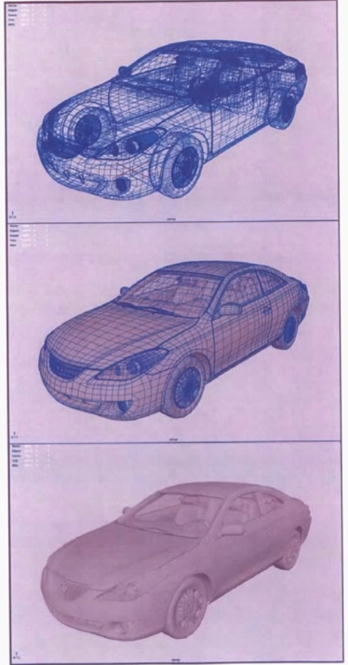
Figure 57: Meshwerks' wireframes for the Toyota Solera

Figure 58: G&W's additions to Meshwerks' wireframes

These wireframes are images formed by a network of lines that represent in great detail the external dimensions of objects – in this case, cars. Wireframes are prepared partly through an automated measurement system, and partly through manual adjustment of those automated measurements to make the resulting set of lines look realistic. In this instance, G&W took Meshwerks’ wireframes, draped over them images of the lights, body, tires, and so forth of each car, and provided the net product (shown in Figure 58) to the ad agency which used them in the advertising campaign. Meshwerks and G&W were paid the amount specified in their contracts and everyone, as best we could tell, was happy. Things went awry, however, when Toyota began using the images in another setting. Specifically, in a variety of ads other than the television spot for which Meshwerks thought its work was originally intended. Meshwerks asked for more money. Toyota refused. Meshwerks then brought a copyright infringement suit contending that it owned the copyright in the wireframes and, therefore, that Toyota could not reproduce them or derivatives of them in unlicensed contexts.
The case was finally resolved in 2008, five years after the original advertising campaign. Now, the plaintiff doesn’t always win in lawsuits like this. Sometimes B is able to avoid liability. For example, by showing that A’s work did not fall within the zone of copyrightable subject matter. Or that the later use of A’s material was expressly or impliedly authorized by the terms of their original contract. Indeed, Toyota, in the case I just summarized, eventually prevailed on the first of those bases. But often, B loses and, therefore, either has to pay A an extra fee or cease using the work in question. Even when B prevails, resolving the dispute typically takes years and costs both parties a lot of money, as it did in this case. The frequency of lawsuits of this sort is attributable not just to the fact that such situations are distressingly common, but also to the fact that the moral intuitions of the parties commonly diverge. Typically, the attitude of B’s managers is that they’ve already paid A an agreed upon and fair price. For A to demand more money now, they see as a form of extortion. By contrast, A feels like he or they have created a valuable work and thus deserves a share of the revenues that are generated when that work is put to an unexpected, but lucrative later use. Underlying this attitude are some of the beliefs associated with the Lockean theory that we discussed in lecture number two. Both parties, in other words, are convinced typically that the other is behaving immorally. That’s a prescription for litigation.

Figure 59: The RMS Titanic

Controversies of this sort can almost always be avoided by addressing the issue up front. Companies in situations of this sort should be watchful for commercial relationships that will generate potentially copyrightable works and clearly provide in advance who will own those works. It’s a mistake to rely on trust, friendship, or a history of amicable dealings to prevent disputes from arising down the road because, as I’ve suggested, moral intuitions commonly diverge in such cases. This kind of anticipatory contractual resolution of copyright issues is like the antenuptial contracts sometimes entered into by prospective spouses: sometimes awkward and seemingly unnecessary when the relationship is fresh, but extremely helpful when the relationship later unravels.
So, to review, the general point illustrated by this example is that the copyright in a work vests automatically in the author of the work and it stays with the author unless expressly transferred to someone else. Failure to be alert to this phenomenon can create big and expensive problems.
Up to now, we’ve been dealing with situations in which the identity of the author of a work is obvious. Sometimes it’s not. Here’s an example. As I’m sure you know, in 1912, the steamship Titanic – shown in Figure 59, just before her first and final voyage – collided with an iceberg in the North Atlantic and sank. Most of the passengers died, including one Harry Elkins Widener, a Harvard graduate. The Principal library here at Harvard was later funded by Harry’s mother who survived the accident, and the library is named for and dedicated to Harry. The ocean where the accident occurred is over 12,000 feet deep. As a result, for 60 years, no one knew exactly where the wreck of the Titanic lay, and certainly no one saw it. Then in 1985, a joint US and French expedition found the wreck. Subsequently, several other expeditions were organized to photograph and film it. One of which produced the photo in Figure 60. One of those filming ventures was organized by a consortium that included a company called RMS Titanic, Incorporated, which technically was the salvor in possession of the wreck. That consortium – we’ll call it RMST for short – entered into an arrangement with a filmmaker named Alexander Lindsay. Lindsay had previously done a British documentary on the Titanic. And he now agreed to do another one for RMST. Unfortunately, for all concerned, the parties failed adequately to capture the terms of their deal in a contract, thus planting the seeds for a subsequent dispute. Lindsay spent a lot of time and effort preparing for and overseeing the making of the film. He was pretty closely involved in the filmmaking process, but here’s the crucial fact: Lindsay did not himself do the actual filming. Instead, he scripted and supervised the filming of the underwater footage. More specifically, Lindsay claimed that he created storyboards which identified specific camera angles and shooting sequences; designed and personally constructed the underwater light towers that were used to illuminate the wreck; provided the photographers who actually did the filming with detailed instructions for positioning and utilizing those light towers; directed the filming from onboard the salvage vessel, Ocean Voyager; screened the footage at the end of the day to ensure that he had the images he wanted; and, in general, supervised all aspects of the preparation of the footage. Lindsay contended that he was never paid for his work – or, at least, not adequately paid. In an effort to secure appropriate compensation, he brought suit against RMST asserting – and here’s the rub – that he was the author of the underwater footage, and therefore, owned the copyright in it. The defendants, RMST, objected, pointing out that Lindsay did not operate the cameras. As a result, RMST argued Lindsay could not claim the status of author. In the end, the court sided with Lindsay. If the facts were as he had claimed, the court ruled, Lindsay should be deemed the author. Here’s the language the court used.

Figure 60: A photo of the bow of the Titatnic wreck

All else being equal, where a plaintiff alleges that he exercised such a high degree of control over a film operation, including the type and amount of lighting used, the specific camera angles to be employed, and other detail-intensive artistic elements of a film, such that the final product duplicates his conceptions and visions of what the film should look like, the plaintiff may be said to be an author within the meaning of the Copyright Act.
The principle that underlies this passage is important. To qualify as an author, it’s neither necessary nor sufficient that you have your hands on the instruments that create the work. If you direct the behavior of others sufficiently closely, that it’s your ideas that are being transposed into tangible form, then you, and not they, are the author. And thus, it is you, and not they, that acquire the copyright.

Joint Authorship
The previous segment of this lecture examined the rules that determine which among competing claimants is the author of a copyrighted work. But occasionally, more than one person can claim to have contributed enough to a work to be called an author and thus, to share in the copyright. The legal condition that arises under such circumstances is known as joint authorship. It doesn’t happen very often, for reasons we’ll discuss in a minute. But when it occurs, it has some important effects.
Each author in such cases is said to be an owner of the whole work, not just the part he or she contributed. Each is free to use the work or to license others to use it. If one of the joint authors licenses it unilaterally and collects license fees, he or she must give the other joint author or authors appropriate shares. If he fails to do so, he’s subject to a suit for accounting. How much of the revenue does he have to give the other joint authors? The presumption is that each one is entitled to an equal share. This is true even if their contributions have clearly been unequal in amount. However, this presumption of equality can be overridden by an agreement among the joint authors. When a joint author dies, his or her interest passes to his or her heirs, not to the other joint authors. In this respect, joint authorship, in copyright law, works like a tenancy in common and real property law, not like a joint tenancy. The main difference between those two legal forms is that the latter carries with it a right of survivorship while the former doesn’t. In sum, joint authorship has many important legal implications.
So, when and how does this situation arise? The answer with respect to US law is that a person claiming to be a joint author has to show both of two things. First, he must show that each of the people, including himself, that he asserts share in the copyright made a copyrightable contribution to the final work at issue. Second, he must show that all of these contributors intended that their various contributions be merged into a unitary whole. These requirements are usually construed quite strictly by the courts. The net result is that most people who seek the status of joint author fail.
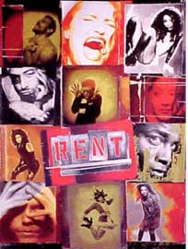
Figure 61: Poster for the musical play “Rent” – Oregon version

Here’s a case that illustrates the impediments that the law places in the path of those who would be joint authors. Rent (Figure 61) is one of the most famous and successful musicals of all time. It was set in and first performed in New York City, but productions of the play have since been staged throughout the world. Figure 61, for example, is a poster from a production in Oregon and Figure 62 is one from Jakarta. My daughters used to sing most of the songs from the play when riding in the backseat of my car. The plot of Rent is loosely based on Puccini’s opera La Boheme, which has long been out of copyright. It’s based on Puccini’s work in much the same rough way that West Side Story is based on Shakespeare’s Romeo and Juliet. Set during a period when AIDS was often fatal, Rent examines the intertwined lives of a group of young, poor artists and musicians, many of them living with the disease.
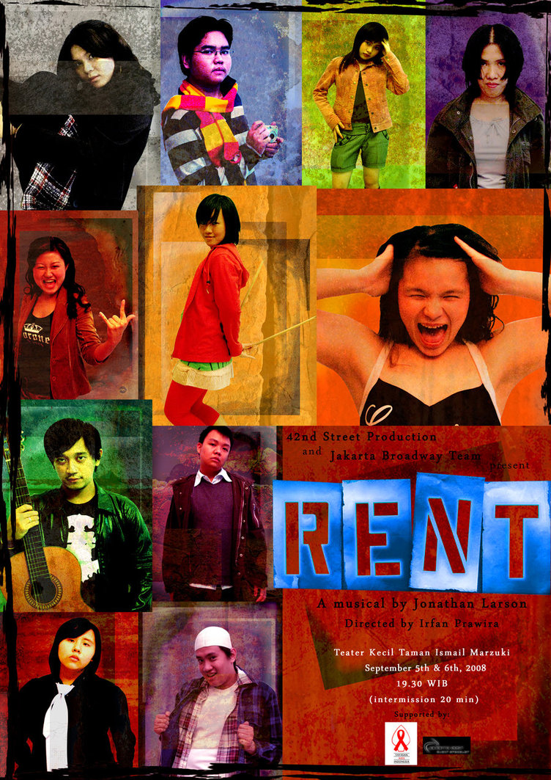
Figure 62: Poster for the musical play “Rent” – Jarkarta version

The genesis of the musical is complicated and those complications are the source of the copyright dispute that concerns us here. The narrative is traced in Figure 63. In 1989, Billy Aronson and composer Jonathan Larson began to collaborate on an adaptation of La Boheme. In 1991, Aronson withdrew from the collaboration. They settled their respective rights in the inchoate script amicably, and Larson carried on with the project by himself. In 1992 and 1993, James Nicola, who was then artistic director of the New York Theater Workshop – a small, nonprofit theater in the East Village – expressed enthusiasm about the script, but Nicola urged Larson to permit the theater workshop to hire a playwright or a book writer who would help Larson improve the story line and the narrative structure of the play. Larson refused, insisting that he wanted to do it himself. In 1994, Larson got a grant to put on a short run of shows. Nicola agreed to produce them at the theater workshop and Michael Greif directed them. The reviews of this initial trial production of Rent were positive, but everyone agreed that the play still needed lots of work. Nicola again pressed Larson to accept some help and finally, in May of 1995, Larson acquiesced. The theater workshop, not Larson, hired Lynn Thomson – a professor of advanced play writing at New York University – to serve as a dramaturg. A dramaturg is someone who assists in some way in the production and development of plays. The contract between the theater workshop and Thomson indicated that she would receive a fee of $2,000 in return for, “providing dramaturgical assistance and research to the playwright and director.”
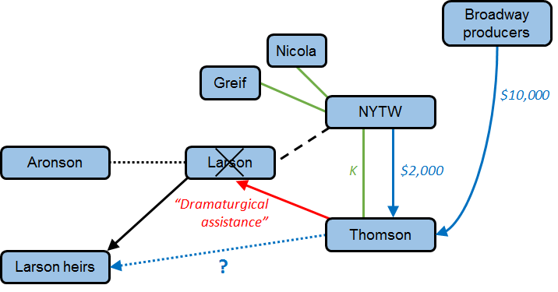
Figure 63: The facts of the Thomson case

In the summer and fall of 1995, Thomson and Larson worked closely together. Thomson came to Larson’s apartment where they worked feverishly to revise the script. Typically, Larson sat at the computer typing revisions while Thomson made suggestions. Many of the adjustments and particular lines that she came up with found their way into the final script. This collaboration was highly successful, at least gauging by the final outcome. The new script was thought to entail a “radical transformation of the show,” and was widely celebrated. The final dress rehearsal was held on January 24, 1996. Tragically, Larson died that evening of an aortic aneurysm. The legal effect of this catastrophe is that his property, including whatever copyright interests he had acquired by that point, passed to his heirs. Thereafter, Nicola, Greif and Thomson worked together to tune the script. The off-Broadway production was highly praised and it soon moved to Broadway. And the rest is history.
As the play became ever more commercially successful, Thomson became ever more unhappy with her paltry compensation and with the absence of any credit she received on the title page of the production. The Broadway producers agreed to pay her an additional $10,000, but she was still not satisfied. She asked Larson’s heirs for a share of the author’s royalties. Those royalties were originally payable to Larson and were now flowing to the heirs. The heirs offered her 1% as what they described as a gift – not enough for Thomson, and negotiations collapsed. Finally, Thomson brought a copyright infringement suit against the heirs. Her principal legal claim was that her contributions to the play were sufficient to render her a joint author. As such, she was entitled to a share of the author’s royalties. She lost at trial and again on appeal. Why? It would seem from this narrative that she had contributed nontrivial amounts of material to the content of the play and thus deserved a fair amount of credit for its success. Nevertheless, in the court’s judgment, she had failed to demonstrate the two conditions that are essential to joint authorship.
As mentioned previously, those two conditions are first, that each of the putative co-authors have made independently copyrightable contributions to the final work; and second, that both intended that their contributions be merged into inseparable or interdependent parts of a unitary whole. The trial court and the Court of Appeals found, or were willing to assume, that the first requirement had been satisfied. Specifically, the trial judge found that, “There are lines in Rent that originated verbatim with Ms. Thomson. I don’t think they amount to 9%, and certainly not 0%. There’s probably enough there that it is not de minimis.” It was the second requirement the tripped Thomson up. The way that the Court of Appeals construed that second requirement was critical. Two or more contributors constitute joint authors only if they all “fully intended to be co-authors.” In other words, entertain in their minds the concept of the joint authors. If any one of them did not have that intention when the work was created, a joint authorship does not emerge. Applying this standard, the courts tried to ascertain what had been the intention of Larson and Thomson. Thomson’s intentions were clear enough – she wanted to be a joint author – but she had to show that Larson also had that in mind. This created an obvious problem. Larson was dead. So, ascertaining his state of mind would have been difficult. More generally, letting the legal outcome in such cases turn on the entirely private subjective intention of one of the parties seems at best an awkward way of resolving the disagreement, because it would enable one contributor – by harboring a secret plan not to create a joint authorship – to defeat the expectations of the others. To address both of these concerns, the court looked for objective manifestations of Larson’s state of mind made before his death. Those manifestations, it concluded, all suggested that Larson did not want to be a co-author. For example, he exercised a veto. In other words, he had final authority over what lines went into the script. Another indicator was that the playbill, over which Larson had control, described Larson himself as the author/composer and referred to Thomson only as a dramaturg. When Larson entered into contracts with the theater workshop, he referred to himself as the author, and so forth. These objective manifestations of Larson’s state of mind were inconsistent, said the courts, with an intention to share authorship and thus, fatal to Thomson’s claim.
The approach adopted by the Court of Appeals in the Rent case – which is now the authoritative interpretation of joint authorship in the highly influential Second Circuit – makes it very difficult for a contributor to a collective work to qualify as a joint author. The reason is that no matter how much he contributed, his claims can be defeated if any one of the other contributors did not want to share authorship and made that desire manifest in some way. To be sure, if all of the contributors to a venture not only put independently copyrightable creations into the pot, but also think about the legal status they want to assume, decide to become joint authors and say as much, then they become joint authors. But if anyone opts out, joint authorship does not ensue. Not all US courts handled this issue in exactly the same way. In particular, the approach adopted by the equally influential Court of Appeals for the Ninth Circuit is somewhat different in emphasis, but the net effect of the Ninth Circuit’s approach is equally unfavorable to persons who seek joint authorship.
Before considering possible explanations for this hostility, I need to finish the story of Rent. In the end, Thomson was not left entirely in the cold. In a coda to its opinion, the Court of Appeals suggested that even though she failed to qualify as a joint author, she might conceivably be able to assert an independent copyright in the individual lines she had contributed to the script. If so, the play could not be publicly performed without either securing her permission or purging the script of those lines. Thomson had not raised this theory at trial, and so the Court of Appeals could not resolve it, but the Court of Appeals implied that she might initiate a second lawsuit on this entirely different basis. She of course did so, whereupon Larson’s heirs – weary of this multi-year fight – settled the case. So in the end, Thomson got some money – how much remained confidential. And perhaps equally important to her, she received credit, not as an author, to be sure, but as a dramaturg on the title page of the playbill, which she had not had previously.
The outcome of this particular story is not our main concern here. The key issue for our purposes is the very high bar that the courts have set for parties interested in joint authorship. So why is the law so hostile to the creation of joint authorship arrangements? One possible explanation is that they are messy in the sense that they can give rise to a confusing pattern of entitlements that are costly to unravel. For example, what if one joint author grants to a licensee an exclusive right to exploit the work in a particular way or in a particular region? The example that Melville Nimmer gives is an exclusive license to show a film in a particular city. Then another joint author grants an inconsistent, also ostensibly exclusive, license to a different licensee to show the same film in the same city. Who has what rights? In the 2008 Sybersound case, which involved a more idiosyncratic set of facts, the Court of Appeals for the Ninth Circuit ruled that the first licensee does not have standing to assert its supposed exclusivity because allowing it to do so would, in effect, curtail the privilege of the second, third, and fourth joint authors. That reasoning may have some logical appeal, but it creates a host of practical problems. The general point is that joint authorship, by fragmenting ownership of a copyright, can create messy and hard to predict patterns of legal rights. It’s better, many economists argue, to keep the legal rights over any given resource – in this case, a copyright – consolidated in a single person or legal entity. In real property law, this attitude underlies impediments to the creation of long-lasting servitudes, meaning promises to use or not use land in a particular way – promises that will bind not only the current possessor of the land at issue, but also his or her successors. In copyright law, the same attitude might account for the impediments the law creates to the formation of joint authorships.
A quite different explanation emphasizes not the imperative of economic efficiency, but the history of the culture and ideology out of which copyright law has emerged. This is an argument has been developed most richly by three historians and copyright scholars – Martha Woodmansee, Jaime Boyle, and Peter Jaszi. Those scholars point out that copyright law emerged at approximately the same time that the movement or ideology commonly known as Romanticism took root first in European culture and then in the culture of many other countries, including the United States. The scholars contend that there’s a causal connection between these two developments – in other words, that copyright law was powered and shaped, at least in part, by Romanticism. One of many ways in which copyright law bears the mark of Romanticism is that the law, like Romanticism, celebrates individual artists and is skeptical of collaboration.
This argument, if well-founded, has implications that reach far beyond the rules governing joint authorship, so I’ll describe it in a bit more detail. Woodmansee, Boyle, and Jaszi contend that until the late 18th century in Europe, writing was often, in practice, done collectively, and neither popular nor elite culture placed a high value on the individual artist or author, nor was innovation especially prized. Rather, from the Middle Ages through the Renaissance, “Writing derived its value and authority from its affiliation with the text that preceded it – its derivation rather than deviation from prior texts.” As an example of this Romantic orientation, Woodmansee points to the career of Samuel Johnson. Johnson, she observes, often collaborated with other writers, spent much of his time preparing editions of other writers’ works, was not much interested in claiming credit for the ideas he provided to other writers, and often took material from other writers without attribution. Beginning in the mid-18th century in both England and continental Europe, there was a broad cultural shift away from this set of attitudes toward one that glorified individual artistic genius. A new Romantic ideal emerged – a person who breaks free of the past and develops an entirely new idea, or at least reworks existing material in an entirely new way. This new ideal could be found in and was popularized by the work of Edward Young, Goethe, Coleridge and above all, Wordsworth. Here’s a passage from an 1815 essay by Wordsworth that distills this new notion.

Of genius the only proof is, the act of doing well what is worthy to be done, and what was never done before. Of genius and the fine arts, the only infallible sign is the widening of the sphere of human sensibility, for the delight, honor, and benefit of human nature. Genius is the introduction of a new element into the intellectual universe; or, if that be not allowed, it is the application of powers to objects on which they had not before been exercised or the employment of them in such a manner as to produce effects hitherto unknown.

This attitude was certainly not limited to writing. During this same period, individual genius became the ideal in almost all fields of artistic endeavor. Closely connected to that ideal was the image of an artist or author as aloof from the grubby business of commercial and industrial life. The canonical image of the creative process became that of a solitary writer or painter alone in the garret, pouring out his soul on paper or canvas. Another closely related idea is that of art for art’s sake – disconnected from both utility and politics.
During the 19th century, this collection of attitudes – which together form the heart of Romanticism – was reinforced by the broader ideological current known as classical liberalism. We touched on this topic briefly in lecture number one. Among the features of 19th century classical liberalism was a tendency to think of many aspects of individual and social life in terms of dichotomies – sets of opposed polls. Such dichotomies included public versus private – in other words, government versus civil society – self versus other, facts versus values, family versus market, and – last but not least – art versus industry.
Copyright law was taking shape during this same historical period. It should not be surprising that copyright bears the imprint of these ideas. At the most general level, the steady expansion during the 19th century of the exclusive entitlements enjoyed by a copyright owner is attributable, at least in part, to the glorification of artists and authors central to Romanticism. But many more specific doctrines in copyright law also seem connected, these scholars argue, to the attitudes associated with Romanticism. Here’s one. You’ll recall from lecture number three that the 19th century witnessed an abstraction and extension of the concept of the work to which copyright attaches. Take a novel, for example. As late as the 1850s, the protection enjoyed by a novel was limited to its text – the sequence of words in which was originally captured. This attitude underlay a judicial ruling that a German translation of Uncle Tom’s Cabin did not infringe Harriet Beecher Stowe’s copyright because generated an entirely different text. As Oren Bracha has shown, by the end of the 19th century, the thing to which copyright attached was understood much more broadly. Here’s a quote from his work. “At the dawn of the 20th century, copyright’s doctrinal terrain came much closer to the theoretical notion of protecting an abstracted intellectual essence, irrespective of the many concrete forms that it could take.” This shift echoes, at least loosely, the transition from the idea of writer as craftsman to the Romantic idea of writer as genius.
A more intriguing possible manifestation of the attitudes associated with Romanticism concerns the longstanding trouble that copyright law experienced when trying to make sense of industrial design. As we saw – again, in lecture number three – at least in the United States, the relevant rule is that a useful article enjoys copyright protection only if – and only to the extent that – its aesthetic dimensions are separable from its functional dimensions. That doctrine of conceptual separability is notoriously difficult to apply. Keith Aoki, a brilliant copyright scholar who tragically died prematurely, suggested that the roots of that fraught doctrine lie in the dichotomy between art and industry that is characteristic of Romanticism and was reinforced by classical liberalism.
We return, finally, to the topic of this lecture segment. The possible connection between the rules governing joint authorship and Romanticism is probably by now obvious. Romanticism celebrates the individual artistic genius. It would not be surprising that the legislators and judges who in the 19th and earliest 20th centuries shaped copyright law should seek to confer the status and economic privileges of authorship upon a single person and should be reluctant to acknowledge the degree to which authors frequently depend not just upon assistants who execute their orders – as in the Titanic case – but more importantly, upon collaborators who contribute meaningfully to the content of their works and thus, arguably, deserve some share of the credit and the associated legal recognition.
This contention – as I say, pioneered by Woodmansee, Boyle, and Jazsi – that copyright laws in Europe and the United States have been influenced in part by Romanticism is lent credence by the contrasts between the cultural and legal traditions in those countries and the cultural and legal tradition in China. This contrast has been explored most provocatively by my colleague Bill Alford – an expert on China and its intellectual property laws, in particular. Alford’s great book – entitled, ironically, To Steal a Book is an Elegant Offense – contends, among other things, that China’s resistance to the adoption of Western copyright law is attributable in part to the absence of a Romantic tradition in Chinese culture. While culture in Europe and the United States was being reshaped by Romanticism, China, Alford argues, remains steeped in the Confucian tradition. Confucianism included, among many other things, a radically different conception of art and creativity. Here’s a passage from Alford’s book, summarizing this Confucian conception.

The power of the past and its consequences for possession of the fruits of intellectual endeavor are well captured in the passage in the Analects in which Confucius indicates, “The master [i.e., Confucius himself] said: ‘I transmit rather than create. I believe in and love the Ancients.’” The essence of human understanding had long since been discerned by those had gone before and, in particular, by the sage rulers collectively referred to as the Ancients, who lived in a distant, idealized “golden age.” To avail themselves of that understanding, in order to guide their own behavior, subsequent generations had to interact with the past in a sufficiently thorough manner so as to be able to transmit it. Yet, as Confucius demonstrated in undertaking to edit the classics and to comment on them in the Analects, transmission, far from being a passive endeavor, entailed selection and adaptation if it was to be meaningful to oneself, one’s contemporaries, and one’s successors.
This sense of the past’s compelling pertinence, and of intellectual endeavor as the medium through which interaction with and transmission of it was possible, permeated virtually all facets of Chinese civilization. As the noted scholar of Chinese literature Stephen Owen has observed, in the Chinese literary tradition “the experience of the past roughly corresponds to and carries the same force as the attention to meaning or truth in the Western tradition.” Thus, in classical Chinese literature, the past survives and warrants consideration not merely as an obvious foil for contemporary activity, but, more important, because “the Confucian imperative insists that in encountering the ancients, we ourselves must be changed [for] we discover in the ancients not mere means, but the embodiment of values.”

It should not be surprising that a country influenced heavily by this vision should have been reluctant to adopt a copyright system centered on the image of an individual artistic genius. And indeed, vestiges of that resistance continue in China today.
The line of scholarship I’ve been discussing has an important critical dimension. Thus far, I’ve been emphasizing its explanatory side. If these scholars are correct, the impact of Romanticism helps us understand how and why copyright law has assumed its current form. But these scholars also contend that the law as currently configured is misguided – even perverse. The image of author or artist as individual creative genius was rarely accurate, they argue, even during its heyday. Since the 19th century, these scholars contend, it’s become ever less realistic as an account of how most copyrighted works are in fact generated. The way in which software is commonly produced, for example, bears little resemblance to the image of the painter alone in the attic. The law, these scholars argue, clings stubbornly to an increasingly outmoded vision of creativity whose inaccuracy causes both unfairness and misaligned incentives.
Not all intellectual property scholars are persuaded by this thesis. For example, Mark Lemley – a leading intellectual property scholar now teaching at Stanford – argues that many important features of modern copyright law cannot plausibly be traced to Romanticism and instead are best understood as efforts to advance the kind of utilitarian objectives I discussed in the previous lecture. One such feature is the work for hire doctrine to which we’ll return our attention shortly. Providing an optimal pattern of incentives for the creation and dissemination of innovations – that, Lemley argues, is what copyright law is and should be primarily about, not celebrating individual artistic genius. This is an important debate. It will arise in various other doctrinal contexts we’ll examine later in this lecture series. By the end of the course, I hope you’re in a position to make your own judgments concerning the nature and strength of the relationship between the Romantic cultural movement and copyright.

Works for Hire
In this last segment of the lecture, we’ll examine the copyright implications of employment relationships broadly defined. The United States is more likely than most countries to confer copyrights on the people who hire or commission artists and authors instead of on the artists and authors themselves. The main legal tool that enables employers and hirers to obtain copyrights is known in the United States as the work for hire doctrine. This is a very important doctrine. Roughly half of the registered copyrights in the United States, which is a rough proxy for commercially valuable works, are works for hire. The designation of a particular copyrighted work as a work for hire has several implications.
Implications of designating a copyrighted work as work for hire
- Ownership of the copyright
- Moral rights not applicable to works for hire
- Duration of work for hire: 95 years from first publication or 120 years from creation
- Renewal rights for old copyrights
- Termination provisions not applicable to works for hire
First and foremost, the employer or other person for whom the work for hire was prepared, is consider the author for copyright purposes. Not the assignee of the true author’s copyright, but the author himself or itself. Next, the modest set of moral rights that, in the United States, are provided by the Visual Artists Rights Act do not apply to works for hire. We’ve discussed moral rights in rough terms a couple of times already. In the eighth week of this course, we’ll consider the Visual Artists Rights Act, which implements some of those rights in the United States. For the time being, you need to know only that works for hire are entirely exempt from that portion of the copyright statute. So, to repeat, roughly half of the registered copyrights in the United States do not give rise to any moral rights.
The rules that we’ll discuss in detail next week concerning the termination of assignments of copyrights are likewise inapplicable to works for hire. In addition, works for hire are governed by different rules pertaining to duration. Regular copyrights, as you now know, last for the life of the author plus 70 years. By contrast, works for hire last for 95 years from the date they are first published, or 120 years from the date they are created, whichever is shorter. Sometimes this will result in a longer term, sometimes a shorter term than a regular copyright, but it’s certainly different. So, that’s enough for now. The main point is that it makes a big difference whether a copyrighted work falls into this special category.
Two routes by which a work can become a “work for hire”
- Prepared by the employee within scope of employment
- Nine types of commission works by independent contractors, when parties agree in writing.
- Contribution to a collective work
- Part of a motion picture or other audiovisual work
- Translation
- Supplementary work (foreword, illustration, etc.)
- Compilation
- Instructional text
- Test
- Answer to a test
- Atlas
b.

So, how does a copyright end up in this special zone? There are two routes. First, work can become a work for hire if it’s prepared by an employee within the scope of his employment. In such cases, as we’ve seen, the employer – not the employee – owns the copyright from its inception. Second, a work can become a work for hire if it falls into one of these nine categories and if the creators of the work and the person commissioning it agree in writing that it shall be considered a work for hire. Here’s a key point – these two paths are exclusive. There’s no other way that a work can become a work for hire. So, if a work is not created by an employee within the scope of his employment and does not fall into one of these nine categories, it cannot become a work for hire even if the parties expressly provide as much in a contract. That exclusivity probably strikes you as odd. Why should the law deny access to this particular legal form to some sets of parties? We’ll come back to that question after we’ve examined these two paths in more detail.
The first of the two paths likely strikes you as the more intuitively plausible. Suppose you run a company, you hire someone, part of that person’s job is to create copyrightable works. It’s not shocking, at least to most US residents, that you the employer would own the copyright in those works. Millions of copyrighted works are born as works for hire in this way. Their legal status rarely gives rise to litigation both because it’s clear and to most observers it seems both fair and efficient. When litigation concerning this first path does arise, it’s usually because the person who created the work can plausibly claim that he’s not really an employee. If he’s a traditional salaried employee, he has no chance of prevailing. But if his relationship with the putative employer is more attenuated, he might. Until 1989, the legal standards used to determine whether a creator was truly an employee for these purposes were murky. Different courts adopted different rules. Finally, the Supreme Court attempted to settle the matter. The case the Supreme Court chose to clarify the law involved interesting facts.
A nonprofit company called CCNV commissioned a sculptor, named James Earl Reid, to prepare a sculpture commemorating homelessness. CCNV wanted to display the sculpture on the mall in the center of Washington DC during the holiday season to sensitize visitors to the plight of the homeless. CCNV gave Reid a fair amount of instruction concerning what it wanted. For example, the sculpture should be a modern nativity scene in which the Holy Family is replaced by three homeless people, they should be African American, they should be depicted lying down, not sitting up or standing, and so forth. But CCNV left most of the artistic decisions in Reid’s hands. CCNV paid Reid $15,000 for his services, but provided him no other compensation, employment benefits, or so forth. Things went well for a while. Reid created the sculpture shown in Figure 64. It was indeed displayed on the mall and seems to have been well received by critics and the public. But the relationship between CCNV and Reid frayed when CCNV planned to take the sculpture on tour in other US cities in an effort to raise more money for the homeless. Reid objected on the grounds that to save CCNV money, he had fabricated the sculpture in a material that could not hold up to such a travel schedule and thus the sculpture would deteriorate which would be offensive to him. This sentiment should remind you of the stances of Von Gerkan and Snow who sought to protect their creations from desecration. At the time the dispute arose, the sculpture was back in Reid’s workshop for some minor repairs. Reid refused to turn it over to CCNV. In response, CCNV brought a copyright infringement suit. Now at the threshold you should notice that this is an odd lawsuit. There’s no question that CCNV owns the sculpture itself, the physical object. CCNV commissioned it and paid for it. CCNV now owns it just as the person who commissions a portrait owns the portrait once it’s delivered. So why didn’t CCNV simply demand that Reid to CCNV the sculpture itself? Why did it seek to establish that in addition it owned the copyright in the sculpture? It’s not entirely clear but probably because CCNV wanted to do things with the sculpture other than show it to people, perhaps make additional copies of it. As you know by now, only the copyright owner is permitted to make copies of the copyrighted work. In any event, CCNV initiated litigation and carried it all the way to the Supreme Court. Because Reid actually made the sculpture, he was in a strong position in this lawsuit. He would seem to be the author and thus, as we’ve seen, the copyright owner.
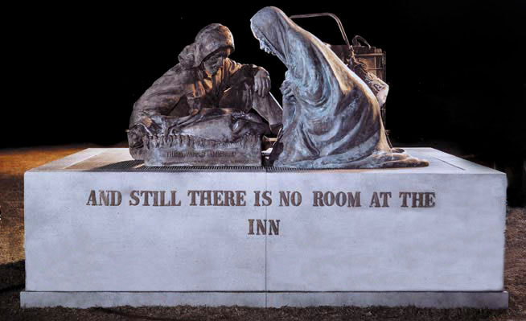
Figure 64: James Earl Reid's sculpture commemorating homelesness

CCNV might have overcome Reid’s presumptive claim to the copyright in any of three ways. First, CCNV could have argued that one of its trustees, a man named Mitch Snyder, supervised Reid’s work sufficiently closely that – like Mr. Lindsey in the Titanic case – Snyder, acting on behalf of CCNV, should be deemed the author. But as you now know, to win on this theory, you need to exercise very tight control over the activities of your assistants, and Snyder’s level of supervision of Reid didn’t come close. So, this wouldn’t work.
Second, CCNV might have admitted that Reid was an independent contractor but asserted that the sculpture was a work for hire because it had been commissioned by CCNV. But this strategy wouldn’t work for two independent reasons. First, you’ll notice that sculpture is not among the nine types of works that can become works for hire through this path. Second, in any event, the parties had not agreed in writing that the sculpture would be a work for hire, thus CCNV was doubly blocked. The upshot was that CCNV’s only plausible theory was that Reid had been an employee, not an independent contractor. If CCNV could classify Reid as an employee, it could win under path one because the sculpture was surely within the scope of his employment. The hard part was to show that he had been an employee. The trial court agreed with CCNV on this crucial point, but the Court of Appeals and eventually the Supreme Court did not. In the course of rejecting CCNV’s position, Justice Marshall writing for the Supreme Court announced a new, or at least a clarified, test for determining when a person should be considered an employee. It’s distilled in Table 3. Here is the key passage in the court’s opinion:
Table 3: Test for determining when a person should be considered an employee, applied to the CCNV case
Hiring party’s right to control | CCNV controls
Skill required * | Reid is sculptor
Source of the tools * | Reid has own tools
Location of the labor * | Reid uses own workshop
Duration of the relationship * | 2 months
Right to assign additional projects * | No right to assign more work
Control over hours of work * | No control
Method of payment * | Flat sum
Right to hire assistants * | Reid had total discretion
Business of the hiring party * | CCNV is not in sculpture
Employee benefits * | Business
Tax treatment * | No payroll or SS taxes
* Tilted in Reid’s favor

In determining whether a hired party is an employee under the general common law of agency, we consider the hiring party’s right to control the manner and means by which the product is accomplished. Among the other factors relevant to this inquiry are the skill required, the source of the instrumentalities and tools, the location of the work, the duration of the relationship between the parties, whether the hiring party has the right to assign additional projects to the hired party, the extent of the hired party’s discretion over when and how long to work, the method of payment, the hired party’s role in hiring and paying assistants, whether the work is part of the regular business of the hiring party, whether the hiring party is in business, the provision of employee benefits, and the tax treatment of the hired party. No one of these factors is determinative.

The Supreme Court then applied this multi-factor test to the facts of the case. All but one of these variables they concluded tilted in favor of Reid. Here again is Justice Marshall’s language.

True CCNV members directed enough of Reid’s work to ensure that he produced a sculpture that met their specifications, but the extent of control the hiring party exercises over the details of the product is not dispositive. Indeed, all the other circumstances weigh heavily against finding an employment relationship. Reid is a sculptor, a skilled occupation. Reid supplied his own tools. He worked in his own studio in Baltimore, making daily supervision of his activities from Washington practically impossible. Reid was retained for less than two months, a relatively short period of time. During and after this time, CCNV had no right to assign additional projects to Reid. Apart from the deadline for completing the sculpture, Reid had absolute freedom to decide when and how long to work. CCNV paid Reid $15,000, a sum dependent upon completion of a specific job, a method by which independent contractors are often compensated. Reid had total discretion in hiring and paying assistants. Creating sculpture was hardly regular business for CCNV. Indeed, CCNV is not a business at all. Finally, CCNV did not pay payroll or Social Security taxes, provide any employee benefits, or contribute to unemployment insurance or workers’ compensation funds.

Since 1989, courts confronted with analogous disputes have relied on this list of factors to determine whether an artist in an ambiguous position should be considered an employee. A few lower courts have tinkered with the test. For example, in one case the Court of Appeals for the Second Circuit announced that a subset of the factors – specifically those highlighted by an asterisk in Table 3 – are especially important and should be given extra weight. But most courts just apply the CCNV list as the Supreme Court formulated it.
Disputes of this sort have not arisen terribly often in the past, but they’re likely to become more common in the future. The reason is that in many modern economies, certainly including that of the US, companies are decreasing their reliance on formal salaried employees and increasing their reliance on people whose relationship to the company is more attenuated. People hired for short periods of time not given traditional employment benefits and so forth. In most respects, this trend is bad for the workers. But in one respect it’s potentially good for the workers and dangerous for the companies – namely, it increases the chances that copyrighted works created by these workers will not be classified as works for hire. Indeed, copyrights in these works will belong to the workers. Unless and until tell the workers assign those copyrights to the companies, their legal position will be stronger. Companies, for their part, should look out for this legal hazard.
The second path to work for hire status seems more clearly marked. As I’ve already mentioned, if a work falls into one of the nine categories and if the commissioning party secures a signed written agreement acknowledging that it shall be deemed a work for hire, that’s the end of the matter. One industry that relies heavily and effectively on this mechanism in the United States is the film industry. You’ll recall the chart showing the legal relationships among the principal participants in the making and distribution of a typical film (Figure 22). As I discussed in lecture number three, the creative contributions of many people – screenwriters, actors, directors, and so forth – are pooled into a single copyrighted work, namely the audio-visual work corresponding to the finished film. Ordinarily that copyright is held by a producer which then enters into a distribution agreement with a studio, which then issues licenses to the various players listed at the bottom of this diagram. There’s a risk lurking in this structure which is probably apparent to you now that we’ve seen how the Rent case ended up. The risk is that some of the contributors to the film listed at the top of the diagram might argue, plausibly, that they own the copyrights in the separate things they contributed to the final product, and thus that the theaters, TV stations, and so forth shown at the bottom of the diagram can’t publicly perform the film, in other words, the film containing their copyrighted works, without getting separate licenses from them. To avoid this outcome, the producer almost always obtains a contract from each of the contributors designating his or her contribution as a work for hire. The result, the producer owns the copyrights in those contributions from their inception. The legal provision that makes all this possible and now indeed routine is shown on the chart in Figure 22.
Notice that one of the nine categories of works for which signed work for hire agreements are effective consists of “a part of a motion picture or other audiovisual work.” Another industry that purports to rely on work for hire agreements is the recording industry. You’ll also recall Figure 21, I hope. It outlines the legal relationships among the principal participants in the making and marketing of a musical composition and an associated sound recording. You’ll recall from lecture number three that the composer acquires the copyright in the composition, typically assigns that copyright to a music publisher, who then issues licenses to many licensees collecting fees from all of them, which the publisher then shares with the composer. The place in this complex industry where work for hire agreements become relevant is the relationship between the performer, who makes a recording of the composition, and the record company. This relationship appears in the bottom right of the diagram. You’ll recall that since 1972 the recording has given rise to a second, separate copyright in the sound recording. Who does that second copyright belong to? If the performer were an employee of the record company, the copyright would, of course, belong to the record company for the reasons we’ve just reviewed. But that’s rare. Nowadays record companies rarely employ performers. Rather the performers are independent contractors. That means that presumptively the performer acquires the copyright. The record company though doesn’t want to leave the copyright in the hands of the performer. Typically, the record company wants to control all aspects of the marketing of the recording and wants to collect all the fees. The cleanest way for the record company to achieve that is to hold the copyright. As a result, as the chart indicates, virtually all recording contracts provide that the performer assigns his or her copyright to the record company. From the standpoint of the record companies, that’s pretty good, but not ideal. The reason it’s not ideal is that in the United States an assignment of a copyright is not permanent. As we’ll see in lecture number six, the assignor holds a non-waivable right to terminate the assignment after a prescribed interval of time. How exactly that termination right works we’ll discuss next week. For the time being, the key fact is that, as I say, it’s non-waivable. The result is that even if in the recording contract the performer purports to surrender his or her right to terminate the assignment at a future date, that surrender is ineffective. The record companies, for obvious reasons, don’t want the performers to hold this power of termination. The record companies want to hold the copyrights in the recordings permanently. How could they do so? By ensuring that the recordings are classified as works for hire.
The large majority of record contracts purport to do just that. In addition to the provisions assigning the performance copyrights to the record companies, those contracts contain provisions indicating that the recordings generated pursuant to the contract constitute works for hire and thus that the copyrights in them belong to the record company from their inception. If effective, these provisions would trump the performer’s termination rights. The problem from the standpoint of the record companies is that it’s far from clear that these provisions, these contractual provisions, are indeed effective. Recall that signed work for hire agreements entered into by independent contractors are valid only if the works to which they pertain fall into this list. Sound recordings, as you’ll notice, don’t appear in this list. Now the lawyers for the record companies contend that the game is not up. Specifically, they argue that the individual songs recorded as parts of the albums or CDs generated under these contracts constitute “contributions to collective works,” and thus qualify under the first item in the list. But even the record company lawyers realize that that argument is shaky. Some copyright scholars have testified on their behalf when the issue has been presented to Congress while others equally strongly disagree.
Aware of the precariousness of their position on this issue, the record companies sought to strengthen it. Through shrewd lobbying, they were able to slip into a seemingly unrelated 1999 statute what was called a “technical amendment,” that added sound recordings to the list on your prospectively. Representatives of the musicians were not consulted when this change was made. When they learned of the change, there was, as you might expect, an explosion. The furor resulted in congressional hearings, a report from the Copyright Office, angry letters from musicians, and so forth. In response, Congress removed the “technical amendment,” thus restoring the original list. The record company lobbyists were able to secure only one concession: an agreement that the repeal should not be construed as a rejection of their original shaky characterization of sound recordings as works for hire because they might be considered contributions to a collective work. The net result of this elaborate maneuvering is the very odd language shown below.

17 USC § 101
In determining whether any work is eligible to be considered a work made for hire under paragraph (2), neither the amendment contained in section 1011(d) of the Intellectual Property and Communications Omnibus Reform Act of 1999, as enacted by section 1000(a)(9) of Public Law 106-113, nor the deletion of the words added by that amendment–
- shall be considered or otherwise given any legal significance, or
(B) shall be interpreted to indicate congressional approval or disapproval of, or acquiescence in, any judicial determination, by the courts or the Copyright Office. Paragraph (2) shall be interpreted as if both section 2(a)(1) of the Work Made For Hire and Copyright Corrections Act of 2000 and section 1011(d) of the Intellectual Property and Communications Omnibus Reform Act of 1999, as enacted by section 1000(a)(9) of Public Law 106–113, were never enacted, and without regard to any inaction or awareness by the Congress at any time of any judicial determinations.

As you can see, the current state of affairs is as if the technical amendment – the 1999 technical amendment – never happened.
So, are sound recordings works for hire or not? We don’t know yet and won’t until the first of the termination rights start to take hold. For the reasons I’ll discuss next week, that, as it turns out, will begin this year – 2013. If in the inevitable litigation sound recordings are not deemed works for hire, then older musicians, like Bruce Springsteen and Eric Clapton, will soon begin to reclaim their copyrights in their early albums and will probably be able to make more money off them. Conversely, if sound recordings are deemed works for hire, then Springsteen and Clapton will remain bound by their original recording contracts. So a great deal hinges on this highly technical and still unresolved issue.
Two general lessons can be distilled from this story. The first is that adjustments in copyright law are often achieved through lobbying by the representatives of the affected interest groups. When two or more powerful groups are opposed, the usual result is stalemate. Only when the relevant groups are aligned does the law move. The technical amendment, so-called, secured by the recording industry in 1999 is a rare exception to that generalization. But note that it was very short lived. Once the representatives of the musicians were alerted, the amendment was rolled back restoring the statutory stalemate. As Jessica Litman has shown, this dynamic in which copyright law changes if and only if the relevant interest groups want it to is common in the United States and not quite so common but still frequently seen in other countries. The second of the general lessons is that in some industries artists are vulnerable. Their bargaining power is, in most instances, inferior to that of the intermediaries with whom they have to deal. As a result, if they’re allowed to sign away their rights, they will. Occasionally the law seeks to mitigate their vulnerability ironically by restricting their contractual freedom. In other words, by preventing them from signing away their rights. The limitations on the set of works that can constitute works for hire when prepared by independent contractors is an example of that approach. We’ll see some other examples next week. Whether these efforts to protect artists or their families from exploitation are effective is far from clear. We’ll see.

The Mechanics of Copyright

The Decline of Formalities
I’ll be examining today the mechanics of copyright, in other words, the way in which the machinery of the copyright system works in practice. As usual, I’ll devote most of my attention to how the US Copyright system works. Indeed, of the 12 lectures in this series, this is the one that pays especially close attention to the idiosyncrasies of the law in the United States. However, I will identify along the way some respects in which the copyright systems of other countries differ. And more importantly, I will emphasize the broad policy questions implicated by the US rules, policy questions that are pertinent to all countries.
The machinery of the copyright system is intricate, surprisingly so. I will not attempt today to catalog all its details. Instead, I will concentrate on three important dimensions of this machine – first, the roles played by formalities; second, the rules governing how long copyrights last, and third, the aspects of the system that attempt to protect vulnerable artists and their families from exploitation. We’ll begin with formalities.
Until quite recently, the United States, unlike most countries in the world, extended copyright protection only to authors who had complied with some administrative requirements known as formalities. These administrative requirements were not especially burdensome, but they were important. Indeed, failure to observe them could result in permanent forfeiture of one’s copyright. In the late 20th century, most of these formal requirements were eliminated, not all at once, but in stages. The result is that since 1989, the copyright system of the United States has been, in this respect, very similar to the copyright systems in most other countries. During this segment of the lecture, I will describe how those formal requirements once worked and the process by which they were largely, although – as we’ll see – not completely abandoned. A threshold question – if these formalities have been more or less eliminated, why do we need to discuss them? There are two answers to that question. First, as you’ll soon see, many of the copyrights that remain commercially valuable in the United States were born during eras in which the formalities were still in force, and the abolition of the formalities was not retroactive. As a result, the legal status today of many copyrighted works depends upon the capacity of the putative owner to demonstrate that the formal requirements were once upon a time appropriately observed. In short, the formalities still matter in practice. The second reason is that, as you will also see, many scholars today believe that the abolition of formalities was a mistake and that the copyright system did function and would function much better if at least some formalities were reinstated. Indeed, these scholars argue, all countries should revive some variant of the model that once existed in the United States. Examining the history of formalities in the United States will help us to assess that important policy argument. With those two considerations in mind, let’s turn to the law.
Table 4: Copright formalities for US works over time
 | Published 1909 – 1977 | Published 1978 – 1989 | Published 1989 –
Notice | Mandatory upon publication | Mandatory within 5 years of publication | Optional, but may affect statutory damages
Registration | Prerequisite for infringement suit; mandatory for renewal | Application prerequisite for infringement suit; necessary for statutory damages and attorney fees | Application prerequisite for infringement suit involving US works; necessary for statutory damages and attorney fees
Deposit | With LOC; failure punished with forfeiture & fines | With LOC; failure punished with fines | With LOC; failure punished with fines

The table above summarizes the changing status in US law of the three most important formalities. I hasten to add that this chart is not comprehensive. It focuses on, as I say, the most important requirements. If you’re hungry for more information on the subject, follow the branch of the map that summarizes the history of formalities. You’ll find they are linked to an excellent article by Professor Jane Ginsburg. On pages 13 and 14 of her article, you’ll find a chart that contains much more detail than the one on your screen. So, with that cautionary note, let’s focus on the main themes.
To make sense of this field, you need to differentiate three eras in the legal history of copyright in the United States – the period between 1909 and the end of 1977; the period between January 1, 1978 and February 28, 1989; and the period between March 1, 1989 and the present.
The first of these eras was governed by the 1909 version of the Federal Copyright Statute. The event that separated the first from the second era was a comprehensive reform of that statute, which was adopted in 1976 but only became effective at the start of 1978. The event that separated the second from the third era was the effective date of the statute, that as we have seen earlier, altered US law enough to enable the United States to join the Berne Convention. We could, of course, look farther back in time than 1909, but no copyrights governed by pre-1909 statutes are still alive today, so we won’t.
During the first of these eras, there were three main formalities. Most important, and for authors the most dangerous, was the notice requirement. When you first published your work, you had to notify the world that you were claiming copyright in it, or you forfeited your rights. The statute was quite precise concerning the content and placement of that notice. For example, if you published a novel, you had to place the notice on the title page or the following page. You had to use the word copyright or any abbreviation thereof, such as the now famous c within a circle. And you had to indicate the date of the publication. Figure 65, for example, is the second page of an edition of Gone with the Wind by Margaret Mitchell, a very popular novel that we will discuss later in this course. The crucial material is indicated here. You might wonder, why is the copyright asserted by McMillan rather than by Mitchell? And what’s the purpose of the language marked with a red line next to it? We’ll address those issues shortly. Now back to the chart – as I say, if you published your work without appropriate notice, you no longer enjoyed copyright protection. This requirement corresponded to and reinforced the distinction, during the era governed by the 1909 statute, between state and federal copyright protection. Here’s how that distinction worked in practice (refer to Figure 66).
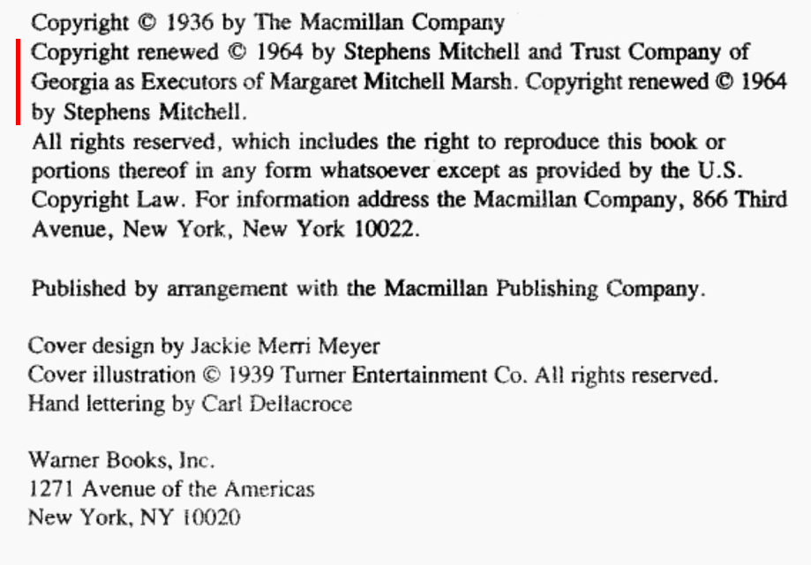
Figure 65: The second page of Gone with the Wind, showing the book’s copyright information

When you first created your work – let’s assume it’s a novel – you acquired a copyright but not a copyright recognized and enforced by federal statutory law. Rather, you enjoyed a copyright recognized and enforced by state common law. If you never published your novel, that common law protection would last indefinitely. But if you published your novel, your common law protection evaporated. From that point forward, you got copyright protection under federal law, if at all. This is the moment when the notice requirement took hold. If you published the novel without the requisite notice, you forfeited federal protection permanently. As a result, the novel fell into the public domain, the set of materials that anyone can use freely. The metaphor of falling is interesting. Why didn’t the novel rise into the public domain? There are various possible explanations for this terminology – perhaps because the public domain was thought of as debased, perhaps because it was analogized to the Lockian untilled field, perhaps because it was thought of as a reservoir, like water, of raw materials. Not clear, but almost certainly, the metaphor of falling had, and still has, power. Back to our story – if by contrast, you or your publisher attached to all copies of the published book the requisite notice, then you did acquire federal copyright protection, but it did not last forever. Rather, it lasted for an initial term of 28 years. When that term ended, the novel again fell into the public domain, unless you, or as we’ll see, a member of your family renewed the copyright, in which case, it would enjoy protection for a second 28-year term, whereupon it would finally and permanently fall to the public domain. Thereafter, anyone could use it, copy it, publish it, read it aloud in a public park, and so forth.
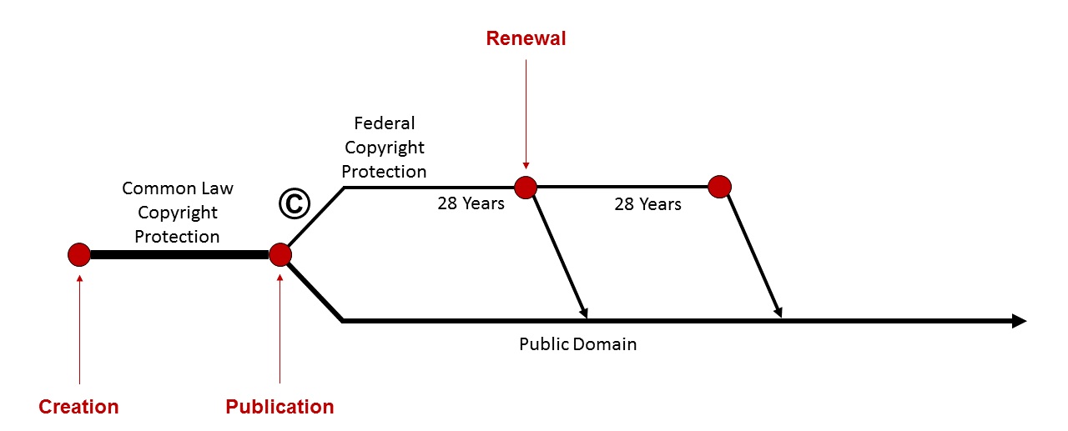
Figure 66: The timeline of copyright protection under the 1909 regime

For the most part, the system worked just fine for sophisticated novelists, like Margaret Mitchell, and publishers, like McMillan. They were aware of the statutory requirements, and complying with them was not hard. But less sophisticated players or the creators of less-conventional works sometimes neglected the notice requirement, and as a result, lost copyright protection permanently. The courts, sympathetic to the plight of these unsophisticated players, begin to tinker with this legal regime, in order to reduce the frequency of forfeitures. They couldn’t, of course, ignore the statutory requirement altogether. Instead, they began to construe the term, “publication,” in a way that helped 90% of authors. They were able to do so because the statute itself did not to find the term publication, but left that up to the courts. Seizing that opportunity, the courts differentiated two kinds of publication – so-called limited publication, which would not trigger the notice requirement, and so-called general publication, which did. The courts then defined general publication narrowly, to exclude lots of things we would actually associate with the term publication. For example, they held that making and distributing a sound recording of a musical composition did not result in publication of the composition and that giving a public lecture did not result in publication of the lecture, unless you passed out unrestricted copies of the text to your audience.
Here’s an important and illustrative case, the outcome of which hinged on this counterintuitive definition of publication. On August 28, 1963, the Southern Christian Leadership Conference organized a march in Washington, DC in support of the civil rights movement. Roughly 200,000 people gathered on the mall at the center of the city. The march culminated with a speech by Dr. Martin Luther King Jr, the founder and president of the Leadership Conference. The latter portions of his speech contained some of the most moving and justly famous lines in US political history. Here are a few.

I have a dream that my four children will one day live in a nation where they will not be judged by the color of their skin, but by the content of their character. I have a dream that one day the state of Alabama, whose governor’s lips are presently dripping with the words of interposition and nullification, will be transformed into a situation where little black boys and black girls will be able to join hands with little white boys and white girls and walk together as sisters and brothers.

As I say, roughly 200,000 people heard this speech live, and millions more saw it on television. Roughly a month afterward, it apparently occurred to King, or his advisers, that he ought to enjoy a copyright in the speech and that other people should have to pay him, if they wished to sell copies the speech. So, on September 30, 1963, King filed for copyright registration and duly received a certificate of registration on October 2. He then initiated an infringement suit against unauthorized seller and prevailed.
It’s probably occurred to you that there’s an important policy issue lurking here. Should political speeches be subject to copyright protection? In the United States, so long as their authors are not officials of the federal government, they are protected by copyright. And Dr. King and his estate have enforced their copyrights in his speeches and letters fiercely. I leave to you the question of whether giving King and his estate this power makes sense on the basis of any of the theories of copyright we’ve considered thus far in this lecture series, but our primary concern today is not with that important policy issue, but with of question of formalities.
For decades, no one seems to have challenged King’s copyright in the “I Have a Dream” speech. Then, in 1994, CBS produced a documentary series on 20th century US history. One segment of one episode in that series focused on the March on Washington. In it, CBS showed roughly 60% of King’s speech. CBS did not, before making the film, ask permission and did not pay the customary license fee. King’s estate predictably brought suit against CBS. CBS’s main line of defense was that King, and subsequently his estate, lacked copyright protection, because King had published the speech in August of 1963 without the statutorily required notice. There’s no question that King had not given any kind of copyright notice when he delivered the speech on the mall. So, the only issue, at least during the preliminary round of litigation, was whether making the speech before a nationwide audience constituted publication. The trial court concluded, yes, and thus that King had forfeited copyright protection. But the Court of Appeals for the 11th Circuit concluded, no. A general publication, the court ruled, occurs only in two situations – first, when tangible copies of a work are distributed to the general public in such a manner as to allow the public to exercise dominion and control over those copies; and second, when the work is exhibited and displayed in a way that invites unrestricted copying by the general public, for example, by publicly displaying a sculpture without any restrictions on the freedom of viewers to photograph it. At the stage of the litigation in which this issue arose, CBS had not yet established that King had done either of those things when he delivered the speech. So, he did not forfeit his copyright in it. So, CBS, as a result, had to obtain a license from King’s estate, if CBS wished to broadcast it. This case illustrates a couple things – on one hand, the crucial importance during this first year of the notice requirement; and on the other hand, the willingness of some courts in borderline cases to construe the term publication in a way that avoided forfeiture.
So, that’s the first of the three main formalities that governed US copyright law until 1978. After that date, the requirement was softened considerably. Between 1978 and 1989, failure to attach notices to copies at the time of registration was not fatal, so long as you made an effort to cure the problem within five years. In 1989, the notice requirement was eliminated as a precondition for copyright protection. Although, as we’ll see in the twelfth lecture, a failure to attach appropriate notices may limit the amount of statutory damages you can collect from infringers. Remember, however, that these changes were not retroactive. So, in the King case, the fact that the CBS documentary was not made until the 1990s did not mean that the notice requirement was irrelevant. Because the speech was made and published in 1963, the 1909 statutory requirements still applied and continue to apply today to pre-1978 works. The second of the three formalities is also illustrated by the King case. Registering your work with the Copyright Office was not a prerequisite to copyright protection, but you could not bring an infringement suit prior to registration, nor could you renew the copyright. That’s the reason King sought and obtained registration before filing his initial suit. In 1978, the renewal system, as we’ll see, disappeared, but registration remained necessary if you wanted to bring a lawsuit. An additional incentive for registration was added, namely that you couldn’t recover statutory damages or attorney’s fees for infringements that began prior to registration. In 1989, registration ceased to be a precondition for initiating a lawsuit with respect to works first published outside the United States, but it’s still remained so for so-called US works.
The softest and least important of the formalities was the requirement that authors deposit two copies of their works with the Library of Congress within three months of publication, basically, in order to help the library build its collection. Failure to comply exposed you to escalating fines. If after being notified by the Copyright Office you still refuse to comply, you could forfeit your copyright, although this seems to have been rare. Forfeiture was eliminated as a sanction in 1978, and that regime continues to the present. So that, in brief, was how the US system of formalities worked and how it has been radically cut back. As we’ve seen, the system had two unfortunate effects. First, it sometimes resulted in inattentive authors losing their copyright protection altogether. Second, it tended to benefit sophisticated parties and institutions and to disadvantage authors and others less aware of the rules of the game. However, in its heyday, the system of formalities also had two important beneficial social functions. First, the registration requirement facilitated socially beneficial licenses and assignments. Suppose you encountered a copyrighted work and wanted to use it for some purpose – for example, you came upon a sound recording you wanted to include in a film or an article you wanted to include in an anthology. If the copyright in the recording or article has been properly registered, you were more likely to be able to locate the copyright owner and thus obtain a license than if had not been registered. Viewed from this angle, however, the system was far from perfect, because as we’ve seen, lots of work still in their first term had not been the subject of litigation and thus were still unregistered. And yet, the copyrights in them were valid. The second of the two beneficial social functions was advanced more effectively by this regime. The notice requirement had the effect that many works, specifically all works published without the proper notice, fell into the public domain. Arguably, this was desirable, both by increasing the set of materials from which future authors could draw freely and by giving all authors an easy way of dedicating their works to the public. If you didn’t want to assert a copyright, all you had to do was publish your work without a copyright notice.
Some evidence that these functions were indeed being advanced can be gleaned from data compiled by Chris Sprigman in his pioneering article on copyright formalities. Figure 67, taken from Sprigman’s article, shows the number of copyright registrations each year, from 1909 through the end of the century. As you can see, it begins at about 100,000 per year and peaks at around 600,000. That might seem like a large number. But it’s a tiny percentage of the set of potentially copyrightable works. Another feature of the system reinforced this effect. As you’ll recall, the original 1909 regime did not give authors a copyright lasting 56 years, but rather gave them an initial term of 28 years plus an option to renew for another 28 years. If they failed to exercise that option, their works fell into the public domain. And most authors did indeed fail, as Figure 68, also from Sprigman, demonstrates. It shows the fraction of works originally registered that were renewed when the time came for renewal arrived. As you can see, that percentage begins around 5% and rises to only around 20%. In other words, the large majority of registered works were not renewed and thus went out of copyright after only 28 years, thus contributing to the public domain reservoir.
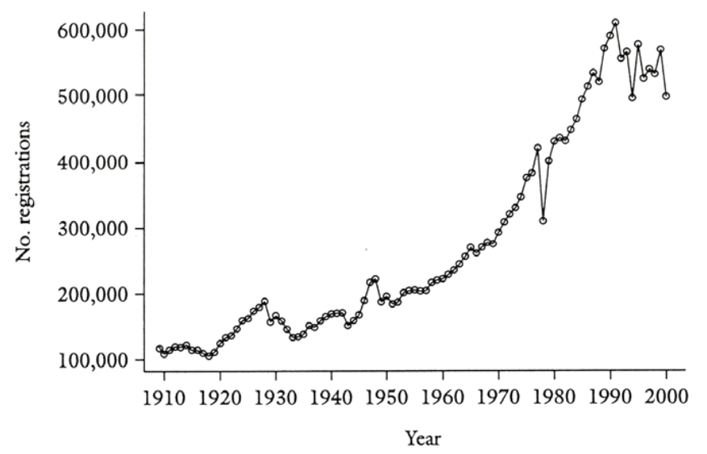
Figure 67: Copyright registrations (excluding renewals), 1910 – 2000

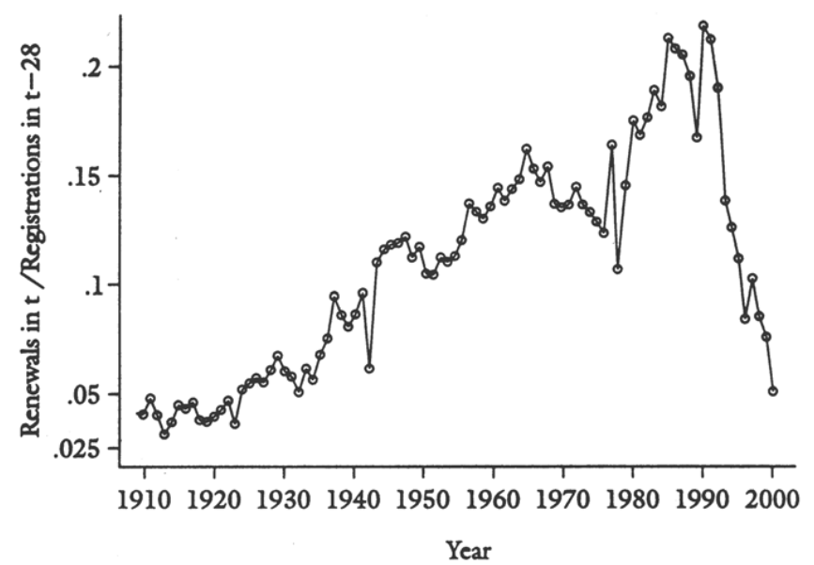
Figure 68: Rate of copyright renewals, 1910 – 2000

The general principle underlying the system is that copyright was an opt-in regime. If you wanted a copyright, you had to affirmatively acquire and keep it. If you didn’t, you lost it. By contrast, the current US regime, and the copyright regimes in virtually all other countries, is an opt-out system. Copyright protection, as we’ve seen, arises automatically. If you don’t want a copyright in one of your works, you have to act affirmatively to give it up, and it’s not easy to do so. Graphically, this difference can be characterized as follows (Figure 69). As soon as you create a work – more specifically, as soon as you fix it in a tangible medium of expression – federal copyright protection automatically arises. You don’t need to wait until publication. And protection lasts not for 20 years or even 56 years, but for your lifetime plus an additional 70 years. Somewhere along this timeline, you or your heirs or devisees may publish the work. And as we’ll see, publication has some important legal effects, particularly if it’s a work for hire. But publication does not alter the existence of the copyright. When the term expires, the work will, as usual, fall into the public domain. But that won’t be until long after you’re dead. Before then, it’s possible to give up your copyright by dedicating it to the public domain, but that, as I say, is hard and rare. The result, as I’ve indicated previously, is that billions of creative works throughout the world are now subject to copyright protection. But the absence of an effective registration system often makes it difficult to locate the owners of those copyrights and thus to obtain permission to make otherwise proscribed uses of those works. The result is needless impediments to cumulative or derivative artistic progress.
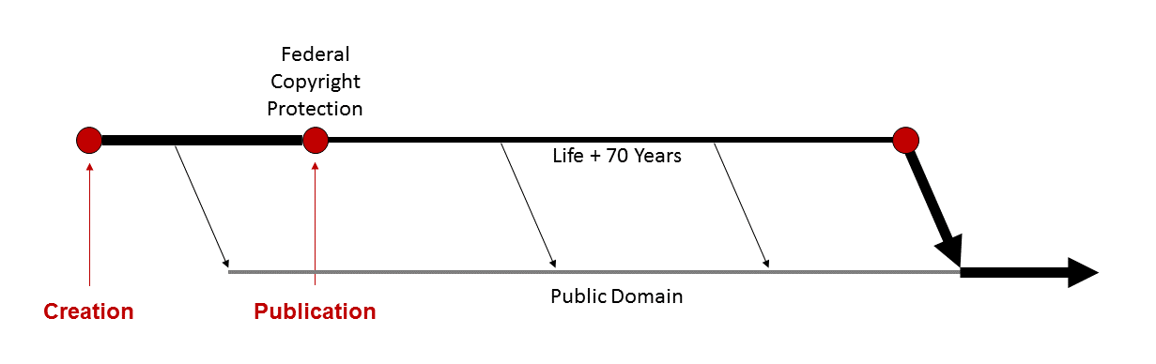
Figure 69: The timeline of copyright protection under the current regime

What might be done to alleviate this problem, without, of course, corroding the rights of the artists and authors who do want and depend upon copyright? There at least three possibilities.
First, and most radically, we might repudiate the provision of the Berne Convention that forbids making compliance with formalities a condition of acquiring or exercising copyrights and then, country by country, reinstate systems of formalities. That might well be socially desirable, but it’s very unlikely.
Second, we might increase the incentives for voluntarily complying with formalities, in particular for registering one’s copyrights. As I’ve said, there already exists some incentives for registration. For example, registered copyrights enjoy a modest presumption of validity, and as we’ve seen in the United States, statutory damages are not available when unregistered copyrights are infringed. But we might amplify the benefits of registration, perhaps by further increasing the remedies available to the owners of registered works. Alternatively, we might make a failure to register more costly, perhaps by expanding the set of exceptions and limitations applicable to unregistered works. But in so doing, we’d need to be mindful of the constraints imposed by the so-called three-step test contained in the Berne Convention and the TRIPS Agreement, which I discussed in the first lecture.
The third of the three possible responses would be to provide a mechanism that makes it easier for authors and artists to donate some or all of their entitlements to the public – to make, in other words, a credible and enforceable announcement to the world that they will retain and exercise only some of the rights that the copyright system automatically confers upon them. That’s basically the idea behind Creative Commons, the brainchild of Larry Lessig. Creative Commons makes available to copyright owners a set of standardized licenses that they can grant to the public at large by attaching appropriate notices to copies of their creations. As we saw in the King case, attaching a copyright notice to copies of one’s work was once essential, if one wanted copyright protection. The Creative Commons notices do the opposite. They signal to the world that the copyright owner wishes to give up some or all of the rights he or she acquires automatically. The following short video from Creative Commons itself shows how these notices work.

Wanna Work Together?
When you share your creativity, you’re enabling people anywhere to use it, learn from it, and be inspired by it. Take the teacher, who shapes young minds with work and wisdom from around the globe; and the artist, who breeds beauty out of bits and pieces she finds online; and the writer, whose stories use ideas and images crafted by people he’s never even met. These people know that when you share your creative wealth, you can accomplish great things. They and millions of other people all around the planet are working together to build a richer, better, more vibrant culture, using Creative Commons. To understand Creative Commons, you need to know a little bit about how copyright works. Did you know that when you create something, anything from a photograph to a song to a drawing to a film to a story, you automatically own and all rights reserved copyright to that creativity. It’s true. Copyright protects your creativity against uses you don’t consent to. But sometimes full copyright is too restrictive. What about when you want all those millions and millions of people out there to use your work without the hassle of coming to you for permission? What if you want your work to be freely shared, reused, and built upon by the rest of the world? Luckily, there’s an answer – Creative Commons. We provide free copyright licenses you can use to tell people exactly which parts of your copyright you’re happy to give to the public. It’s easy. It only takes a minute. And it’s totally free. Just come on our website and answer a few quick questions like – will you allow commercial uses of your work? And will you allow your work to be modified? Based on your answers, we’ll give you a license that clearly communicates what people can and can’t do with your creativity. You don’t give up your copyright. You refine it, so it works better for you. Welcome to a new world where collaboration rules. It didn’t even exist just a few years ago. But now there are millions and millions of songs, pictures, videos, and written works available to share, reuse, and remix, all for free. Want to work together? Then join the commons – Creative Commons.

If you’re persuaded by this video and follow the narrator’s instructions to go to the Creative Commons website, you will find there six main licensing options which give you and other authors of a variety of sets of rights that you and they may decide to retain or surrender. In addition to the six licenses listed on your screen, Creative Commons makes available to copyright owners a standardized notice known as CC0, that they can employ to give up all of their rights – in other words, as I’ve said, to donate their works to the public domain. An important footnote – as you know by now, in some countries, authors enjoy some non-waivable moral rights, in other words, entitlements that they cannot give up. In those countries, use of the CC0 label may not be fully effective or at least not permanent. That troubling possibility has not yet been tested. But this label, CC0, provides authors an easy way to give up as many rights as they can. In terms of our schematic characterization of the copyright system, here’s what CC0 enables. The current regime, as you’ll recall, works like this. CC makes it easier for copyright owners to opt out of some more or all of their rights, in other words, to as shown in Figure 70.
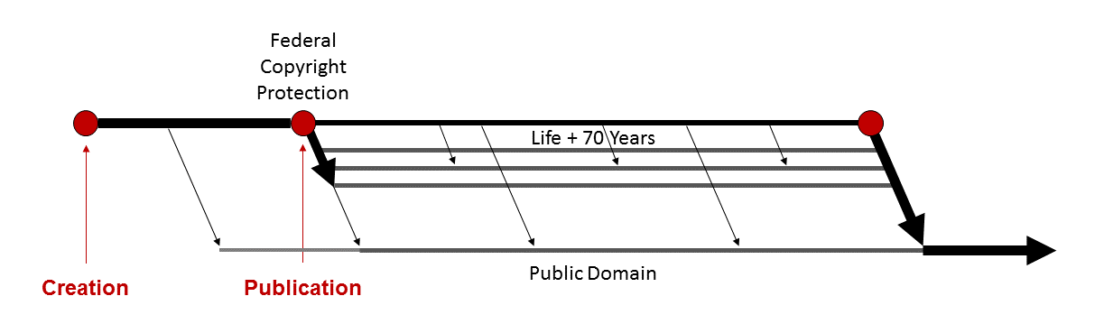
Figure 70: The effect of Creative Commons

The advantage of Creative Commons, as compared to the other two ways of tempering the unfortunate side effects of our current lack of formalities, is that it in no way undermines the right of copyright owners who want to retain all of their rights. It is this optional feature that prompted Jack Valenti, the former head of the Motion Picture Association of America and a staunch defender of copyright, to endorse Creative Commons.

Jack Valenti, Motion Picture Association of America
I’m glad to be here via this video. I wish I could be there in person. But I wanted to say just few words about Larry Lessig’s concept of Creative Commons. I’m attracted to it for the following reasons. First, Larry makes it clear that he is respectful of and supports copyright – copyrighted material that artists create – and he believes it ought to be protected. But he also says, and I agree, that there are those people who have copyrighted material who may want to give up part of their copyright or all of it, to put on the Creative Commons and let other people view it or hear it or whatever, and I have no problem with that. I think that’s part of the free and society in this country, that if you want other people to have your material you have created free of charge with your permission, wonderful. And I find that to be a salutary kind of thing. But I think it’s also important, as Larry staunchly believes, that those people who have copyrighted material – whether it be in a book or a television program or home video or music or movie or computer software – and who want it protected, so that they can make sure that it can move through the various venues where that material is brought to the public and given to consumers at fair and reasonable prices.

The disadvantage of Creative Commons is that the majority of copyright owners do not and will not use it, either because they were unaware of it, don’t understand it, or simply don’t want to give up any rights. Creative Commons thus mitigates the troubling impact of our lack of formalities, but certainly doesn’t eliminate them. What else might we do without sacrificing the clear benefits of our current regime? I’ll leave that to your imagination and deliberation.

Duration
In this segment of the lecture, we’ll examine the rules that determine how long US copyrights last. You’re probably thinking, well, this will be a short segment. How complicated can it be? The answer, unfortunately, is quite complicated. The reason for the complexity is that the relevant rules in the United States have been amended several times, but the amendments have been only partially retroactive. The result is that there are several subsets of copyrighted works that are governed by different sets of duration rules. Here’s how I’ll try to untangle this knot. I’ll begin by reviewing the history of the pertinent laws. I’ll then start over and consider the impact of that history on the duration of different groups of works.
Figure 71 shows the way things worked under the original version of the 1909 copyright statute. As we’ve seen, the first term of federal protection lasted for 28 years after the date of publication. If the copyright was properly renewed, it lasted for another 28-year term, commonly known, for obvious reasons, as the renewal term. Here are a few more details we have not yet discussed. The application for renewal could be filed any time during the year preceding the expiration of the initial term. If the author was still alive at that time, he or she was the person presumptively entitled to apply for and receive the renewed copyright. If the author had died, his or her surviving spouse or children could do so. If there were no surviving spouse or kids, the author’s executor had the right, if the author had left a will. If he or she had not left a will, then his or her next of kin had the renewal right. A technical point that, as we’ll see later had some important practical effects, the renewal term was not thought of as a continuation of the initial term. It was said to be a new term – a new estate – that belonged to the person who applied for and received it.
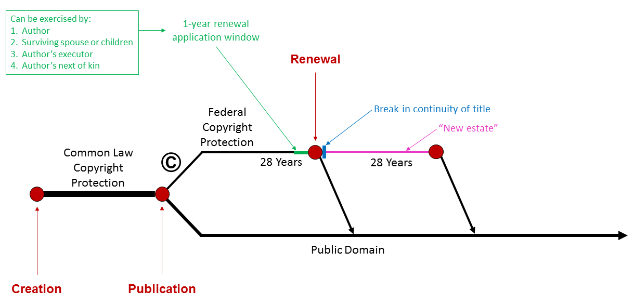
Figure 71: Durations under the 1909 copyright regime
With respect to works first published under the auspices of the 1909 statute, this basic structure has remained intact, but the length and mechanics of the renewal term have been adjusted several times. In 1976, the renewal term was extended from 28 to 47 years. In 1998, as part of the Copyright Term Extension Act, it was extended from 47 to 67 years. In 1992, the renewals of works that at the time were still in their first term was made automatic rather than voluntary. The result is that copyrighted works ceased falling into the public domain at the end of their initial 28-year terms. The 1976 general reform of the copyright statute, which became effective as we’ve seen at the start of 1978, instituted a radically new regime. As we’ve seen, works created thereafter acquired federal copyright protection immediately, which lasted for the life of the author plus 50 years. The Copyright Term Extension Act in 1998 extended that term to its current duration – the life of the author plus 70 years. Measuring duration by the life of the author would not work for anonymous works, pseudonymous works, and works for hire, so these were given terms of years that were meant to approximate the duration of regular copyrights – a century from the date of creation or 75 years from first publication, whichever happened first. The Copyright Term Extension Act in 1998 also extended those terms by 20 years.
How long a US copyright lasts depends on when and how it was created
- Works published before 1923
- Works published 1923 – 1963
- Works published 1964 – 1977
- Works created but not published before 1978
- Works created in 1978 or later
Lurking in these details are two general themes. The first, I’ve already mentioned – the gradual transition from an opt-in to an opt-out system. The second, probably obvious, is that copyrights keep getting longer. They never, even prospectively, get shorter.
OK, now let’s adopt a precedents stance. It’s 2013, how long do US copyrights last? The answer depends upon when and how they were born. More specifically, you need to differentiate five different categories of copyrighted works.
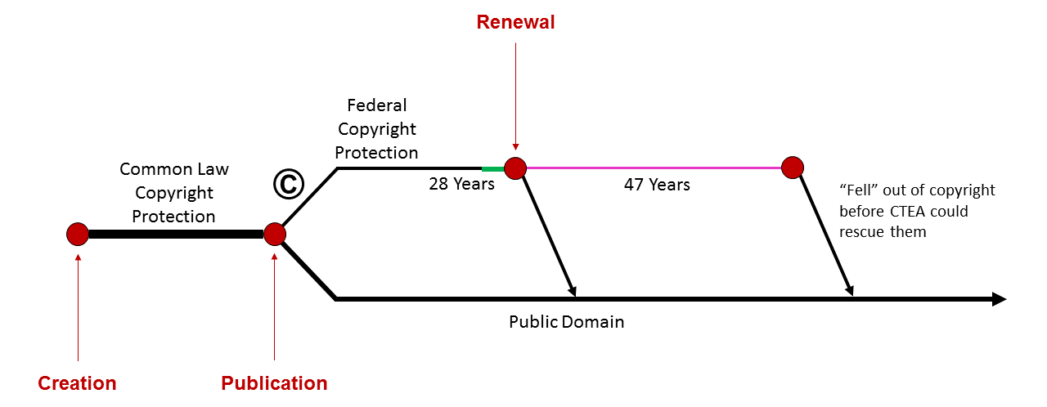
Figure 72: Copyright duration of works published before 1923

The simplest group consists of works published before 1923 (Figure 72). Some of these got the benefit of the extension of the renewal term from 28 to 47 years, but all of them fell into the public domain before the Copyright Term Extension Act could rescue them and the Act did not lift them back up. The upshot is that the copyrights on these works have expired.
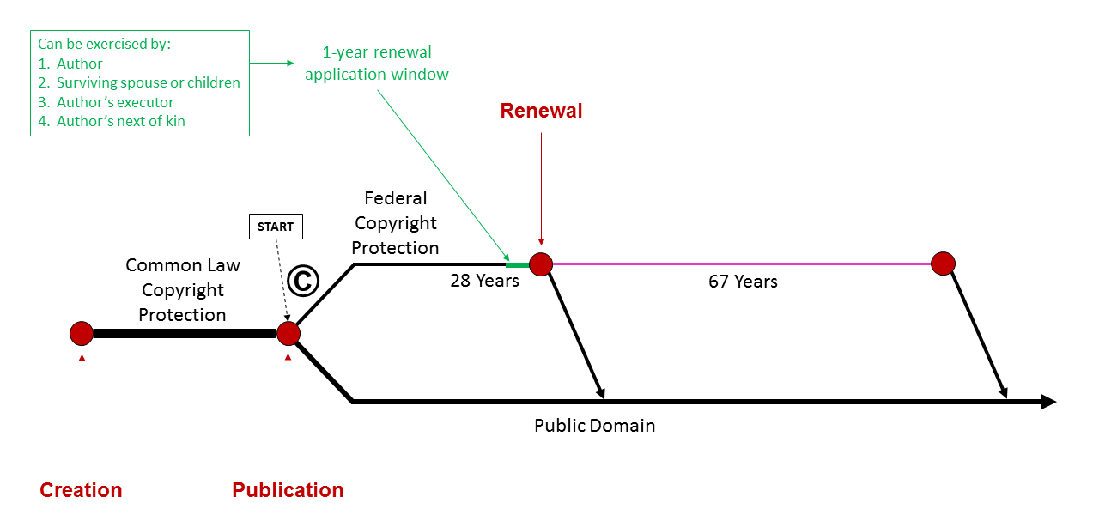
Figure 73: Copyright duration of works published 1923 – 1963

The second category consists of works published between 1923 and 1963 (Figure 73). These were rescued before their expiration by the Copyright Term Extension Act. The most famous and influential member of this group is Mickey Mouse – a copyrighted character, who first appeared publicly in the 1928 cartoon, Steamboat Willie. Copyrights in these works will begin to expire in 2018, 95 years after their first publication. Mickey Mouse, himself, will fall into the public domain on or about 2023, unless yet another amendment of the statute rescues him again. Not all works published during this interval are still alive, however. Only those who were properly renewed, by people eligible to renew them, survived. As we’ve seen, the large majority of works registered during this interval were not renewed. The net effect is that most of the work copyrights in this category of works have expired.
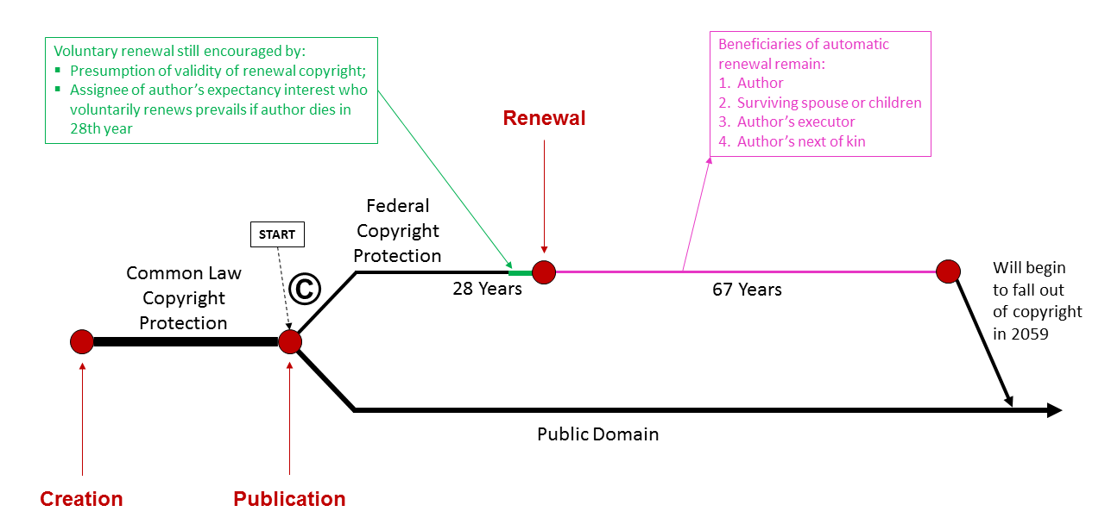
Figure 74: Copyright duration of works published 1964 – 1977

Not so with respect to works first published between 1964 and 1977 (Figure 74). These get the benefit of the change from voluntary renewal to automatic renewal. Who owns these copyrights? Presumptively, the same person or persons who are eligible to apply for renewal onto the previous regime. Another important footnote: just because these copyrights are subject to automatic renewal doesn’t mean that they cannot be voluntarily renewed, and the system contains some important incentives for people who voluntarily renew. The upshot, as you might imagine, is that voluntary renewal remained common after 1992. The key point for our present purposes is that works in this third category have not yet fallen into the public domain. They will begin to do so in 2018, like their surviving older cousins.
Works in the fourth category overlap the fundamental change in the copyright system caused by the general reform of the statute in 1976. These were created but not published before 1978 (Figure 75). Federal copyright protection for these last for the lives of their authors plus 70 years or the end of 2002, whichever is later. In addition, if they were published by the end of 2002, they got an extra lease on life until, at a minimum, the end of 2047. The purpose and effect of this provision was to nudge the heirs of the authors of such things to publish them.
We come, finally, to the newest set of works, those created in 1978 or later. These, as you now know, last for the life of the author plus 70 years. That means that they will start expiring in 2048 at the earliest (Figure 76). As we’ve seen, anonymous works, pseudonymous works, and works for hire get treated differently. They will begin to expire in 2073 at the earliest (Figure 77).
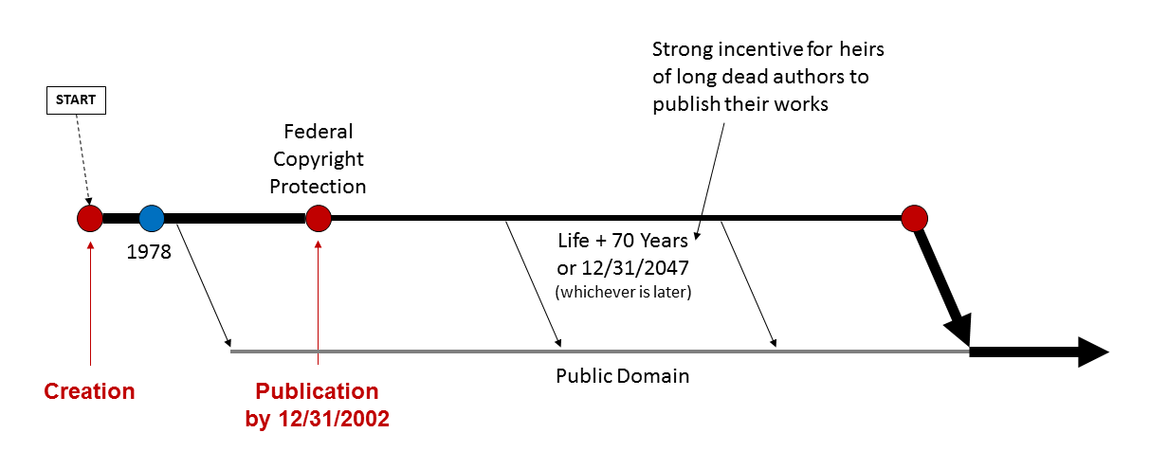
Figure 75: Copyright duration of works created but not published before 1978

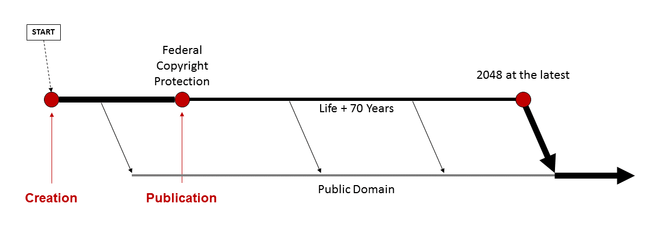
Figure 76: Duration of works created in 1978 or later

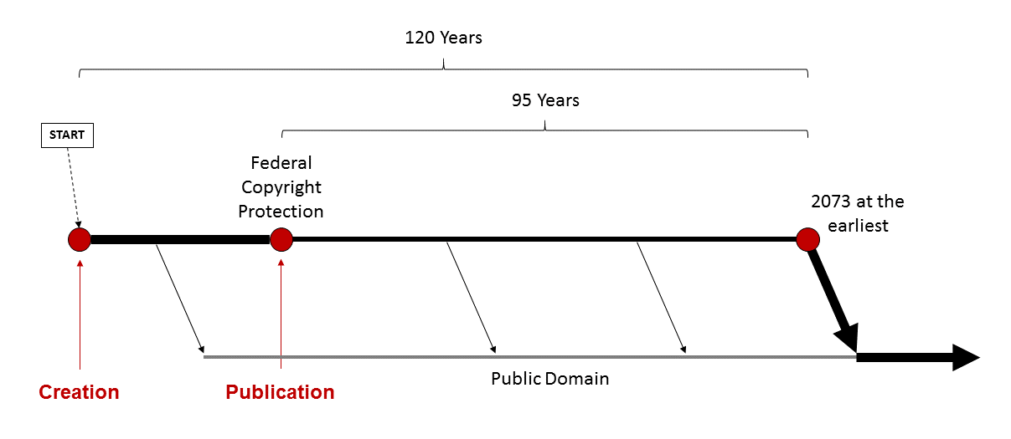
Figure 77: Duration of works created in 1978 or later, for anonymous works, pseudonymous works, and works for hire

So, that’s where things stand. The bottom line: if you need to know the status of a particular US work, first ascertain which of these five categories it falls into. Works in the first box are in the public domain. Works in the second box probably are in the public domain, but you need to check whether the copyrights were timely renewed. Works in the third box are most likely not in the public domain, unless of course they were published without the required copyright notice, but their copyrights will begin to expire in 2018. Works in the fourth box could be in the public domain, unless they were published before 2002 – you need to check. And finally, works in the fifth box are probably not in the public domain. The exceptions to this last proposition are those published between 1978 and 1989, without the required statutory notice and that defect was not cured within five years, and works published recently subject to CC0 proclamations. Otherwise, these works will not begin to fall until 2048 at the earliest. Messy, very messy.

Protective Provisions
In the 1940s, in the case of Fred Fisher versus Witmark, US courts confronted for the first time the question of whether an author may assign his so-called expectancy interest in the renewal term for his copyright. Here’s the context in which that question arose (see Figure 78).
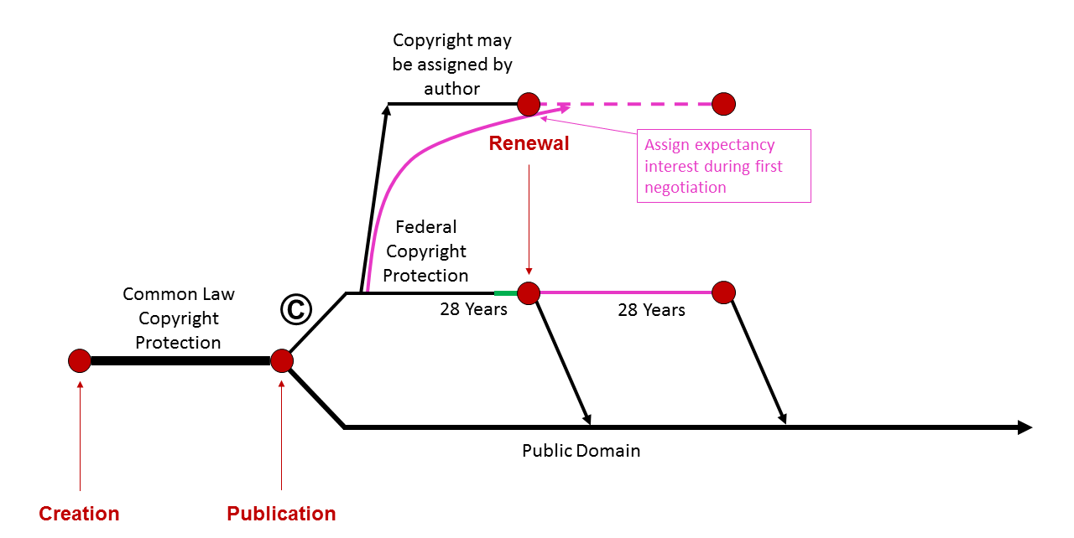
Figure 78: Copyright under the 1909 regime, showing the ability to assign renewal rights

You’ll recall that the 1909 copyright system worked like this: so long as he complied with the rest requisite formalities, the author of a work received a 28-year initial term of federal copyright protection. During the 28th year, he could apply for a second 28-year term. If he had died, his widow or children could apply, and so forth. As I’ve indicated, the renewal term was said to be a new estate, not just a continuation of the earlier term. It was common during this period, like today, for authors to assign their copyrights. This was especially common in the music industry. As we saw in the third lecture in this series, composers very commonly assigned the copyrights in their compositions to music publishers. The effect of such an assignment was that the assignee – the publisher – acquired the initial 28-year term. If the composer was still alive at the end of the term, he would often renew the copyright, and then assign the renewal term to a publisher, often but not always the same publisher. If he died, his widow could do so. From the publisher’s standpoint, this was not ideal. The publisher couldn’t be sure of getting the second term and in any event, during the 28th year, the publisher would have to negotiate with the composer, or his widow, or executor, concerning the terms of the new assignment. If the song in question had proven popular, the publisher might be obliged to pay considerably more to get the renewal term than it had paid to get the initial term. So, publishers, and analogous assignees in other industries, frequently asked authors during the first negotiation to assign to them not only the first copyright term, but also the author’s contingent rights to the renewal term, known as an expectancy interest. The reason for this terminology – the reason that they were called contingent – is that the author only had a right to renew if he was still alive in the 28th year. If he had died by then, his widow or executor had the right to renew, and the author lacked the power to assign his widow’s contingent rights. The net effect is that the assignee obtained the first term for sure, and the renewal term if and only if the author survived until the 28th year. For obvious reasons that too is not ideal from the standpoint of the assignee, because it meant that sometimes the assignee would have to renegotiate with a widow or executor, but it was a lot better than always having to renegotiate.
Let’s pause for a technical point. How exactly was this assignment of the expectancy interest achieved? The answer is usually by the author conveying to the assignee an irrevocable power of attorney – in other words, legal authority to do what otherwise the author himself had the right to do, namely, to file the renewal application, and to get the resultant renewal term. This prevented the author from changing his mind in the 28th year, and filing for renewal himself and refusing to transfer the renewal term. As I say, these arrangements were common, but it wasn’t obvious that they were valid. In other words, it wasn’t obvious that the purported assignment of the expectancy interests were enforceable. The 1909 statute did not address the issue explicitly, but the House and Senate reports explaining the basis of that statute contained a passage that seemed to cast doubt on the validity of these assignments. Here it is. The crucial language is underlined.

House Report
It was urged before the committee that it would be better to have a single term without any right of renewal, and a term of life and fifty years was suggested. Your committee, after full consideration, decided that it was distinctly to the advantage of the author to preserve the renewal period. It not infrequently happens that the author sells his copyright outright to a publisher for a comparatively small sum. If the work proves to be a great success and lives beyond the term of twenty-eight years, your committee [meaning: your congressional committee] felt that it should be the exclusive right of the author to take the renewal term, and the law should be framed as is the existing law, so that he could not be deprived of that right.

This passage suggests that the purpose of not giving an author from the outset a single term of life plus 50 years, or something shorter, like 56 years, but instead requiring him to renew the copyright in the 28th year, was precisely to give him an opportunity to renegotiate the terms of any assignment. And the reason why that’s important is that, as the committee explains, authors tend to be either vulnerable or naive, and therefore, to assign their initial terms for too little money. In other words, the law was designed to protect authors from their own foolishness or vulnerability. Permitting them to assign their expectancy interests, along with the first term, arguably would defeat that goal. The upshot is that there was a plausible argument that these assignments of expectancy interests were invalid; but for many years, they were used without being challenged in court. Finally, one composer did so. His name was George Graff. In 1912, Mr. Graff helped compose the song, “When Irish Eyes are Smiling.” Here’s a brief excerpt of a 1913 recording of the song.

[Music: “When Irish Eyes Are Smiling”.]
(Lyrics) There’s a tear in your eye. And I’m wondering why, for it never should be there at all. With such power in your smile, sure a stone you’d beguile, and there’s never a teardrop should fall. When your sweet lilting laughter like some fairy song, and your eyes sparkling bright as can be you should laugh all the while, and all other times smile. And now smile a while for me.

When he first wrote this song, Graff assigned the copyright, in the initial 28-year term, to a music publisher, Witmark and Sons, in return for some royalties. Five years later, he encountered financial difficulties. To raise some cash, Graff gave up his royalties for “Irish Eyes,” and for 68 other songs, and in addition, assigned his expectancy interest in the renewal term for all of those 69 songs, to Witmark in return for a lump sum payment of $1,600. Subsequently, “Irish Eyes” became very popular, and earned Witmark lots of royalties, none of which, of course, went to Graff. In 1939, on the first day of the 28th year of the copyright, Witmark, the publisher, exercised its right to renew the copyright for an additional 28-year term. Graff, unhappy, insisted that his 1917 assignment of the expectancy interest to Witmark had been invalid, and purported to renew the copyright in “Irish Eyes” himself, and then assign it for more money to a different publisher, Fred Fisher Music. The two publishers then fought it out. The timeline of the various actions and the parties involved is shown in Figure 79.
Although, as you can see, the case that grew out of this complicated narrative involved two publishers, it had big implications for all other composers and artists in analogous positions. If Witmark prevailed, then many authors would not get a second bite at the apple. They could, and would, assign their expectancy interests, along with the first term of their copyrights, sometimes for very little money. Then, when the time for renewal arose, they would have no rights. By contrast, if Fred Fisher Music prevailed, authors in the future would be unable to assign their expectancies, but on the other hand, would be in a much better bargaining position at renewal time.
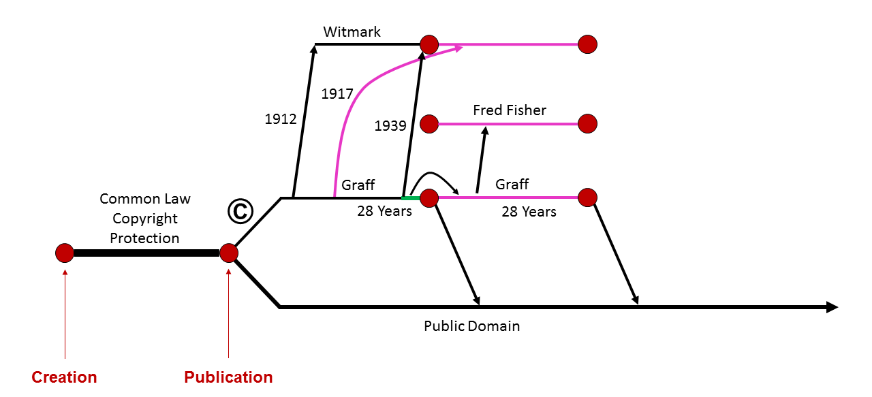
Figure 79: The parties involved in and the timeline of Fred Fisher Music v. M. Witmark & Sons

So, the stakes were high. The case proceeded through three levels of courts. The trial judge ruled in favor of Witmark. The Court of Appeals affirmed, by a vote of two judges to one, and the Supreme Court affirmed, by a vote of five to three, one justice not participating. The law was thus settled. Expectancy interests of this sort are indeed assignable. For our purposes, even more important than this outcome is the language used by the opposing groups of parties and judges. Two radically different conceptions of authors, their characteristics, and their needs figured in this case. The first was well expressed by Judge Jerome Frank, who dissented in the Court of Appeals.

In considering those facts, we should take judicial notice of the economic capacities and business acumen of most authors. We need only take judicial notice of that which every schoolboy knows – that, usually, with a few notable exceptions, such as Shakespeare and George Bernard Shaw, authors are hopelessly inept in business transactions and that lyricists, like the defendant Graff, often sell their songs “for a song.”

Appreciation of these facts, Frank contended, should prompt us to treat lyricists, and authors in general, as especially vulnerable, perhaps even a “necessitus class,” and to curtail their contractual freedom for their own good. Specifically, we should disable them from assigning their expectancy interests, which Frank argued the statute, properly construed did. The opposing narrative and vision was equally well stated by Justice Felix Frankfurter, who wrote the majority opinion for the Supreme Court.

It is not for courts to judge whether the interests of authors clearly lie upon one side of this question rather than the other. We cannot draw a principle of law from the familiar stories of garret-poverty of some men of literary genius. Even if we could do so, we cannot say that such men would regard with favor a rule of law preventing them from realizing on their assets when they are most in need of funds. Nor can we be unmindful of the fact that authors have themselves devised means of safeguarding their interests. We do not have such assured knowledge about authorship, and particularly about song writing, or the psychology of gifted writers and composers, as to justify us as judges in importing into Congressional legislation a denial to authors of the freedom to dispose of their property possessed by others. While authors may have habits making for intermittent want [in other words, they don’t manage their money well] they may have no less a spirit of independence which would resent treatment of them as wards under guardianship of the law.

Frankfurter’s vision, his insistence that authors were responsible adults, autonomous individuals, and should not be treated as wards of the state, prevailed in this particular case. But Judge Frank’s competing vision, that the law should be crafted to nurture and protect improvident authors, to shield them from their habitual folly, also had a significant following. Three of the Supreme Court justices dissented. Instead of writing a dissent themselves, they merely indicated that they agreed with the analysis of the language and history of the copyright law in the dissenting opinion of Judge Frank, in the court below.
These competing visions are outgrowths of deeper and broader themes in copyright law, and in US law in general. Indeed, both of these opposed visions can be found in the legal systems of most countries, at least in Europe and North America. The broader theme that underlies the Frankfurter argument is sometimes called individualism. Here’s how Duncan Kennedy, the scholar who has done the most to identify and explore these ideological currents, describes it.

The essence of individualism is the making of a sharp distinction between one’s interests and those of others, combined with the belief that a preference in conduct for one’s own interests is legitimate, but that one should be willing to respect the rules that make it possible to coexist with others similarly self-interested. The form of conduct associated with individualism is self-reliance. This means an insistence on defining and achieving objectives without help from others (i.e., without being dependent on them or asking sacrifices of them). It means accepting that they will neither share their gains nor one’s own losses. And it means a firm conviction that I am entitled to enjoy the benefits of my efforts without an obligation to share or sacrifice them to the interests of others.

An attitude strongly associated with this outlook is a hostility to paternalism, legal rules that restrict people’s freedom for their own good, such as a rule preventing authors from assigning their expectancy interest on the grounds that they will be better off if they’re forced to wait until the end of their initial copyright terms.
Opposed to individualism is altruism. Here’s how Kennedy described it.

The essence of altruism is the belief that one ought not to indulge a sharp preference for one’s own interest over those of others. Altruism enjoins us to make sacrifices, to share, and to be merciful. It has roots in culture, in religion, ethics and art, that are as deep as those of individualism. (Love thy neighbor as thyself.)
The simplest of the practices that represent altruism are sharing and sacrifice. Sharing is a static concept, suggesting an existing distribution of goods which the sharers rearrange. It means giving up to another gains or wealth that one has produced oneself or that have come to one through some good fortune. It is motivated by a sense of duty or by a sense that the other’s satisfaction is a reward at least comparable to the satisfaction one might have derived from consuming the thing oneself. Sharing may also involve participation in another’s losses: a spontaneous decision to shift to oneself a part of the ill fortune, deserved or fortuitous, that has befallen someone else. Sacrifice is the dynamic notion of taking action that will change an ongoing course of events, at some expense to oneself, to minimize another’s loss or maximize his gain.

This orientation tends to sustain a much more favorable posture toward paternalism. People, viewed this way, should not be left to their own devices. The law should, at least sometimes, intervene to save them from themselves.
Kennedy’s great essay, from which these passages are drawn, explores in depth the relationship between these competing attitudes concerning the substance of human relations, and analogously competing attitudes toward the proper form of legal rules. If you’re curious, I strongly encourage you to explore that essay (available online). But our concern here is with the narrower question of how the attitudes I’ve just summarized find expression in copyright law. Legislators, when adjusting the copyright statute, and judges, when construing and applying the statute, are frequently pulled in different directions by these warring impulses. Sometimes, as in the Witmark case, the individualist impulse prevails. But sometimes the protective impulse prevails. One manifestation of the protective impulse was left intact by the controversial decision in Witmark. As we’ve seen, if an author had died by the time the renewal window opened, his widow or children could renew and keep the copyright. They could do so, even if the author had assigned his contingent expectancy interest. The reason, to repeat, is that all the author had, and thus all he could assign, was the right to renew the copyright if he was alive at the start of 28th year. If he didn’t make it, he had nothing, and thus his assignee acquired nothing. The purpose and effect of this rule, of course, was to shield authors’ widows, widowers, and children, from foolish assignments, by giving them separate rights. Now those rights were far from perfect. Most importantly, they only have value if the author died less than 28 years after publication. But they were better than nothing, and sometimes quite valuable.
Another very important manifestation of what I’m calling it the protective impulse in US copyright law is the set of so-called termination rights. These were first introduced in the comprehensive 1976 reform of the copyright statute, and subsequently modified by the 1998 Copyright Term Extension Act. I mentioned these termination rights at the end of the preceding lecture. I now want to outline them in a bit more detail. Here’s how they work.
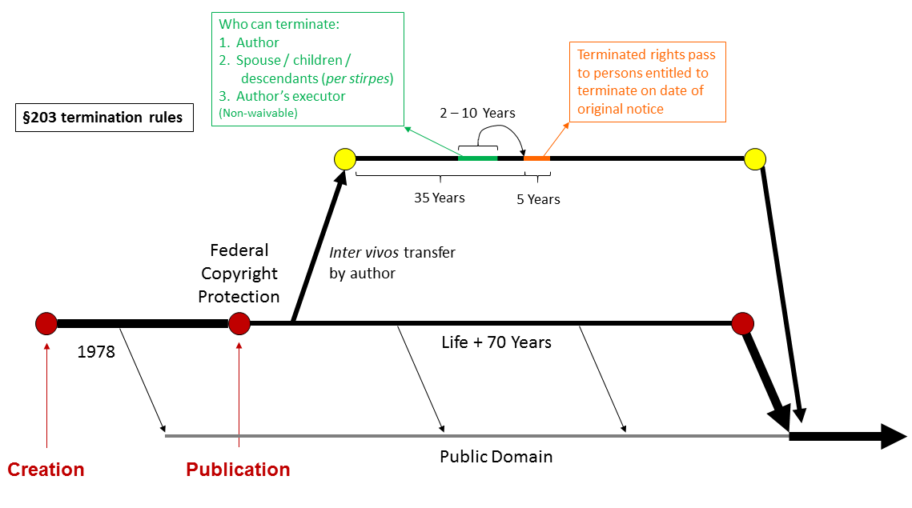
Figure 80: Termination rights for works created in 1978 or later
There are two groups of these rights. The first apply to works created in 1978 or later (see Figure 80). You’ll recall that federal copyrights in such works arise when they are first fixed in a tangible medium, and last for the life of the author plus 70 years. The authors of such works, of course, initially acquire those copyrights, but frequently assign them, or portions of them, to other parties. For example, as we’ve seen, musicians commonly assign the copyrights in their sound recordings to record companies. These are known as inter vivos transfers, because they occur during the author’s lifetime. Typically, such assignments are permanent. In other words, the assignee gets the full copyright term. And notice, this effect is a bit odd. The assignee’s rights last for a period of time tied to the lifespan of the author. The longer the author lives, the more valuable are the assignee’s rights. For those of you familiar with the language of common law real property law, the effect is analogous to a life estate pur autre vie, plus 70 years. Curious, but that’s how it works.
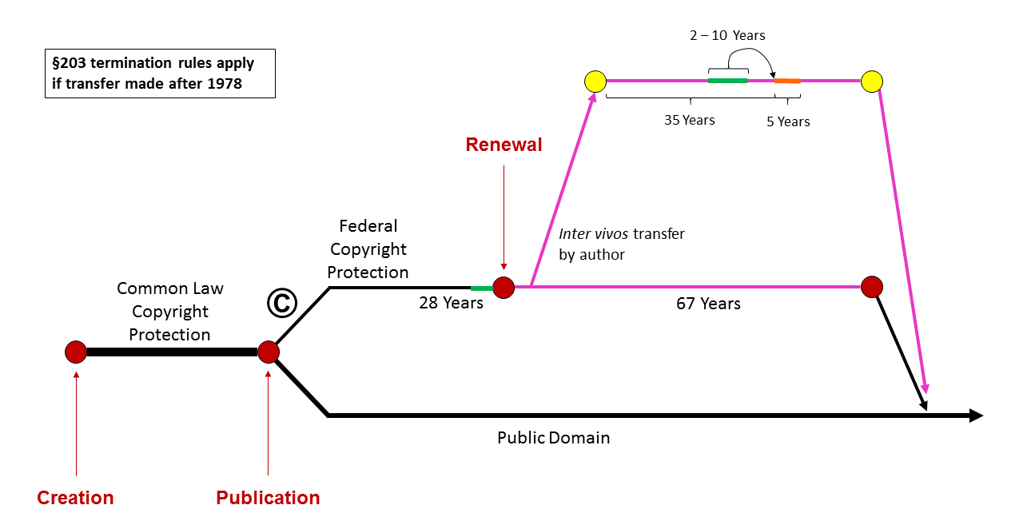
Figure 81: Termination rules that apply if rights were assigned after 1978
Suppose that a particular author assigns her rights for a pittance, and then later comes to regret her decision. Can she ever get the copyright back? The answer is yes. Section 203 of the statute gives her the right to terminate the assignment during a five-year window that opens 35 years after the date of the original assignment (refer to Figure 81). If she wishes to exercise that right, she must notify the assignee between two and five years before the termination itself. If she has died, her spouse or descendants get the right to terminate, and to recover the copyright. A crucial difference between this system and the renewal system we examined a minute ago is that the termination rights are non-waivable. In other words, the author may not, when she assigns her copyright, agree to waive her rights later to terminate the assignment. If she purports to do so, that waiver will not be enforced. In other words, Congress, when it created this system, adopted Judge Frank’s view of the legitimacy and importance of protecting authors from their own ill-advised decisions, rather than Justice Frankfurter’s hostility to making authors wards of the state. Who enjoys the copyrights after the original assignments are terminated? The person or persons who, according to the list in the upper right hand corner of this slide, are entitled to terminate on the date the notice to terminate is given.
What about older works, specifically those published between 1964 and 1977? Copyrights in these, you’ll recall, function very differently. Federal copyright protection is attached to them only upon publication, with appropriate notice, and now lasts for an initial term of 28 years, and an automatic renewal term of 67 years, for a total of 95 years from the date of publication (see Figure 82). Suppose that, sometime after 1978, the author, having renewed assigns the remainder of the renewal term. The assignee will keep it for the balance of the term, unless the author can terminate the assignment. Again, Section 203 the statute gives her the right to do so during a five-year window that opens 35 years after the date of the original assignment. These rights work the same way as the set we just considered.
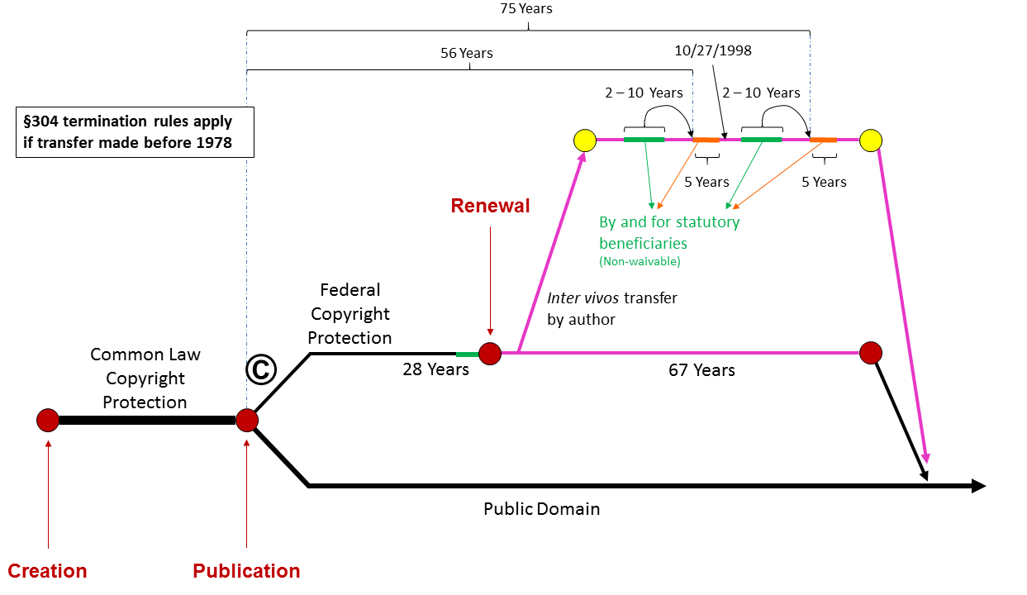
Figure 82: Termination rules that apply if rights were assigned before 1978
If the assignment was made before 1978, a different set of termination rules apply. Section 304 of the statute gives the author – or if she has died, the members of her family – the right to terminate at any time during a five-year window that opens 56 years after the date of the original publication. In other words, when federal copyright protection started. Mechanically, these termination rights work essentially the same way as the set we just considered, and can be exercised by the same parties. They, too, cannot be waived. If the author or her family members miss that window, another one opens 75 years after the original publication.
Finally, what about works first published between 1923 and 1963? As we’ve seen, the subset of these works that were properly renewed during the 28th year of the original term are still alive today. If they were assigned by the author to someone else, may the author or her family terminate those assignments? Again, the answer is yes. If the assignment was made in 1978 or later, the Section 203 rules apply (Figure 81). If the assignment was made before 1978, the double windows of Section 304 apply (Figure 82). As I trust you can see, these rules are Byzantine in their complexity, and their intricacy often defeats authors or their families, who lack the money or knowledge to hire lawyers who can guide them through these reefs. But at least well advised authors or their families can use these procedures to recover the copyrights they once purported to alienate permanently. In this way, the law attempts to protect them from their own lack of foresight.
These termination rights represent perhaps the clearest expression in copyright law of the vision expressed by Judge Frank. A final manifestation of that vision we discussed at the end of the previous lecture. Here’s a reminder. You’ll recall that the law limits the set of types of works that can become works for hire, through signed written contracts. Sound recordings don’t appear on this list. They were briefly added, and then withdrawn. That means that record companies may be prevented, for the reasons we discussed last week, from treating the sets of sound recordings they commission from recording artists as works for hire. To be sure, the record companies can, and typically do, obtain from recording artists assignments of their copyrights, but they may not be able to enforce the provisions of the typical recording contracts that purport, in addition, to render those sound recordings works for hire. The reason why this highly technical difference is so important should by now be clear. Works for hire are not subject to the termination rules. So, if the recordings are works for hire, the recording artists and their families will never get the copyrights back. Springsteen and Clapton will have to make do with their current revenue streams. If they are not works for hire, but are merely assigned copyrights, then the artists and their families can begin terminating them, 35 years after those assignments were initially executed. Suppose that a particular assignment was made immediately after this set of rules became effective, namely on January 1, 1978. When can the assignments be terminated? Right now, in 2013. Thus, the courts will soon be obliged to determine the status of these recordings.
The general point lurking in these details is that this legal doctrine arguably represents yet another manifestation of the protective impulse exemplified by Judge Frank’s opinion. One possible explanation for the fact that this list of potential works for hire is exclusive, and does not contain sound recordings, is that Congress wished to prevent recording artists from entering into deals by which they permanently surrender their rights for too little money. In other words, Congress wanted to ensure that they, or their families, get a second bite at the apple, and so deprived them of the legal power to give up the chance in the future to take that bite.
To summarize, I have discussed today three dimensions of the copyright system in the United States. First, the vestigial but important role played by formalities, and the associated policy debates concerning whether formalities should be reinstated. Second, the intricate rules governing the duration of copyrights. And third, the equally intricate rules that attempt to shield artists and their families from exploitation.
These three features surely do not exhaust the set of important aspects of the copyright machine. Other gears and levers are identified in the map. They include the rules that determine how one makes an effective assignment, or license of a copyright, or one of its component exclusive rights, and the effect of such licenses and assignments. The rules governing the relative rights of the contributors to a collective work, such as the authors of freelance articles published in a newspaper, and the owner of the copyright in the collective work itself. The recording system that plays a limited role in resolving disputes that arise when a copyright owner make successive and consistent transfers of his or her rights. The messy issues generated when the United States sought to restore the copyrights of some non-residents, and so forth. You’re welcome, of course, to explore the relevant branches of the map on your own. In addition, some of these issues will be discussed in the classes and discussions that will follow this lecture. But the three themes we have examined today should suffice to give you at least a general sense of how the copyright system works in practice, and the broad policy issues implicated by that machinery.

The Rights to Reproduce and Modify

Reproduction
We arrive, finally, at the heart of copyright law. In the next three lectures, we’ll examine the principal rights that a copyright owner enjoys and the corresponding limitations upon those rights, designed to accommodate the interests of the public at large. Here’s how my presentation will be organized.
In this lecture and the next one, I’ll be examining the economic rights enjoyed by a copyright owner. As you’ll see, there are four clusters of such rights – first, the copyright owner’s exclusive right to reproduce the copyrighted work; second, the exclusive right to make modifications of the copyrighted work, commonly known as the right to make derivative works; third, the right to control the distribution, exportation, and importation of copies of the work; and fourth, the right to control public performances or public displays of the work.
Today, I’ll be examining the first two of those rights – the right of reproduction and the right of modification. Next week, I’ll take up the third and fourth of the rights. And the week after that, I’ll discuss the major exceptions and limitations that copyright law imposes upon these exclusive rights. During this tour, I will focus, as I did during the first half of the course, primarily on the law in the United States, but I will also identify some respects in which the law in other countries parallels or differs from US law.
Section 106 of the US Copyright Statute confers on copyright owners a broad and seemingly unqualified set of rights. Here they are:

17 USC § 106
Subject to sections 107 through 122, the owner of copyright under this title has the exclusive rights to do and to authorize any of the following:
(1) to reproduce the copyrighted work in copies or phonorecords;
(2) to prepare derivative works based upon the copyrighted work;
(3) to distribute copies or phonorecords of the copyrighted work to the public by sale or other transfer of ownership, or by rental, lease, or lending;
(4) in the case of literary, musical, dramatic, and choreographic works, pantomimes, and motion pictures and other audiovisual works, to perform the copyrighted work publicly;
(5) in the case of literary, musical, dramatic, and choreographic works, pantomimes, and pictorial, graphic, or sculptural works, including the individual images of a motion picture or other audiovisual work, to display the copyrighted work publicly; and
(6) in the case of sound recordings, to perform the copyrighted work publicly by means of a digital audio transmission.

Sections 107 through 122 then carve out of those rights a long list of exceptions. Some of those exceptions are very specific and narrow; others are broader. The broadest of all is the fair use doctrine, embodied in Section 107, which we’ll discuss in two weeks. As you can see, the introductory clause of Section 106 makes the rights it creates “subject to” – in other words, qualified by – Sections 107 through 122. The result of this structure is that, to get an accurate sense of the scope of a copyright owner’s exclusive rights, you must oscillate between the generous grants contained in Section 106 and the myriad exceptions contained in the following provisions. And that’s what we’ll be doing.
The first and simplest of the rights conferred on a copyright owner by Section 106 is the right to reproduce – in other words, to copy – the copyrighted work in copies or phonorecords. This entitlement is commonly considered the core of copyright. The name of this entire field suggests as much. The heart of copyright is the exclusive right to copy. As it’s used in the law, the term “reproduction” has three independent dimensions. To prevail, a plaintiff must satisfy all three.
To prove unauthorised reproduction the plaintiff must show:
- Copying
- What the defendant created is a “copy”
- Improper appropriation
The first pertains to the way in which the defendant generated the allegedly infringing things. Only if he did so by copying is the defendant liable. The second pertains to the character of the allegedly infringing things. Only if they constitute “copies” is the defendant liable. And the third pertains to the nature and amount of the material the defendant took from the plaintiff. Only if it rises to the level of “improper appropriation” is the defendant liable. We’ll consider them in that order.
In patent law, as some of you know, independent invention is no excuse. A defendant cannot escape liability by showing that he dreamed up, on his own, an invention that happens to match the plaintiff’s patent. Not so in copyright law. There, independent creation is an excuse. Suppose, for example, I write a poem. Later, you, never having seen mine, write and publish exactly the same poem. I have no claim against you. You infringe my copyright in my poem only if you copy mine. So, what exactly does that mean? The clearest type of copying is mechanical reproduction. If you make a photocopy of the piece of paper upon which my poem is written, you have copied it. If you rip a CD containing a sound recording, which, in turn, embodies a musical composition, you have copied, specifically in a phonorecord, both the composition and the sound recording. If you replicate a CD-ROM containing a software program, you infringe the copyright in the program. None of this should be surprising. But as used in the law, the term “copying” is not limited to mechanical reproduction. It also includes having the copyright work in mind when making a substantially similar embodiment. So, if you read and memorize my poem and then write it down, you have copied it. If you listen to a performance of my musical composition and then record your own rendition of my composition, you have copied it. If you watch a movie and then write a short story containing an identical plot, you have copied the audiovisual work embodied in the film, and so forth.
The most intriguing cases in this area involve situations in which the defendant is exposed to the plaintiff’s work and then, sometime later, creates a very similar work without being aware that it mimics the plaintiff’s work. In other words, the defendant believes he is being original, but he’s not. The law governing such situations is harsh. In the 1924 case of Fred Fisher versus Dillingham, Judge Learned Hand summarized the relevant rule as follows.

Everything registers somewhere in our memories, and no one can tell what may evoke it. Once it appears that another has, in fact, used the copyright as the source of this production, he has invaded the author’s right. It is no excuse that, in so doing, his memory has played him a trick.

The most famous case of this general sort involved the following facts. In 1963, The Chiffons, a popular quartet in the United States, released a recording of “He’s So Fine,” a song that had been composed by Ronald Mack. Here’s a brief excerpt.
[Music: The Chiffons, “He’s So Fine”.]
The Chiffons’ recording was a hit in both the United States and in England. George Harrison heard the song, but forgot it. Six years later, he composed and performed “My Sweet Lord.” Here’s an excerpt.
[Music: George Harrison, “My Sweet Lord”.]
Bright Tunes Music, the assignee of Mack’s copyright, brought an infringement suit against Harrison and prevailed. Both the trial court and the Court of Appeals credited Harrison’s testimony that he was unaware of The Chiffons’ recording when he made his own song. However, they ruled, Harrison could not escape on this basis. Here’s the key passage in the appellate court’s opinion.

It’s not new law in this circuit that, when a defendant’s work is copied from the plaintiff’s, but the defendant, in good faith, has forgotten that the plaintiff’s work was the source of his own, such innocent copying can nevertheless constitute an infringement. It’s settled that intention to infringe is not essential under the Copyright Act.

The court then went on to suggest a possible policy basis for this seemingly unforgiving rule.

As a practical matter, the problems of proof inherent in a rule that would permit innocent intent as a defense to copyright infringement could substantially undermine the protections Congress intended to afford copyright owners. We therefore see no reason to retreat from this Circuit’s prior position that copyright infringement can be subconscious.

The rule announced and applied by the court in this case bears emphasis. Innocent copying is still infringement. In this special sense, copyright infringement is a strict liability offense.
The final, perhaps non-obvious, aspect of the scope of copying is that it encompasses translation of the plaintiff’s work into a different medium. So, for example, an unauthorized motion picture version of a novel, a doll that mimics a cartoon character, a still photograph of a ballet are all covered. So, to summarize, a plaintiff, to establish that a defendant has violated the plaintiff’s exclusive right of reproduction, first must show that the defendant “copied” the plaintiff’s work, which means either that the defendant mechanically reproduced it or had the plaintiff’s work in mind, even subconsciously, when making his own product.
How, then, does a plaintiff prove copying in this sense? There are four.
Techniques to use to prove copying
- Direct evidence
- Access and similarity
- Striking similarity
- Common errors
First, the plaintiff can introduce direct evidence of copying. Surprisingly often, evidence survives of a defendant’s conscious intentional use of the plaintiff’s work during the course of his own creative processes, and that evidence turns up in discovery. Second, the plaintiff can show that the defendant had access to his work and that the defendant’s work and the plaintiff’s work are sufficiently similar to raise an inference of copying. For example, the plaintiff may be able to show that the defendant had the plaintiff’s book on his bookshelf or received the plaintiff’s screenplay in the mail. More commonly, the plaintiff may be able to show that his work – say, a song or a movie – was widely performed in areas and at times that would make it highly likely that the defendant heard or watched it. So, for example, few people, at least in the Western hemisphere, can plausibly contend that they’ve never heard a Beatles song or watched a James Bond movie. When the plaintiff can demonstrate access of this sort, all he then needs to demonstrate is sufficient similarity between the defendant’s and the plaintiff’s work to make plagiarism more likely than independent creation. The character and amount of similarity that’s necessary for this purpose is sometimes called probative similarity. It’s different from the kind of similarity that we will discuss in a minute, under the heading of “Improper Appropriation,” because its function is different. Its role, to repeat, is to support an inference that the way the defendant created his work was wrong, not that the amount he took was too much. The courts, unfortunately, sometimes conflate these two types of similarity, but you should not.
What if the plaintiff has no evidence that the defendant had access to his work, but can show that the defendant’s work is extremely similar to his? Is that enough to show copying? US courts used to disagree on this point. Some Courts of Appeals said yes; others said no. All of the Courts of Appeals now seem to agree that sufficiently “striking” similarity between unusual aspects of the two works can suffice. However, the inference of copying that arises in such circumstances can be overcome if the defendant demonstrates that he did not have access to the plaintiff’s work or that both the plaintiff’s work and the defendant’s work could have been copied from something in the public domain.
Finally, an especially powerful way of showing copying is to demonstrate that the same errors can be found in both the plaintiff’s and the defendant’s works. Sometimes, such errors are deliberate. The writers of travel guides, for example, often insert fictitious entries in their lists of hotels and restaurants precisely in order to enable them to detect copying of their material by the publishers of other guides to the same cities or countries. This is a very effective way of ferreting out copying, although it can be inconvenient for the readers who visit the non-existent sites. At other times, the errors are inadvertent. Paul Goldstein, for example, points to one case in which a legal publisher, as part of an infringement suit against another publisher, admitted that, in 50 pages of the plaintiff’s treatise, there were 138 inaccurate citations, and the same mis-citations appeared in the defendant’s text – embarrassing, but convincing, evidence of copying.
Assuming that the plaintiff can surmount this first hurdle, the second of the three things the plaintiff must show is that the thing the defendant made through copying is sufficiently concrete and stable to be called a copy. In the overwhelming majority of cases, this is easy. But occasionally, a plaintiff falters here. The statutory definition the plaintiff must satisfy is shown below (17 USC § 101). From this language, the courts have extracted the requirements that the thing produced by the defendant be tangible – in other words, a material object – fixed, and intelligible. The most slippery of these requirements is fixation. You’ll recall that fixation is a precondition of copyright protection under US law, although not under the law of most countries. Here, we encounter a second, closely related manifestation of the laws concerned with fixation. Not only must the plaintiff’s work be fixed in order to enjoy copyright protection; the defendant’s work must also be fixed in order to violate the plaintiff’s copyright, at least under Section 106(1).

17 USC § 101
“Copies” are material objects, other than phonorecords, in which a work is fixed by any method now known or later developed, and from which the work can be perceived, reproduced, or otherwise communicated, either directly or with the aid of a machine or device. The term “copies” includes the material object, other than a phonorecord, in which the work is first fixed.
“Phonorecords” are material objects in which sounds, other than those accompanying a motion picture or other audiovisual work, are fixed by any method now known or later developed, and from which the sounds can be perceived, reproduced, or otherwise communicated, either directly or with the aid of a machine or device. The term “phonorecords” includes the material object in which the sounds are first fixed.

Recently, the Second Circuit Court of Appeals decided a complicated and important case in which this fixation requirement proved critical. Because the case implicated several other legal rules, as well, I’m going to describe the facts in some detail. Then, I’ll discuss one of the issues raised by those facts today and come back to other dimensions of the case next week.
Cablevision is a small cable TV system based in New York City. Like all cable companies, it aggregates audiovisual programming from several sources. For example, Warner Brothers may produce a movie, license it to NBC, and then Cablevision picks up NBC’s signal. Cartoon Network and HBO provide programming directly to Cablevision, and so forth. As you might expect, Cablevision pays for the right to broadcast this material either according to the terms of voluntary licenses or through a compulsory license. Those licenses are important and complex. We’ll touch on them briefly at the end of the next lecture. For present purposes, all you need to know is that these licenses do not give Cablevision the right to make copies of the TV shows or movies in question, only to publicly perform them. So, to return to the narrative, Cablevision combines these various streams of programs into a single, composite, encoded signal, which it sends via cable, of course, to its customers. Each customer receives the composite signal through a set-top box, which decodes it, relays it to a television, which, in turn, displays it to the subscriber sitting on his couch.
If, as is likely, the subscriber doesn’t want to watch all shows at the times they are broadcast, he’s likely to employ a device to record them. Once upon a time, the device would have been a VCR. Today, it’s likely to be a digital video recorder, commonly known as a DVR. Then, when the subscriber wants to watch a given show, he plays the copy stored on the DVR. So, this pattern should be entirely familiar to most of you, but if you’ve been following this course of lectures from the beginning, it should make you uneasy. There’s no question that the DVR recording, represented by the blue dot in Figure 83, is a copy of the television shows in question. The subscriber who makes those copies does not have a license from Warner Brothers or Cartoon Networks to do so. Is the subscriber then violating section 106(1) of the copyright statute? The answer is yes, but that violation, as we’ll see, is excused under the fair use doctrine. When and how that crucial principle was established we’ll discuss in a few weeks. For now, it’s enough to recognize that the subscriber can slip the noose by pleading fair use.
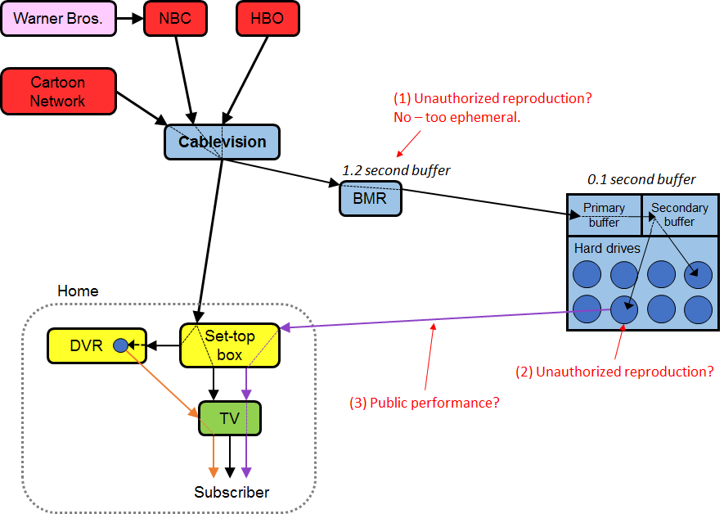
Figure 83: The operations of Cablevision

Now, back to our story. In 2006, Cablevision had an idea. What if, instead of relying on individual subscribers to make copies of shows on their home DVRs, it offered to make copies for them using a cloud-based technology? This would be more efficient and convenient than the home devices, sufficiently so, that the subscribers would be willing to pay a premium for it. So, Cablevision created, though it did not immediately implement, what it called a remote storage DVR, or RS-DVR system. Its main features, in the language of the court eventually called upon to review the system, looked like this.

Under the new RS-DVR, this single stream of data is split into two streams. The first is routed immediately to customers, as before. The second stream flows into a device, called the broadband media router (BMR), which buffers the data stream, reformats it, and sends it to the Arroyo server, which consists, in relevant part, of two data buffers and a number of high-capacity hard disks. The entire stream of data moves to the first buffer, the primary ingest buffer, at which point the server automatically inquires as to whether any customers might want to record any of that programming. If a customer has requested a particular program, the data for that program move from the primary buffer into a secondary buffer and then into a portion of one of the hard disks allocated to that customer. As new data flow into the primary buffer, they overwrite a corresponding quantity of data already on the buffer. The primary ingest buffer holds no more than 0.1 seconds of each channel’s programming at any moment. Thus, every tenth of a second, the data residing on this buffer are automatically erased and replaced. The data buffer in the BMR holds no more than 1.2 seconds of programming at any time. While buffering occurs at other points in the operation of the RS-DVR, only the BMR buffer and the primary ingest buffers are utilized absent any request from the individual subscriber. To the customer, however, the processes of recording and playback on the RS-DVR are similar to that of a standard set-top DVR. Using a remote control, the customer can record programming by selecting a program in advance or by pressing the Record button while playing a given program. To begin playback, the customer selects the show from an on-screen menu of previously recorded programs. The principal difference in operation is that, instead of sending signals from the remote to an on-set box, the viewer sends signals from the remote through the cable to the Arroyo server at Cablevision’s central facility, which then delivers the program to the subscriber’s home. In this respect, RS-DVR more closely resembles a video-on-demand service, whereby a cable subscriber uses his remote and cable box to request transmission of content, such as a movie, stored on computers at the cable company’s facility. But unlike a video-on-demand service, RS-DVR users can only play content that they previously requested to be recorded.

So, those are the facts. You can guess what happened next. Cartoon Network and the owners of the copyrights in the other shows that would be delivered to subscribers through the system initiated a lawsuit against Cablevision, not because they thought this was a bad idea, but because they wanted Cablevision to pay them additional license fees to deploy this new feature, which Cablevision was unwilling to do. The plaintiffs contended that the RS-DVR system would violate their copyrights in not just one, but three, separate ways.
First, they argued that buffering an audiovisual work, specifically for 1.2 seconds in the BMR and for a tenth of a second in the primary ingest buffer of the Arroyo server, creates a series of replicated pieces of the work, which, although each one is stored only briefly, gives rise in the aggregate to a copy of that work and thus violates Section 106(1) of the Copyright Act. Second, they argued that making the much more durable copies of their shows on the Arroyo server hard drives gives rise to a second violation of Section 106(1). Third, they argued that the delivery of the programming from the Arroyo server to the subscriber at the subscriber’s request would constitute an unauthorized “public performance” in violation of Section 106(4). We’ll discuss the second and third of those claims in future lectures. For present purposes, we’re concerned only with the first one.
The district court agreed with the plaintiffs that the buffer triggered a violation of section 106(1). But the Court of Appeals reversed. Here’s the crucial language in the appellate court’s opinion.

Copies, as defined in the Copyright Act, are material objects in which a work is fixed by any method and from which the work can be reproduced. The act also provides that a work is fixed in a tangible medium and expression when its embodiment is sufficiently permanent or stable to permit it to be reproduced for a period of more than transitory duration. We believe that this language plainly imposes two distinct, but related, requirements – the work must be embodied in a medium, i.e., placed in a medium such that it can be perceived, reproduced, et cetera, from that medium; and it must remain thus embodied for a period of more than transitory duration. Unless both requirements are met, the work is not fixed in the buffer. And as a result, the buffer data is not a copy of the original work whose data is buffered.

Because the data being channeled toward the Arroyo server reside in no buffer for more than 1.2 seconds before being automatically overwritten, the court concluded that the duration requirement had not been satisfied and thus that the defendant’s technology did not result in the creation of any copies.
For reasons we’ll explore later, the Court of Appeals also rejected the second and third of the plaintiff’s claims. As we’ll see, the bases of those rulings were also highly technical, and thus arguably a bit counterintuitive. The net result was that Cablevision was permitted to deploy its new service. This decision, which the Supreme Court declined to review, has facilitated the emergence of many analogous cloud-based services, which, in turn, have had huge economic implications. As Josh Lerner discovered, “VC investment in cloud computing firms increased significantly in the United States relative to the EU after the Cablevision decision.” The decision, it appears, led to additional incremental investment in US cloud computing firms that ranged from $728 million to approximately $1.3 billion over the two and a half years after the decision. When paired with the findings of enhanced effects of VC investment relative to corporate investment, this may be the equivalent of $2 billion to $5 billion in traditional R&D investment. An essential step in the ruling that catalyzed this investment was, as we’ve seen, the court’s judgment that the fixation requirement had not been satisfied by the buffer copies.

Improper Appropriation
Cases like Cablevision, in which the parties struggle over whether what the defendant has produced constitutes a copy, are rare. Much more common are cases in which the parties struggle over whether the character and amount of material copied by the defendant from the plaintiff’s work rise to the level necessary to constitute infringement. Once again, the burden is on the plaintiff. The plaintiff must show not only, as we’ve seen, that the defendant copied from the plaintiff’s copyrighted work, but also that the copying, assuming it to be proved, went so far as to constitute improper appropriation.
Methods to use to show improper appropriation
- Comprehensive copying
- Fragmented literal similarity
- Comprehensive nonliteral similarity (“substantial similarity” test)
There are three more or less discreet ways in which the plaintiff can do so. First, he could show that the defendant made a verbatim copy of his entire work. This is what Melville Nimmer helpfully refers to as comprehensive copying. This happens more often than you might think. Examples include peer to peer sharing of sound recordings and the comprehensive replication of digital copies of films that were at issue in the Cablevision case, which we just discussed. So long as the plaintiff’s work qualifies for copyright protection, applying the standards we discussed in the first lecture, comprehensive copying of this sort easily gives rise to a violation of section 106(1).
Things get a bit more complicated when what the defendant has copied verbatim is not the entire work but a piece or slice of the plaintiff’s work. Nimmer refers to this as “fragmented literal similarity.” An example can be found in this lecture. You’ll recall that I illustrated the principle of subconscious copying by playing for you a segment of the Chiffons recording of Donald Mack’s composition “He’s So Fine.” In order to enable you to hear that recording, I had to create a copy of that segment in the recording of this lecture, which you are now watching and listening to. I did not copy the entire song. So, I’ve not engaged in comprehensive copying. Instead, I copied a piece of it, specifically a piece long enough for you to assess the plausibility of the court’s conclusion that George Harrison had innocently copied Mack’s composition. Thus, I have engaged in “fragmented literal copying,” both of Mack’s composition and of the Chiffons sound recording of that composition.
To prevail in a fragmented literal similarity case, the plaintiff must show two things in addition, as we’ve seen, to the fact of copying. First, he must show that the slice the defendant took includes some copyrightable expression, not merely ideas or facts. All the factors we discussed in lecture number one concerning the idea-expression distinction become relevant here. For example, if the slice the defendant took consists of a sentence that is the only effective way of conveying a particular idea, then pursuant to the merger doctrine, the taking of that sentence does not constitute a copyright infringement. Can I escape liability on this basis for copying a slice of “He’s So Fine”? No, there’s plenty of copyrightable expression in the 30 second slice that I appropriated. Second, the plaintiff must show that the slice that the defendant took is big enough. How big is that? The adjective most often used by the courts is substantial. The portion taken must be a substantial part of the plaintiff’s work measured both qualitatively and quantitatively. Relatively small slices have been deemed sufficient to pass this test provided that they’re sufficiently important to the plaintiff’s creation.
For example, in the 1980 Iowa State research case, the defendant, ABC, broadcast as part of its coverage of the Olympics two brief excerpts from the plaintiff’s documentary film examining the life of a wrestler. One excerpt was 2 and 1/2 minutes long, the other 12 seconds. In the judgment of the Second Circuit, that was plenty. A willingness to find liability upon the taking of relatively small excerpts is not limited to the United States. For example, the courts in Australia have proven to be similarly protective of plaintiffs. In a recent high profile case, the plaintiff owned the copyright of “Kookaburra,” a nursery rhyme originally written by Marion Sinclair in 1932. It was popular in Australia for decades. And indeed, I can remember my mother singing it to me in the United States. The key segment of the song goes like this. I’m going to do my best here.
[Music: “Kookaburra”, sung by Terry Fisher.]
My apologies to Ms. Sinclair. In the late 1970s, the Australian rock group Men at Work composed and recorded an equally famous, perhaps more famous, song called “Down Under.” I’m going to play a short passage of that song. Listen carefully for the flute riff that comes near the end.
[Music: Men At Work, “Down Under”.]
The same riff appears several other times in “Down Under,” and each time is equally short. George Ham, one of the members of Men at Work, added this riff to the song in order to inject some “Australian flavor” into it. In the ensuing copyright litigation, Ham testified that, like George Harrison, he was not aware that he was lifting this segment from “Kookaburra.” Somewhat more specifically, here’s how Judge Jacobson, who oversaw this case, summarized Ham’s affidavit.

He said that the flute section, which he added, fitted rhythmically to “Down Under” and the percussion drum section at the start of the song, which is in fact played on beer bottles with different amounts of water in them. Mr. Ham pointed out that the lyrics, vocal melody, chords, and bass lines were already established when he heard “Down Under.” He looked for a complimentary part for his instruments, and especially one which fell into the “tongue in cheek” nature of the song. He described the flute line as an Aussie cliché melody, or what he thought was an Irish Australian style melody.

Now, Judge Jacobson did not definitively resolve the question of whether Ham had been aware when he inserted the riff that had been taken from “Kookaburra,” apparently assuming that, as we saw in the George Harrison case, subconscious copying is actionable. The decisive issue in Judge Jacobson’s judgment was the amount taken. Here’s how the court expressed the relevant standard. Copyright infringement arises when a defendant “has copied a substantial part of the copyrighted work. The question whether he has copied a substantial part depends much more on the quality than on the quantity of what he has taken.” That standard, the judge ruled, had been met in this case. The remedy? The defendants had to pay the plaintiffs 5% of the royalties they had earned on the song since 2002 and into the future. In 2011, the highest court in Australia refused to hear an appeal from the ruling, leaving Jacobson’s decision intact.
This case had a tragic coda. In April of 2012, George Ham died at age 58 of an apparent drug overdose. It seems that one factor in his decline was his dismay that his legacy had been permanently tarnished by the judgment that he had copied another musical work, suggesting that, more important for him than the financial liability arising out of this case was the reputational harm it generated.
So, to summarize, in a case involving fragmented literal similarity, the plaintiff must prove that the defendant took a substantial portion of the plaintiff’s work measured qualitatively and quantitatively. In practice, that requirement is forgiving, permitting plaintiffs to recover for the taking of quite small pieces. There’s a limit, however. That limit is sometimes referred to as the “de minimis doctrine.” An excellent description and illustration of this doctrine to be found in Judge Leval’s 2001 opinion in the case of Davis versus The Gap.

The de minimis doctrine is rarely discussed in copyright opinions because suits are rarely brought over trivial instances of copying. Nonetheless, it is an important aspect of the law of copyright. Trivial copying is a significant part of modern life. Most honest citizens in the modern world frequently engage, without hesitation, in trivial copying that, but for the de minimis doctrine, would technically constitute a violation of law. We do not hesitate to make a photocopy of a letter from a friend to show to another friend, or of a favorite cartoon to post on the refrigerator. Parents in Central Park photograph their children perched on José de Creeft’s Alice in Wonderland sculpture. We record television programs aired while we are out, so as to watch them at a more convenient hour. Waiters at a restaurant sing “Happy Birthday” at a patron’s table. When we do such things, it is not that we are breaking the law but unlikely to be sued given the high cost of litigation. Because of the de minimis doctrine, in trivial instances of copying, we are in fact not breaking the law. If a copyright owner were to sue the makers of trivial copies, judgment would be for the defendants. The case would be dismissed because trivial copying is not an infringement.

Now, one warning about this otherwise illuminating passage. Judge Leval’s example in the middle of this paragraph about recording television programs while we are out is not, strictly speaking, an example de minimis copying. Rather, as I mentioned in connection with the Cablevision case, that’s an example of fair use, a doctrine that Judge Leval himself has done more to reshape and invigorate than any other judge. But if you exclude that one instance, the passage in front of you nicely illustrates the general and unsurprising principle. The law will not penalize the taking of trivial amounts.
There’s one important exception to the de minimis doctrine. It’s illustrated by the facts of the 2005 case of Bridgeport Music. The plaintiff in that case owned the copyright in a sound recording of the song “Get Off Your Ass and Jam,” which was originally made by George Clinton Jr. and the Funkadelics. The Funkadelics’ recording of “Get Off” opens with a solo guitar riff that contains three notes and lasts a total of four seconds. Here it is.
[Music: Funkadelics, “Get Off Your Ass and Jam”.]
Gangsta rap group NWA subsequently recorded a song entitled “100 Miles and Runnin’,” which contained a sample from the Funkadelics recording. Specifically, NWA copied two seconds of the four second riff, lowered the pitch, looped that slice, and extended it to 16 beats. The loop, created by NWA, lasts a total of seven seconds. That seven second segment derived from the original recording appears in five places in “100 Miles.” I’m going to play one of those five appearances. Listen carefully, because the segment appears in the background. And it’s hard to hear. A word of warning, in the foreground of this excerpt are some explicit lyrics that may offend some listeners. If you don’t wish to hear them, you should skip over the next 20 seconds of this lecture.
[Music: NWA, “100 Miles and Runnin’”.]
Despite the brevity of the sample taken from the Funkadelics recording, the copyright owner brought an infringement suit. Really, you may think. To be sure, as the district court that heard the case observed, the segment taken by the defendants, though tiny, was arguably important to the defendant’s work. In the court’s words “The portion of the song at issue here is an arpeggiated chord, that is three notes that, if struck together, comprise a chord, but are instead played one at a time in very quick succession, that is repeated several times at the opening of ‘Get Off.” The arpeggiated chord is played on an unaccompanied electric guitar. The rapidity of the notes and the way they are played produce a high-pitched whirling sound that captures the listener’s attention and creates anticipation of what is to follow”. Well, maybe, but the fact remains that the excerpt taken is very short – to repeat, two seconds long, much shorter than the excerpt in the Kookaburra case, and much less distinctive. Indeed, if I hadn’t pointed it out, almost surely you would not have noticed it. This would thus seem to be an easy case of de minimis copying, taking an amount too small to warrant the attention of the law. And the district court so ruled. Surprisingly, the Sixth Circuit Court of Appeals reversed, holding broadly that the de minimis defense is not available to a defendant who samples sound recordings. Taking even a tiny piece of someone’s sound recording will trigger a violation of section 106(1).
The rule, announced in Bridgeport Music, was widely denounced. And it may well be a bad rule. But it’s somewhat less shocking than it first appears. The reason is that in US law, sound recordings get narrower protection than other sorts of copyrights. Here’s the relevant provision.

17 USC § 114(b)
The exclusive right of the owner of copyright in a sound recording under clause (1) of section 106 is limited to the right to duplicate the sound recording in the form of phonorecords or copies that directly or indirectly recapture the actual sounds fixed in the recording. The exclusive right of the owner of copyright in a sound recording under clause (2) of section 106 is limited to the right to prepare a derivative work in which the actual sounds fixed in the sound recording are rearranged, remixed, or otherwise altered in sequence or quality. The exclusive rights of the owner of copyright in a sound recording under clauses (1) and (2) of section 106 do not extend to the making or duplication of another sound recording that consists entirely of an independent fixation of other sounds, even though such sounds imitate or simulate those in the copyrighted sound recording….

As you can see, imitating a sound recording does not constitute infringement. With respect to all other types of copyrighted works, including musical compositions, imitation does constitute infringement, but not for sound recordings. Only capturing the actual sounds fixed in the recording gives rise to liability. Dubbing is actionable, but not imitation. This provision explains why, as we discussed in lecture number three, musicians are free to make covers of commercially released songs. As we saw there, musicians have to pay the composers of those songs or their assignees a modest compulsory fee, but they don’t have to get the composer’s permission. Even more strikingly, they don’t have to pay anything to the owners of the copyrights in the sound recordings embodying the original rendition of the song, because they’re not capturing its actual sounds.
Now, the reason why this rule is relevant to digital sampling is that, as the Sixth Circuit observes, it creates an inexpensive alternative to sampling. As the court explained, “It must be remembered that if an artist wants to incorporate a riff from another work in his or her recording, he’s free to duplicate the sound of that riff in the studio. The market will control the license price and keep it within bounds. The sound recording copyright owner cannot exact a license fee greater than what it would cost the person seeking the license to just duplicate the sample in the course of making the new recording.” In other words, the court argues, a blanket rule that all digital sampling, no matter how small, gives rise to liability would not “stifle creativity.” Because rap artists and others can either imitate the sounds they want or can obtain a license, the fee for which will be low, because the licensor is aware that imitation is lawful.
The court’s last argument in support of its ruling is different. Not only would a blanket prohibition on sampling not stifle creativity, said the court, it’s fair. Why? Because “Sampling is never accidental. It’s not like the case of a composer who has a melody in his head, perhaps not even realizing that the reason he hears the melody is that it’s the work of another which he had heard before. When you sample a sound recording, you know you are taking another’s work product.” Notice here the echoes of the fairness theory of copyright in general. Intentionally taking someone else’s “work product,” the court suggests, is wrong, morally wrong, and deserves to be punished. I leave to you the question of whether these arguments in combination are convincing.
I hasten to add that the elimination of the de minimis defense for sound recordings does not necessarily mean that all digital sampling is unlawful. It’s still in principle possible for samplers to avoid liability on the basis of fair use. We’ll take up that option in two weeks. Incidentally, the fair use doctrine as you’ll see also provides the best line of defense for me if the Funkadelics or NWA or the Chiffons object to my use in this lecture of pieces of their recordings.
The seemingly absolute position, taken by the Sixth Circuit Court of Appeals in the Bridgeport case, is not limited to the United States. In the 2008 Metall auf Metall case, the Federal Supreme Court of Germany similarly ruled that the sampling of any part of a digital recording gives rise to infringement of the neighboring right in the recording. So, the Bridgeport Music doctrine, for better or worse, seems to be spreading.
The third path to a demonstration of improper appropriation is the most interesting and complicated. It involves situations in which the defendant has not copied any portion of the plaintiff’s work verbatim, but has instead created a different but similar work. Such cases of, to use Nimmer’s phrase, comprehensive nonliteral similarity, are governed in the United States by the so-called “substantial similarity” test. As you might expect, the defendant is liable under this approach if and only if his work is substantially similar to the plaintiff’s
Before considering what that phrase might mean, we need to confront two threshold questions. First, are additions relevant? In other words, can a defendant escape liability by showing that he added sufficient things to the plaintiff’s work to make the two works different? The canonical answer is no. As Judge Hand once put it, “No plagiarist can excuse the wrong by showing how much of his work he did not pirate.” However, as we’ll see, courts don’t always adhere strictly to that guideline. Second, what happens when the plaintiff’s work contains some material protected by copyright law and some material that’s not protected, for example that consists of facts or scenes a faire? Cases of this sort present courts with an analytical challenge. Similarity that arises because the defendant has mimicked unprotected material should of course not give rise to liability. On the other hand, if the courts or juries ignore the unprotected material altogether, they may fail to give the plaintiff appropriate protection for the original way in which he has arranged the unprotected pieces.
No single way of handling this problem governs all cases. Instead, one can find in the case law a spectrum of approaches. At one extreme is what is sometimes called the totality approach. As that label suggests, it urges the trier of fact, whether a judge or a jury, to compare the two works in their totality and decide if they are, viewed in this way, substantially similar. At the opposite extreme is the so-called filtration approach. The essence of this strategy is that the trier of fact is instructed to remove all unprotected material from the plaintiff’s work before comparing it to the defendant’s. The context in which the filtration approach is most consistently applied is computer software. I’ll spend a bit of time exploring how filtration works in that setting.
You’ll recall from lecture three that some, not all, software firms seek to control four sorts of behavior – reproduction by consumers of the object code embodying their works, reproduction by commercial enterprises of the object code of their works, incorporation of parts of their source code into new programs, and finally, nonliteral copying, namely the production and distribution of programs that have the same structure, sequence, or organization, even though they have none of the original source or object code. The first two of these activities, I hope you now see, are forms of comprehensive literal similarity. The third is an example of fragmented literal similarity. And the fourth is an example of comprehensive nonliteral similarity. It’s in this fourth and last setting that the question of filtration arises. When does a program that resembles another program in structure and function, but contains none of the same source code, give rise to infringement? The courts that first addressed this issue analyzed it using essentially the same tools that they employed when analyzing nonliteral similarity between two films or photographs. As a result, the plaintiffs, with some frequency, won.
Then, in 1992, the influential Second Circuit Court of Appeals adopted a sharply new approach. In the Altai case, the Second Circuit adopted what has come to be called the abstraction filtration comparison test for cases involving nonliteral similarity of software. As its name suggests, this test has three parts. Part one, abstraction, is adapted from the test formulated by Judge Learned Hand long ago for determining when the plot of one literary work is too close to the plot of another. Here’s how Judge Hand described that test in the 1930 Nichols case.

Upon any work, and especially upon a play, a great number of patterns of increasing generality will fit equally well as more and more of the incident is left out. The last may perhaps be no more than the most general statement of what the play’s about, and at times might consist only of its title. But there’s a point in this series of abstractions where they are no longer protected since otherwise the playwright could prevent the use of his ideas, to which, apart from their expression, his property is never extended. Nobody has been able to fix that boundary. And nobody ever can. In some cases, the question has been treated as though it were analogous to lifting a portion out of the copyrighted work. But the analogy is not a good one. Because though the skeleton is a part of the body, it pervades and supports the whole. In such cases, we are rather concerned with the line between expression and what is expressed.

Graphically, this approach might be represented as shown in Figure 84. At the lowest level of abstraction, in other words the level with the most detail, the plot of a play might be depicted as shown at level of the diagram. Long lines represent major events, shorter lines minor events. Abstracted one level, in other words removing some of the minor incidents, the plot would look like level 2. Abstracted another level, it would look like level 3, and so forth. At the highest level of abstraction (level 6), the plot is extremely general, something like boy meets girl, they quarrel and separate, they make up, and live happily ever after. Somewhere in this sequence of nested patterns lies a line, hard to discern but nevertheless present. Formulations of the plot sufficiently abstract to fall above the line constitute, within the language of copyright law, mere ideas. Formulation sufficiently detailed to fall below the line consist of protected expression. Only if the defendant’s plot parallels the plaintiff’s at a level of detail below the line has the defendant infringed the plaintiff’s work.
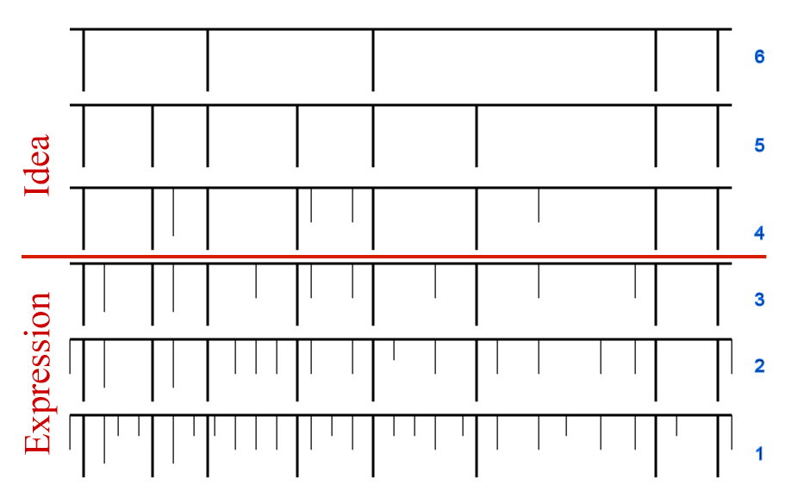
Figure 84: The Nichols "pattern" test

In the Altai case, the Second Circuit adapted the so-called pattern test, originally develop to deal with plots, to software. A software program, the court held, can be arranged into levels of abstraction just like a plot. The highest level consists of a general description of the function of the program. At the next level down are major modules or subroutines. At the next level are finer divisions among parts of modules, until one reaches at the lowest level the source code. Once the various levels of the program have been separated in this fashion, the Altai test requires the trier of fact to remove, in other words to filter out, features that do not enjoy copyright protection. With respect to software, the court ruled, there are many reasons for disqualifying features. First, the court should identify and then filter out elements of the plaintiff’s program that are necessary for the program to operate efficiently (Figure 85). For example, anything necessary to enable the program to sort and search efficiently should be removed. Next to go are features that are dictated by external factors (Figure 86). These include features necessary to meet mechanical specifications of the computer, the compatibility requirements of other programs, the design standards of the computer manufacturers, demands of the industry being served – in other words, the demands of customers – and widely accepted programming practices. Finally, and least surprisingly, it should identify and eliminate features that the original programmer had taken from the public domain (Figure 87). The net result is an abridged pattern of features, like a comb missing many teeth. The third and last step in the Altai test is comparison (Figure 88). The features of the defendant’s program are laid alongside the now filtered version of the plaintiff’s program and the two are compared. If and only if they appear substantially similar is the defendant liable.
Since 1992, most courts confronted with cases of this general sort have employed the Altai test. It’s not quite universal and the Supreme Court has never lent Altai its imprimatur, but it is surely dominant. As you might surmise, the Altai approach favors defendants. Its adoption made it significantly more difficult for software developers to recover against competitors who deployed structurally similar programs. The Altai approach has many critics. Executives in major software firms sometimes point to this decision as one of the reasons why they’ve turned increasingly to patent law to protect their innovations. And some scholars, like Dennis Karjala, point out that the relationship between the idea-expression distinction that underlies the abstraction portion of the test and the filtration portion of the test is far from clear. But for better or worse, the test seems here to stay.
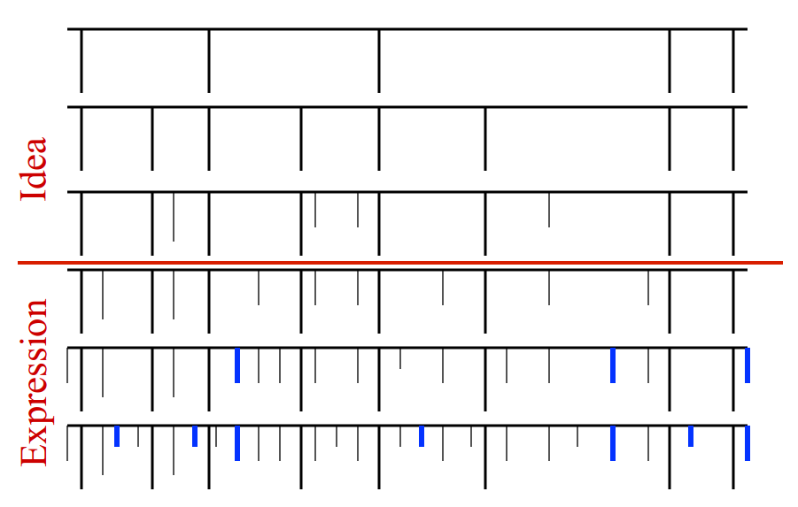
Figure 85: Pattern test for software, step 1 – remove elements dictated by efficiency
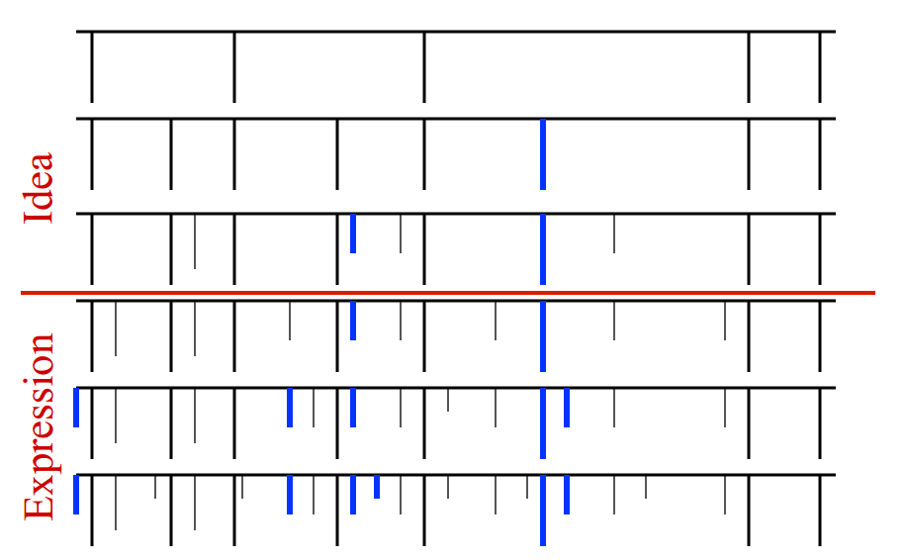
Figure 86: Pattern test for software, step 2 – remove elements dictated by external factors
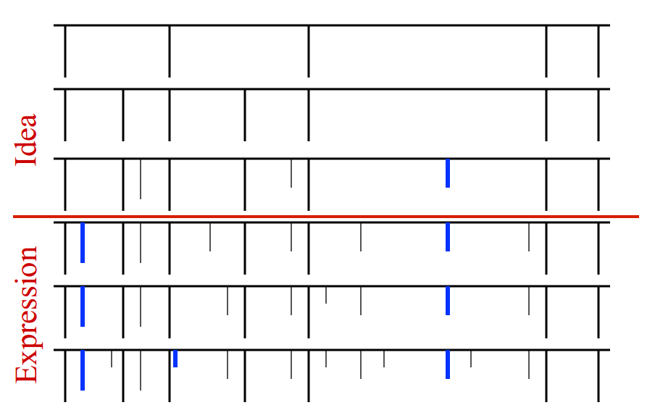
Figure 87: Pattern test for software, step 3 – remove elements taken from public domain
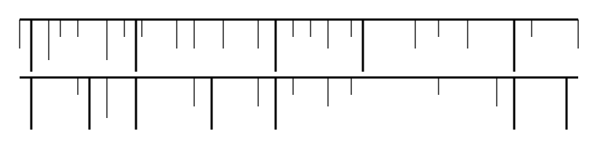
Figure 88: Pattern test for software, step 4 – compare elements of defendant’s program vs protected parts of plaintiff’s program

Now, let’s return to the main road. The fundamental problem I’ve noted is how to separate protected from unprotected material when applying the substantial similarity test. The approach most generous to copyright owners is totality analysis. The least generous approach is the abstraction filtration comparison test now applied by most US courts in the context of software. In between these two is the “more discerning observer test.” The way in which that approach works is best explained after we’ve explored the meaning of substantial similarity. So, to that troublesome concept we now turn.
The most important descriptions of the level of similarity required to trigger liability, as taken from case law
- "Same aesthetic appeal"
- Apparent appropriation
- "Total concept and feel"
- Extrinsic/intrinsic test (CA9)
The courts have had great difficulty defining exactly how much similarity between a defendant’s work and a plaintiff’s work is necessary to trigger liability. They’re agreed that it’s not a mathematical question. The percentage of overlap is not decisive. The standard is much more impressionistic than that. But the courts have trouble capturing in words the level required. Various formulations can be found in the case law. Listed below are the most important. You should not think of these formulations as distinct tests analogous to the avowedly distinct tests that are used to determine conceptual separability with respect to useful articles. Rather, they at least purport to be different ways of describing the same standard.
Often, courts say that two works are substantially similar if they have “the same aesthetic appeal.” For example, in the 2001 Boisson case, the Second Circuit said “Generally, an allegedly infringing work is considered substantially similar to a copyrighted work if the ordinary observer, unless he set out to detect the disparities, would be disposed to overlook them and regard their aesthetic appeal as the same.” In the 2005 Mannion case, the district court relied on this test to rule that a jury could find substantial similarity between a magazine photo of Kevin Garnett and a photo prepared for a billboard advertising Coors beer (shown in Figure 89).
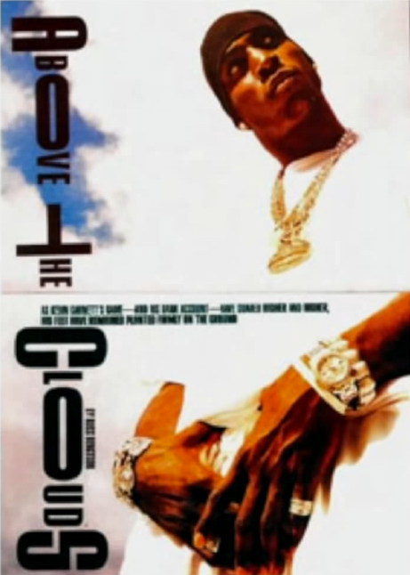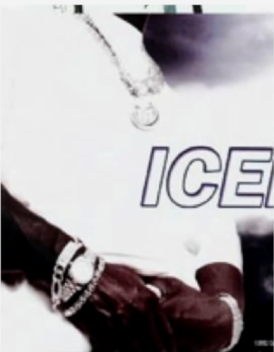
Figure 89: Comparing a magazine photo of Kevin Garnett and a photo prepared for a billboard advertising Coors beer

Another slightly different formulation – in the Ideal Toy case, the same court defined the relevant test as “whether an average lay observer would recognize the alleged copy as having been appropriated from the copyrighted work.” Applying this language, a lower court in the 1987 Steinberg case concluded that a famous cover of The New Yorker magazine, suggesting the myopia of residents of New York City, was infringed by a poster publicizing the movie Moscow on the Hudson (both shown in Figure 90).
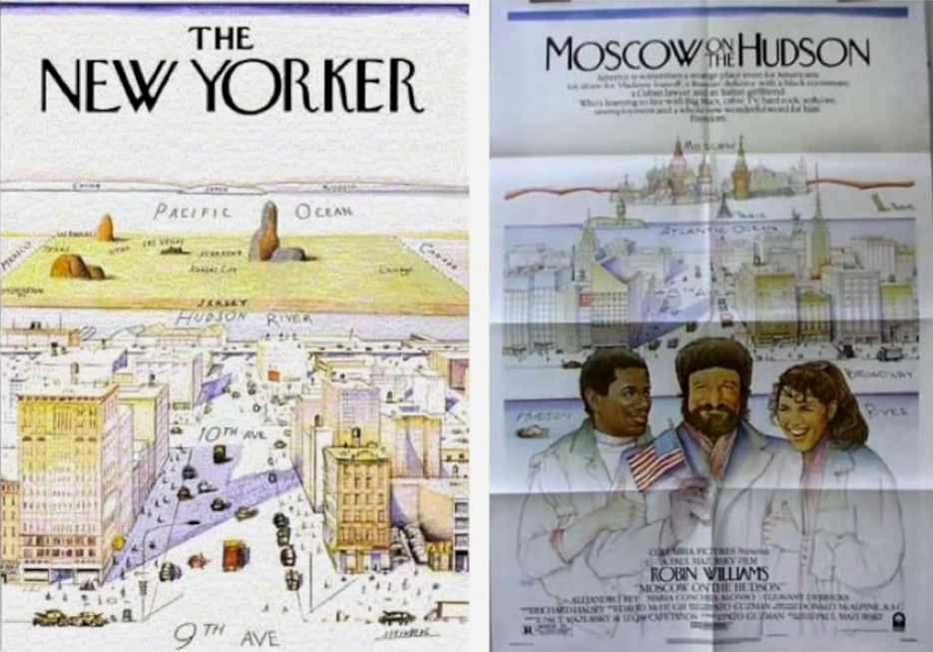
Figure 90: A cover of The New Yorker magazine compared to a poster advertising the movie Moscow on the Hudson

Yet another variation – sometimes courts contend that attention should be focused on “the overall concept and feel of the two works.” For example, in the Krofft case, the Ninth Circuit relied on that phrase in ruling that the characters, flora, fauna, and layout of an imaginary land depicted in an advertisement for McDonald’s restaurants resembled sufficiently the corresponding features of the imaginary land depicted in the Fun Stuff children’s show, sufficiently closely to give rise to liability (see Figure 91). Individual features, the court noted, were very similar. For example, “both lands are governed by mayors who have disproportionately large round heads dominated by long, wide mouths.” But the real basis of liability was the overall judgment that McDonaldland “captured the total concept and feel of the Fun Stuff show.” In a similar vein, a district court in the Kisch case concluded that a rational jury might find substantial similarity in the “underlying tone or mood,” of the two photos depicted in Figure 92. From what perspective should these judgments be made? In other words, through whose eyes should the trier of fact view the two works when determining whether they’re substantially similar? The dominant answer to that question is the average lay observer – in other words, not an expert in the field of art or literature at issue, but an ordinary lay person. That answer is subject to two qualifications, however. First, on occasion, courts will adopt the perspective of the members of the intended audience for the two works. For example, in the Krofft case, which I just mentioned, the Ninth Circuit at one point sought to assess the degree to which the Fun Stuff show and McDonaldland would have looked similar to the children at which both works were primarily aimed. For those of you familiar with trademark law, this maneuver should remind you of the ways in which courts sometimes assess the likelihood of consumer confusion that arises when two trademarks are similar.
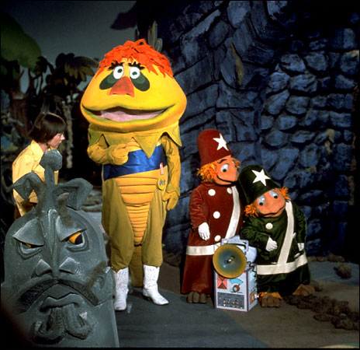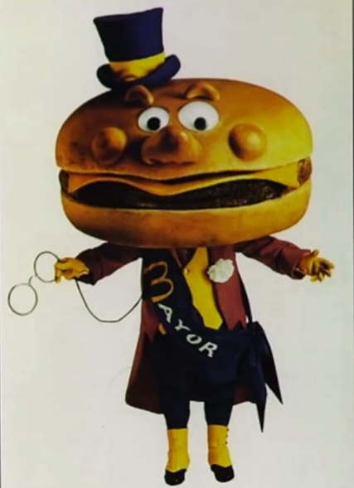
Figure 91: The mayor character in the TV show “Fun Stuff” contrasted with the mayor of McDonaldland

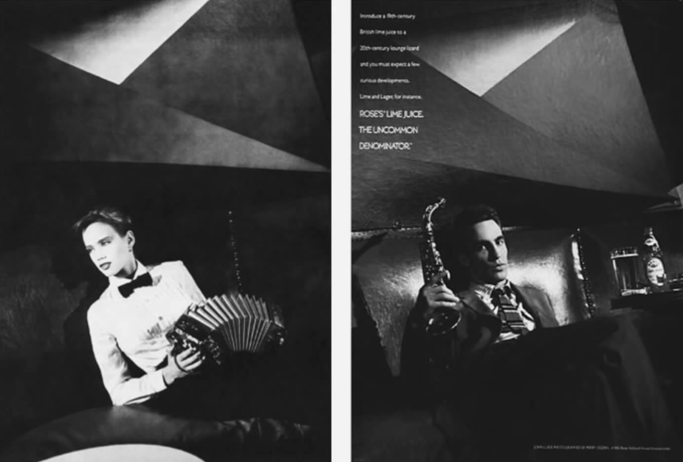
Figure 92: Comparing the photos in the Kisch case

The second qualification is that courts will occasionally adjust their glasses when the plaintiff’s work contains some unprotected material, as well as some protected material. As you’ll recall, I described the two polar positions taken by courts when dealing with such cases – the so-called totality analysis and the filtration approach exemplified by the Altai case. In between those two positions is the so-called “more discerning observer” test. The Second Circuit in the Boisson case explained this approach as follows.

In the Folio Impressions case, part of the plaintiff’s fabric was not original, and therefore not protectable. We articulated the need for an ordinary observer to be “more discerning in such circumstances.”
“[T]he ordinary observer would compare the finished product that the fabric designs were intended to grace (women’s dresses), and would be inclined to view the entire dress – consisting of protectable and unpredictable elements – as one whole. Here, since only some of the design enjoys copyright protection, the observer’s inspection must be more discerning.”
Shortly after Folio Impressions was decided, we reiterated that a “more refined analysis” is required where a plaintiff’s work is not “wholly original,” but rather incorporates elements from the public domain. In these instances, “[w]hat must be shown is substantial similarity between those elements and only those elements that provide copyrightability to the allegedly infringed compilation.” In contrast, where the plaintiff’s work contains no material imported from the public domain, the “more discerning” test is unnecessary.
In applying this test, a court is not to dissect the works at issue, and to separate components and compare only the copyrightable elements. To do so would be to take the “more discerning” test to an extreme, which would result in almost nothing being copyrightable. Because original works broken down to their composite parts would usually be little more than basic unprotectable elements, like letters, colors, and symbols. This outcome – affording no copyright protection to an original compilation of unpredictable elements – would be contrary to the Supreme Court’s holding in Feist Publications.”

OK, that’s a lot of language. And after all that, it’s still not entirely clear what the court has in mind. The bottom line seems to be when comparing the two works, don’t filter out the unprotected material as the court did with software in Altai, but instead adopt a more skeptical stance than the hypothetical ordinary observer.
As we’ve seen, the emphasis in all of these cases is on some variant of an ordinary lay observer. Does that mean that expert witnesses have no role in substantial similarity determinations? Not quite. Although the ultimate judgment must always be made from the standpoint of an ordinary observer, experts can help in framing the ultimate judgment. The Court of Appeals for the Ninth Circuit has developed the most elaborate – some scholars say, convoluted – system for combining expert and lay analysis. In the Ninth Circuit, there are now two steps to a determination of substantial similarity – an extrinsic test and an intrinsic test. With respect to the first, expert opinion is relevant, but not with respect to the second. To win, the plaintiff has to satisfy both. So what do these two terms, extrinsic and intrinsic, mean? It’s not entirely clear, in part because the Ninth Circuit’s usage has changed over time. In the Krofft case, where this approach was first deployed, the extrinsic test was defined as “similarity in ideas.” Intrinsic was defined as “similarity in expression.” This formulation, you probably noticed, is hard to reconcile with the fundamental principle that copyright law doesn’t protect ideas at all. Perhaps sensing that problem, in subsequent cases the Ninth Circuit has formulated the approach differently. For example, in the Cavalier case, extrinsic is treated as “an objective comparison of specific expressive elements,” while intrinsic is “a subjective comparison of the total concept and feel” of the two works. In the Swirsky case, the court backed up a bit, defining the issue addressed by the extrinsic test as “whether the two works share a similarity of ideas and expression as measured by external objective criteria,” while the intrinsic test again focused on total concept and feel. Even the Ninth Circuit acknowledges the clumsiness of these maneuvers. In Swirsky, for example, the judges admitted, “The extrinsic test provides an awkward framework to apply to copyrighted works like music or art objects, which lack distinct elements of idea and expression. Nevertheless, the test is our law, and we must apply it.” So too must litigants when they appear in the courts of the Ninth Circuit.
This concludes our review of the doctrine of substantial similarity. In closing, I would urge you not to put too much stock in the language the courts employ when setting forth these various formulations. At least as good a guide to the law in this area is the pattern of results reached in the cases. That’s the main reason, aside from simple entertainment, that during our tour I’ve been telling you the central facts of several of these cases and how they were resolved. This is not to say, of course, that the results in these cases are entirely consistent. They surely are not. But from them, you can distill an impression of the degree or kind of similarity that will likely get you in trouble, and the degree or kind that will not. More guidance than that may be impossible.

Derivative Works
Unauthorized modifications of copyrighted works implicate two distinct interests on the part of copyright owners. The first of those interests we considered in lecture number two. Modifications of copyrighted works can threaten the owner’s moral rights, specifically their rights for integrity. Recall in this connection von Gerkan’s “Berlin Train Station” or Snow’s “Canadian Geese.” When those works were modified, the authors experienced pain and anger, and sued successfully to stop the modifications. The legal rules underlying their lawsuits, we’ve already discussed. The second of the interests is economic, rather than moral and character. Making or licensing modifications of their works is one of the ways that copyright owners earn money. If they could not prevent unauthorized modifications, they would earn less. The economic rights related to modifications will be the focus of this last segment of today’s lecture. To many copyright owners, this source of revenue is very important.
Here’s an example. J. K. Rowling, the author of the Harry Potter series of stories, of course earns royalties when her books are reproduced and sold. But she also collects license fees from people who translate her books into other languages, and more importantly, in studios that wish to make motion picture adaptations of her stories. The studios, in turn, not only earn money by distributing copies of the films through the myriad channels I described in lecture number three, but also when subtitled versions are released, and when various paraphernalia based upon the stories is manufactured and sold – dolls, glasses, Quidditch pads, and so forth. The expectation of those ancillary revenue streams increases the license fees the studios are able and willing to pay to Rowling. These and other sources of income growing out of the novels made Rowling, at least at one point, a billionaire. Rowling’s capacity to control these various offshoots of her novels finds apparent support in Section 106(2) of the Copyright Statute. That section provides that a copyright owner has the exclusive right “to prepare derivative works based upon the copyrighted work.” So, what’s a derivative work? Section 101 tells us “A derivative work is a work based upon one or more preexisting works, such as a translation, musical arrangement, dramatization, fictionalization, motion picture version, sound recording, art reproduction, abridgment, condensation, or any other form in which a work may be recast, transformed, or adapted.”
In view of the growing importance of the revenue streams associated with such adaptations, you might expect that there would be a great deal of case law interpreting and applying Section 106(2). Interestingly, there’s not. The main reason is that the reproduction right – which, as we’ve seen, is shielded by Section 106(1) – is now construed so broadly that it encompasses almost all of the territory that you would expect to be covered by 106(2). Indeed, the scope of 106(2) is most often defined by 106(1). If a defendant’s work does not incorporate enough of the plaintiff’s work to violate the rules that we considered in the previous segment of this lecture, it does not constitute a derivative work and, thus, does not violate 106(2).
A good illustration of the way in which the derivative work right is now overshadowed by the reproduction right can be found in the case of Castle Rock Entertainment versus Carol Publishing. The plaintiff owned the copyright in the well-known Seinfeld television series. The defendant prepared what it called a “trivia book,” which posed questions of varying levels of difficulty concerning what happened in the television show. For example, one question asked readers to match the names on the left with the characteristics listed on the right. When the defendant first released the trivia book, the Seinfeld copyright owners appeared to have been amused, rather than angry. Indeed, NBC, which broadcast the show, initially asked the defendants for free copies of the book, which it then distributed with promotions of the show. Note how sharply this casual response contrasts with the anger expressed by von Gerkan and Snow when their works were adapted. In any event, it eventually occurred to the copyright owners in Seinfeld that the trivia book encroached on their rights. They brought a copyright infringement suit and prevailed. It’s not at all obvious that the plaintiff should have won. Is it really the case that the creator of a work of fiction can prevent others from writing a separate work that asked questions concerning the plot? If a high school English teacher assigns a novel and then creates a multiple-choice quiz that requires students to answer questions concerning what happened in the book, is she engaged in copyright infringement? What if she sells compilations of her quizzes to other teachers? I leave that to you. For the moment, we’re concerned only with the statutory basis of the court’s ruling. At the very beginning of the Court of Appeal’s analysis in the Castle Rock case, it seems that the key issue will be whether the trivia book constitutes a “derivative work,” an adaptation that will bring it within the statutory definition of derivative work. So, the first sentence of the pertinent section in the court’s opinion is “The Copyright Act of 1976 grants copyright owners a bundle of exclusive rights, including the rights to reproduce the copyrighted work in copies and to prepare derivative works based upon a copyrighted work.” But in the second sentence of the opinion, the court shifts to the now familiar language of reproduction. “Copyright infringement is established when the owner of a valid copyright demonstrates unauthorized copying.” Section 106(2) then plays no further role in the court’s opinion.
In this respect, the Castle Rock opinion is typical. Rarely does a copyright owner’s right under Section 106(2) – to control derivative works – give him power greater than he already enjoys under 106(1). But every once in a while, the difference between the two provisions matters. First, a defendant will sometimes purchase an authorized copy of a copyrighted work and then physically alter it or integrate it with another work. In such a case, the defendant has not violated 106(1) because he’s not made a copy; he’s bought one. Thus, he can be liable, if at all, only for preparing a derivative work. Two cases of this sort involving very similar facts are notorious. In each one, the defendant purchased books containing copies of the plaintiff’s copyrighted artwork, cut out individual images from those books, glued the pictures onto tiles, and then sold the tiles. In one of the cases, the Ninth Circuit concluded that section 106(2) had been violated. “By borrowing and mounting the pre-existing copyrighted individual art images without the consent of the copyright proprietors, appellant has prepared a derivative work and infringed the subject copyrights.” In the other case, the Seventh Circuit, dismayed by the implications of the Ninth Circuit’s ruling concerning the status of many common and innocuous habits, like marking up copies of case books, took the opposite position. As you might expect, such disputes don’t arise often.
The second context in which 106(1) and 106(2) might diverge concerns the requirement of fixation. As we discussed in the previous section of this lecture, to establish a violation of the right of reproduction the plaintiff must show, among other things, the defendant made a copy of the plaintiff’s work. And that, in turn, requires that the thing the defendant produced be fixed for more than a transitory duration. Notice that the language of 106(2) is different. It makes no mention of copies or phonorecords. Instead, it refers to “preparing” derivative works. That seems to leave open the possibility that 106(2) could be violated without making anything firm. One passage in the pertinent legislative history lends support to that possibility. The House of Representatives report that companies the 1976 statutory reform contained this sentence. “Preparation of a derivative work, such as a ballet, pantomime, or improvised performance, may be an infringement even though nothing is ever fixed in tangible form.” Despite the apparent clarity of this statement, the courts have been very reluctant to accept violations of 106(2) in the absence of some kind of fixation. For example, the Ninth Circuit has ruled that “To narrow the statute to a manageable level, we have developed certain criteria the work must satisfy in order to qualify as a derivative work, one of which is that it must exist in a concrete or permanent form.”
Finally, a few odd statutory provisions treat parties who make derivative works more favorably than those who merely make copies. One such provision is Section 104A(d)(3), which governed the rights and obligations of a person who has prepared a derivative work based upon an underlying work that used to be in the public domain in the United States because of a failure to comply with US formalities, but has now been restored to copyright protection because of the TRIPS Agreement. The statute permits such a person to keep on exploiting his derivative work, provided that he pays the owner of the restored copyright a reasonable compensation. To avail himself of this option, he must show that his product is a derivative work, not just a copy of the original. How much must he have changed the original work to qualify? In the judgment of the Third Circuit, not much. Changes that embody “some minimal degree of creativity” suffice.
One last aspect of Section 106(2) merits reiteration. What happens when you prepare a derivative work without permission? Well, you expose yourself to the various remedies for copyright infringement that we’ll consider in detail in the last lecture in this series. But something else happens that’s perhaps less obvious. You forfeit whatever copyrights you might otherwise have enjoyed in your derivative work. The relevant statutory provision is Section 103(a), which provides the subject matter of copyright, as specified by Section 102, includes compilations and derivative works, but protection for a work employing pre-existing material in which copyright subsists does not extend to any part of the work in which such material has been used unlawfully.
A nuance lurks in this language. Some courts have held that a person who, without permission, makes a derivative work forfeits protection only in the portion of the derivative work that is “pervaded” by the underlying work. In other words, you may still claim a copyright in a portion of the derivative work that is entirely untainted. Putting that nuance to one side, the main point is that, in this context, an infringer doesn’t get copyright protection, even for his own creative material.
In lecture three, I discussed this principle briefly in connection with the Sylvester Stallone Rocky case. Here’s another, even more odd illustration. At one point in his career, the artist sometimes known as Prince adopted as his name the image shown in Figure 93. During this period, a guitar maker and Prince fan by the name of Ferdinand Pickett made a guitar that incorporated most of this shape and allegedly showed the guitar to Prince. Pickett apparently hoped that Prince would buy the guitar, and thus enhance Pickett’s reputation. Prince did not do so, but instead commissioned another guitar maker to fabricate guitars incorporating his symbol and played them in concerts. Enraged, Pickett brought a pro se copyright infringement suit against Prince. Pickett acknowledged that Prince held a valid copyright in the image he had selected as his name, and that Pickett’s guitar was a derivative work based upon that copyrighted image. Nevertheless, he contended that Prince could not make a copy of Pickett’s guitar without Pickett’s permission. Seven years later, the Court of Appeals for the Seventh Circuit finally resolved the dispute in Prince’s favor. Judge Posner, writing for the court, expressed doubt that Pickett’s guitar embodied sufficient originality to warrant a copyright in the first place. But in any event, Posner ruled, its status as an unauthorized derivative work meant that Pickett had no copyright protection for it. Thus, even if Prince had seen and copied Pickett’s guitar, he would not be liable. The trial judge’s comment on the case seems apt. “Defendant may as well have had in mind this protracted litigation when he asked, ‘Why do we scream at each other? This is what it sounds like when doves cry.’” As Mark Lemley has observed, patent law works quite differently. A person who, without permission, makes an improvement on a patented invention may obtain a patent for his improvement. This creates a situation of so-called blocking patents. Neither the holder of the patent on the original invention nor the holder of the patent on the improvement may practice the improvement without the permission of the other. So, is the net result that the improvement never gets manufactured and used? Sometimes. But what usually occurs is that the two parties negotiate a deal by which they divide in some way the benefits of the now improved invention. In Lemley’s view, this setup creates a more efficient pattern of incentives for both primary and secondary innovators than the copyright system. You might ask yourself, what would have happened in the Stallone and Prince cases if a system of blocking copyrights, analogous to the system of blocking patents, had been in place?

Figure 93: Prince’s “Love Symbol #2”

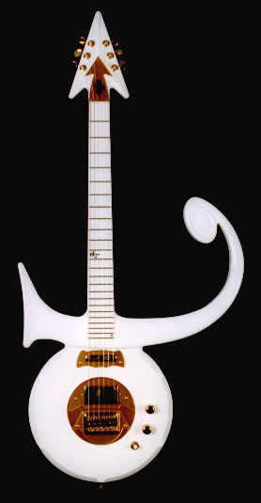
Figure 94: Pickett's guitar design
This concludes our analysis of the rights of reproduction and modification.

Distribution & Performance Rights

Distribution
In the preceding lecture, I examined two of the four major economic rights associated with a copyright, specifically the right to control reproduction and the right to control modifications of a copyrighted work. In this lecture, I’ll examine the other two major economic rights – the right to control distribution, and the right to control public performances and displays. As usual, I’ll spend most of the time discussing the law in the United States, but will also indicate various issues on which the law in other countries differs.
We’ll begin with the right of distribution. This aspect of copyright law is characterized by a clash between two powerful sets of impulses. On one side are strong economic interests of copyright owners. On the other side is an equally powerful set of attitudes, hostile to the copyright owners’ yearning for continuing control over embodiments of their works. The tension between these forces has generated and will continue to generate strife and periodic doctrinal eruptions. The interests of the copyright owners are strong for three reasons. They want to be able to control what purchasers and possessor of copies of their works do with those copies.
The first, and least important, of those reasons is that such control supplements the copyright owner’s right of reproduction. Specifically, by enabling the owners to attack intermediaries who do not themselves make unauthorized copies, but who traffic in unauthorized copies. In this sense, the distribution right is analogous to the rules in criminal law penalizing the receipt of stolen property. The second, and more important reason is that copyright owners would like to suppress, if possible, resales and lending of copies of their works. In other words, they would like to prevent the first purchaser of a copy from passing it on to others. Why? Because the result would be to increase demand for copies, and thus to enhance the copyright owner’s income. For example, novelists would like to be able to prevent sales of used copies of their books. Movie studios would like to prevent, or to charge for resales or rentals of DVDs embodying their works, and so forth. Third, copyright owners would like to prevent arbitrage, which corrodes their ability to engage in lucrative, differential pricing. This last point is both complicated and important. I touched on it very briefly at the end of lecture number four. I now want to discuss it in more detail. The following analysis consists of a condensed version of an argument deployed in much more fine grain in an article I wrote some years ago on this topic. If you’re curious about this phenomenon, you might wish to follow the links on my home page.

Figure 95: Pricing on the American Airlines website for a flight 143 on 1 June 2014


Figure 96: Seating configuration of the Boeing 757-200 aircraft

Differential pricing, otherwise known as price discrimination, consists in the core case of charging different consumers different prices for access to the same good or service. A subtler form of differential pricing involves charging different consumers different prices for different versions of the same good or service when the variation cannot be explained by differences in the costs of the versions. A familiar example of the core case of differential pricing is when a bus company or museum charges lower entrance fees to students or senior citizens than it does to middle aged, non-students. A familiar example of the subtler form is the practice of airlines to charge vastly more for a business class seat than for a coach class seat for a given trip. Suppose, for example, that I want to fly from Boston to Los Angeles in the afternoon of June 1, 2014, roughly three months from right now. I prefer American Airlines, so I visit the website of the company, and check for available flights and prices. Flight 143, which departs at 4:30 in the afternoon, suits my schedule well. I now have to choose a class. As you can see in Figure 95, there are various options. But the major choice involves where in the plane I will sit. Flight 143 uses the Boeing 757-200 aircraft, which is configured as shown in Figure 96. So, if I want to sit in what’s known as the main cabin, I will pay $400 or $500. If I want to sit up front, in first class, I’ll pay more than three times as much. The difference between these prices cannot be explained on the basis of the extra costs associated with a wide seat, better food, and more attentive service. Rather, it reflects primarily the airline’s shrewd effort to capitalize on differences in the price sensitivity of the two types of passengers. If I’m wealthy, or I’m able to rely on the generous business expense account, I’ll choose first class. If neither, I’ll choose the main cabin.
Price discrimination usually increases the profits of the firm that engages in it. Why, then, is it relatively uncommon? Because, with rare exceptions, the practice of price discrimination is feasible only when three conditions coincide. First, the firm ordinarily must have market power. In other words, there must exist no readily available, equally satisfactory substitutes for the good or service the firm is selling. Otherwise, customers from whom the firm seeks to extract a high price, will defect to competitors. Next, the firm must be able to differentiate among its customers on the basis of the values they place on the firm’s product or service. There are several ways in which this could be achieved. In what economists refer to as first degree price discrimination, the firm gathers information about individual buyers, and attempts to charge each one the most that he or she is able and willing to pay for the good or service in question. In so-called second degree price discrimination, the seller does not know how much buyers are able willing to pay, but induces them to reveal their resources or their preferences through their purchasing decisions. Among the techniques of this sort are volume discounts and versioning, such as the practice I mentioned a minute ago, of differentiating business class and coach tickets, and then charging radically different prices for them. In so-called third degree price discrimination, the seller does not know the purchasing power of individual buyers, but is able to separate them into groups that correspond roughly to their wealth or eagerness. The student discounts and senior discounts I mentioned previously are examples.
Opportunities to engage in first degree price discrimination have traditionally been rare, but opportunities for second and third degree discrimination abound. One area in which they’re proliferating especially rapidly are the kinds of the informational products to which copyright law applies. Take software, for example. One of the ways in which software firms seek to enhance their revenues is by selling identical or versioned copies of their products to students for vastly different prices than the prices they charge professionals. Here’s an illustration. As of today, February 23, 2014, Adobe’s Creative Suite 6 is ordinarily priced at $1,700, but is available to students and teachers – groups that tend to be poorer than average – for $590, a huge markdown. As I hope you recognize, this is an example of third degree price discrimination in which the copyright owner uses a criterion to separate set of potential customers for its product into two or more subgroups, which differ roughly in their price sensitivity, and then charges the members of the two groups very different prices. An example of second degree price discrimination is the way in which book publishers typically package and release their products. In the usual case, a hardcover edition is sold at a substantial price. And then a few months later, or a few years later, a much cheaper paperback version is released. For example, right now I’m reading Scott Turow’s novel “Identical”, the newest in a series of excellent legal thrillers. I bought a hard cover copy of this book about a month ago from Amazon.com for $28. I could have obtained from Amazon a paperback copy for a much lower price, but I would have had to wait until July of this year to get it. The cost of manufacturing a hardcover copy of a book is not double the cost of manufacturing a paperback copy. Rather, the sharp price difference is a form of differential pricing. More specifically, this common marketing practice, used by book publishers, combines two distinct price discrimination schemes. The first is known as versioning. Just as was the case with respect to business class versus coach airline tickets, publishers expect price insensitive consumers, like me, to buy the premium – in other words, hardcover editions – and poorer consumers to prefer the economy model. The second strategy is sometimes known as intertemporal price discrimination. The reason the publishers do not ordinarily release the paperback editions at the same time as the hardback editions is that they don’t want buyers who care little about price but find paperbacks perfectly acceptable to opt for paperbacks, so they wait until the market consisting of wealthy consumers has been pretty well exhausted through sales of hardbacks before putting the cheaper versions on the shelves.
The same composite strategy underlies the so-called windowing system through which most Hollywood movies, at least until recently, were marketed (see Figure 97). Typically, a firm was first licensed for performances in American movie theaters. Roughly three months later, it was released both in foreign theaters and through pay per view channels. Three months after that, DVD copies were made available for sale and rental. After three more months, it was released to premium cable television channels. A year later, it was shown on television in countries outside the United States, and then on network television inside the United States. And finally, after another three years, it was licensed to local television syndicators. The price per viewing paid by consumers in each of these windows was lower than in the preceding window. Again, we see here a combination of versioning, which prompts consumers to sort themselves by format, and intertemporal discrimination, whereby the most price sensitive consumers have to wait the longest.
There are many more examples of price discrimination by copyright owners, some of which we’ll encounter later in the course, but there remains one more condition essential to the strategy. To engage in effective price discrimination, the copyright owner must be able to prevent, or at least to limit, arbitrage. In other words, it must be able to stop customers to whom it sells copies of its work a low price from reselling them, either directly or with the aid of intermediaries, to customers from the firm is seeking to extract a high price. If it can’t do so, then the copyright owner forfeits its high margin customers, which is disastrous. This is where the right to control distribution comes into play. What copyright owners would most like would be a legal right to prevent altogether any resales of copies of their works. Not just for the reason we’ve already seen – namely, that such a right would increase demand for their products – but also for the subtler reason that it would enhance their capacity to charge different customers different prices without worrying that poor customers who bought the copies for low prices would resell them to rich customers for intermediate prices, and thus corrode the high-end market.
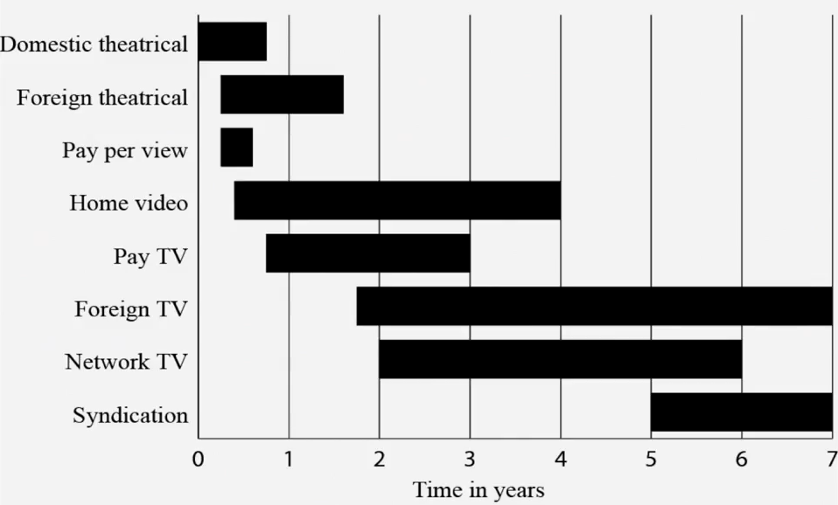
Figure 97: Market windows for major films from release date, circa 1990

To summarize, for three reasons, copyright owners would like strong rights to control distribution of copies of their works. First, it would help them to attack intermediaries who traffic in unauthorized copies. Second, it would enhance demand for copies of their works. And third, it would enhance their ability to engage in differential pricing.
Opposed to these interests are not only the obvious economic interest of consumers, in reducing the amount they have to pay for access to copyrighted works, but also three widely shared attitudes hostile to the kind of control the copyright owners seek. First, copyright owners who seek to prevent resales or lending of copies of their works are often seen as greedy. They’ve already been paid once when a copy of their works was first sold. They’re not morally entitled to more. This sentiment is loosely tied to the principle of proportionality that figures so prominently, as we saw in lecture number two, in the fairness theory of copyright. Copyright owners, it is widely thought, do not deserve to collect more revenue than they receive from the first sale of copies. Exactly why not is unclear, but this attitude is very common. Second, many people – and many lawyers in particular – are skeptical of attempts to control a thing after you’ve sold it. Viewing the same issue from the other side, a widely-shared attitude is that once you have bought an object, you are entitled to do with it whatever you want. Among the manifestations of this sentiment in the law is the bias against restraints on alienation of real property – in other words, land – and the impediments I mentioned once before to servitudes, longstanding restrictions on what people who buy land can do on or with it. The same sentiment figures in the debate over the Monsanto case, which was decided last year by the United States Supreme Court, which concerned the right of a purchaser of seeds that contain genes subject to patent protection to grow crops from that seed, save some of the seeds produced by those crops, and then use the saved seed to grow more crops. The Monsanto case involved patent and contract law, not copyright law, so the complex legal issues at issue in that case are not pertinent to our subject here, but one of the general sentiments expressed often in the public debate over that case is that the farmer, Vernon Bowman, having bought the seed, should be able to do what he wants with it. The same sentiment tilts against the interests of copyright owners to control redistribution of copies of their works.
The third attitude is skepticism concerning differential pricing. Now, this attitude is not universal. Some forms of differential pricing – for example, the practice of US private universities of charging students very different tuition fees depending on the financial resources of their families – are accepted without much grumpiness. But other forms, even trivial in amount, can provoke rage. Here’s just one example. In the fall of 2000, Amazon.com began to adjust the prices of a few DVDs, depending on the status of the purchasers. It seems – although most Amazon representatives denied this – that repeat customers, identifiable by the Amazon cookies on their computers, were quoted higher prices for films than were new customers. Presumably, Amazon thought the new customers might shop around, and so offered them lower prices to induce them to buy. When this practice was revealed on an online DVD talk forum, the response of most participants was fury. “I will never buy another thing from those guys,” declared one consumer. Surveys confirm the prevalence of the sentiment that underlies this reaction. For, example in 2005, the Annenberg Center asked 1,500 adult internet users some questions concerning their views of online marketing practices. 87% disagreed with the proposition that “It’s OK if an online store I use charges different people different prices for the same products during the same hour.”
The way this attitude bears on our subject today is that, to the extent copyright owners seek increased control over the distribution of their works in order to more effectively engage in differential pricing, they face strong – though not universal – popular resistance. The tension between these competing forces is managed to some degree by a set of interlocking statutory provisions, to which we’ll now turn.
17 USC § 106(3)
Subject to sections 107 through 122, the owner of copyright under this title has the exclusive rights to do and to authorize any of the following:
…
(3) to distribute copies or phonorecords of the copyrighted work to the public by sale or other transfer of ownership, or by rental, lease, or lending
17 USC § 602(a)
Importation into the United States or exportation from the United States, without the authority of the owner of copyright under this title, of copies or phonorecords of a work that have been acquired outside the United States is an infringement of the exclusive right to distribute copies or phonorecords under section 106 actionable under section 501.
This subsection does not apply to —
(1) importation of copies or phonorecords under the authority or for the use of the Government of the United States or of any State or political subdivision of a State, but not including copies or phonorecords for use in schools, or copies of any audiovisual work imported for purposes other than archival use;
(2) importation, for the private use of the importer and not for distribution, by any person with respect to no more than one copy or phonorecord of any one work at any one time, or by any person arriving from outside the United States with respect to copies or phonorecords forming part of such person’s personal baggage; or
(3) importation by or for an organization operated for scholarly, educational, or religious purposes and not for private gain, with respect to no more than one copy of an audiovisual work solely for its archival purposes, and no more than five copies or phonorecords of any other work for its library lending or archival purposes, unless the importation of such copies or phonorecords is part of an activity consisting of systematic reproduction or distribution, engaged in by such organization in violation of the provisions of section 108(g)(2)
17 USC § 109
(a) Notwithstanding the provisions of section 106(3), the owner of a particular copy or phonorecord lawfully made under this title, or any person authorized by such owner, is entitled, without the authority of the copyright owner, to sell or otherwise dispose of the possession of that copy or phonorecord.
(b)(1)(A) Notwithstanding the provisions of subsection (a), unless authorized by the owners of copyright in the sound recording or the owner of copyright in a computer program (including any tape, disk, or other medium embodying such program), and in the case of a sound recording in the musical works embodied therein, neither the owner of a particular phonorecord nor any person in possession of a particular copy of a computer program (including any tape, disk, or other medium embodying such program), may, for the purposes of direct or indirect commercial advantage, dispose of, or authorize the disposal of, the possession of that phonorecord or computer program (including any tape, disk, or other medium embodying such program) by rental, lease, or lending, or by any other act or practice in the nature of rental, lease, or lending.
(b)(1)(B) This subsection does not apply to —
(i) a computer program which is embodied in a machine or product and which cannot be copied during the ordinary operation or use of the machine or product; or
(ii) a computer program embodied in or used in conjunction with a limited purpose computer that is designed for playing video games and may be designed for other purposes.
(b)(1)(C) Nothing in this subsection affects any provision of chapter 9 of this title.
17 USC § 101
“Publication” is the distribution of copies or phonorecords of a work to the public by sale or other transfer of ownership, or by rental, lease, or lending. The offering to distribute copies or phonorecords to a group of persons for purposes of further distribution, public performance, or public display, constitutes publication. A public performance or display of a work does not of itself constitute publication.

The financial interests of copyright owners are protected by Section 106(3) and 602(a) of the US Statute. The first of these, as you can see, gives copyright owners the exclusive right “to distribute copies or phonorecords of the copyrighted work to the public by sale or other transfer of ownership, or by rental, lease, or lending.” 602(a) gives copyright owners analogous rights to control importation and exportation of copies of their works. Now, if these are the only relevant statutory provisions, they would reflect total victory by the copyright owners, but each of these provisions is qualified by others. The right granted by 106(3) is curtailed quite sharply by 109(a), which, as you can see provides that “the owner of a particular copy or phonorecord lawfully made under this title, or any other person authorized by such owner, is entitled to sell or otherwise dispose of the possession of that copy or phonorecord.” This provision is widely known as the first sale doctrine. The basic idea underlying this doctrine is that once a copyright owner has sold a copy, he cannot control resales, gifts, et cetera. We’ll return to the precise meaning of this provision in a minute. The right to prevent unauthorized importation of copies is also qualified in various ways. Three specific exceptions are listed under 602(a). In addition, the way in which 602(a) is phrased leaves open the possibility that it is qualified, not just by these specific exemptions, but also by the much broader first sale doctrine embodied in 109(a). How might this work? Well, you’ll notice that 602(a) refers to unauthorized importation as “an infringement of the exclusive right to distribute copies under Section 106.” Section 106, in turn, makes all the rights it grants to copyright owners “subject to sections 107 through 122.” Included in that list is 109(a), which we’ve already seen. Through this chain of connections, it’s possible that the first sale doctrine qualifies the importation right, as well as the right to control domestic distribution of copies of the work. We’ll return to this textual nuance shortly.
The first sale doctrine embodied in section 109(a) is itself subject to exceptions. Specifically, to the provisions of 109(b)(1)(a). The key language is “neither the owner of a particular phonorecord, nor any person in possession of a particular copy of a computer program, may, for the purposes of a direct or indirect commercial advantage, dispose of that phonorecord or computer program by rental, lease, or lending.” The primary purpose of this provision was to shut down stores that, at the time of its adoption, were renting audio CDs to customers who would then copy the sound recordings on those CDs to the hard drives of their computers, return the CDs to the stores, and thereby avoid the cost of buying CDs of their own. As you can see, this exception is subject to exceptions of its own. So graphically, the relationship among these various provisions might be represented as shown in Figure 98 – 106(3) and the primary portion of 602(a) advance the interests of copyright owners. 109(a) and 602(a) (1–3) establish limits on those rights, giving expression to the sentiments opposed to the copyright owner’s interests. 109(b)(1)(a) reinstates a portion of 106(3), with respect to some categories of works. 109(b)(1)(b) tempers that reinstatement. As I hope you can see from the diagram, this combination of statutory provisions seeks to manage the deep tension between the competing forces that shape this field of the law, but the statute is not precise enough to resolve all issues. The result is that there’s lots of litigation along this fault line. I’ll describe two sets of cases of this sort. Others will likely come up in the discussions that accompany this lecture.
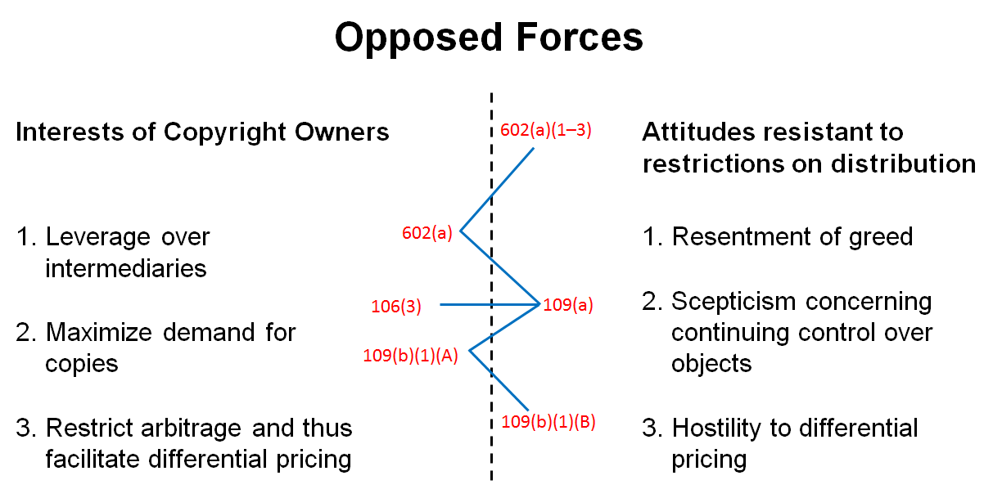
Figure 98: The relationship between provisions of sections 602, 106 and 109
The reason why the relationship between 109(a) and 602(a) is so important is that it determines the power of copyright owners to engage in international geographic price discrimination. In other words, to sell copies of their works at high prices to customers in the United States, and at lower prices to customers in poorer countries. In lecture number three, I mentioned one among the many companies that engage in this practice – Omega. Here’s a brief reminder. Omega has obtained a US copyright on the design shown in Figure 23. Omega engraves a version of this logo on the underside of its watches. Omega sells those watches all over the world. Typically, it sells them for lower prices in poor countries than in the United States. Some years ago, Costco, a discount retailer using an intermediary, purchased some of the watches that Omega had sold cheaply outside the United States, imported them into the United States, and then began selling them in its US stores for prices lower than those used by Omega’s authorized US dealers. Omega brought suit against Costco, contending that the so-called parallel importation violated Omega’s copyright in the logo. Now Costco had a seemingly strong defense. In an earlier case, called Quality King vs Lanza, the United States Supreme Court held that 109(a) did indeed limit the reach of 602(a), with the result that a copyright owner could not block importation of copies that he or it had sold outside the United States. However, Quality King involved so-called round trip parallel importation. In other words, a situation in which the copies of the work in question were lawfully manufactured in the United States, shipped overseas, sold at low prices there, bought overseas by an arbitrageur, and then imported by the arbitrageur back into the United States, where they were sold for prices lower than those charged by authorized US dealers. Omega, relying on a concurring opinion by Justice Ginsburg in the Quality King case, pointed out that its situation was different. The watches that bore its copyrighted logo, and thus the copies of the logos themselves, were not first made in the United States. They were manufactured in Switzerland. As a result, Omega argued, 109(a) did not bar its claim against Costco because 109(a) only applies, as you can see, to copies “lawfully made under this title.” The phrase, “this title,” refers to title 17 of the US Code, namely, the US Copyright statute. Omega argued that, because the watches were not made in the US, they were not made under the US statute, and thus the provision did not apply. And thus, Omega had a right, under 602, to block unauthorized importation of the watches bearing the logo into the United States. It’s a clever argument, and it worked. The Court of Appeals for the 9th Circuit agreed with Omega, ruling that the first sale doctrine applies to copies manufactured outside the United States only if an authorized first sale occurs within the United States. Costco asked the Supreme Court to review the case, which it did, but the Supreme Court was unable to resolve the question. Four justices sided with Costco, four with Omega, and Justice Kagan recused herself. The result is that the lower court’s ruling stood. In other words, Omega won. But the main issue had not been definitively resolved.
Last year, in the Kirtsaeng case, the Supreme Court was provided a second opportunity to address this issue. The essential facts of that case were straightforward. Supap Kirtsaeng was born in Thailand, but educated in the United States. In 2007, he was studying for a Ph.D. In mathematics at UCLA. Like many students, he had discovered that copies of the English language textbooks could be purchased more cheaply abroad than in the United States. Kirtsaeng decided to capitalize on this fact in order to finance his graduate education. He asked his relatives in Thailand to buy large quantities of textbooks of various sorts, and ship them to him in California. He then resold the books to US students for prices below the rates that the publishers were charging in the United States – well above the prices in Thailand. He was thus able to repay his relatives and keep a substantial amount of money for himself. This system enabled him, in short order, to earn roughly a million dollars. Enough to finance his graduate education and then some. At this point, you’re probably wondering, wasn’t Kirtsaeng aware of the legal risk he was running? After all, the copies of the books he was importing bore clear warnings that his conduct was unlawful, like the warning shown Figure 99. He might have thought that he, like many students, could avoid the wrath of the publishers if he operated on a small scale. But did he think that he could sell a million dollars of books with impunity? Apparently, yes. In making that judgment, he relied on advice from his relatives in Thailand, and upon the website Google Answers, which assured him that he could legally resell the foreign additions in the United States. In the short term, Kirtsaeng’s reliance on that advice proved foolish. One of the publishers, John Wiley, brought suit against him, contending that unauthorized importation of the books constituted copyright infringement. Because all of the books in question had been manufactured and first sold by Wiley’s wholly owned subsidiary outside the United States, Wiley could and did point to the Omega decision for support. Wiley prevailed in the trial court, and then the Second Circuit Court of Appeals. Kirtsaeng asked the Supreme Court to review the case, which agreed. The stakes were very high. Not just book publishers, but the sellers and buyers of all copyrighted materials distributed at different prices in different countries would be affected by the outcome. As one might imagine, the Supreme Court was deluged with briefs from organization with stakes in one result or another. This legal battle was paralleled by a struggle for dominance in the so-called court of public opinion. Here’s one Foray into that war, sponsored by the groups supporting Kirtsaeng.
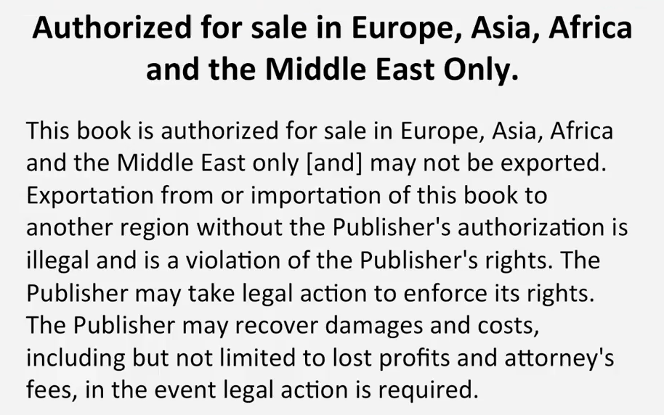
Figure 99: An example of the import restriction text on a textbook

[Video by the Owners’ Rights Initiative]
The Owners’ Rights Initiative hit the streets to see what you think of the Wiley v. Kirtsaeng case.
Mark, Maryland: I think that once you’ve bought an item, you should be able to do with it what you want. If you want to resell it, that should be up to you.
John, New York: Because I paid money for it, and gosh dang it, I should be able to do whatever I want with it.
Toby, United Kingdom: I don’t own anything, I’m just borrowing things from a company for a long time, which seems to be outrageous.
Jack, New York: How can they tell you that you don’t own what you buy? You used your own money to buy that.
Mike, Kentucky: I think that would be totally unfair, and against capitalism.
Carolyn & Dan, Indiana: I would say it would be important to everybody, because that’s just the way of America. We buy, we sell, we trade.
Toby, United Kingdom: Country boundaries aren’t what they once were. So, of course, you should be able to buy and sell things, regardless of where you get them from.
Eric, Washington D.C.: Of course, of course. Because most of the things I’ve got on now are made from someplace else.
Lawrence & Montay, Washington D.C.: I’d be very highly upset and pissed off due to the simple fact that they’re trying to tell me what to do with an item.
Alan, Washington D.C.: It’ll affect everybody. Anybody that has a power to purchase now will be impacted by this.
Doug, California: For one thing, in college books, it would be a killer. It’s already so expensive to go to college that you should be able to use whatever textbooks we want, wherever we got them, without having the threat of the government telling us that that’s not appropriate to use.
Keenan, California: It really hurts the consumers. I’m really concerned about the consumers because I’ m a consumer.
Toby, United Kingdom: That seems to add a whole new level of administration that’s going to cost millions and millions of dollars. And that’s just – all that money going into having to ask someone if you wants to sell your own things? That seems silly.
Tanisha, Washington D.C.: Just thinking of kind of the gravity of what that would mean. It would piss me off a little bit.
Kim & Mia, Virginia: If I want to buy it, I’ll buy it. If I want to sell it, I’ll sell it. It’s my right.
For more information visit www.ownersrightsinitiative.org

Perhaps moved in part by sentiments like these, the Supreme Court, in the Kirtsaeng case – somewhat to my surprise – reversed the ruling of the lower court, holding that one way parallel importation, like round trip parallel importation, is privileged by section 109. The heart of the court’s rationale was that the statutory phrase “lawfully made under this title” is not a geographic limitation. So long as copies of a work are made with the authorization of the copyright holder, they are, in the Supreme Court’s judgment, lawfully made under this title. The decision by the Supreme Court is widely and rightly regarded as a win for at least some consumers in the United States, who may, as a result of the ruling, be able to obtain copyrighted materials more cheaply. On the other hand, the decision disadvantages the residents of poor countries. The reason is that the sellers of copyrighted materials are likely, in the future, to find it somewhat harder to engage in international geographic price discrimination. If so, how will they respond? One option, of course, will be to reduce the prices of their goods in the United States. If their markets are poor countries are large enough, they may do that, but it’s at least as likely that they will increase the prices of their goods in poor countries, thus disadvantaging consumers there.
So, returning to our chart, the ruling in Omega has now been superseded by the ruling in Kirtsaeng. The struggle over this issue is probably not finished. Copyright owners, most of whom are unhappy with this outcome, are already seeking to change the law, either through an amendment of the US Copyright statute, or through adoption of a treaty provision that would compel the United States and all other members of the treaty to amend the statute. Indeed, they’re likely to seek not just a return to the Omega rule – which would forbid unauthorized one way parallel importation – but elimination or qualification of the earlier ruling in Quality King, which, as you recall, authorized round trip parallel importation. Stay tuned. But for the time being, here’s where the law stands.
OK, that’s one of the zones of ongoing litigation on this fault line. There’s another volcano. Autodesk makes CAD software. In other words, computer aided design programs. Its main product is known as AutoCAD. It distributes AutoCAD in the old-fashioned way – namely, on CD-ROMs. Just as we saw with Adobe, AutoCAD engages in explicit price discrimination. It sells the program to commercial users, presumably architects, for very high prices. It then uses various techniques to sell the program to other groups, such as students, for much lower prices. One of those techniques is versioning. For example, a student edition – presumably a de-tuned edition – of the program is available for less than 5% of the commercial version.
Another technique that Autodesk employs to facilitate price discrimination is contract. In other words, the company seeks to impose upon customers various restrictions on what they’re permitted to do with the copies of the programs they buy. In the 1990s, those restrictions included the following. First, Autodesk retains title to all copies. Second, Autodesk grants the customer a nonexclusive, non-transferable license to use the software. Third, the purchaser agrees to refrain from various activities, including reverse engineering the software, or using it outside the Western hemisphere. Fourth, the purchaser agrees to destroy copies of the software within 60 days of the time the purchaser upgrades it. Among other things, these restrictions sought to destroy the secondary market for copies of AutoCAD.
In 1999, a company called CTA acquired, through legitimate channels, 10 copies of the 14th release of AutoCAD. Some months later, CTA paid a modest fee for an upgrade to obtain the 15th release of the program. But instead of destroying its copies of the 14th release, CTA sold them to a man named Vernor, who, in turn, offered them for sale on eBay. Vernor was a pure intermediary. He signed no contract with Autodesk and never installed or used the software. His only ambition was to resell the copies at a profit. Autodesk got wind of this plan, and sought to block the eBay sales on the ground but they would violate Autodesk’s exclusive right under 106(3) to distribute copies of the program. Vernor contended that the sales in question were privileged under 109(a). So, here’s how the competing parties told their stories and described their legal implications.
Vernor conceded that Autodesk had a valid copyright in AutoCAD. Exercising its exclusive right under 106(1) to reproduce the software, Autodesk made a copy on a CD-ROM. Exercising its exclusive right under 106(3) to distribute that copy, Autodesk then sold it to CTA. CTA then exercised its privilege, under 109(a), to resell the validly acquired copy to Vernor, who, similarly, relied on 109(a) in seeking to resell the copy through eBay to another buyer. As Vernor told the tale, every step in this process, including the last one, was lawful (see Figure 100).

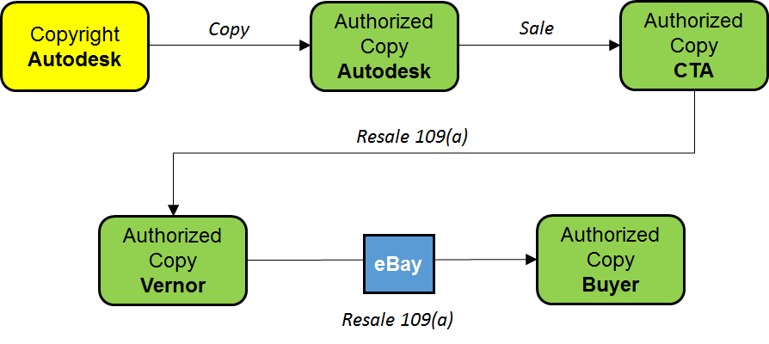
Figure 100: Vernor v Autodesk, Inc. – Vernor’s narrative

Autodesk, not surprisingly, saw things differently. Steps one and two were just as Vernor described them, but instead of selling the copy to CTA, Autodesk contended that it merely leased the copy to CTA in return for various promises. CTA then purported to sell to Vernor a copy it did not know, because 109(a) only applies to “the owner of a particular copy.” It did not shield this transaction. The purported resale thus violated Autodesk’s distribution rights under 106(3). For the same reason, this last transaction was not shielded by 109(a). Vernor was no more an owner of the copy than was CTA. Thus, selling the copy on eBay also violated 106(3). In sum, according to Autodesk, the last two transactions were unlawful (see Figure 101).

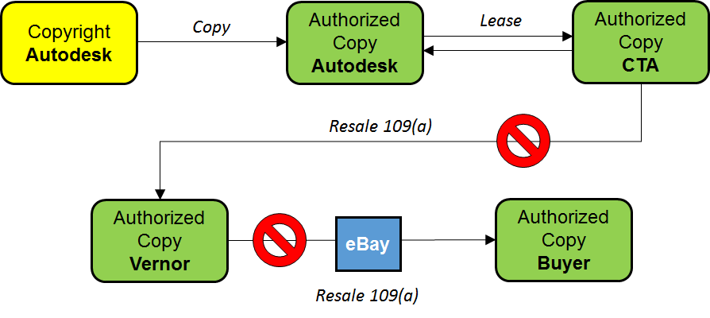
Figure 101: Vernor v Autodesk, Inc. – Autodesk’s narrative

The key issue in the case thus became whether the relationship between Autodesk and CTA had been a lease or a sale. Vernor, of course, preferred the latter, Autodesk the former. In 2010, the Court of Appeals for the Ninth Circuit ruled in Autodesk’s favor. Here’s the decisive portion of the court’s opinion.

We hold today that a software user is a licensee, rather than an owner of a copy, where the copyright owner
- specifies that the user is granted a license
- significantly restricts the user’s ability to transfer the software; and
- imposes notable use restrictions.

The way in which this decision fits into the overall landscape of the law governing distribution rights is indicated on the mind map. It’s reasonably well settled that, using Nimmer’s typology, a transaction involving a copy of a copyrighted work is covered by 109(a), and thus lawful, if and only if four conditions are satisfied.

- A copy was lawfully manufactured with the authorization of the copyright owner.
- The copy was transferred under the copyright owner’s authority.
- The defendant qualifies as the lawful owner of that particular copy.
- The defendant thereupon disposed of that particular copy, as opposed to, for example, reproducing it.

When software firms provide customers copies of their programs in return for money, requirements 1 and 2 are more or less automatically satisfied. However, if the software firm adds to the transaction enough conditions to make the deal appear to be a lease of a copy, and thus not a sale, then requirement 3 is not satisfied and as a result, the customer does not have a privilege to resell that copy. This option is highly beneficial to software firms for two reasons. First, by suppressing resales of copies, it enables the firms to sell more original copies. Second, it helps the firm suppress arbitrage of copies sold cheaply to students and so forth, and thus protects the firm’s primary markets, consisting of adult or commercial users. The result, as you might expect, makes the software firms happy, but makes their customers much less happy. Again, a highly technical ruling, which locates this particular transaction on one side rather than the other of the fault line, has large economic implications.
A summary of the case law affecting provisions 602, 106 and 109 is shown in Figure 102.

Performances
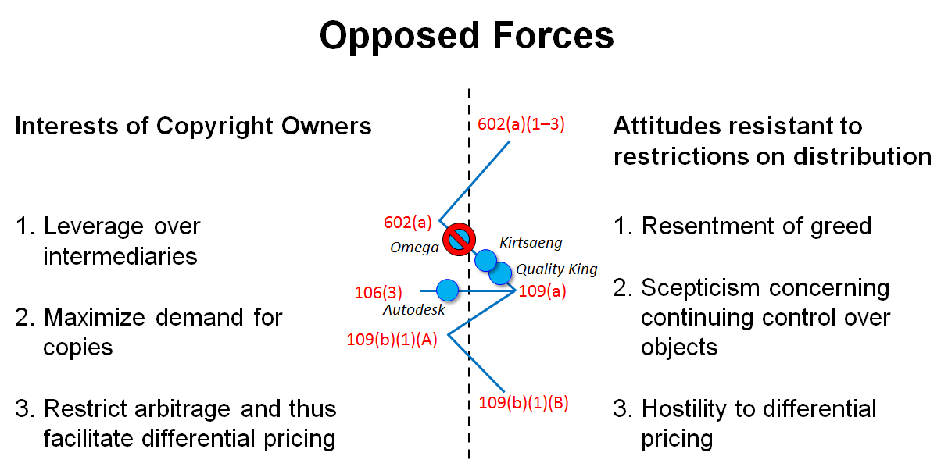
Figure 102: Case law affecting the provisions of sections 602, 106 and 109

The statutory provisions that govern the rights of performance and display are relatively few, but they’re slippery. So, it’s important to be attentive to nuances here. The primary provisions are subsections 4, 5, and 6 of section 106 (see below). Subsection 4 gives the owner of the copyright in a literary, dramatic, musical, choreographic, pantomime, or audiovisual work the exclusive right to perform that work publicly. Subsection 5 is analogous. It applies to the same types of copyrighted works, plus pictorial, graphic, or sculptural works and the individual images of an audiovisual work. It gives the owner of such things the right to display them publicly. Finally, subsection 6. This was added quite recently, specifically in 1996. As I hope you’ll recall from lecture number 3, before 1996 the owners of copyrights and sound recordings in the United States did not enjoy any rights in public performance. At that time, the only provision dealing with public performances was subsection 4, and if you look back at that subsection, you’ll notice that sound recordings do not appear in the list of types of works that are covered. Musical works appear. As you know by now, that means musical compositions but not sound recordings. As I explained in lecture number 3, the record companies that hold the copyrights in most commercially valuable sound recordings have long complained about this state of affairs. In 1996 and then with a little bit of adjustment in 1998, Congress responded partially to the record companies’ pleas and granted them a limited, very limited, public performance right, which is now embodied in subsection 6. As you can see, it only applies to performances “by means of a digital audio transmission.” In just a minute, I’ll give you some examples of transmissions that fit within this phrase.

17 USC § 106
106: Subject to sections 107 through 122, the owner of copyright under this title has the exclusive rights to do and to authorize any of the following …
(4) in the case of literary, musical, dramatic, and choreographic works, pantomimes, and motion pictures and other audiovisual works, to perform the copyrighted work publicly;
(5) in the case of literary, musical, dramatic, and choreographic works, pantomimes, and pictorial, graphic, or sculptural works, including the individual images of a motion picture or other audiovisual work, to display the copyrighted work publicly; and
(6) in the case of sound recordings, to perform the copyrighted work publicly by means of a digital audio transmission.
17 USC § 101
To “perform” a work means to recite, render, play, dance, or act it, either directly or by means of any device or process or, in the case of a motion picture or other audiovisual work, to show its images in any sequence or to make the sounds accompanying it audible.
To “display” a work means to show a copy of it, either directly or by means of a film, slide, television image, or any other device or process or, in the case of a motion picture or other audiovisual work, to show individual images nonsequentially.
To perform or display a work “publicly” means—
(1) to perform or display it at a place open to the public or at any place where a substantial number of persons outside of a normal circle of a family and its social acquaintances is gathered; or
(2) to transmit or otherwise communicate a performance or display of the work to a place specified by clause (1) or to the public, by means of any device or process, whether the members of the public capable of receiving the performance or display receive it in the same place or in separate places and at the same time or at different times.

The crucial terms in these three statutory provisions are performance, display, and public. Fortunately, all three are defined in Section 101 of the statute. As you can see, “perform” is a very capacious definition. I’ll give some examples of its reach shortly. The key word in the definition of “display” is show. Both performances and displays of copyrighted works can only give rise to liability if they’re done publicly. Section 101 defines “publicly” as one of two things. The first of these two subsections is sometimes called the Public Place Clause, and is the more intuitively plausible meaning of public. The second subsection is sometimes known as the Transmit Clause; it, as we’ll soon see, is a very generous definition of public that sweeps within it many ways in which copyrighted materials are made available today.
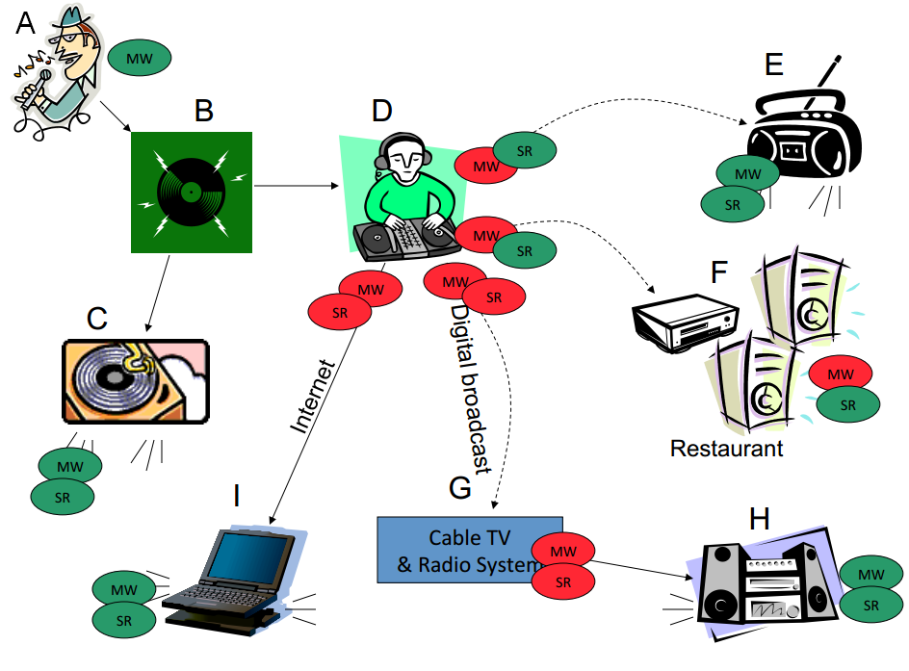
MW: music work; SR: sound recording; private performances are marked in green, public ones in red
Figure 103: Violations of § 106

Those are the main statutory provisions. Now let’s turn to some examples to give these provisions a bit of shape. Here’s a hypothetical but not implausible scenario, the purpose of which is to illustrate these concepts (refer to MW: music work; SR: sound recording; private performances are marked in green, public ones in red
Figure 103). Suppose:
- A sings a copyrighted musical composition into a microphone in a recording studio.
- Record company B records A’s rendition on a record. I know these technologies are quaint, but bear with me.
- C purchases a copy of the record and plays it on a turntable in his or her living room. Sounds are generated, either from the turntable directly or more likely from an amplifier and a set of speakers connected to the turntable. Those sounds spread through C’s living room.
- Another copy of the record is purchased by radio station D. A disc jockey working for the radio station plays the record on a turntable there. The signal generated by the radio station is broadcast over the airwaves. The broadcast is represented in this diagram by the dotted line on the slide. More specifically, this is a traditional analog, over the air transmission.
- It’s received in the home of E, who, in her living room, plays another stereo, depicted by a boombox. Sound comes out of the speakers into E’s living room.
- The next day, the disc jockey plays the record again, broadcasting it again through an analog signal. This time, it’s received by a tuner and an associated stereo system located in a restaurant (F). The sounds generated by the stereo spread through the restaurant. The customers, eating their meals, hear it.
- The next month, the radio station shifts to a digital broadcasting technology. The DJ plays the record again. Suppose cable system G picks up the digital signal and relays it, through a cable of course, to homeowner H, who plays it through a stereo in her home.
- Finally, suppose that the station abandons over the air broadcasting altogether and shifts to webcasting over the internet. Yet again, the DJ plays the record. The owner of a laptop (I) residing in another state receives that webcast and listens to it in her living room.
Now let’s consider the legal significance of this sequence of events. My suggestion, when you’re confronted with a real or hypothetical story of this sort, is that you analyze it in three steps. Breaking the issues down this way may seem needlessly laborious, but it will help alert you to some hidden landmines.
Step number 1 is to identify all of the performances. Keep in mind the capacious definition of performance in the statute. Also keep in mind that when dealing with music, you have to look for both performances of musical compositions and performances of sound recordings. Let’s start with the musical work. Here are all the places in the hypothetical story where and when the musical work (abbreviated with MW) was performed.
- When A sings the song, that’s a performance.
- When the sound emerges from the record player in the living room of C’s home, that’s also a performance of the musical work.
- When the radio station plays the record the first time, it too is performing the musical work. This is slightly less obvious, but remember that the term performance includes to render a work either directly or by means of any device or process. That has been construed to include sending signals of this sort.
- When E receives the signal in her living room and sends the sound out into her living room, that’s yet another separate performance.
- Same thing happens with the restaurant. When the station sends the signal containing a rendition of the song, that’s a performance. When the restaurant receives that signal and plays it for its customers, that’s another performance.
- Things get even more complicated when we get to the cable system. Here there are three performances: by the station when it broadcasts the rendition of the song, by the cable system when it relays that signal, and by the homeowner who receives the relayed signal and plays it in her home.
- With respect to the webcast, there are only two: by the station and by the recipient when she plays it.
Each time A’s rendition of the musical work is performed, the sound recording embodying that rendition is also performed, except of course when A sang it, because there’s no recording yet. Why differentiate the performance of the musical work and the performances of the sound recording? Because the copyrights in these things may well be held by different parties and because, as you already know, they’re governed by different rules.
All right. That’s step 1 of the analysis.
Having identified all of the performances, the next step is to determine which of them are public. If they’re not public, we don’t have to worry about them anymore. If they are, we’ll have to proceed to step 3.
- A’s performance is not public because it’s done in the studio without an audience, and this doesn’t fit either of the two definitions of public.
- Neither of C’s two performances, of the musical work or of the sound recording, is public, because they occur in C’s living room.
- The same is of course true of E’s living room, H’s living room, and I’s living room.
- The radio station (D), however, is in a very different position. Every time it broadcasts a signal containing the song, it is publicly performing both the composition and the sound recording. The relevant definition of public is, of course, the Transmit Clause, specifically this part of the clause: “to transmit a performance of the work to the public, even if the members of the public capable of receiving the performance receive it in separate places or at different times.” The result is that, even if all of the station’s listeners are home alone in their living rooms, the transmission of the signal to them is still public.
- The same is true of the transmission by the cable company (G). This may not be altogether obvious to you, but soon I’ll return to the special legal status of cable companies.
- What about the performance in the restaurant (F)? That’s not a transmission, so the Transmit Clause is not relevant, but the other definition of public, the so-called Public Space Clause, applies. What if there’s only one patron eating dinner when the song is played, or indeed no customers at all? Doesn’t matter. So long as the restaurant is open to the public, the performance is public.
The third and last step is to survey the public performances we’ve identified and determine if there any grounds for exempting them from the reach of the statute. There are several possible exemptions, one of which you already know. If the work performed is a sound recording and if the way in which it is performed is not a digital audio transmission, then it’s not covered by either 106(4) or 106(6). So, all of these performances escape, either because they are analog or they are not transmissions:
- D’s performance of the SR to E
- D’s performance of the SR to F
- F’s performance of the SR
For the time being, anyway, the rest do not.
This concludes our survey of the basics. Now let’s consider some refinements. Focus on the upper right-hand corner of the diagram. You’ll recall that the way in which the music got into E’s ears is that singer A sang the composition, record company B recorded A’s rendition, radio section D played the record and broadcast the signal over the airwaves. E’s radio, located in her living room, picked up that signal and converted it into sound waves. If E listens to the music while alone in her living room, the two performances that occur at E are surely not public. Now let’s alter the facts slightly. Suppose that E’s dining room is adjacent to her living room. She has a dinner party in the dining room, and the invitees are able to hear the music coming out of the radio. Is that a public performance? The answer is no. The guests are social acquaintances gathered together in a room that’s not open to the public.
Suppose that E is a professor. She invites the students in one of her seminars to her house for dinner. The radio is playing in the background. Is that a public performance? This is closer to the line. The answer is still probably no, but an argument might be made that E’s home is now “a place where a substantial number of persons outside of a normal circle of a family and its social acquaintances is gathered.”
Change the facts once again. The personnel are the same, but instead of hosting her students in her house, E holds a party in a semi-separate room of a restaurant. The radio in the room plays A’s rendition. Is that a public performance? Yes. The restaurant is a place that’s open to the public, and therefore, under the first of the two clauses, would clearly be considered public.
Now suppose that E takes her radio to a public park at 5 o’clock in the morning, tunes it to the D station, and listens to it while doing some exercises. The park is otherwise empty, so no one but E hears the radio. Is that a public performance? Strictly speaking, yes, because the place is open to the public, even though she’s the only listener. The chances of copyright owners pursuing her for infringement are tiny, but at least technically that’s a public performance. It’s still possible that it may nevertheless be excused by one of the exceptions we’ll consider later in this lecture, but E is at least presumptively in trouble.
For the past few minutes, we’ve been considering possible applications of the first and more intuitive of the definitions of public, the Public Place Clause. The more serious and economically important puzzles in this area arise under the second branch, the so-called Transmit Clause. Here are three illustrative cases.
The first is Redhorn, one of the old chestnuts of copyright law. It involved a very early application of VCR technology. The defendant operated a somewhat shady operation that rented VHS tapes but also provided small, carpeted rooms in the back of the facility where you could have a VHS tape played. Here’s how the system worked. The customer would walk into the front of the store, where he’d see many tapes displayed. He’d select one. The attendant would place it into a VCR and activate it. The customer would retire to a room in the back, where he alone, or with a companion or two, would watch it. The court of appeals ruled that this system entailed public performances of the audiovisual works on the VHS tapes for two independent reasons. First, because the facility is open to the public. This again is a bit counterintuitive. After all, it’s only open to a couple of members of the public at a given time. But as a whole, it’s open to the public and that’s enough to render the performances public under clause number 1. The second reason is more interesting for our purposes. The performances are also public because they involve transmissions. Short transmissions, to be sure, presumably from the front desk to the room in the back, but transmissions nevertheless, and members of the public are capable of receiving those transmissions in the same place or separate places at different times. The court didn’t spell this out in great detail, but its analysis seems to be that a given audiovisual work is shown to successive customers or groups of customers in the same room at different times through the same transmission facility. That’s enough to make it public and to make the proprietor liable for some $44,000.
The second case is the important recent decision in Cablevision, one aspect of which I discussed in the previous lecture. The essential facts are depicted in Figure 83. As you’ll recall, the owners of the copyrights in the works that would be stored and then replayed by Cablevision challenged this technology on three grounds. A, that the brief retention of slices of each work in the BMR buffer constituted in the aggregate an unauthorized reproduction of the work. B, that the more durable retention of a copy on the hard drive of the Arroyo server also violated 106(1). And C, that the transmission from the Arroyo server to the customer, when the customer asks to watch one of his saved programs, constitutes a public performance of the work. The trial court, as we saw, accepted all three claims. But the court of appeals rejected all three. How did the court of appeals reject the third argument? It might have done so by ruling that even if the transmission involved a public performance, that transmission is initiated by the subscriber when he presses the button on his remote control in his living room, not by Cablevision. But it did not. The court assumed, for the sake of argument, that Cablevision is responsible for the transmission. Nevertheless, it ruled that the transmission did not violate Section 106(4). Crucial to this ruling are two facts – that the transmission is only delivered to one person at a time and that each subscriber receives his transmission from the unique copy the work. If Cablevision transmitted the work to multiple subscribers seriatim from the same copy, then in the court of appeals’ judgment, this case would resemble Redhorn, which, as we saw, gave rise to liability. But the fact that each subscriber received a transmission from his own personal copy made all the difference. Here’s the crucial language from the opinion. “Because each RS DVR playback transmission is made to a single subscriber using a single unique copy produced but that subscriber, we conclude that such transmissions are not performances to the public and therefore do not infringe any exclusive right of public performance.” This fact was also emphasized by the solicitor general when advising the Supreme Court not to review the decision.
As we saw in lecture number 7, the ruling in Cablevision catalyzed a great deal of investment in cloud-based services – several billion dollars. However, the aspect of the court’s ruling I just emphasized renders that investment less efficacious than it could be. Why? Because constructing systems that store individual copies of works for individual subscribers is very inefficient. The Cablevision ruling also catalyzed considerable innovation with respect to technologies and business models in the entertainment industry. When those innovations have been challenged by copyright owners, some have been held to be lawful, while others have been ruled to run afoul of the owner’s rights. The most important of the innovations that came to grief was the service briefly offered by Aereo, an ingenious but risky startup. To understand the nature and novelty of the Aereo system, you need a bit of background.
For a long time, as you probably know, television stations have been broadcasting entertainment and sports programming free over the public airwaves. This system has worked well for consumers located in metropolitan areas with good television reception, but less well for consumers in rural areas with poor reception. For several decades, the latter group of consumers has overcome this impediment by subscribing to cable television services such as Comcast in the United States. Among the many channels that cable companies typically carry are over the air broadcasts that the cable systems pick up in major cities and then we redistribute through their cables. Do the cable companies have to pay the owners of the copyrights in the programs that they relay in this fashion? When cable systems were first introduced, the Supreme Court answered no, on the grounds that the cable companies neither reproduced nor publicly performed the programs. In 1976, Congress repudiated that position and in the process adopted the expansive definition of public performance with which we’ve been wrestling. Since then, the cable companies have been obliged to pay copyright owners whose programs they retransmit, although the amount they pay is capped by a special compulsory license of the sort I’ve mentioned before and we’ll consider again in the final segment of this lecture. Nowadays, a growing group of consumers get access to audiovisual entertainment not through over the air broadcasts or by subscribing to expensive cable systems, but through the internet. This arrangement works fine if the programming they want is available either for free, from sites like YouTube, or from various fee-based on-demand or subscription services now accessible through the internet, but what if the programming they want to watch is broadcast over the airwaves by television stations located in distant cities? Until recently, there was no convenient way for them to gain access to that material. Enter Aereo, the third case.
For consumers of the sort I’ve just described, located in the New York metropolitan area, Aereo set up a new subscription service. Here’s how it worked. Suppose, counterfactually, that I live in Westchester County, I’m a fan of the New York Yankees baseball team, and I don’t subscribe to cable TV. A subset of Yankees games are broadcast on WWOR, an over-the-air television station based in northern New Jersey, which operates a broadcast tower on the top of the Empire State Building. When I’m at home, I watch the broadcast for free, but I often travel for work, and I want to watch the games when I’m on the road. For a fee of $12 per month, Aereo would, at my request, pick up the broadcast of a particular game, convert it to packets, and stream those packets to me over the internet, enabling me to watch the game on my laptop or tablet. Now if the way that Aereo picked up the program was by building and operating a single big TV receiver on Long Island, then it would have been working very much like a cable company and thus would have been obliged to pay fees to the owners of the copyrights in the broadcast of the games. But it didn’t. Instead, Ariel obtained thousands of tiny TV antennas, each the size of a dime, which it arranged in arrays. Then, when I asked to see a particular game, Aereo would rent me one of those tiny, individual antennas and tune it to the free, over the air broadcast. One more potentially important feature of Aereo’s system. The game would not be shown to me live. Instead, like Cablevision, Aereo captured and recorded the live program. The packet sent to me would be from that personal recording. However, the resultant lag time was tiny, a few seconds. A different service offered by Aereo, not considered in the judicial opinion that I’m about to describe, allowed subscribers like me to time-shift programs – for example, to replay the recording of the game hours or days after it was first broadcast. But for the time being, keep your focus on the nearly live broadcasts.
By now, it should be obvious that the reason why Aereo used this seemingly bizarre technology was to make its system resemble, as closely as possible, the system created and upheld in the Cablevision decision and thus to avoid having to pay for the material it was supplying to its subscribers. At first it seemed that Aereo had succeeded. When copyright owners challenged the system, the trial court ruled in favor of Aereo, relying heavily on the Cablevision doctrine. So did the court of appeals for the Second Circuit, by a vote of 2 to 1. But the Supreme Court granted certiorari and in July of 2014 reversed by a vote of 6 to 3. The basis for the Supreme Court’s ruling, unfortunately, is not completely clear. Justice Breyer, writing for the court, repeatedly stressed that Aereo’s business looked a lot like a cable television service, which Congress had made clear both (a) performed programs they relayed, and (b) made those performances to the public. But what about the aspect of the Aereo system that differentiated from a cable system – namely, that each Aereo subscriber received an individual transmission from an individual copy of the program at issue? Breyer’s answer, in brief, was that neither the subscribers nor the owners of the copyrights in the programs cared about what was going on under the hood, and so neither should the law. Breyer’s analysis is distilled in the sentence set forth below.

[I]n light of the purpose and text of the [Transmit] Clause, we conclude that when an entity communicates the same contemporaneously perceptible images and sounds to multiple people, it transmits a performance to them regardless of the number of discrete communications it makes.

This language is quite broad. Among other things, it seems to render irrelevant the factor that the court of appeals treated as so important in Cablevision – namely, whether a transmission is made to a single subscriber using a single unique copy produced by that subscriber. Does this then mean that RS DVR services are doomed? Some copyright owners and commentators think so. My own view is no. Most RS DVR systems remain lawful in the United States. The principal reason is that, although Justice Breyer did not expressly endorse the Cablevision decision, he went out of this way to emphasize several limitations on the Supreme Court’s ruling against Aereo. For example, Breyer stressed the fact that neither Aereo nor its subscribers had paid for access to the programs that Aereo streamed. And Breyer strongly suggested that the case would have come out differently otherwise. Here’s the crucial sentence:

[A]n entity that transmits a performance to individuals in their capacities as owners or possessors does not perform to ‘the public,’ whereas an entity like Aereo that transmits to large numbers of paying subscribers who lack any prior relationship to the works does so perform.

This sentence, although not a model of clarity, would seem to leave a safe harbor for cloud locker services and arguably for services like Cablevision that allow consumers who have already paid for programming to watch those programs at later times or in different places. Finally, Breyer pointedly emphasized “[T]he doctrine of ‘fair use’ can help to prevent inappropriate or inequitable applications of the [Transmit] Clause.” The potentially expensive safe harbor that might be built on that sentence will become apparent next week. Sadly, the net effect of the Supreme Court’s ruling in Aereo is to reduce considerably the clarity that in the wake of Cablevision stimulated so much investment in cloud-based technologies. For the next few years, lower courts confronted with challenges to businesses that offer consumers new kinds of streaming services will have to determine whether they are more like Cablevision or more like Aereo. Until the dust settles, entrepreneurs and technology innovators will have some trouble predicting what they can and cannot do.
An additional source of instability is the divergence between the United States and Europe with respect to the permissibility of services of this general sort. As I hope you’ll call from the first lecture in this series, one of the multilateral treaties to which the United States is a party is the WIPO Copyright Treaty of 1996. Articles 6 and 8 of that treaty require member countries to provide copyright owners a generous version of the right of distribution and a right of communication to the public. Both provisions use the phrase “make available to the public,” which arguably encompasses more activities than are reached by US law. Nevertheless, after the treaty was ratified, the United States took the position that this language did not require any adjustment in US law because sections 106(3) and 106(4), as construed by the US courts, already adequately provided such a so-called make available right. That contention was dubious when it was first made and has become more so over time. In Europe, as professor Jane Ginsburg of Columbia Law School has shown, the right to make works available to the public is construed more broadly than in the United States and in particular is less forgiving of cloud-based services of the sorts we have been considering. The Information Society Directive of 2001, which implemented in the EU the WIPO Copyright Treaties, requires EU member states to “provide authors with the exclusive right to authorize or prohibit any communication to the public of their works by wire or wireless means, including the making available to the public of their works in such a way that members of the public may access them from a place and at a time individually chosen by them.” In 2013, the European Court of Justice ruled that a British company called TVCatchup, which had offered a service that resembled that provided by Aereo, violated this particular entitlement. The ruling forced a redesign of TVCatchup, and that company is now in financial trouble. Even more striking was the insistence by the European Commission that Italy rescind a law that had granted partial immunity to an RS DVR service analogous to that offered by Cablevision.
The United States is not likely in the near future to adopt the EU’s more restrictive interpretation of the so-called make available right, but the gap between the US and the EU on this score is not good for business. In particular, it’s likely to bedevil enterprises that seek to provide novel cloud-based services not just to US customers but to users of the internet in other countries. I’ve concentrated in this lecture entirely on section 106(4) and have paid no attention to section 106(5), the right of public display. The reasons are that the bulk of the economic and litigation action involves performances, not displays, and that the definition of display is clearer and more intuitive than that of performance. The statute defines “display”, pretty much the way you’d expect, as to show a copy of the work either directly or by means of a film, slide, television image, or other device or process, or in the case of a motion picture or other audiovisual work, to show the individual images nonsequentially. That definition creates few interpretive difficulties with respect to real space displays. Now recently, information technology, such as the practice of framing websites, has generated some interesting interpretive problems, but I’ll leave such matters to the discussions that will accompany this lecture.

Exceptions & Limitations
In this segment, I’ll examine statutory exceptions to and limitations upon copyright owners’ rights of public performance and display. For this purpose, we’ll be returning once again to the mind map of copyright law.
The first thing to notice is that the exceptions are embodied in a long, itemized list. The general strategy underlying this list contrasts very sharply with the strategy underlying the more famous fair use doctrine, which we’ll be considering next week. The basic idea underlying fair use, as you’ll see, is that we use general, open-ended standards to confer upon courts a great deal of discretion to decide on an ad hoc basis whether a particular, unauthorized activity by a defendant should be excused as fair. By contrast, the list of exceptions to the public performance right are, or at least appear to be, quite precise. As we’ll see, this approach resembles more closely the European style of exceptions and limitations than it does the US fair use approach. So, let’s run down the list.
Exceptions
- Classroom
- Distance learning
- Religion
- Nonprofit
- Homestyle
- FMLA
- Some webcasts
- Real-space displays

17 USC § 110
Notwithstanding the provisions of section 106, the following are not infringements of copyright:
(1) performance or display of a work by instructors or pupils in the course of face-to-face teaching activities of a nonprofit educational institution, in a classroom or similar place devoted to instruction, unless, in the case of a motion picture or other audiovisual work, the performance, or the display of individual images, is given by means of a copy that was not lawfully made under this title, and that the person responsible for the performance knew or had reason to believe was not lawfully made;
(2) except with respect to a work produced or marketed primarily for performance or display as part of mediated instructional activities transmitted via digital networks, or a performance or display that is given by means of a copy or phonorecord that is not lawfully made and acquired under this title, and the transmitting government body or accredited nonprofit educational institution knew or had reason to believe was not lawfully made and acquired, the performance of a nondramatic literary or musical work or reasonable and limited portions of any other work, or display of a work in an amount comparable to that which is typically displayed in the course of a live classroom session, by or in the course of a transmission, if—
(A) the performance or display is made by, at the direction of, or under the actual supervision of an instructor as an integral part of a class session offered as a regular part of the systematic mediated instructional activities of a governmental body or an accredited nonprofit educational institution;
(B) the performance or display is directly related and of material assistance to the teaching content of the transmission;
I the transmission is made solely for, and, to the extent technologically feasible, the reception of such transmission is limited to—
(i) students officially enrolled in the course for which the transmission is made; or
(ii) officers or employees of governmental bodies as a part of their official duties or employment; and
(D) the transmitting body or institution—
(i) institutes policies regarding copyright, provides informational materials to faculty, students, and relevant staff members that accurately describe, and promote compliance with, the laws of the United States relating to copyright, and provides notice to students that materials used in connection with the course may be subject to copyright protection; and
(ii) in the case of digital transmissions—
- applies technological measures that reasonably prevent—
(aa) retention of the work in accessible form by recipients of the transmission from the transmitting body or institution for longer than the class session; and
(bb) unauthorized further dissemination of the work in accessible form by such recipients to others; and
(II) does not engage in conduct that could reasonably be expected to interfere with technological measures used by copyright owners to prevent such retention or unauthorized further dissemination;

One of the more straightforward exceptions is section 110(1). That provision permits in a classroom a public performance or display that would otherwise violates Section 106(4) or 106(5) as long as it’s done live, and as long as the copy of the work in question was prepared lawfully. This means that when I present audiovisual works in the course of outlining case studies in my classroom, I’m on safe ground, so as long as the material I show was prepared lawfully. A closely related provision is 110(2), also known as the Teach Act, which deals with distance learning. It’s a very good idea to have a statutory provision that creates a safe harbor for distance learning. Unfortunately, in practice this particular provision is almost completely ineffective. The first thing you notice about 110(2) is that it’s extremely complicated, contrasting sharply with the simplicity of 110(1). The portions underlined impose upon a defendant who seeks to invoke this provision many quite detailed obligations. Most importantly, 110(2) is only applicable to formal instruction of enrolled students. That’s it’s inapplicable to the copies of these recorded lectures that I make available to the public. It’s also limited to streaming of materials. If a teacher wishes to invoke this provision, he cannot make copies of any of those materials available for downloading, nor can he stream copyrighted materials in a way that enables students to copy them. Again, this restriction renders the provision useless for the kind of instruction I’m trying to do in this course. Next, the provision is limited to materials that are not designed for distance education. In other words, the copyrighted works at issue have to have been designed for some other purpose and then adapted to distance education. A teacher must accompany those materials with instructions about copyright law. This may not be a problem in this course, which happens to be about copyright law, but it’s a burden with respect to most other courses. Finally, the teacher must adopt technologies to prevent the recipients from saving the materials to which they are given access. These restrictions, when you add them all up, are sufficiently burdensome that very few distance learning enterprises rely on 110(2). To the extent that its purpose was to facilitate distance education, it’s widely considered to have been a failure. Now, it likely occurs to you to ask how then does Fisher get away with including some copyrighted materials in his recorded lectures? The answer is that some are licensed. But for the most part, I rely on the fair use doctrine. Next week, you’ll be in a position to judge whether my invocation of fair use is persuasive.

17 USC § 110
Notwithstanding the provisions of section 106, the following are not infringements of copyright:
- performance of a nondramatic literary or musical work or of a dramatico-musical work of a religious nature, or display of a work, in the course of services at a place of worship or other religious assembly;

Section 110(3) is much simpler than 110(2). It deals with public performances of religious works in the course of services. It’s not obvious that this exception advances social welfare. Putting aside the constraints imposed by the clauses in the US Constitution pertaining to the establishment and free exercise of religion, and just doing the provisioning from a policy angle, the result of 110(3) is to make it a lot easier for churches and other religious establishments to operate. But it also means that the creators of religious materials, specifically non-dramatic, literary musical works, don’t get paid as much insofar as often the principal value of their creations is through performances. Perhaps the premise is that religious composers are motivated by non-monetary incentives, and thus we don’t need to compensate them in order to stimulate their work? Not clear.

17 USC § 110
Notwithstanding the provisions of section 106, the following are not infringements of copyright:
(4) performance of a nondramatic literary or musical work otherwise than in a transmission to the public, without any purpose of direct or indirect commercial advantage and without payment of any fee or other compensation for the performance to any of its performers, promoters, or organizers, if—
(A) there is no direct or indirect admission charge; or
(B) the proceeds, after deducting the reasonable costs of producing the performance, are used exclusively for educational, religious, or charitable purposes and not for private financial gain, except where the copyright owner has served notice of objection to the performance under the following conditions:
(i) the notice shall be in writing and signed by the copyright owner or such owner’s duly authorized agent; and
(ii) the notice shall be served on the person responsible for the performance at least seven days before the date of the performance, and shall state the reasons for the objection; and
(iii) the notice shall comply, in form, content, and manner of service, with requirements that the Register of Copyrights shall prescribe by regulation;

Section 110(4) is the so-called nonprofit exception. This one is often neglected, but it’s actually very important. As you can see, it privileges live performances of a non-dramatic literary or musical work without any purpose of direct or indirect commercial advantage. Restaurant waiters, for example, sometimes sing Happy Birthday to patrons. That’s not copyright infringement as long as there’s no direct or indirect commercial advantage. If the restaurant or the waiters charge the friends of the birthday boy or girl, they would not be shielded by this provision, but as long as there’s no independent charge for the performance, they’re probably on safe ground. Some years ago there was a big controversy that implicated this particular provision. ASCAP is one of the organizations in the United States that issues blanket licenses, blanket performance licenses, to many organizations allowing them to publicly perform musical works. Foolishly, ASCAP apparently decided to seek license fees from the Girl Scouts in return for permitting the Scouts to sing songs around their campfires. This was a public relations disaster for ASCAP. The Wall Street Journal wrote a scathing article about it. And in the end, ASCAP backed down and now grants the Girl Scouts public performance rights for a nominal fee. How did ASCAP get itself in this position in the first place? In particular, doesn’t 110(4) permit the Scouts to perform the songs without getting a license? It’s not entirely clear, but the answer seems to be the Girl Scout camps that the ASCAP threatened with liability were charging for access to them. That made 110(4) inapplicable.

17 USC § 110
Notwithstanding the provisions of section 106, the following are not infringements of copyright:
(5)
(A) except as provided in subparagraph (B), communication of a transmission embodying a performance or display of a work by the public reception of the transmission on a single receiving apparatus of a kind commonly used in private homes, unless—
(i) a direct charge is made to see or hear the transmission; or
(ii) the transmission thus received is further transmitted to the public;
(B) communication by an establishment of a transmission or retransmission embodying a performance or display of a nondramatic musical work intended to be received by the general public, originated by a radio or television broadcast station licensed as such by the Federal Communications Commission, or, if an audiovisual transmission, by a cable system or satellite carrier, if—
(i) in the case of an establishment other than a food service or drinking establishment, either the establishment in which the communication occurs has less than 2,000 gross square feet of space (excluding space used for customer parking and for no other purpose), or the establishment in which the communication occurs has 2,000 or more gross square feet of space (excluding space used for customer parking and for no other purpose) and—
(I) if the performance is by audio means only, the performance is communicated by means of a total of not more than 6 loudspeakers, of which not more than 4 loudspeakers are located in any 1 room or adjoining outdoor space; or
(II) if the performance or display is by audiovisual means, any visual portion of the performance or display is communicated by means of a total of not more than 4 audiovisual devices, of which not more than 1 audiovisual device is located in any 1 room, and no such audiovisual device has a diagonal screen size greater than 55 inches, and any audio portion of the performance or display is communicated by means of a total of not more than 6 loudspeakers, of which not more than 4 loudspeakers are located in any 1 room or adjoining outdoor space;
(ii) in the case of a food service or drinking establishment, either the establishment in which the communication occurs has less than 3,750 gross square feet of space (excluding space used for customer parking and for no other purpose), or the establishment in which the communication occurs has 3,750 gross square feet of space or more (excluding space used for customer parking and for no other purpose) and—
- if the performance is by audio means only, the performance is communicated by means of a total of not more than 6 loudspeakers, of which not more than 4 loudspeakers are located in any 1 room or adjoining outdoor space; or
(II) if the performance or display is by audiovisual means, any visual portion of the performance or display is communicated by means of a total of not more than 4 audiovisual devices, of which not more than one audiovisual device is located in any 1 room, and no such audiovisual device has a diagonal screen size greater than 55 inches, and any audio portion of the performance or display is communicated by means of a total of not more than 6 loudspeakers, of which not more than 4 loudspeakers are located in any 1 room or adjoining outdoor space;
(iii) no direct charge is made to see or hear the transmission or retransmission;
(iv) the transmission or retransmission is not further transmitted beyond the establishment where it is received; and
(v) the transmission or retransmission is licensed by the copyright owner of the work so publicly performed or displayed;

Now, we get to two related exceptions – the so-called home-style exception and the FMLA, which is an abbreviation for Fairness in Music Licensing Act. The home-style exception embodied in Section 110(5)(B) is, as its informal name suggests, a privilege for publicly performing copyrighted works using the kind of apparatus that you would ordinarily find in a home. That’s a little vague, and it’s changing as technology evolves, but the rough idea is that if the gizmo you used perform a work is the kind of tuner plus speakers that you would ordinarily have in your living room, then it’s OK. The standard is vague and not often litigated, but there it is. As I trust you see, this exception operates to shield some of the performances we were worried about in the previous segment of this lecture. Unfortunately, it’s not broad enough to shield stores and restaurants who want to play music to entertain their customers, but need to deploy apparatuses bigger than you would find in an ordinary home. So, organizations representing restaurants and stores sought and obtained 110(5)(B) commonly known as the Fairness in Music Licensing Act. This one is extremely complex. You can read the details at your leisure. The operators of bars, restaurants, and retailers when deciding how big an operation to set up and how to outfit it, pay lot of attention to the details here. If they’re able to stay under these statutory ceilings, they can escape altogether an obligation to pay copyright owners, particularly ASCAP, any licensing fees. An alarm bell should be going off now. You’ll recall that the Berne Convention requires member countries to grant certain substantive rights and limits their ability to carve exceptions out those rights. The TRIPS Agreement, discussed in lecture number one, incorporates and extends those requirements and creates a mechanism for punishing WTO countries that fail to abide by them. May the US without running afoul of those agreements carve out of the performance right an exception this broad? The European Union thought no and brought a dispute resolution proceeding against the US concerning the FMLA and won. In other words, the US, in this respect, was deemed to be in violation of TRIPS. So, did the US Congress amended the statute? Surprisingly, no. Instead, the US responded by submitting this dispute to binding arbitration which resulted in a monetary judgment. The result was that the United States has to pay the EU a fee and continues to do so, over a million a year, to compensate for the injuries that EU copyright owners incur because of this exemption.

17 USC § 109
I Notwithstanding the provisions of section 106(5), the owner of a particular copy lawfully made under this title, or any person authorized by such owner, is entitled, without the authority of the copyright owner, to display that copy publicly, either directly or by the projection of no more than one image at a time, to viewers present at the place where the copy is located.
(d) The privileges prescribed by subsections (a) and (c) do not, unless authorized by the copyright owner, extend to any person who has acquired possession of the copy or phonorecord from the copyright owner, by rental, lease, loan, or otherwise, without acquiring ownership of it.

The last of the exceptions we’re going to deal with in this lecture concerns not public performances, but public displays. This exemption is contained not in section 110, which has occupied us until this point, but in section 109. As we can see here, 109I provides notwithstanding the provisions of section 106(5). That’s the public display right. The owner of a particular copy lawfully made under this title to display that work publicly is not violated if he shows it to viewers present at the place where the copy is located. The upshot is that you can hang a painting on the wall of your living room, and you can host a wedding reception or a garden tour in your house, enabling lots of strangers to see the painting without infringing the painter’s copyright. As you can see, this is a major exception and helps to relieve the otherwise quite surprising reach of 106(5).
For the past several minutes, we have been examining types of performances that the law excuses outright. In other words, we’ve been studying statutory provisions that give people an unqualified privilege to engage in particular sorts of performances and displays without permission and without paying the copyright owners anything. We turn finally to a set of provisions that permit people to engage in particular sorts of performances without permission, but require them to pay the copyright owner’s fees that are set in some way by the government. As you know now, such provisions are known as compulsory licenses. From the standpoint of the copyright owners, these provisions are not great because they deprive the owners of the capacity to control uses of their works and, typically, though not invariably, force them to accept license fees that are lower than the copyright owners given their druthers would demand. But from the standpoint of the owners, such provisions are much better than the exceptions we’ve just finished surveying because the owners are at least paid something.
There are five main compulsory licenses. These provisions give qualified privileges to public broadcasting organizations, some types of webcasts engaged in digital audio transmissions, re-transmissions by cable systems and satellites, and jukeboxes. The ways in which the compulsory fees are set are complex and vary considerably across these provisions. Businesses that depend on these compulsory licenses for revenue or freedom to operate, of course, pay a great deal of attention to the details of the regimes, but I will not do so here. Instead, I will concentrate on the general, normative question posed by all such compulsory licenses. What might justify using this technique? The question is difficult and important because you can readily see reasons why governments should not use this technique. As I mentioned, it deprives owners of control. They must acquiesce in uses of their works that they might hate. You will recall from lecture number two that scholars like Rob Merges sharply criticize compulsory licenses on this basis. In addition, the processes by which most of the compulsory rates are set and collected are expensive and cumbersome. The advocates of compulsory licenses bear the burden of establishing that despite these drawbacks, compulsory licenses make sense. How might they do so? Defenders of compulsory licenses commonly make four arguments. I’ll describe them, note the principal rebuttals to these arguments, and let you weigh the competing claims.
Compulsory licenses
- Public broadcasting system
- Some webcasts
- Cable retransmissions
- Satellite retransmissions
- Jukeboxes
The first argument is the compulsory licenses facilitate socially beneficial uses of copyrighted materials that otherwise would be frustrated by high transaction costs. It would be prohibitively costly, so the argument goes, for jukebox operators, say, to negotiate licenses with the owners of the copyrights in all the songs and sound recordings they want to perform. The result is that were it not for compulsory licenses, we would have no jukeboxes. The retort is that transaction costs are not as high as the story suggests. And information technology is causing them to decline. So, it is said, compulsory licenses are outmoded.
The second argument is that inequality in the bargaining power of the copyright owners, on one hand, and these particular types of users on the other, would enable the owners in an uncontrolled market to extract excessive license fees from the users. Excessive either in the sense of being exploitative and unfair, or in the sense of being much higher than is necessary to motivate the owners’ creativity and, thus, socially wasteful. Skeptics suggest that the beneficiaries of most of these compulsory licenses are far from being powerless.
The third argument is that the ratio of socially beneficial incentives to corresponding social losses is higher with respect to compulsory licenses than with respect to freely-negotiated licenses. We touched on this argument briefly in lecture number four. Here’s a brief review. Copyright law, seen through the eyes of an economist, is a device that shields an innovator from competition in sales of copies of his creation. At least if there are no close substitutes for his innovation, this shield enables the innovator to set the price for access to those copies well above the marginal cost of producing them. The resultant monopoly profits, represented by the blue zone in this now familiar simplified graph (Figure 104, left), provide an incentive for innovators to produce their creations in the first instance. An unfortunate side effect of the strategy is that some potential consumers are priced out of the market for copies of the creation, giving rise to a welfare loss represented by the red zone. That’s regrettable, but we accept those social costs in order to offer creators sufficiently large carrots to induce them to make things we need or enjoy. If administered sensibly, compulsory licenses, it is argued, enable us to improve on the system. Compulsory licenses force copyright owners to accept fees lower than they would otherwise demand. That, of course, reduces their profits, but the loss is partially offset by an increase in output. The result is that the blue zone in this picture (Figure 104, right) is smaller than the blue zone in the preceding picture, but not by an enormous amount. Conversely, as you can readily see when the images are juxtaposed, the imposition of a compulsory license sharply reduces the concomitant dead-weight loss. The ratio between incentives and losses associated with uncontrolled licensing markets on the left is lower than the ratio between incentives and losses associated with controlled markets on the right. Opponents contend that the administrative costs associated with the system on the right will exceed the cost savings it enables.
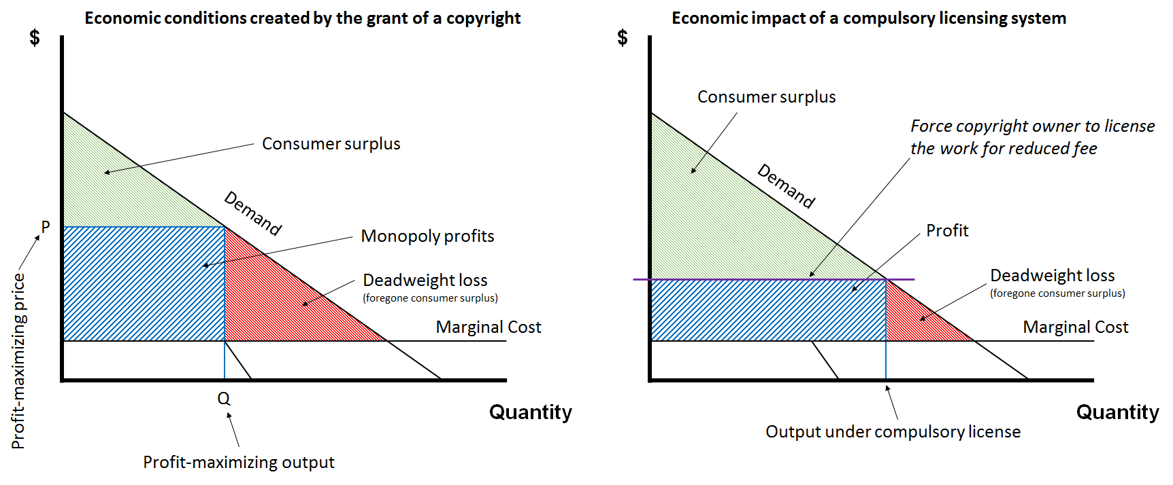
Figure 104: The economic effects of a copyright vs that of a compulsory licensing system

The last of the four arguments is the simplest. Compulsory licenses are sometimes necessary, it is said, to enable socially-beneficial activities to flourish. This is a hard argument to make with respect cable re-transmissions, but perhaps easier with respect to public broadcasting systems. The argument can be expressed in the language of economics. Public broadcasting has strong positive externalities that the stations are unable to capture, so we need to reduce its costs if it is to survive. Or the same argument can be expressed in more moral terms. Public broadcasting helps educate the citizenry, generating a more informed, responsible, and tolerant electorate. For that reason, we should and do place a thumb on its side of the scale. You decide who’s right.

Fair Use

The History of Fair Use
In the seventh and eighth lectures, I described the four economic rights enjoyed by the copyright owner, the rights of reproduction, modification, distribution, and public performance. Along the way, I identified several specific exceptions and limitations, each of which narrows the reach of one of those four economic rights. In addition to the specific exceptions that we considered there, there are in the United States two general limitations on copyright entitlements – in other words, limitations that are applicable to all four of the economic rights. These are the doctrines of fair use and copyright misuse. Of the two, fair use is by far the more important, so I will concentrate exclusively on it in this lecture. If you’re curious about copyright misuse, you can, of course, explore on your own the pertinent branch of the map of copyright law that accompanies this lecture. Here’s how my presentation will be organized.
In the first segment of the lecture, I will describe the history of the fair use doctrine in the United States. In the second segment, I will describe the shape of the fair use doctrine today, illustrating my analysis with examples drawn from several modern cases. In the third and final segment, I will describe how some countries other than the United States attempt to deal with the issues that in this country are addressed using fair use. My hope is that, by the end, you’ll not only have a sense of how the fair use doctrine works, but also its merits and demerits, and how it stacks up against alternative approaches employed by other countries.
The seeds of what would become the fair use doctrine in the United States were planted in English law beginning in the mid-18th century. Then, in the case of Folsom vs. Marsh, just a story relied in part on the English precedents to hold that some activities inconsistent with the US federal copyright statute nevertheless constituted “fair and bona fide abridgments” or “justifiable uses,” and therefore did not give rise to liability. The language in which just his story purported to distill English cases was to prove, as we’ll see, influential. Here’s how he put it.

In deciding whether to excuse a particular use, one should look to the nature and objects of the selections made, the quantity and value of the materials used, and the degree in which the use may prejudice the sale, or diminish the profits, or supersede the objects of the original work.

In several other US cases in the late 19th and early 20th centuries, federal courts followed Folsom in excusing as fair various activities that appeared to run afoul of the copyright statute. In these early decisions, the question of what constituted a fair use was not crisply differentiated from the issue of whether the defendant’s behavior abridged the plaintiff’s exclusive rights. But by the middle of the 20th century, courts in the US had begun consistently to refer to the concept of Fair Use as a distinct legal issue. Specifically, as an affirmative defense excusing otherwise unlawful conduct.
For most of its history, fair use was an entirely judge-made doctrine. That changed in 1976 when Congress revamped the copyright statute, it acknowledged and approved the line of judicial decisions that had created fair use, and Congress codified those decisions in Section 107 of the reconstructed copyright statute. When codifying fair use however, Congress made explicit, but it did not intend to “freeze” the doctrine, but rather expected it to continue to evolve particularly in order to accommodate “rapid technological change.” The text of Section 107 is set forth below.

17 USC § 107
Notwithstanding the provisions of sections 106 and 106A, the fair use of a copyrighted work, including such use by reproduction in copies or phonorecords or by any other means specified by that section, for purposes such as criticism, comment, news reporting, teaching (including multiple copies for classroom use), scholarship, or research, is not an infringement of copyright. In determining whether the use made of a work in any particular case is a fair use the factors to be considered shall include—
(1) the purpose and character of the use, including whether such use is of a commercial nature or is for nonprofit educational purposes;
(2) the nature of the copyrighted work;
(3) the amount and substantiality of the portion used in relation to the copyrighted work as a whole; and
(4) the effect of the use upon the potential market for or value of the copyrighted work.
The fact that a work is unpublished shall not itself bar a finding of fair use if such finding is made upon consideration of all the above factors.

As you can see it has three parts. The first maybe thought of as a general introduction. The most important words in this portion of the provision are the first eight. As you can see, they make clear that Section 107 qualifies all of the exclusive rights enjoyed by a copyright owner, including the Visual Artists Rights Act, which is embodied in Section 106a.
The middle portion of this introductory paragraph appears also to be important because it seems to identify a set of activities that are especially eligible for treatment as fair uses. As we will see, however, the courts have not given this list of illustrative activities much weight. The heart of Section 107 to which the courts have given a great deal of weight is the middle portion (“In determining whether the use …”). Several dimensions of this paragraph merit emphasis. Most importantly, fair use, as you can see, is an ad hoc case specific doctrine. It is applied on a case by case basis by considering the four numbered factors. No one of these factors is determinative, nor is the list of factors exhaustive as one can tell by the use of the verb shall include.
The third segment of Section 107 can be thought of as a coda. “The fact of the work is unpublished shall not itself bar a finding of fair use if such findings made upon consideration of all of the above factors.” This provision was added later. Its purpose was to repudiate some decisions by the Court of Appeals for the Second Circuit that had sharply limited the availability of the fair use doctrine for biographers who quoted in their works, unpublished letters, diaries, and so forth. The coda does not grant the biographers an unqualified privilege to use such things, but it reduces the height of the hurdle that biographers must clear.
Since the adoption of Section 107, the fair use doctrine has been construed and applied four times by the United States Supreme Court. In three of those four cases, the court’s analysis was elaborate. In the remaining portion of this segment of the lecture, I’ll describe the three major cases, the way in which the Supreme Court resolved them, and how, as a result, the fair use doctrine has evolved.
The first of the three decisions was Sony Corporation vs. Universal City Studios – popularly known as the Betamax case. Here’s some background. The chart set forth in Figure 22 should by now be familiar to you. It describes the legal relationships and business models and gives shape to the film industry in the United States. In the 1970s, a significant portion of the revenues upon which the film studios depended came license fees the studios derived from television networks. Those fees were generated as follows. You’ll recall from the preceding lecture that the US film studios traditionally relied on a so-called windowing system to maximize revenue they were able to extract from a heterogeneous group of customers. We’re concerned here with the seventh of the eight traditional windows (refer to Figure 97 on page 186). Roughly two years after a film was first released in US theaters, the studio would typically license it to a television network. The network would remove material inappropriate for general audiences, and divide the film into roughly 10 minute segments inserting advertisements in between those segments. This composite would then be broadcast to the network’s viewers. The viewers would not pay either the networks or the studios directly. Instead, they would purchase, or so it was thought, more of the products that were advertised in the course of the film. The advertisers paid a portion of their increased revenue to the television networks in the form of advertising fees, and the networks in turn paid a portion of those fees to the studios thus closing the loop. This system has been running well for several decades.
Then in the late 1970s, the Sony Corporation disrupted it by offering consumers, for the first time, affordable and convenient videocassette recorders known as VCRs. Sony sold these machines to a rapidly growing set of consumers receiving in return substantial revenue. I know because I bought one in 1983 and it wasn’t cheap. One of the functions of these recorders was to enable consumers to make copies of the films broadcast by the television networks. Now you might think that this development would please the networks and the studios because the markets for their shows and films would grow, but the studios, as it turned out, were more worried about the likelihood that viewers would use their new VCRs to avoid watching the embedded advertisements. The simple way of doing this was by fast forwarding through those advertisements during the playback of the tapes – a technique still commonly employed by viewers using more modern technologies. A more complex way of avoiding the advertisements was to designate a member of the family to watch a program when it was broadcast live, and to pause the recording whenever advertisements appeared, thus enabling the other members of the family to watch the tape later to avoid seeing the advertisements altogether. Advertisers fearing this effect threatened to reduce the fees they paid the networks. The networks in turn threatened to reduce the license fees they paid the studios.
Two of the studios, Disney and Universal, decided to try to stop this threat. How? In theory, they could have pursued individual VCR users for copyright infringement. As you know by now, making a verbatim copy of an audio-visual work violates Section 106.1 of the statute. That’s what the viewers were doing with their new machines. So, the studios could have brought infringement suits against the viewers. They did not for two reasons. First, there were too many viewers to make this strategy effective. Individual lawsuits would have been hopelessly impractical. Second, the studios did not wish to alienate their customers. So instead, they brought an infringement action against Sony, the manufacturer of the machines that made this conduct possible. Now Sony was not making any copies of any film, So the studios were unable to assert that Sony was itself violating section 106.1 of the statute. Instead, the studios asserted that Sony was engaged in contributory copyright infringement by facilitating and encouraging the unlawful behavior of the viewers.
The lawsuit percolated slowly up through the courts. The trial court found in favor of Sony. The ninth circuit reversed. And finally, in 1984, the United States Supreme Court decided, by a vote of five to four, with Sony, ruling that it had not engaged in contributory copyright infringement. The court’s ruling depended upon two nested propositions. First, the manufacture of a device that can be used to violate the copyright laws is liable for contributory infringement only if that device is not “capable of substantial noninfringing uses.” Second, timeshifting copyrighted programs is a fair use. The first of these two propositions has had a major effect on the law governing the doctrine of contributory copyright infringement. We will return to this aspect of the Betamax case when we examine contributory infringement doctrine in the 11th lecture in the series. For now, our focus is on the second of the propositions. Here’s a bit more detail concerning its underpinnings.
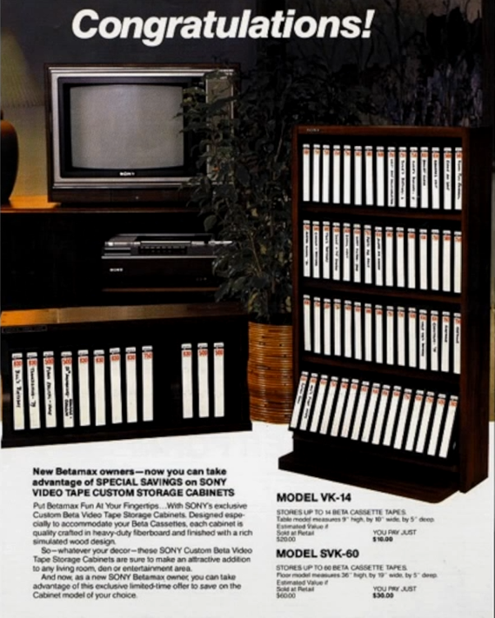
Figure 105: An advert for Sony Betamax tape storage cabinets

The majority of The Supreme Court pointed out that VCRs are commonly used for two quite different purposes. First, they’re sometimes used for “librarying”, a term the courts invented to describe taping broadcast television shows or films with an expectation of retaining the tapes and using them to replay the shows or films repeatedly. That activity is tacitly promoted by the advertisement in Figure 105. Second, VCRs are even more often employed to tape shows or films that are broadcast at a time inconvenient for the viewer, enabling the viewer to watch them once at a later time, whereupon the tapes are erased. The latter function, promoted by this advertisement, the court described as “timeshifting”. Because time shifting is a common use of the machines, if it were lawful, Sony could escape liability under the first of the two holdings. The court decided that timeshifting was indeed lawful because it qualified as a fair use under Section 107 of the statute, and therefore, Sony was home free. To support its judgment on this issue, the court surveyed the four statutory fair use factors. With respect to the first factor, the court emphasized the fact that the behavior of the VCR users was in the court’s judgment noncommercial in character. Here’s how Justice Stevens writing for the court put the point.

Although not conclusive, the first factor requires that the commercial or nonprofit character of an activity be weighed in any fair use decision. If the Betamax were used to make copies for a commercial or profit making purpose, such use would be presumptively unfair. The contrary presumption is appropriate here, however, because the district court’s findings plainly establish that timeshifting for private home use must be characterized as a noncommercial, nonprofit activity.

Interestingly, Stevens did not mention in his opinion the second statutory factor – the nature of the copyrighted work, so we’ll leave that box blank. The third factor – the amount of copying – would seem to disfavor of finding a fair use, insofar as the VCR users were making verbatim copies of entire shows or films. “Nevertheless, the court ruled that in light of the fact that “timeshifting merely enables a viewer to see such a work which he had been invited to witness in its entirety free of charge,” the fact that the entire work is reproduced does not have its ordinary effect of militating against the finding of fair use. The court thus implied that this third factor was neutral. The decisive factor in the court’s judgment was the fourth – the magnitude of the adverse impact upon the potential market for the studio’s films. In the court’s judgment, the noncommercial character of the viewer’s activities cast the burden of proof with respect to this factor upon the studios. Here’s how it put the point.

A challenge to a noncommercial use of a copyrighted work requires proof either that the particular use is harmful. Or that, if it should become widespread, it would adversely affect the potential market for the copyrighted work. Actual present harm need not be shown, nor is it necessary to show as certainty that future harm will result. What is necessary is that showing by preponderance of the evidence that some meaningful likelihood of future harm exists.

In the court’s view, the record in the case – which had been created in 1978 – failed to establish a likelihood of economic injury to the studios. Accordingly, the court ruled that the fourth factor inclined in favor of a finding of fair use. Finally, the court pointed to a variable not included in the statutory list of factors. “The district court’s conclusions are buttressed by the fact that to the extent time shifting expands public access to freely broadcast television programs, it yields societal benefits.” Taking all these variables into account, the Supreme Court affirmed the district court’s judgment that timeshifting should be considered fair.
Justice Blackmun wrote a dissent in the case, which was joined by three other justices. Blackmun disagreed with the majority of the justices on two main points. First, drawing on the Ninth Circuit’s opinion, he differentiated what he called ordinary and productive uses of copyrighted materials. Suggesting that the latter – meaning productive uses – are more likely to qualify as fair than the former. Here’s how Blackmun made his argument.

The situations in which fair use is most commonly recognized are listed in section 107 itself. Fair use may be found when a work is used “for purposes such as criticism, comment, news reporting, teaching, … scholarship, or research.” … Each of these uses reflects a common theme. Each is a productive use resulting in some added benefit to the public beyond that produced by the first author’s work. The fair use doctrine, in other words, permits works to be used for “socially laudable purposes”. I am aware of no case in which the reproduction of a copyrighted work for the sole benefit of the user has been held to be fair use.

Second, Blackmun interpreted the fourth statutory factor more expansively than did the majority. Specifically, Blackmun emphasized the adjective potential in the statute. Here’s how he interpreted that word.

The requirement that a putatively infringing use of the copyrighted work, to be “fair,” must not impair a “potential” market for that work has two implications. First, and infringer cannot prevail merely by demonstrating that the copyright holder suffered no net harm from the infringer’s action. Indeed, even the showing that the infringement has resulted it in a net benefit to the copyright holder will not suffice. Rather, the infringer must demonstrate that he had not impaired the copyright holder’s ability to demand compensation from (or to deny access to) any group who would otherwise be willing to pay to see or hear the copyrighted work. Second, the fact that a given market for a copyrighted work would not be available to the copyright holder were it not for the infringer’s activities does not permit infringer to exploit that market without compensating the copyright holder.

Applying this definition of potential market to the facts of the case, Blackmun concluded that the needle tilted toward the studios. And so far as a finding of fair use, we deprive them of access to the “market consisting of those persons who find it impossible or inconvenient to watch the programs at the time they are broadcast, and who wish to watch them at other times. These persons are willing to pay for the privilege of watching the copyrighted work at their convenience as is evidenced by the fact that they are willing to pay for VCRs and tapes. Undoubtedly, most also would be willing to pay some kind of loyalty to copyright holders. The studios correctly argue that they’ve been deprived of the ability to exploit this sizable market.” The majority of the justices, as you’ve seen, were unconvinced.
In the many briefs filed with the Supreme Court – and in associated congressional testimony which was being conducted at more or less the same time – the studios and their allies predicted dire consequences if Sony escaped liability. Most lurid was a statement by Jack Valenti, the president of the MPAA whom you encountered in lecture number six. Valenti famously declared, “The VCR is to the American film producer and the American public as the Boston Strangler is to the woman home alone.” As it turned out, the result of the court’s decision was not so dire. Indeed, the film industry seems to have benefited from the machines. Box office revenues did not seem to suffer. Even more dramatically, the widespread distribution of VCRs made possible the emergence of a new and even more lucrative market consisting of home video rentals and purchases.
While the courts were dealing with the Betamax case, a second major dispute implicating the fair use doctrine was brewing. The facts were very different. In the late 1970s, former President Gerald Ford with a substantial assistance of a ghost writer wrote an autobiography. He assigned the copyright in the book to Harper and Row in return for a substantial payment. In 1979 Harper and Row entered into a contract with Time Magazine, under which Time acquired the right to publish excerpts from the book just before the publication of the book itself. Unfortunately for Time, The Nation Magazine scooped it. Here’s how.
A few weeks before the Time article was to appear, an unknown person provided a copy of the manuscript to Victor Navaski, who was then editor of The Nation. Navaski hastily drafted an article describing the book. Included in that article were some 300 words taken from Ford’s manuscript. When The Nation’s story appeared, Time Magazine canceled its contract with Harper and Row, and refused to pay the balance of the contract price. Harper and Row thereupon brought a copyright infringement suit against The Nation. Once again, the parties traded victories as the case wound its way upward through the judicial system. The district court ruled in favor of Harper and Row by a vote of two to one. Court of Appeals for the Second Circuit reversed, ruling that the modest amount of verbatim copying made by The Nation should be excused as fair. The Court of Appeals ruling was in turn reversed by the United States Supreme Court by a vote of six to three. Justice O’Connor, writing for the court, concluded that all four of the fair use factors tilted in favor of the plaintiff. With respect to the first factor, she emphasized the following two points. First, the defendant was making money from the unauthorized use. The Betamax opinion, you’ll recall, had included the sentence, “Every commercial use of copyrighted material is presumptively an unfair exploitation of a monopoly privilege that belongs to the owner of copyright.” That presumption, O’Connor ruled, operated to the disadvantage of the defendant here because he was engaged in a profit-making venture. Second, O’Connor stressed the illicit way in which Navaski had gained access to the plaintiff’s manuscript. This was germane, she contended, because one dimension of the “character” of the defendant’s use is “the propriety of the defendant’s conduct.” Fair use, she insisted, presupposes good faith and fair dealing.
With respect to the second statutory factor, O’Connor conceded that “the law generally recognizes a greater need to disseminate factual works than works of fiction or fantasy.” However, she concluded that the quotations Navaski had taken from Ford’s manuscript were more expressive than factual. Even more important was the fact that the manuscript had been unpublished at the time the defendant acted, and thus economically especially vulnerable.
With respect to the third factor, O’Connor ruled that the assessment of amount must be as much qualitative as quantitative. The fact that Navaski had only taken some 300 words was less important than the fact that the portion taken was “essentially the heart of the book,” including the precise language in which Ford explained his decision to pardon Richard Nixon.
Like the court in the Betamax case, O’Connor placed greatest weight on the fourth and final factor. But she defined the phrase “potential market” in the fourth factor more broadly than had just Stevens in the Betamax case. Citing Justice Blackmun’s Betamax dissent, O’Connor ruled that “to negate fair use, one need only show that if the challenged use should become widespread, it would adversely affect the potential market for the copyrighted work. This inquiry must take into account not only harm to the original, but harm to the market for derivative works.” Application of that framework to the facts of this case plainly favored the plaintiff, she ruled, because Time Magazine’s decision to cancel the contract with Harper and Row cost it significant revenue. The bottom line is the fair use defense failed.
The third of the three cases arrived in the Supreme Court almost a decade later. Whereas the Betamax case, as we saw, involved audio-visual works, and the Harper and Row case involved literary works, this one involved music. The plaintiff was Acuff-Rose Music, a music publisher that held the copyright in the composition, “Oh, Pretty Woman”, originally written by Roy Orbison. Here’s an excerpt of Orbison’s rendition of his composition. [Music: Roy Orbison, “Oh, Pretty Woman”.]
In 1989, Luther Campbell, one of the members of the rap group, 2 Live Crew, wrote a song that he characterized as a parody of Orbison’s composition. Here’s an excerpt of 2 Live Crew’s rendition of Campbell’s song. [Music: 2 Live Crew, “Pretty Woman”.]
Before this recording was released, the manager of 2 Live Crew sought a license from Acuff-Rose, but was refused. 2 Live Crew released the recording anyway. A year later, after roughly 200,000 copies have been sold, Acuff-Rose brought a copyright infringement suit. Now you might wonder why 2 Live Crew did not rely upon the Section 115 so-called cover license that we’ve discussed previously, which would have allowed them to release the recording without permission provided they paid Acuff-Rose a modest fee which they seemed to have been going to do. The reason is that, as You’ll recall the Section 115 license is only available to a musician who makes a cover that does not alter “the basic melody or fundamental character” of the composition at issue. 2 Live Crew, as you might expect, conceded that they could not satisfy that requirement. As a result, the only basis on which 2 Live Crew might have avoided liability was fair use.
Once again, the courts that consider the case split. The trial court ruled that 2 Live Crew was shielded by the fair use doctrine. The Court of Appeals for the Sixth Circuit reversed by a vote of two to one, and the United States Supreme Court in turn reversed the Court of Appeals, this time in a unanimous opinion. Although technically, the Supreme Court remanded the case for further proceedings, its ruling was widely and rightly interpreted as a victory for 2 Live Crew. Although Justice Souter, writing for the court, purported to merely be applying well settled principles, in fact his opinion represented a substantial reconfiguration of the fair use doctrine. The most important of the shifts implicit, in Souter’s opinion, concerned factor number one. You’ll recall that in the Betamax case, Justice Blackmun, in dissent, had differentiated ordinary from productive uses of copyrighted works, arguing unsuccessfully that the latter deserved wider latitude when applying the fair use doctrine. And Campbell, just as Souter, tacitly adopted Blackmun’s position. The crucial language is below.

The first factor in a fair use enquiry is ‘the purpose and character of the use.’… The central purpose of this investigation is to see, in Justice Story’s words, whether the new work merely ‘supersede[s] the objects’ of the original creation, or instead adds something new, with a further purpose or different character, altering the first with new expression, meaning, or message; it asks, in other words, whether and to what extent the new work is ‘transformative.’ Although such transformative use is not absolutely necessary for a finding of fair use, Sony, [464 U.S.] at 455, n. 40, the goal of copyright, to promote science and the arts, is generally furthered by the creation of transformative works. Such works thus lie at the heart of the fair use doctrine’s guarantee of breathing space within the confines of copyright, see, e. g., Sony, supra, at 478-480 (Blackmun, J., dissenting), and the more transformative the new work, the less will be the significance of other factors, like commercialism, that may weigh against a finding of fair use.

The principles set forth in this paragraph, as we will see, have colored all subsequent fair use jurisprudence. Applying this approach to the facts of the Campbell case, the Supreme Court announced broadly “parody is an obvious claim to transformative value.” What then constitutes a parody? The court offered several definitions, including the following.

Modern dictionaries accordingly describe a parity as a “literary or artistic work that imitates the characteristic style of an author, or a work, for comic effect or ridicule,” or as a “composition in prose or verse, in which the characteristics turns of thought and phrase, and an author or class of authors are imitated in such a way as to make them appear ridiculous.” For the purposes of copyright law, the nub of the definitions and the heart of any parodist’s claim to quote from existing material, is the use of some elements of a prior author’s composition to create a new one that, at least in part, comments on that author’s works.

All of the justices, except Justice Kennedy, seemed satisfied that 2 Live Crew’s song fit within this definition, and thus that the first statutory factor favored the defendant. To be sure, the Supreme Court did not rule that any work that falls within this definition automatically qualifies as fair. On the contrary, the court announced that “parody, like any other use, has to work its way through the relevant statutory factors and be judged case by case in light of the ends of copyright law.” However, as we will see, the way in which the court worked those statutory factors strongly favored parodists.
With respect to the second factor, the court conceded that Orbison’s song “fell within the core of copyright’s protective purposes,” but it discounted the significance of that fact when the defendant’s work consists of a parody. You’ll recall that in the Harper and Row case, Justice O’Connor countered the third factor against Victor Navaski on the grounds that he had taken the heart of President Ford’s biography. In the Campbell case, the Court of Appeals relied in part on O’Connor’s language when ruling against 2 Live Crew.
Justice Souter, writing for the Supreme Court, appeared to agree with the premise. Namely that 2 Live Crew had taken the heart of Orbison’s song. However, Souter did not consider that fact fatal. Here’s the way he put the point.

If quotation of the opening riff and the first line may be said to go to the heart of the original, the heart is also what most readily conjures up the song for parody. And it is the heart at which parody takes aim. Copying does not become excessive in relation to parodic purpose merely because the portion taken was the original’s heart. If 2 Live Crew had copied a significantly less memorable part of the original, it is difficult to see how its parodic character would come through.

The Supreme Court did not definitively resolve the application of the fourth factor, instead remanding the case to the lower courts for reconsideration of this issue. But the guidelines that Souter provided the lower courts strongly suggested that the outcome of that inquiry would favor 2 Live Crew. In particular, the Supreme Court repudiated the “presumption that the Court of Appeals had quite plausibly derived from the Betamax and Harper and Row opinions. Namely the presumption that commercial uses of copyrighted materials give rise to injuries to the market for the original work.” Souter and Campbell limited the scope of that ostensible presumption to the context of “verbatim copying of the original in its entirety for commercial purposes.” No such presumption, he contended, is appropriate when the defendant’s use is transformative as in parody. The likely result, the 2 Live Crew song would qualify as a fair use.
So, this concludes our review of the way in which fair use doctrine in the United States evolved from its inception in the early 19th century through the Campbell case. The table below summarizes the application of the four fair use factors in the three cases.
Table 5: The application of the fair use factors in the Sony, Harper & Row, and Campbell cases
 | Sony | Harper & Row | Campbell
- Purpose and character of defendant’s use | ▪ | ▪ | ▪
- Nature of copyright work |  | ▪ | ▪
- Amount of copying | Neutral | ▪ | Neutral
- Impact on potential market | ▪ | ▪ | ▪
 | Fair | Unfair | Fair
▪ Favours fairness ▪ Disfavours fairness

Fair Use Today
Many cases implicating the fair use doctrine have been decided by the federal courts since 1976, when section 107 was added to the federal statute. The most important of those cases are, of course, the three United States Supreme Court decisions that I reviewed in the previous segment of this lecture. But those three decisions leave many issues unresolved. Some, but not all, of the gaps left by the Supreme Court have been filled by the lower court’s rulings. In this segment of the lecture, I’ll try to describe the shape of the fair use doctrine today. I’ll attempt both to identify the dimensions of the doctrine that are now reasonably well settled and to highlight the dimensions that remain contested. For this purpose, I’ll be using the now familiar map of copyright law.
As we’ve seen, courts almost always analyze their fair use defenses by considering the four factors listed in section 107. I will follow their lead in this regard. In other words, I will describe to you what each factor has come to mean and the role it has come to play in the overall landscape of fair use. The first factor, as you now know, concerns the purpose and character of the defendant’s activity. The courts look askance at some kinds of behavior and regard much more favorably other kinds of behavior. Four sub-factors under this general heading can be distilled from the case law. These so-called sub-factors identify the kinds of things that the courts attend to when discussing the character of the defendant’s behavior.
The first sub-factor is whether the defendant is engaged in commercial or non-commercial activities. As you might imagine, the more commercial the defendant’s conduct, the less likely is the defendant to be given the benefit of fair use. This sub-factor, as we’ve already seen, figured prominently in the Betamax case. It has been declining in importance since then but has not disappeared altogether.
You might think that the application of this sub-factor would be straightforward, and often it is. But difficulties arise out of the ambiguity of the term “commercial.” Courts rarely define that term explicitly. Most often, they seem tacitly to assume that “commercial” means revenue generating or perhaps profit making, but occasionally, in borderline cases, courts will attempt to define the term more precisely. One such definition can be found in the Harper & Row case. There, Justice O’Connor defined “commercial” as “whether the user stands to profit from the exploitation of the copyrighted material without paying the customary price.” This would be an altogether conventional definition but for the term “customary,” which seems to imply that some potentially profit-making activities are nevertheless not commercial in character if it’s not customary for firms engaged in the activity at issue to pay for access to works of the sort claimed by the plaintiff. It’s unlikely that Justice O’Connor intended to narrow the meaning of “commercial” in quite this way, but judicial definitions sometimes assume lives of their own, and this one has. So for example, Justice O’Connor definition can be found in the 11th Circuit’s opinion in the Letterese case and the Fourth Circuit’s opinion in the AV case. A much more generous definition of the term “commercial” can be found in the Ninth Circuit’s opinion in the Napster case. Now, we’ll discuss Napster in some detail in the 11th lecture when we examine, as I said, the doctrine of contributory copyright infringement, but the basic facts of the Napster case are undoubtedly familiar to most of you. The Napster file sharing service did not itself redistribute sound recordings, but it facilitated unauthorized copying and distribution of sound recordings by its subscribers. One of the issues in the infringement suit brought against Napster by the record companies and the music publishers was whether the conduct of Napster subscribers qualified as fair uses, just as the conduct of Sony’s customers, as we’ve seen, qualified as fair uses in the Betamax case. The Ninth Circuit concluded no. One of the steps in the Ninth Circuit’s analysis that led to this conclusion was the judgment that the behavior of the individual Napster users should be considered commercial in character. That highly counter-intuitive finding rested upon the capacious definition of “commercial”: in the Ninth Circuit’s judgment, the term included “repeated and exploitative copying in order to save the expense of purchasing legitimate copies.” Thus, even though the Napster users were not making any money, they were engaged in commercial behavior, said the Ninth Circuit, because they were avoiding paying money. This is an outlier position. It’s far from clear that other courts in analogous circumstances would follow the Ninth Circuit’s lead.
In some fair use cases, the defendant’s behavior does not give rise directly to an increased revenue stream but contributes to an overall process or enterprise whose ultimate objective is plainly commercial. The courts have not yet worked out a consistent way of handling such cases. So here are two influential decisions involving this general issue that resolved it in different ways. The first case is Sega Enterprises versus Accolade, which was decided by the Court of Appeals for the Ninth Circuit in 1992. To understand the decision requires a bit of background. In the context of computer software, the term “interoperability” refers to the ability of one program to talk or work with another. An especially important context involving interoperability concerns the relationship between operating systems and application programs. The intellectual property questions implicated by this issue have been examined most thoroughly by Julie Cohen, who teaches copyright at Georgetown. As Cohen observed in an article some time ago, there are three main business models adopted by different groups of software firms pertaining to the issue of interoperability.
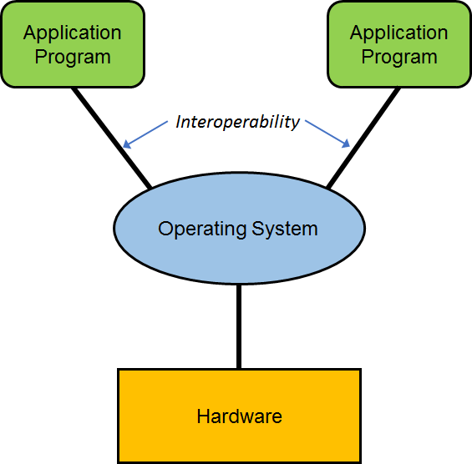
Figure 106: Interoperability

The first approach, exemplified by Microsoft, grants the developers of application programs free or more or less free access to the interfaces necessary to render their programs compatible with a proprietary operating system. The second business model, which was pursued at least at one time by several game console manufacturers, including Nintendo, entails permitting the developer of application programs – in this case, games – to manufacture and distribute games that would run on a proprietary operating system console, but only if the game developers pay license fees. The third strategy, exemplified by MAI Systems Corporation, repudiates interoperability. Manufacturers adopting this approach seek to maintain complete control over application programs as well as their operating systems.
The Sega case involved the second of these three approaches. The plaintiff, Sega, manufactured and sold game consoles which included operating systems. A small piece of the operating system consisted of a bit of code known as a lockout program. Sega’s own games as well as the games produced by independent but licensed game manufacturers included the key necessary to open the lock on Sega’s system. The defendant in this case, Accolade, wished to manufacture and distribute games compatible with the Sega system without obtaining a license from Sega and without paying the associated license fees. To do this, Accolade engineers made copies of significant portions of Sega’s software, used decompilers to ascertain the crucial piece of source code, and then included the essential bit in its own games, thereby rendering them compatible with the Sega system. Sega brought suit asserting, among other things, that by copying Sega’s software in the course of this reverse engineering process, Accolade had engaged in copyright infringement. The Court of Appeals for the Ninth Circuit ruled that Accolade had indeed violated section 106(1) of the statute, but it escaped liability under the fair use doctrine. The central theme in the Ninth Circuit’s opinion was that Accolade’s purpose was legitimate and socially beneficial. It’s not altogether obvious why, unless one believes that increasing the availability of video games enhances social welfare, but in any event, our main concern here is with the portion of the court’s opinion that addresses the nature and character of the defendant’s activity and specifically whether Accolade’s conduct should be described as commercial or not. The Ninth Circuit, when addressing that issue, conceded that Accolade was a for-profit company and the ultimate ambition of the challenged behavior was, of course, to enhance Accolade’s profits. Nevertheless, the Ninth Circuit refused to classify Accolade’s unauthorized copying as commercial in character. Here’s the relevant passage from the opinion.
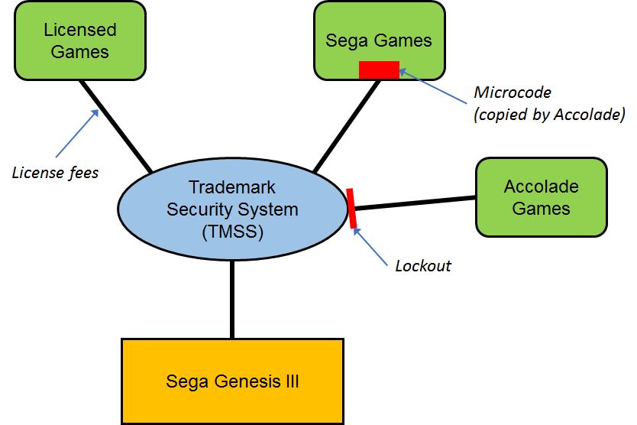
Figure 107: Sega Enterprises Ltd. v. Accolade, Inc. (9th Cir. 1992)

Taken together, these facts indicate that although Accolade’s ultimate purpose was the release of Genesis-compatible games for sale, its direct purpose in copying Sega’s code, and thus its direct use of the copyrighted material, was simply to study the functional requirements for Genesis compatibility so that it could modify existing games and make them usable with the Genesis console. Moreover, no other method of studying those codes was available to Accolade. On these facts, we conclude that Accolade copied Sega’s code for a legitimate, essentially non-exploitative purpose and that the commercial aspects of its use can best be described as of minimal significance.

OK, that’s one approach.
The second case was decided a few years later by the Court of Appeals for the Second Circuit. The essential facts were as follows. Texaco employed between 400 and 500 researchers nationwide. Their job was to conduct scientific research in order to develop new products and technologies in the petroleum industry. Texaco subscribed to various scientific journals. However, it did not purchase enough copies of those journals to serve fully the needs of its many researchers. A custom seems to have developed within the Texaco facilities under which individual scientists would either make themselves or ask to be made for them utho copies of articles contained in the print journals that the scientist might find useful in their own research. The publishers and copyright owners of the articles challenged this practice as copyright infringement. Texaco’s primary line of defense for this behavior was fair use. The Court of Appeals for the Second Circuit ultimately sided with the publishers and rejected the fair use defense. The step in the court’s analysis with which we are primarily concerned here involves whether the behavior of the scientists qualified as commercial. The Court of Appeals equivocated on this point. Unlike the Ninth Circuit, the Second Circuit did not discount altogether the profit-making objective of the company as a whole. However, it too accorded some weight to the fact that the immediate objective of the scientists was research. Here’s the key passage in the Second Circuit’s opinion.

In this particular case, the link between Texaco’s commercial gain and its copying is somewhat attenuated, the copying at most merely facilitating Chickering’s research [Chickering was one of the scientists] that might have led to the production of commercially-valuable products. Still, we need not ignore the for-profit nature of Texaco’s enterprise, especially since we can confidently conclude that Texaco reaps at least some indirect economic advantage from its photocopying. As the publishers emphasized, Texaco’s photocopying for Chickering could be regarded simply as another factor of production utilizing Texaco’s efforts to develop profitable products. Conceptualized in this way, it is not obvious why it is fair for Texaco to avoid having to pay at least some price to copyright holders for the right to photocopy the original articles.

So where does the combination of these two cases leave us? The answer is, unfortunately, without clear guidance. When employees within a for-profit enterprise engage in unauthorized copying whose immediate purpose might be characterized as research or study, the employer may be able to contend that it should not be hit with the label “commercial.” But how much latitude it will be given on this score is, unfortunately, hard to predict.
As I said, the question of whether a defendant’s behavior is commercial or non-commercial in character remains a significant part of the fair use inquiry. However, that sub-factor is being eclipsed increasingly by the second sub-factor, which asks whether the defendant’s behavior is transformative. As we saw, this theme was highlighted by the United States Supreme Court in the Campbell case. Since the Campbell decision, the issue of transformativeness has grown further in importance. Today, it’s fair to say that defendants unable to persuade a court that their activities are transformative are unlikely to prevail on fair use grounds, whereas defendants who are able to assume the mantle of transformativeness are quite likely to prevail. As one might expect, litigants now spend much of their time struggling over who has the better of the argument on this issue. Unfortunately, as we will see, there remains significant ambiguity concerning the possible meaning or meanings of the term “transformative.” This uncertainty destabilizes fair use analyses and increases the notorious unpredictability of the doctrine as a whole.
The only dimension of this issue that is clear cut concerns the status of parody. It’s now well settled that parodies, even bad parodies, do qualify as transformative uses. Plaintiffs no longer contended parodies of their works are not transformative. Instead, plaintiffs seek to persuade tribunals that, in borderline cases, the defendants’ works do not constitute parodies. Much hinges on this issue. When evaluating disputes of this sort, courts commonly make reference to the definitions of parody that were offered by the Supreme Court in Campbell. You’ve seen these definitions once before in this lecture. Here they are again.

Modern dictionaries describe a parody as a “literary or artistic work that imitates the characteristic style of an author or work for comic effect or ridicule” or as a “composition in prose or verse in which the characteristic turns of thought and phrase in an author or class of authors are imitated in such a way as to make them appear ridiculous.” For the purposes of copyright law, the nub of the definitions is the use of some elements of a prior author’s composition to create a new one that, at least in part, comments on that author’s works.

The ambit of this definition is perhaps best illustrated by example. Annie Liebovitz, as you likely know, is a famous and accomplished photographer. In 1991, she took a nude photograph of the pregnant Demi Moore which appeared on the cover of the August 1991 issue of Vanity Fair magazine. The photo plainly alluded to Botticelli’s “The Birth of Venus” (see Figure 108).
In 1994, Paramount Pictures began to promote its upcoming movie Naked Gun 33⅓. One of its posters included this composite photo of Leslie Nielsen, the star of the film. Liebovitz brought a copyright infringement suit. Interestingly, Paramount conceded that its poster violated Liebovitz’s rights under section 106 but sought refuge in fair use. The district court granted summary judgment for the defendant, and the Court of Appeals affirmed. A key step in the Court of Appeals analysis was a determination that the poster constituted a parody of the Demi Moore photo. The court justified that determination in the following terms.

Being different from an original does not inevitably comment on the original. Nevertheless, the ad [meaning the poster] is not merely different. It differs in a way that may reasonably be perceived as commenting through ridicule on what a viewer might reasonably think is the undue self-importance conveyed by the subject of the Liebovitz photograph. A photographer posing a well-known actress in a manner that calls to mind a well-known painting must expect or at least tolerate a parodist’s deflating ridicule. Apart from ridiculing pretentiousness, the ad might also reasonably be perceived as interpreting the Liebovitz photograph to extol the beauty of the pregnant female body and, rather unchivalrously, to express disagreement with this message. The district court thought such a comment was reasonably to be perceived from the contrast between a serious portrayal of a beautiful woman taking great pride in the majesty of her pregnant body and a ridiculous image of a smirking, foolish-looking pregnant man.
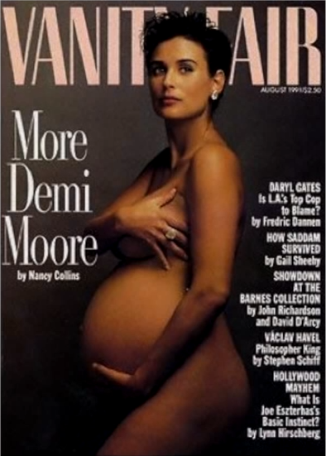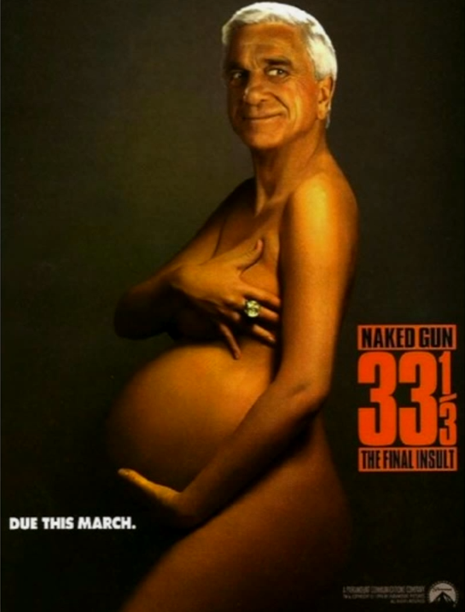
Figure 108: The Vanity Fair cover featuring Demi Moore, a portion of Botecelli's "The Birth of Venus", and the Naked gun 33⅓: The Final Insult poster that parodies the Vanity Fair cover

A very similar analysis underlay the determination five years later by the Ninth Circuit Court of Appeals that a series of photos by Thomas Forsythe constituted parodies of Mattel’s copyrighted character Barbie. Figure 109 shows a familiar image of Barbie. Mattel owns copyrights to parts of this figure – specifically, in the court’s words, “to the unadorned Superstar Barbie head and parts of the figure, including revisions to the hands, feet, neck, shoulder, and buttocks.” Forsythe, without permission, took a series of photos of naked Barbie dolls, which he called “Food Chain Barbie” (shown in Figure 109).
The Ninth Circuit, when the case arrived at its doorstep, concluded that Forsythe’s photos plainly qualified as parodies.
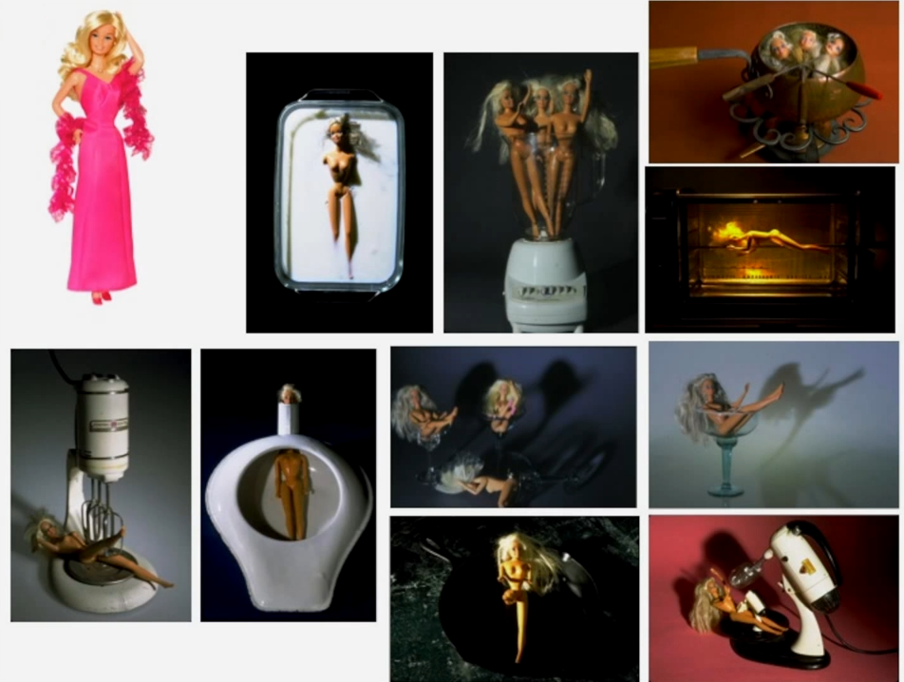
Figure 109: Mattel’s Barbie and photos from Forsythe’s series “Food Chain Barbie”

Mattel, through impressive marketing, has established Barbie as the ideal American woman and a symbol of American girlhood for many. As abundantly evidenced in the record, Mattel’s advertisements show these plastic dolls dressed in various outfits, leading glamorous lifestyles, and engaged in exciting activities. To sell its product, Mattel uses associations of beauty, wealth, and glamour. Forsythe turns this image on its head, so to speak, by displaying carefully-positioned, nude, and sometimes frazzled-looking Barbies in often ridiculous and apparently dangerous situations. His lighting, background, props, and camera angles all serve to create a context for Mattel’s copyrighted work that transform Barbie’s meaning. Forsythe presents the viewer with a different set of associations and a different context for this plastic figure. In some of Forsythe’s photos, Barbie is about to be destroyed or harmed by domestic life in the form of kitchen appliances yet continues displaying her well-known smile, disturbingly oblivious to her predicament. As perpetrated in some of Forsythe’s photographs, the appliances are substantial and overwhelming, while Barbie looks defenseless. In other photographs, Forsythe conveys a sexualized perspective of Barbie by showing the nude doll in sexually-suggestive contexts. It’s not difficult to see the commentary that Forsythe intended or the harm that he perceived in Barbie’s influence on gender roles and the position of women in society.

An important procedural issue lurks in this passage. The Ninth Circuit is not interested in what the public at large thinks of Forsythe’s photos. Indeed, it approved the trial court’s refusal to consider a survey that Mattel had commissioned on the issue. Why? Because “the issue of whether a work is a parody is a question of law, not a matter of public majority opinion.”
So, those are two cases in which the defendant successfully invoked the privileged status of parodies. To repeat, parodies are not per se entitled to the fair use defense, but attaining that status helps you a great deal. In part because of the importance of this issue, courts are not always so receptive to defendants’ claims that their works constitute parodies. For example, the Second Circuit brushed aside the contention of Jeffrey Koons that when he used the photograph shown in Figure 110 as the reference work for this painted wooden sculpture (shown in Figure 111) he meant to mock the conventional, saccharine character of the photo. The court rejected Koons’ claim that his work was a parody of the plaintiff’s. Its rejection was based in part on the fact that the photograph was not widely known to the public, and thus most viewers of the sculpture would not know what it was aimed at, but in addition, the court was not persuaded that the sculpture meant to critique the photo.

The problem in the instant case is that even given that String of Puppies is a satirical critique of our materialistic society, it is difficult to discern any parody of the photograph Puppies itself. We conclude, therefore, that this first factor of the fair use doctrine cuts against a finding of fair use. The circumstances of this case indicate that Koons’ copying of the photograph Puppies was done in bad faith primarily for profit-making motives and did not constitute a parody of the original work.
  Figure 110: Art Rogers, photograph: Puppies, 1980 | 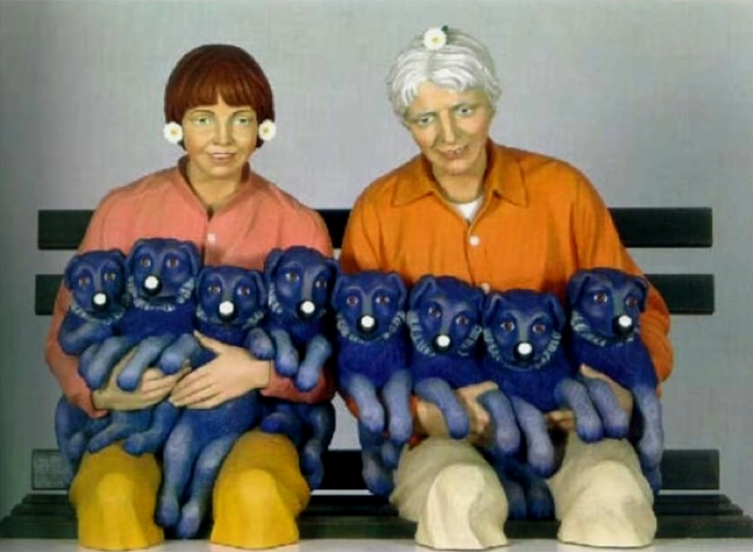  Figure 111: Jeff Koons, wood painted sculpture: String of Puppies, 1998

The same court was similarly unimpressed by the efforts of the defendants in the Castle Rock case, which I discussed in the preceding lecture, to establish that their trivia book was a parody of the Seinfeld television series. The defendant argued that the book “is a quintessential example of critical text of the TV environment … expos[ing] all of the show’s nothingness to articulate its true motive forces and its social and moral dimensions”. The court was unmoved. “Any transformative purpose possessed by the defendant’s book is slight to nonexistent. We reject the argument that it was created to educate Seinfeld viewers or to criticize, expose, or otherwise comment upon Seinfeld. The book’s purpose, as evidenced definitively by the statements of the book’s creators and by the book itself, is to repackage Seinfeld to entertain Seinfeld viewers.”
So, to repeat, parodies definitively qualify as transformative under factor number one. What about a defendant’s work that criticizes a plaintiff’s work but does not mock it? These too are highly likely to be treated as transformative. Here’s an example. One of John Lennon’s most famous songs is “Imagine.” Portions of its lyrics are critical of organized religion. Here’s an excerpt.

[Music: John Lennon, “Imagine”.]
(Lyrics) It isn’t hard to do.
Nothing to kill or die for, and no religion too.
Imagine all the people…

In this case, the defendant, without permission, included this segment of Lennon’s recording of the song in a movie that defended theories of intelligent design and criticized theories of evolution. The Southern District of New York ruled that the use of the excerpt from Lennon’s song was transformative because its purpose was “to criticize what the filmmakers see as the naiveté of John Lennon’s views,” and the court went on to rule in the defendant’s favor.
That non-parody criticism counts as transformative is not quite so clear as the proposition that parody counts as transformative. Indeed, at least one case, the Free Republic decision decided by the Central District of California in 2000, seems to stand for the opposite position. But the privileged status of criticism nowadays approaches that of parody.
Beyond this point, the meaning of “transformative” becomes increasingly contested and murky. Figure 112 shows a graphic representation of the nature of the ongoing debate on this front. Parody, as we’ve seen, clearly qualifies. A work by a defendant that criticizes the plaintiff’s work is also highly likely to qualify as transformative. Outside of this central zone, there are currently four main competing interpretations of “transformation.” The first treats works that physically modify the plaintiff’s work as transformative. The second equates the term “transformative” with “socially beneficial.” The third attaches the term “transformative” to works by defendants that have purposes that are different from the purposes of the plaintiff’s works. And the fourth associates the term “transformative” with creative uses of plaintiff’s works. This diagram intentionally depicts these interpretations as overlapping because, as you might imagine, some works will qualify as transformative under more than one interpretation. Were the circle simply boundaries, the diagram would be misleading in that it would suggest that each category has crisp boundaries. In truth, they’re all matters of degree. For example, one defendant’s work might be slightly socially beneficial, while another’s might be strongly so. Thus, the areas are shaded, recognizing that each category varies in density – strong near the core, weaker near the edges. Mapped onto this diagram are the leading cases involving fair use.
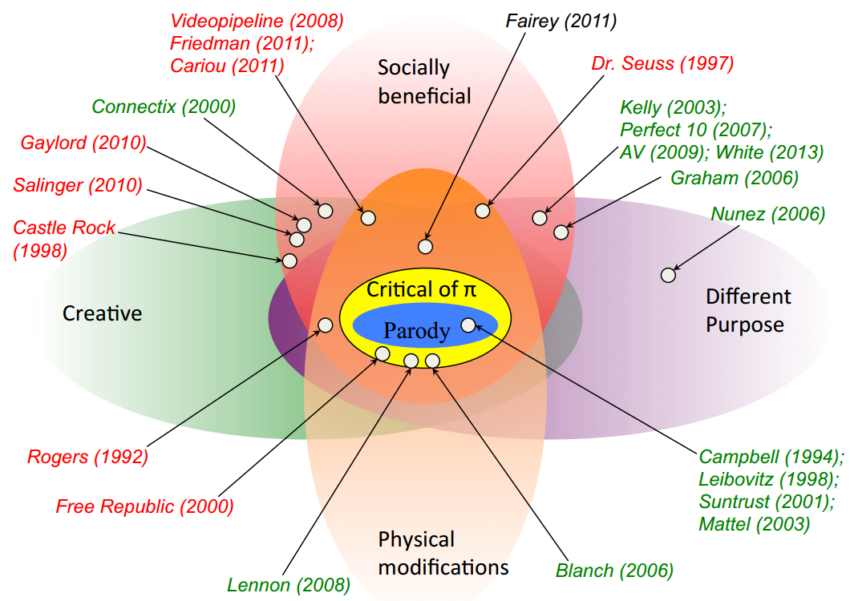
Case color legend: Defendant prevailed (green); Plaintiff prevailed (red); Unresolved (black).
Figure 112: The nature of “transformative” and leading cases involving fair use

I’ve tried, by locating each case or set of cases, to suggest which and how many of the meanings of “transformative” they might qualify for. The colors of the case names indicate who won or was favored. In the green cases, the defendant prevailed – in other words, the court either ruled in the defendant’s favor or indicated the fair use was likely. In the red cases, the plaintiff prevailed in the same sense. In the black cases, the issue of fair use was never resolved. Some of these cases you already know about. Others I will discuss later, and still others will be addressed in the classes and seminars that accompany this lecture series. One of the functions of this map is to suggest the relative strength of these four competing interpretations within the current case law.
For a while, the physical modifications approach seemed to have a significant following, but it has since faded. Why? Most likely because this interpretation is hard to reconcile with the proposition that copyright owners enjoy under section 106(2) the right to control the making of derivative works. Thus, as you’ll notice, many of the cases within this zone are red, meaning that the fair use defense failed.
More popular is the second approach, which looks to the degree to which a defendant’s conduct can be thought of as socially beneficial. However, you’ll also see some red cases in this zone. More popular still is the different purposes approach. Most of the cases in this zone, especially recent cases, you’ll see are green. The last approach finds as yet only modest support in the case law, although it figures more strongly in scholarship. We’ll return to this fourth option when we discuss cultural theory in the next lecture.
So, that’s where things currently stand with respect to transformation. Because of the prominent place of this issue in modern fair use doctrine, the struggle over the meaning of this term will likely continue for some time. I’ve devoted disproportionate attention to the first two sub-factors of factor number one because they’re particularly important. The current status of the other sub-factors and of the second and third factors in the list in section 107 can be described much more quickly. You’ll recall that Justice O’Connor in Harper & Row decreed that fair use presupposes “good faith and fair dealing.” As you might expect, lower courts give that statement some weight, but as it turns out, not much. Here’s a representative statement by the Second Circuit.

[J]ust how much weight within the first factor should a court place on this sub-factor of bad faith? … Campbell provides … support for the proposition that while the good or bad faith of a defendant generally should be considered, it generally contributes little to fair use analysis. … We believe this analysis further supports our conclusion that a finding of bad faith is not to be weighed very heavily within the first fair use factor and cannot be made central to fair use analysis. The Court recognized the continuing relevance of Harper & Row but clarified that the bad faith sub-factor can be de-emphasized and will not be dispositive of the first factor or fair use.

The Harper & Row opinion also included a statement suggesting that customary activities were more likely to qualify as fair than unconventional ones. “The fair use doctrine was predicated,” said Justice O’Connor, “on the author’s implied consent to reasonable and customary use when he released his work for public consumption.” This perspective associates the concept of fair use with an implicit license issued by a copyright owner. Some scholars – for example, Lloyd Weinreb in an influential article in the Harvard Law Review – have endorsed this perspective, but it has little following currently in the case law, in part because so many fair use cases nowadays involve new technologies as to which custom is essentially irrelevant.
If the first statutory factor focuses on the defendant, the second focuses on the plaintiff. The basic idea here is that some kinds of copyrighted works deserve stronger protections against unauthorized activities than do others. The way this is achieved is by making it harder for defendants to assert fair use when they make unauthorized uses of the former than the latter. So, what kinds of works are more deserving of protection? There are two well-recognized answers to that question and one additional answer that is implicit in the case law but not expressly recognized. The two well-established variables are A, unpublished works get more protection than published works, and B, creative works get more protection than factual ones. The Second Circuit’s decision in the Blanch case summarizes these two variables nicely.

Two types of distinctions as to the nature of the copyrighted work have emerged that have figured in the decisions evaluating the second factor – one, whether the work is expressive or creative, such as a work of fiction, or more factual, with a greater leeway being allowed to a claim of fair use where the work is factual or informational; and two, whether the work is published or unpublished, with the scope for fair use involving unpublished works being considerably narrower.

This point bears emphasis, because it’s not often recognized. Not all works, it turns out, enjoy the same degree of protection. The closer you are to the bottom left corner of Figure 113, the stronger your legal shields. The closer you are to the upper right corner, the weaker your shields. The implicit supplement to these two variables is that, in practice, computer software seems to get less protection than other sorts of copyrighted works. In other words, in the software context, defendants have an easier road to hoe.
The third factor is the least surprising component of modern fair use doctrine. The more you take from a plaintiff’s work, the weaker, in general, is your fair use defense. As from the Harper & Row case, the inquiry under this factor is both quantitative and qualitative. If you take a small slice but it’s a very important part of the plaintiff’s work, you’re in trouble on this front. Note that, at least ostensibly, it doesn’t matter whether the slice you take forms a large or small portion of your own work. It’s only relevant whether it’s a large and important part of the plaintiff’s.
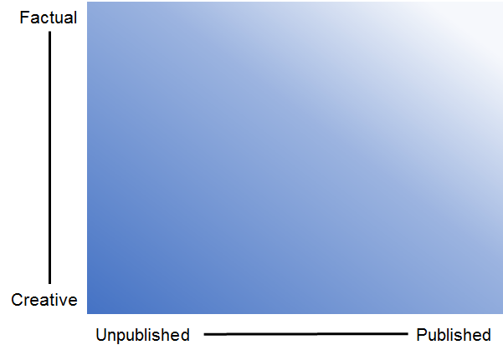
Figure 113: Strength of copyright protection

The only thing that’s surprising about this variable is how often it does not prove decisive. Think of the cases we’ve considered thus far. In the Betamax case, the VCR users were making verbatim copies of entire copyrighted works and yet were found to have engaged in fair use. In Harper & Row, by contrast, the Nation took some 300 words from Ford’s vastly larger manuscript and still lost.
We come finally to factor number four. For many years, this was said to be the most important factor. Today, it may have to play second fiddle to factor number one and the transformativeness inquiry in particular, but it’s still given great weight. The core idea is straightforward. The greater the injury sustained by the plaintiff as a result of the defendant’s conduct, the less likely it is that the defendant’s conduct will be deemed fair. But as we’ll see, complexities and conflicts lie just under the surface of that statement.
The first guideline when applying this factor is that not all kinds of what might be considered injuries count. In particular, it’s now reasonably clear that four types of what might be considered losses by the plaintiff are excluded from consideration. First, a plaintiff cannot claim that he suffered economic harm because he was prevented from charging the defendant a license fee. Among the reasons that foregone license fees from the defendant are excluded from the analysis is that otherwise the fourth factor would always favor the plaintiff, which was plainly not Congress’ intent. Second, loss of revenue resulting from the plaintiff’s inability to charge the defendant or others for the right to make transformative uses of the plaintiff’s work also do not count. As you can see, this sub-factor dovetails with the first factor. It reinforces the privileged position within the fair use calculus of transformative uses. To illustrate, a plaintiff cannot assert under the auspices of the fourth factor that he suffers economic losses because of his inability to charge parodists fees. Third, as we saw in the Campbell case, plaintiffs cannot assert as economic injuries diminution in their markets resulting from defendants’ criticism or ridicule of their works. The borderline question, the answer to which is not yet clear, concerns injuries arising from what might be called tarnishment of the plaintiff’s work – in other words, corrosion as result of the defendant’s conduct of the positive associations that the plaintiff’s work has in the minds of consumers. Finally, at least one court has held that a plaintiff can only complain of injuries to the market for the copyrighted work at issue in the case, not collateral injuries to other copyrighted works owned by the plaintiff.
These exclusions are important, but they leave many opportunities for plaintiffs to identify economic harms. In particular plaintiffs may count under the fourth factor not only damage to the existing markets for the copyrighted works but also damage to “potential markets” for the work, and they may also claim injuries that have not yet occurred as a result of the defendant’s behavior but that will occur if the defendant’s conduct becomes widespread.
The most important and fraught word in this formula is “potential.” As I say, it’s now clear that injuries to potential markets count in the plaintiff’s favor. What’s unclear is what constitutes a potential market. One can find in the case law a broad spectrum of approaches to this key question. Near one extreme is the position apparently taken by the Ninth Circuit in the Galoob case. Potential markets consist of markets that the plaintiff has developed or is likely to develop. This approach would exclude, for example, markets that the plaintiff lacks the technical capacity to exploit or that are within the defendant’s control. Near the opposite extreme is the position that, as we saw, was taken by Justice Blackmun dissenting in the Betamax case. Any group of people who would pay for access to the plaintiff’s work constitute a potential market, even if the plaintiff is unable or uninterested in exploiting that market and even if the market would not exist but for the defendant’s initiative or technological innovation. In between these positions are several intermediate options. The formulation that seems to appear most often in the case law is the one listed on the third tier on the chart. The markets cognizable under the fourth factor include “traditional, reasonable, or likely to be developed markets,” but some courts expressly or implicitly adopt positions more favorable to plaintiffs or more favorable to defendants.
A possible explanation for why this crucial issue remains unresolved is that no court has convincingly connected its stance on this question to any of the underlying theories of copyright. Until that happens, litigants and judges will struggle to define the set of harms that plaintiffs may point to when resisting fair use defenses.

Other Approaches
In this final portion of the lecture, I will juxtapose the US fair use doctrine with the approaches taken to similar issues by countries outside the United States. Which legal regime makes the most sense is currently hotly debated. Many countries – for example, Australia, China, Hong Kong New, Zealand and South Africa – are currently reviewing their laws in this area, so the legal landscape may shift soon. In the meantime, you can and should form your own opinions concerning which approach is optimal.
In the past 15 years, five countries have adopted general exceptions to the rights of copyright owners that resemble the fair use doctrine in the United States. Their details vary in ways that may prove to be important, but they share with the US regime two crucial characteristics. First, comprehensive coverage – in other words, these regimes are potentially applicable to all types of activities – and second, reliance on ad hoc multi-factor analysis to determine whether particular non-permissive uses of copyrighted materials should be deemed fair. I’ll be referring to legal regimes that share these characteristics as model number one. Here are some examples.
Countries with general exceptions similar to the fair use doctrine
- Sri Lanka (2003)
- Singapore (2004)
- Israel (2007)
- South Korea (2011)
- Philippines (2012)

Sri Lanka – Intellectual Property Act
Section 11: Fair Use
11. (1) Notwithstanding the provisions of subsection (1) of section 9, the fair use of a work, including such use by reproduction in copies or by any other means specified by that section, for purposes such as criticism, comment, news reporting, teaching (including multiple copies for classroom use), scholarship or research, shall not be an infringement of copyright.
(2) The following factors shall be considered in determining whether the use made of a work in any particular case is fair use :—
(a) the purpose and character of the use, including whether such use is of a commercial nature or is for non-profit educational purposes ;
(b) the nature of the copyrighted work ;
(c) the amount and substantiality of the portion used in relation to the copyrighted work as a whole ; and
(d) the effect of the use upon the potential market for, or value of, the copyrighted work.
(3) The acts of fair use shall include the circumstances specified in section 12.

As you can see, the relevant provision of the Sri Lankan copyright act is virtually identical to section 107 of the US Act – it has the same preamble and the same four factors. It emits only the coda of section 107, which makes clear that unauthorized uses of unpublished works can sometimes qualify as fair.

Singapore – Copyright Act
Section 35: Fair dealing in relation to works
(2) For the purposes of this Act, the matters to which regard shall be had, in determining whether a dealing with a literary, dramatic, musical or artistic work or with an adaptation of a literary, dramatic or musical work, being a dealing by way of copying the whole or a part of the work or adaptation, constitutes a fair dealing with the work or adaptation for any purpose other than a purpose referred to in section 36 or 37 shall include —
(a) the purpose and character of the dealing, including whether such dealing is of a commercial nature or is for non-profit educational purposes;
(b) the nature of the work or adaptation;
(c) the amount and substantiality of the part copied taken in relation to the whole work or adaptation;
(d) the effect of the dealing upon the potential market for, or value of, the work or adaptation; and
I the possibility of obtaining the work or adaptation within a reasonable time at an ordinary commercial price.

Singapore’s copyright statute, amended the year after Sri Lanka’s norm, is similar. Factors a, b, c, and d once again echo, as you can see, the components of fair use in the United States. But factor E is new: the instruction to consider “the possibility of obtaining the work or adaptation within a reasonable time at an ordinary commercial price” has the effect of limiting the availability of fair use somewhat, because it weakens the position of defendants who could have obtained a license from the plaintiff but refused to do so. It may also put pressure on copyright owners to collaborate in the organization of systems – like the Copyright Clearance Center in the United States – that are designed to facilitate licensing, although that remains to be seen. If it does the net effect would be roughly analogous to a compulsory licensing system of the sort we have previously considered in this course. Economists disagree concerning whether this provision can be shown to have contributed to Singapore’s subsequent economic boon.

Israel – Copyright Act
Section 19: Fair Use
(a) Fair use of a work is permitted for purposes such as: private study, research, criticism, review, journalistic reporting, quotation, or instruction and examination by an educational institution.
(b) In determining whether a use made of a work is fair within the meaning of this section the factors to be considered shall include, inter alia, all of the following:
(1) The purpose and character of the use;
(2) The character of the work used;
(3) The scope of the use, quantitatively and qualitatively, in relation to the work as a whole;
(4) The impact of the use on the value of the work and its potential market.
I The Minister may make regulations prescribing conditions under which a use shall be deemed a fair use.

The Israeli provision adopted three years after Singapore’s adds yet another novel element. As you can see, the final subsection empowers the Minister of Justice to “make regulations prescribing conditions under which a use shall be deemed a fair use”. Thus far, apparently, the government has not exercised this power, but it offers an intriguing potential way of providing guidance, both to copyright owners and to users, concerning their respective rights through a mechanism less expensive and fraught than litigation. Another feature of the Israeli regime that emerges from the case law, rather than the statute or accompanying regulations, concerns attribution. Professor L. Corcoran has pointed out that some courts in Israel have taken the position that “appropriate credit must be accorded to the original author in order for the use to be considered fair”. Such a requirement would implicitly import into the fair use doctrine one of the components of moral rights. A possible justification for such a move will emerge from our discussion next week of cultural theory.

South Korea – Copyright Act
Article 35-3: Fair Use of the Work
Art 35-3: (1) Other than the cases stipulated from Article 23 to Article 35–2, Article 101–3 to Article 101–5 it shall be permissible to use works for purposes such as news reporting, criticism, education, or research which do not conflict with a normal exploitation of the work and do not unreasonably prejudice the legitimate interests of the right holder.
(2) The following four factors must be considered in determining whether a particular use is fair:
1. the purpose and character of the use, including whether such use is of commercial nature or is for nonprofit purposes;
2. The nature of the copyrighted work;
3. Amount and substantiality of the portion used in relation to the copyrighted work as a whole; and
4. The effect of the use upon the actual and potential market or value of the copyrighted work.

An adjustment of the copyright system of South Korea, adopted – not coincidentally – soon after the completion of a free trade agreement between Korea and the United States, also echoes section 107, but with a different tweak. As you can see, the preamble of the Korean statute incorporates a version of the so-called three-step test, which we considered in lecture number one. Only uses “which do not conflict with a normal exploitation of the work and do not unreasonably prejudice the legitimate interests or the right holder” and also pass muster under the four factors can be deemed fair. This tweak proved decisive in a 2013 decision in which the Seoul district court denied a fair use defense to a liquor wholesaler who posted news articles for his employees, reasoning that recognizing such an exemption would indeed conflict with the normal exploitation of those works and unreasonably prejudice the legitimate interests of the copyright holders.

Philippines – Intellectual Property Code
Section 185: Fair Use of a Copyrighted Work
185.1. The fair use of a copyrighted work for criticism, comment, news reporting, teaching including multiple copies for classroom use, scholarship, research, and similar purposes is not an infringement of copyright. Decompilation, which is understood here to be the reproduction of the code and translation of the forms of the computer program to achieve the inter-operability of an independently created computer program with other programs may also constitute fair use. In determining whether the use made of a work in any particular case is fair use, the factors to be considered shall include:
(a) The purpose and character of the use, including whether such use is of a commercial nature or is for non-profit education purposes;
(b) The nature of the copyrighted work;
(c) The amount and substantiality of the portion used in relation to the copyrighted work as a whole; and
(d) The effect of the use upon the potential market for or value of the copyrighted work.
185.2. The fact that a work is unpublished shall not by itself bar a finding of fair use if such finding is made upon consideration of all the above factors.

The parallel provision of the Philippine statute also deviates slightly from section 107 of the US statute, but in a way that expands rather than constricts its coverage. As you can see, the provision invites courts to treat as fair decompilation of computer programs for the purpose of achieving interoperability with other programs
So, those are the principal extant examples of model number one. Although the number of countries that currently employ this approach is small, the overall trend in the world is toward this model. It’s likely that in the next few years more countries will adopt similar systems.
Radically different, at least inform, is model number 2, to which currently a much larger set of countries subscribe. Instead of conferring upon judges substantial discretion in determining on an ad hoc basis which uses should be deemed fair, under this approach the legislature specifies in advance the kinds of uses that are permissible and thus indirectly declares that all other uses that encroach on the copyright owner’s exclusive rights are impermissible. The paradigmatic application of this approach is the system currently employed in the European Union.

EU Copyright Directive
Article 5: Exceptions and limitations (some parts summarized)
Section 1: Mandatory exception
1. Temporary acts of reproduction referred to in Article 2, which are transient or incidental [and] an integral and essential part of a technological process and whose sole purpose is to enable:
(a) a transmission in a network between third parties by an intermediary, or
(b) a lawful use
of a work or other subject-matter to be made, and which have no independent economic significance, shall be exempted from the reproduction right provided for in Article 2.
2. Member States may provide for exceptions or limitations to the reproduction right provided for in Article 2 in the following cases:
5.2(a). Photocopying
5.2(b). Private copying
5.2(c). Reproductions by Libraries
5.2(d). Ephemeral Recordings
5.2I. Reproductions by Social Institutions
3. Member States may provide for exceptions or limitations to the rights provided for in Articles 2 [right of reproduction] and 3 [right to communicate or make works available to the public] in the following cases:
5.3(a). Teaching and Research
5.3(b). People with Disabilities
5.3(c). Current Events
5.3(d). Criticism or Review
5.3I. Governmental Use
5.3(f). Speeches
5.3(g). Religion
5.3(h). Architecture and Sculpture
5.3(i). Incidental Inclusion
5.3(j). Advertising Art
5.3(k). Parody
5.3(l). Equipment Repair
5.3(m). Reconstructing buildings
5.3(n). Private study
5.3(o). Minor pre-existing exceptions

As you can see, article 5 of the 2001 EU Copyright Directive, which binds all member countries, sets forth a list of specific exceptions and limitations. Only one of those exceptions is mandatory under article 5.1: countries must exempt from liability incidental economically unimportant reproductions of copyrighted works either by Internet intermediaries or that are necessary to facilitate other lawful activities. All of the other provisions in the directive are permissive: they identify types of unauthorized use of copyrighted materials that member countries may permit but are not obliged to do so. The five sub-parts of section 5.2 identify uses that unless excused would violate only the right of reproduction. The 15 sub parts of section 5.3 identify uses that unless excused would violate both the right of reproduction and the right to communicate works or make them available to the public. Altogether, there are 21 provisions in the list; some are extremely specific, such as 5.3(m) which pertains to copying a building plan for the purpose of reconstructing the building in question, and 5.3(j), which pertains to reproducing or showing work solely for the purpose of advertising exhibitions or sales of art. Others are broader and more culturally important, such as 5.3(b), which governs reproductions of copyrighted works in order to make them a more usable by people with disabilities, 5.3(d), which pertains to quotation of copyrighted works for the purpose of criticizing them, and 5.3(k), which governs use for the purpose of caricature, parody, or pastiche activities that – as we’ve seen – figure prominently in US fair use case law.
To repeat, all of the provisions except for 5.1 are permissive. So, which of these have been adopted in which countries? It’s a hard question to answer. There are currently 28 member countries of the EU, although the number will soon shrink to 27. Multiplying 28 countries by 20 optional provisions yields 560 possible implementations. I considered trying to create a chart indicating which countries have implemented which provisions, but was daunted by the scale of the task. Fortunately, a selfless group of European copyright scholars have recently done so. Their work can be found at the website copyrightexceptions.eu.
Figure 114 shows the chart that the scholars have created, indicating the treatment in each member country of each option. As you can see, some of the directives’ invitations to create exceptions have been accepted by all or almost all of the member countries. Examples include 5.2I, which gives latitude to public libraries and museums when reproducing materials, so long as it’s not used for commercial advantage; 5.3(a), which pertains to reproductions or communications tied closely to teaching or scientific research; 5.3(b), previously mentioned, which benefits persons with disabilities; and 5.3(c), which is designed to give the press some freedom when reproducing or communicating copyrighted materials pertaining to “current economic political or religious topics”, so long as they give the sources appropriate attribution. Others are less widely accepted; an unsurprising example is 5.3(l), which pertains to copying for the purpose of repairing or demonstrating equipment; much more surprising, at least to US lawyers and residents, is the incomplete acceptance of 5.3(k), which governs parody and its cousins.
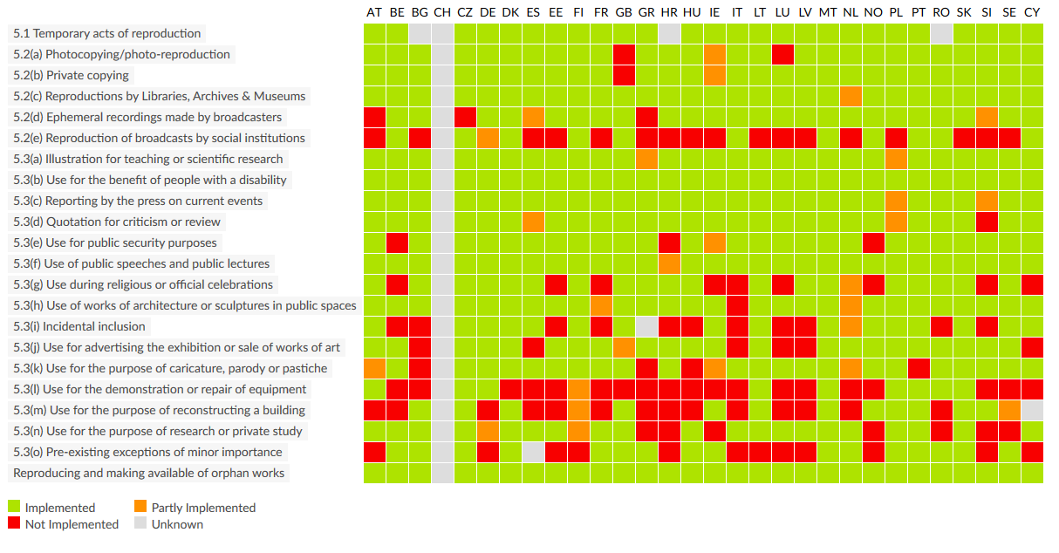
Figure 114: Implementation status of the 22 exceptions and limitations to copyright for all 28 EU member states

There’s a great deal of information in this chart and I encourage you to pause at this point and study it. However, one crucial dimension is necessarily omitted from the chart – namely, how exactly each country has implemented each of the provisions that it has chosen to incorporate. As Professor Bernt Hugenholtz points out in a recent article, some of the provisions of article 5 of the directive are drafted in a way that leaves the legislators of the member countries considerable discretion in this regard, and they have exercised that discretion in very different ways. Consider, for example, 5.3(d), which permits member countries to privilege “quotations for purposes such as criticism or review provided they relate to a work which has already been lawfully made available to the public in which the source is indicated and their use is in accordance with fair practice and the extent required by the specific purpose”. The language, and in particular the language I emphasized in the quotation, permits – indeed forces – a legislature either itself to make a judgment concerning what constitutes fair practice or to delegate that judgment to the courts. As Professor Hugenholtz points out, the French legislature has chosen to define the quotation right narrowly, limiting the privilege to quote analyses and short quotations justified by the critical polemical educational scientific or informatory nature of the work in which they are incorporated. Swedish law, by contrast, is more permissive: anyone may, in accordance with proper usage and to the extent necessary for the purpose, quote from works which have been made available to the public. The relevant provision of the law in the Netherlands is also generous, but makes more explicit reference to social practice; a quotation there need only be “commensurate with what might reasonably be accepted in accordance with social custom and the number and size of the quoted passages are justified by the purpose to be achieved”. Many other similarly wide variations on the ways in which each provision has been implemented in the different member countries can be identified by visiting the website created by the European scholars, clicking on particular provisions, and then clicking on the countries and the adjacent maps of the region. Try it. One of the conclusions you’re likely to take away is that copyright law in the European Union is less harmonized than is commonly supposed.
Putting these variations to one side, it’s important to remember that the list of exceptions and limitations in article 5 is exhaustive. Member countries, as we have seen, are not obliged to recognize all and they adapt a subset, but they may not recognize more. Many of the activities that escape liability in the United States on fair use grounds are dealt with in specific provisions in the EU’s list, but other things – such as copying student essays verbatim for the purpose of running a plagiarism detection service – that have been able to pass muster under fair use in the United States are too new or idiosyncratic to have been anticipated in 2001 and thus would be hard to justify under the EU’s approach.

Copyright Law of the People’s Republic of China
Section 4: Limitations on Rights (summarized)
Article 22: In the following cases, a work may be used without permission from, and without payment of remuneration to, the copyright owner, provided that the name of the author and the title of the work are mentioned and the other rights enjoyed by the copyright owner in accordance with this Law are not prejudiced:
- Personal study
(2) Comment
(3) Inclusion for current events
(4) Rebroadcasts for current events
(5) Speeches
(6) Teaching or research
(7) Governmental use
(8) Libraries
(9) Free live performances
(10) Copying public art
(11) Translations from Han
(12) Transliteration into braille

China currently employs the same general approach used by the European Union. Article 22 of China’s copyright law contains a list of enumerated exceptions, although it is shorter than the EU list. Some items are relatively conventional – for example, the ninth exception for “gratuitous live performances of a published work for which no fees are charged the public nor payments are made to performers” echoes a provision of the US statute, and the tenth exception, which privileges “copying, drawing, photographing or video recording of a work of art put up or displayed in an outdoor public place” is an enlarged version of section 5.3(h) of the EU directive, which permits countries to privilege “use of works such as works of architecture or sculpture made to be located in public places”, which in turn echoes but expands upon a narrow safe harbor in US law. But, two provisions in article 22 of the Chinese statute stand out for their novelty and scope. Section 9, which creates an expansive privilege for free live performances of public works, and section 11, which establishes a privilege to translate “a public published work of Chinese citizen or legal entity from Han language into minority national languages for publication and distribution in the country”.
Figure 114, displayed earlier, catalogues the implementation of the set of exceptions and limitations enumerated in article 5 of the EU directive. The green squares identify countries that have adapted each. Figure 115 includes an overlay that indicates in green which of those provisions find analogues in the law of China. I use the word analogues deliberately because the language of the relevant provisions of China’s article 22, whose numbers are shown inside the green squares, differs significantly from the corresponding language used in the EU. At the bottom of the chart are indicated the two provisions of the Chinese statute that find no counterparts in Europe, and, finally, indicated in red are the provisions accepted in at least some EU countries that have no counterparts in China.
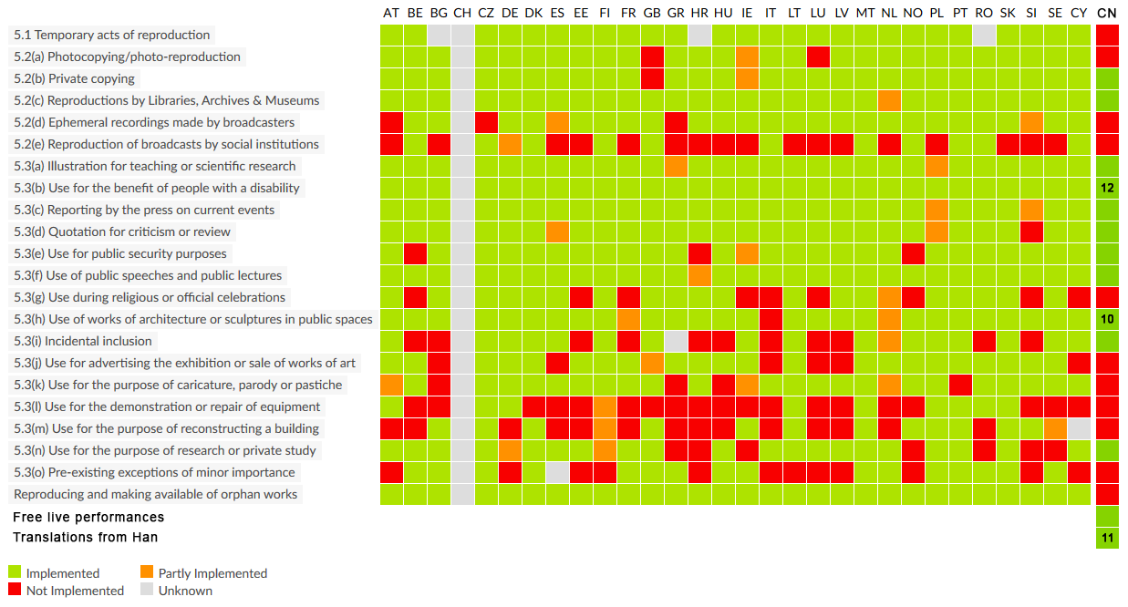
Figure 115: Implementation status of the 22 exceptions and limitations to copyright for all 28 EU member states, with China added for comparison

So, as we’ve seen, there are currently two polar positions with respect to copyright limitations: the open-ended fair use approach, employed in the United States and a few other countries, and the enumerated exceptions approach, pursued in the EU, China and several other nations. In between these two models is another group of countries that have adopted what might be described as hybrid approaches. These combine in some way the ad hoc analysis that prevails in the United States with the strategy exemplified by the EU of listing specific safe harbors. Such hybrids come in various shapes and sizes. Here are a few examples.
The relevant provision of the copyright statute of Malaysia contains a very long list of exceptions, making it resemble the EU regime, but the first provision in the list is unusually broad: it exempts acts “by way of fair dealing including for purposes of research private study criticism review or the reporting of news or current events”. The resemblance to the US fair use doctrine is strongly reinforced by an accompanying provision that lists the factors that should be considered when determining whether a particular use is fair. These factors are virtually identical the factors identified in section 107.
The list of enumerated exceptions in India’s statute is even longer. It includes 33 safe harbors – indeed, the legislature ran out of letters in the alphabet – but, as is true in Malaysia, the first item in the list is phrased quite broadly, seemingly inviting courts to make their own determinations concerning which activities within the zones of private use, research, criticism, or review should constitute fair dealing. India did not invent the idea fair dealing; the phrase and the concept originated, as one might expect, in the United Kingdom, but the relevant portions of UK law have recently been substantially revised in ways that move it closer to the United States. A highly influential report by a commission chaired by Ian Hargreaves prompted parliament to add to a rather narrow fair dealing defense several important new safe harbors, including one for caricature, parody or pastiche. To be sure, these revisions fell short of adding a truly open-ended fair use doctrine to UK law. Indeed, as pointed out by Professor Jamie Boyle, the commission, of which Boyle was a member, was at pains to renounce the ostensibly vague US approach. However, as Boyle also points out, when you add all these changes up they come pretty close to matching the ambit of the US system. That generalization is reinforced by reading a helpful summary of the current state of UK law put by the UK Copyright Service, to which I provided a link in the map.
So, to summarize: there currently exists in the world what could be described as a spectrum of approaches to the identification of exceptions and limitations to copyright. At one extreme is the United States, the opposite extreme is the European Union, and in between are several hybrids.
So, which strategy is best? That question is often addressed as if it were purely a question of the optimal legal form. So conceived, the question is a variant of an age-old debate in legal theory. Fair use is said to be an example of a type of legal norm commonly known as a standard, while the enumerated exceptions approach is an example of a type of legal norm commonly known, somewhat confusingly, as a rule. A standard is a norm that makes direct reference to policy objectives, such as the avoidance of unjust enrichment or, say, minimizing harm to the environment, and then leaves judges or other officials lots of discretion in deciding how best to accomplish those ends when resolving particular disputes. A rule, by contrast, constrains discretion; it requires judges or other officials to respond in a determinant way to a specific set of readily ascertainable variables. So, for example, a norm that declared that only wise persons are eligible to be president would be a standard; by contrast, a norm that declares that only persons over 35 years old may be president, such as the norms currently in force in the United States, Indonesia and Brazil, is a rule. Here’s another example: a norm prescribing that custody of children in contested divorces shall be determined by considering only “the best interest of the child” is a standard; by contrast, a norm proscribing that the community property of a divorcing couple shall be divided exactly equally between the former spouses is a rule.
Standards and rules, it is widely believed, have characteristic advantages and disadvantages. For example, standards are more flexible, but also more unpredictable; rules are more predictable and also less conducive to corruption or bias, but rules are also inevitably both under over-inclusive and under-inclusive – in other words, they will fail to advance policy goals as precisely as well-administered standards. So, which is better? The conventional answer is that it varies by context.
Much of the debate about fair use employs this framework. Should we have more “ruleness” – in other words, move closer to the EU approach – or should we have more “standardness” – in other words, move closer to the US approach. Scholars who argue about the issue in these terms draw on many of the same considerations that figure in the more general debate about the relative merits of rules and standards. However, close study of the ways in which these various legal regimes operate in practice casts doubt on the accuracy and utility of these axes of differentiation.
Consider first the question of predictability: it’s commonly said that US law, the regime most like a standard, is, as one might expect, highly unpredictable. Whether the defendant in a particular case will be able to escape liability by invoking section 107 is difficult to determine in advance and depends, to a distressing degree, on the personalities or attitudes of the judge, judges or jury called upon to make the determination. That’s true, but several scholars have argued convincingly not as true as is commonly thought. The reason is that over time the courts have tacitly subdivided the universe of cases implicating colorable fair use defenses into subfields and have converged on guidelines concerning how the four factors will be interpreted in each subfield. An example of scholarship in this vein is a 2004 article by Professor Michael Madison, in which he argues that most fair use cases in the United States conform to one of eight patterns (listed on the right) and that the results reached in each sector are less unpredictable than is usually thought. The taxonomies offered by other scholars in this group differ, but they make the same general argument concerning sector-specific relative stability. The upshot is that the unpredictability of fair use may not be as severe as the conventional accounts suggest. The corresponding supposed rigidity and resistance to judicial discretion of the enumerated exceptions approach may also be overstated. As we have seen, many of the provisions in the list of exceptions used by many countries give judges a fair amount of latitude when determining which activities to condemn and which to exempt. This leads to a more fundamental point: even when the statutes did not confirm such authority on judges, judges sometimes claim it. China provides important examples. As we’ve seen, article 22 of China’s Copyright Act, like article 5 of the EU Copyright Directive, purports to be exhaustive. However, as Professor Seagull Song has shown (“Reevaluating Fair Use in China”, 2011), Chinese judges have sometimes asserted the authority to exempt from liability activities that do not fall into any of the 12 exceptions enumerated in the statute. For example, in a 2006 case a state-owned television station sought to escape liability for an unauthorized broadcast of the plaintiff’s copyrighted movie by invoking section 22(6) which privileges some activities in connection with “classroom teaching or scientific research”. Beijing Haidian District Court rejected this argument, concluding – plausibly – that section 6 only covers uses in connection with in-person classroom teaching. However, the court did not treat its rejection of section 6 as decisive; instead, it went on to entertain the possibility that a consideration of (a) the purpose of the defendant’s activity and (b) its effect on the market for the plaintiff’s work might support denial of copyright liability. Similarly, in a more recent dispute involving facts essentially identical to the Google Books case in the United States, the Beijing Higher People’s Court ruled that in exceptional circumstances exceptions and limitations outside the zone specified in article 22 should be recognized by the courts. And what factors should be considered in determining whether a case is exceptional in the sense? “The intention and type of use, the nature of the work being protected, the proportion of the work being used, and whether the defendant’s behavior has affected the normal use of the work and whether it will unreasonably damage the legal rights of the copyright owner”. Such considerations resemble, reasonably closely, those that a US court considers under the auspices of section 107. Now, we should not make too much of judicial statements like these. Other courts in China, at other times, have treated the list of exceptions set forth in article 22 as truly exhaustive, and even the courts that have ventured outside the statutory garden have done so cautiously as evidenced by the fact that in both of the cases just summarized the defendant in the end lost. In other words, the court in each dispute concluded that the necessary exceptional circumstances had not been demonstrated. One result was that Google lost in China, whereas it won in the United States. Nevertheless, both cases reveal Chinese judges tugging a regime that ostensibly exemplifies model number two in the direction of model number one.
“A Pattern Oriented Approach to Fair Use” by Michael Madison (2004)
- Journalism
- Parody and satire
- Criticism and comment
- Scholarship and research
- Reverse engineering
- Legal and political argument
- Storytelling
- Comparative advertising, information merchants, and ordinary personal use
The ways in which courts are called upon to interpret statutes in the middle zone also calls into question the common assumption that these regimes are less likely to excuse unauthorized uses of copyrighted materials than type one regimes. For example, in a recent case the Delhi High Court ruled that commercial reproduction of course packs by a copy shop is not unlawful. In doing so, the court relied not on the expansive language of section 52(a), which I discussed a minute ago, but on an aggressive interpretation of one of the specific enumerated exceptions – specifically, section 52(i), which immunizes “the reproduction of any work by a teacher or a pupil in the course of instruction”. The court forthrightly tied its ruling to a general policy argument:

Copyright, specially in literary works, is thus not an inevitable, divine, or natural right that confers on authors the absolute ownership of their creations. It is designed rather to stimulate activity and progress in the arts for the intellectual enrichment of the public. Copyright is intended to increase and not to impede the harvest of knowledge. It is intended to motivate the creative activity of authors and inventors in order to benefit the public.

Viewed from this angle, the activity of the defendant which had the effect of increasing sharply the affordability of course materials to students should be excused, so the court ruled. By contrast, a court in South Korea – one of the countries that employ the open-ended model number one – recently ruled against the fair use argument made by a company claiming, analogously, that it’s unauthorized activities would have important educational benefits.
The capacity of courts lying in the middle zone to extend the reach of seemingly narrowly-crafted exceptions is also evident in recent history of Canada. At the start of the 21st century, the statutory exceptions in the Canadian copyright statute were not especially capacious. However, as Michael Geist has shown, the Canadian Supreme Court in a series of important opinions read those provisions very broadly. Perhaps most importantly, the court, nudged by activists like Geist himself, led the world in reconceiving the boundaries on copyright owners’ entitlements not as “exceptions” to an otherwise comprehensive set of authors’ exclusive rights, but as expressions of and shields for offsetting rights of the users of copyrighted materials. In another recent essay, Professor Elkin-Koren offers a theoretical justification for such a reorientation.
The bottom line: it’s probably fair to say that overall model number one is superior to model number two to the extent one values flexibility and generosity of scope, and that model number two is superior to the extent one values predictability and constraints on judicial discretion. But the differences between these two approaches on these axes are not as great as is usually supposed. In determining the ambit instability of the limitations upon copyright, the overall legal form employed by the legislature in a particular country may be less important than (a) the details of the individual provisions within that model and (b) the attitudes toward intellectual property held by the judges who are called upon to interpret those provisions.
Now, returning to the United States for a moment, here’s a final orthogonal note about legal form. As I’ve indicated, it’s assumed nearly universally that the US fair use doctrine is a standard, as opposed to a rule, and has both the strengths and the weaknesses of a standard. But if you examine section 107 and the case law built upon it closely, that characterization proves not entirely accurate. A true standard, you’ll recall, identifies a substantive goal – like promoting the best interests of children or ensuring that national leaders are wise – and then gives judges discretion in advancing that goal. That’s not really what the fair use doctrine in the United States does; rather, section 107 identifies some factors the judges should consider, but doesn’t tell them why those factors matter. It doesn’t, in other words, identify the pertinent substantive goal. The result is the judges in the United States are forced to decide for themselves what copyright law should be trying to achieve: maximize social welfare, reward authors fairly, protect personhood interests – as we’ve seen all those are possible aspirations. Which one is your primary concern will make a big difference in how the statutory fair use factors are construed and applied. Judges in the United States disagree concerning the fundamental purposes of copyright; it should thus not be surprising that as a result those judges disagree somewhat concerning how fair use should be construed. To function as a true standard, the doctrine would have to identify more explicitly one or more substantive goals. Such an adjustment of the doctrine would have several advantages, including reduction in the unpredictability of how it would be applied to novel problems. Such a reform could be implemented relatively easily at the statutory level by inserting into the preamble of section 107 a statement of its overarching objective. Alternatively, the United States Supreme Court could sharpen up the normative foundation of the doctrinal revolution it initiated in the Campbell decision. That leaves only the question of what the substantive objective should be. A possible answer to that question is presented at the end of the next lecture in this series.

Cultural Theory

Premises
As you know by now, there are four main theories of intellectual property in general, and copyright in particular.
The fairness theory, which finds inspiration in the work of John Locke, centers on the principle that the law should be organized to provide authors and inventors what they morally deserve. Somewhat more specifically, the law, seen from this perspective, should award them property interest or monetary rewards commensurate with their creative efforts. The fairness approach has disproportionate influence in the United States and other countries influenced by the common-law tradition, but finds some support throughout the world.
The personality theory, which finds inspiration in the work of Kant and Hegel, is founded on the principles that intellectual products are extensions of the personalities of their creators, and that the law should be organized to respect and nourish the psychic bonds between creators and their expressive products. The dimension of copyright law that is most closely associated with personality theory is the set of so-called moral rights, which are most generously recognized and enforced in continental Europe, and in other jurisdictions influenced by the civil law tradition.
The third approach is the welfare theory, a branch of the broad philosophic tradition of utilitarianism. The welfare theory of copyright starts with the proposition that intellectual products are public goods, an unusual and especially important subset of products defined by two related characteristics: they are both non-rivalrous and nonexcludable. Copyright law, seen from this angle, constitutes a mechanism employed by governments to prevent such public goods from being produced in less than socially optimal quantities. The general guideline that emerges from this philosophic tradition is that the law should be adjusted so as to combine optimally, on the one hand, incentives for innovation, and on the other hand, mechanisms for ensuring that the fruits of innovation can be consumed or reused by others. This theory has gained in strength in recent years. It is now the dominant approach to copyright law, at least in the United States, in part because of the resonance between it and the utilitarian tenor of the Constitutional clause on which intellectual property rights founded in the United States, and in part because this theory has been refined and popularized by an influential group of scholars, some of whom have since become judges.
We come, finally, to the fourth theory. This is currently the least well known and least influential of the approaches, but it is, I think, growing in strength, both among scholars and among lawmakers. It centers on the principle that copyright law, like other fields of law, should be organized so as to foster and sustain a just and attractive culture. The cultural theory incorporates some aspects of the other three theories, but as we’ll see, also stands apart from them on important dimensions. Like the welfare theory, it’s prospective and consequential – in other words, it urges us to create a legal framework that will enable or prompt people to behave in ways that will give rise to a more attractive society in the future. But it differs from welfare theory in a fundamental respect: it’s not founded on the principle of consumer sovereignty, the notion that we should measure people’s wellbeing by what they themselves currently desire or loathe. In other words, the cultural theory takes the risky and controversial position that people are not always the best judges of their own interests, and that the law should sometimes guide them in directions they are not currently inclined to go. Like the personality theory, the cultural theory tries to identify in advance fundamental human needs. However, as we’ll see, the set of needs that figure in most current versions of cultural theory is different from the set that figures in personality theory. Cultural theory is also much less willing to privilege the psychic bonds between artists and their creations over all other considerations.
Like the fairness theory, and unlike the welfare theory, cultural theory is intensely concerned with justice. However, it’s less interested in individualized conceptions of justice – in other words, attempts to give individual workers or authors what they have earned through their labor – and more concerned with distributive justice – in other words, ensuring that all persons are given fair shares of material resources, and above all, fair access to the opportunities necessary for full human flourishing.
In the second segment of this lecture, it will become apparent that these differences in orientation prompt advocates of cultural theory to recommend a pattern of reforms to copyright law that is significantly different from the pattern commended by any of the other approaches.
As my tone undoubtedly conveys, I myself find this approach to be the most congenial and powerful of the four. The result is that my presentation of this approach will be less dispassionate than were my presentations of the other three. I’ll do my best at the end to identify the main weaknesses of cultural theory, but it would be hopeless for me to conceal the fact that I find it to be, on balance, the most powerful of the four approaches. Needless to say, you should make your own judgments concerning the merits and demerits of this perspective. One of the reasons why I have waited until now to present this argument to you is to ensure that you are familiar with the rival approaches and their doctrinal implications, and thus inoculated against my favoritism.
Here’s how I plan to organize my presentation. In the first segment of the lecture, I will outline the premises of this approach. In the second segment, I will canvas various issues in copyright law, with which you are now familiar, and suggest how cultural theory might illuminate them. In the third, I will address a few possible reforms outside of copyright law that the cultural theory might commend, and then discuss the principal limitations and vulnerabilities of this argument. So, let’s begin.
At the outset, it should be emphasized that, like each of the other three approaches, cultural theory is best understood as a family of related arguments, not a single, tightly-knit, determinant argument. Put differently, it’s an orientation – a way of thinking about life, culture, and law – not an algorithm. Partly as a result, people who adopt this approach disagree among themselves, just as, as we have seen, the economists who dominate the welfare approach, and the philosophers who dominate the fairness approach, also disagree among themselves. Who, then, are the people who have contributed to the cultural theory? They are surely not limited to law. Indeed, most of the inspiration from this approach comes from outside law. In philosophy, it has deep roots in the work of Aristotle and more modern expression in the arguments of Amartya Sen and Martha Nussbaum. In political theory, roots can be found in the writings of the 18th century commonwealth men, such as Trenchard and Gordon in England, the early Karl Marx, Alexis de Tocquevile, Hannah Arendt, and modern communitarian theorists. Recently, the work of several social psychologists, including Edward Deci, Richard Ryan, Martin Seligman, and Christopher Atman, have lent substantial support to this perspective.
Among legal scholars, and specifically among the subset of legal scholars who focus on intellectual property, important contributors include Keith Aoki, Yochai Benkler, Julie Cohen, Neil Netanell, Madhavi Sunder, Talha Syed. Some of their works are listed on the map. If you’re curious about their perspectives, follow the links. My own work in this area began with an essay I wrote on fair use in 1988 and has continued to guide my exploration of different dimensions of intellectual property ever since. Indeed, I find myself closer to this approach now than I did a decade ago. During the remainder of this lecture, I will focus on my own particular variant of cultural theory. These other scholars are, as I say, pursuing analogous projects, but likely none would agree with all aspects of my argument. The most fundamental of the premises upon which the argument is based is the proposition that there exists such a thing as human nature – it’s hard to discern, but real and stable. Because of their nature, people flourish under some conditions and suffer, or atrophy, under others. From those observations emerges a normative guideline. Social and political institutions, including law, should be organized so as to facilitate human flourishing. Eight conditions contribute to human flourishing. Not all eight are essential to a full and satisfying life. Indeed it’s doubtful that anyone has ever fully experienced, on a sustained basis, all eight. Life isn’t perfect. But these are the components of a good life. The most obvious is life itself. The flourishing is possible only if you are alive – somewhat more specifically, if you are able to live a life of normal length. Nuances lurk in the adjective “normal,” but we need not tarry to consider them here. The second, nearly as obvious, is health. Illness impairs flourishing. Freedom from psychic and physical pain is one of the conditions that contributes to living well. As Martha Nussbaum observes, health, in this sense, includes reproductive health. Now things begin to get more subtle and controversial. A substantial degree of autonomy is important to human flourishing. No one, of course, is wholly self-made or self-directed, but a life without a substantial degree of self-determination is a life not fully lived. George Kateb, the person from whom I first learned political theory, put the point memorably. “One’s dignity resides in being, to some important degree, a person of one’s own creating, making, choosing, rather than being merely a creature or a socially manufactured, conditioned, manipulated thing, half-animal and half-mechanical, and therefore wholly socialized.” Kateb, in this passage, was drawing in part on the work of John Stuart Mill, who also emphasized the constitutive value of choice. The same theme figures heavily in the writings of many other liberal theorists, including John Rawls and Ronald Dworkin. It also infuses Yochai Benkler’s commentaries on the affordances enabled by participation in information networks.
Conditions necessary for the full realization of personhood

- Life
- Health
- Autonomy
- Engagement
- Self-expression
- Competence
- Connection
- Privacy
It’s important to note three refinements of this idea. First, autonomy does not mean freedom from social connections. On the contrary, it means, rather, that the bonds and communities through which we define ourselves are at least partly chosen, not inherited or coerced. Second, the dimension of autonomy that turns out to contribute most to well-being is the subjective feeling of self-determination, which is only partly dependent on the objective number of options that one has. Third, autonomy not only makes one feel better, it’s also adaptive. Social psychologists have found that autonomous motivations, meaning motivations arising out of voluntary choice, increase job performance, particularly when the task at issue is complex and requires creativity.
Of course, one can have too much of a good thing, even autonomy, as Barry Schwartz has shown. But a substantial degree of self-determination is key to the good life. The fourth of the conditions conducive to flourishing is engagement, by which I mean participation in shaping an important dimension of one’s environment. Many groups of theorists have emphasized one or another aspect of this principle. Karl Marx, for example, placed great weight in his insightful early writings on engagement in work. People ought to have access to what he called meaningful work, by which he meant work that requires skill and concentration, presents the laborer with challenges and problems he can overcome only through the exercise of initiative and creativity, and is part of a larger project he considers socially valuable and must take into account in making his decisions. Notice that the fact that the job is connected to a socially valuable project is part of this vision, but not the whole of it. Fulfillment comes only through participation in the choices that determine the direction of the venture and whether it succeeds. That’s where engagement lies. Notice also the beneficial role played in this vision by risk. Certainty that a venture will succeed innervates engagement.
But work is not the only arena in which one can find fulfilling engagement. Another is politics. This theme figured prominently in the work of classical Republican political theorists, including the pamphleteers and activists who helped power the American Revolution. They celebrated what they called civic virtue, a key component of which was active participation in politics. But not any sort of participation – rather, they privileged participation in a particular posture – altruistic, deliberative, genuinely committed to the welfare of the polity as a whole, not to the advancement of self-interest or factional interest. Again, we see the conjoining of involvement, choice, and, last but not least, commitment to a larger enterprise one believes to be socially beneficial. In Martin Seligman’s words, “using one’s signature strengths and talents to belong to and serve something bigger than oneself.” Within legal scholarship, this theme found expression in a highly influential set of articles during the 1980s and 1990s that sought to reorient constitutional law and administrative law around the idea of altruistic, deliberative citizenship. Key figures in that surge were Frank Michelman and Cass Sunstein. Sunstein later went on to become a central figure in the Obama administration.
Yet another arena for self-fulfilling engagement is culture itself. We live today in a cloud of symbols and images that, like our jobs and our polities, are all too often out of our control. The result is cultural alienation analogous to alienation in the workplace. Retaking some degree of responsibility and control for the shape of that semiotic environment is another way of achieving engagement.
Each of these groups of theorists argued vigorously for the benefits, individual and collective, of the particular kind of engagement they celebrated. My own view is that no one of these forms of participation has pride of place, and that it’s hopeless to try to do them all. There just aren’t enough weekends. The more general insight, latent in all three variants, is that active, risky, altruistic engagement in the shaping of a significant aspect of one’s world is key to human flourishing.
Closely related to engagement in this sense is self-expression. Projecting oneself into or onto the world has long been regarded as constitutive. It’s at this point that the cultural theory of copyright overlaps most clearly with the personality theory. Indeed, the reflections I discussed in the second lecture by T. H. Green and others concerning the importance of preserving opportunities for self-expression could be simply incorporated here by reference. A more recent manifestation of the same theme can be found in the work of Larry Lessig, in particular his book on remix.
Competence, we know intuitively, is also crucial to human flourishing. We feel better, and we do better, when we have a sense that we are capable of performing the tasks we address – not that we are certain of success, but that we have the requisite talents and skills. A large body of literature in social psychology confirms this intuition. A sense of competence is key to learning, and a sense that one is incompetent is strongly correlated with depression. Again, the subjective feeling of competence is at least as important as the reality for both performance and well-being. This fact creates interesting complications and possibilities when combined with the fact that assessments of competence are often distorted in systematic ways. Unskilled people, psychologists tell us, typically overestimate their competence, while highly skilled people typically underestimate their competence. But this is a nuance, not the core point.
The seventh theme in the list should not be surprising. We flourish through connection with others. We atrophy alone. The vocabulary employed to express this age-old insight in different disciplines varies. A philosopher, such as Nussbaum, might use the term “affiliation.” The psychologists, Deci and Ryan, use the term “relatedness” and place it on a par with autonomy and competence as a fundamental human need. In political theory, the theme finds clearest expression in communitarian arguments.
Finally, privacy – on this issue, like self-expression, the cultural approach of copyright overlaps with the personality theory. Both invite attention to the fundamental human need for relief from the crowd, access to settings conducive to experimentation, and intimacy.
The list is rough and tentative. It is grounded in millennia of reflection and experience, but it is still being tested and refined. Date categories are not watertight. On the contrary, these conditions reinforce and run into one another. That, in turn, means that the set of functionings essential to human flourishing could be organized somewhat differently. But with those qualifications, there’s remarkable convergence by scholars working in many disciplines concerning the importance of these eight things to a good life.
Having cataloged briefly the conditions that contribute to human flourishing, the next issue is how widely available we should strive to make those conditions. An enormous literature within political theory addresses that question. Many different criteria have been proposed for how much equality or inequality with respect to these or any other resources is morally justified. Three of the many contending positions are listed on the right. Exploring this literature would take us very far afield. Fortunately, for present purposes, we need not do so because there’s broad, although, of course, not unanimous, agreement among the contending camps that all societies today are characterized by unjustifiably high levels of inequality. In other words, our task for the foreseeable future is to adjust our institutions so as to make the eight conditions constitutive of a good life more widely and equally available. At some point, the issue of just how equal will become salient, but unfortunately, not in the near term. So when considering modifications of copyright law, we can postpone efforts to resolve this fundamental issue decisively and instead commit ourselves to substantial movement in the direction of equality.
Contending positions on distributive justice
- “Universal basic capabilities” – Nussbaum/Sen
- “Sufficientism” – Harry Frankfurt
- “Democratic equality” – Elizabeth Anderson
How, then, could we make a good life more widely available? Many possible initiatives undoubtedly spring to mind. Suppress both organized and disorganized violence. Increase the availability of health care and vaccines. Reorganize workplaces to increase opportunities for genuine participation, and so forth. It would be foolish to attempt here to itemize all of the political and legal reforms that would help advance the goals I have posited. Although some initiatives are obvious, others are not at all. I’m just now beginning work on a book, tentatively entitled Good Life, Good Law, that will attempt a partial survey of this large landscape. It will likely take years. For the time being, we can and should limit our attention to dimensions of reform that are likely to implicate the subject at hand – namely, copyright. As you might expect, those dimensions all involve improving our culture, broadly defined. Four dimensions of culture seem especially closely connected to realization of the aspirations we have identified thus far. The first is cultural diversity. Diversity fosters human flourishing in many interlocking ways. It increases both the fact and the experience of choice. Thus, at least if those choices concern things that matter to the chooser, diversity increases autonomy. Diversity also increases invitations and opportunities for self-expression and for engagement to other dimensions of the good life. The way in which these themes reinforce one another was recognized long ago by Mill. “The more multifarious the lifestyles and ideas on public display in a society, the more each of its members must decide for herself what to think and how to act, thereby developing her own mental and moral faculties, and rendering the culture as a whole even more rich, diversified, and animating.” For many of the same reasons, a rich artistic tradition sustains opportunities for flourishing of many sorts. This point was made crisply by Ronald Dworkin, one of the foremost Anglo-American legal theorists. “The more complex and resonant the shared language of a culture, the richer it is in the raw materials of representation, metaphor, and allusion, the more opportunities for creativity and subtlety in communication and thought it affords the members of the culture.” This claim, and the related notion that governments should actively seek to foster a rich artistic tradition, is unlikely to shock Europeans, but it is far from universally accepted in the United States or many other countries. It should be.
Third, education, it turns out, is the linchpin of the good life. Autonomy, engagement, self-expression, and competence are all dependent upon the kind of knowledge and skills that only education can provide. Recognizing that education is the preconditions for many dimensions of human flourishing has two important implications. First, it highlights the importance of ensuring that education is widely – ideally, universally – available. Second, it should guide reform of extant educational systems. Our goal should be to enable and encourage lifelong learning that supports creativity, competence, and confidence. We currently fall far short of that. Technology is rapidly expanding our capacity to construct a system for vibrant, empowering, lifelong education available to people worldwide. We should adjust copyright law to facilitate that project, not impede it.
The fourth dimension of a nourishing culture is democracy – by this, I mean, to the extent feasible, participatory democracy, not representative democracy. There are two aspects of this theme. The first and more familiar is political democracy. There are, of course, well-known reasons grounded in considerations of legitimacy and the quality of governance for vesting political power in the people at large. I will not rehearse those arguments here. For present purposes, I’m more concerned with a less instrumental value of political democracy, the value that most impressed Tocqueville when he visited the United States in the early 19th century – specifically, the beneficial effect of political engagement on the people who participate in governance. Active citizenship, in short, is good for the heart and the soul, as well as the polity. For essentially the same reason, we should strive to increase participatory democracy with respect to cultural meanings, what John Fiske, Michael Madow, and Jack Balkan have called semiotic democracy. This theme merits some more elaboration.
During the 19th and 20th centuries, the cloud of images and symbols I mentioned a minute ago gradually, then rapidly, became increasingly dense. Equally important, control over the content of that cloud became increasingly concentrated in fewer and fewer companies, advertising houses, and political consultants located in a few countries. The semiotic power, in other words, was held by fewer and fewer people. To be sure, the concentration was never total. As cultural populists point out, opportunities for cultural resistance – for recoding centrally-fashioned and distributed symbols – survived. But those opportunities shrank, and the refashioned images almost never have the currency of the originals.
Information technology not only is enabling radically new forms of education, as I just mentioned. It is also beginning to reverse this trend toward the concentration of semiotic power. Digital technologies are enabling an ever-larger group of people to engage in remixing of cultural forms. Surveys done by my colleagues John Palfrey and Erst Gosser suggests that, already, roughly one in four young people worldwide now engage in remixing digital content into their own artistic creations. That number will surely climb. This is a trend that should be celebrated and facilitated, not denounced. It implicates favorably several of the dimensions of the good life. Specifically, it expands opportunities for autonomy, engagement, self-expression, competence, and connection. Now, to be sure, it’s crucial that we not lose sight of the importance of preserving the incentives and rewards for the creation of the cultural artifacts that others can then remix. But there may be ways of tuning copyright law to reconcile these competing goals. That possibility and many other potential reforms of the copyright system, we’ll take up next.

Implications
In the previous segment of the lecture, I outlined the premises of one variant of that approach. We now turn to some implications for copyright law of that variant. The question I’ll try to answer is: if for our aspiration were to foster A, opportunities for the good life, and B, the cultural conditions that sustain such opportunities, how might we adjust the law? Listed on the next page are 13 zones of possible legal reform. Items 1 through 8 involve copyright law proper. Items 9 through 11 involve alternatives or supplements to copyright. Items 12 and 13 involve other intellectual property regimes. In this segment of the lecture, I’ll consider the first eight which, as I say, concern copyright law itself. In the third and last segment of the lecture, I’ll consider, among other things, the supplementary implications alluded to in items 9, 10, and 11. The remainder I’ll leave to another time and place.
This list of possible zones of reform is meant to be illustrative, not exhaustive. It’s designed to suggest how the theory might be applied, not to provide a comprehensive recipe for rebuilding copyright.
The first doctrinal implication is probably the most obvious. Copyright law affects education in countless ways. We should adjust and apply the law so as to enable, not interfere with, the kind of education I sketched and advocated before the break. For example, in lecture number eight in this series, I discussed the provision of the US copyright statute that attempts to facilitate distance learning. We saw that that provision, popularly known as the TEACH Act, is almost completely ineffective in practice. Its limitations are so severe that almost no distance learning venture relies on it. Certainly, I’m not relying on it for this course. Right now, meaning the winter of 2013, the World Intellectual Property Organization is discussing a possible model provision that countries might employ in the future to enable d istance education. When addressing this issue on the national or the global level, our goal should be to capitalize on the extraordinary opportunities for distance learning enabled by new technologies without, of course, corroding crucial incentives to create educational materials in the first instance. A useful exercise in this regard might be to ask what legal reforms would be necessary to make possible an edX course analogous to the one supported by this lecture series but in a field where the thicket of copyrights is more dense. Constructing an edX course that focuses on law, and in particular on US law, is relatively easy, because the primary source of materials – statutes, judicial opinions, and so forth – are in the public domain in the United States. Developing a similar course that deals with contemporary art, for example, or a modern social science would be much harder, because a much smaller percentage of the pertinent source materials are publicly available. It’s worth asking yourself which of the rules we have examined thus far in this course would I amend in order to make such a course feasible. In particular, how would I qualify copyright owners’ existing rights to control the reproduction, distribution, and public performance of their works?
Zones of possible legal reform
- Education
- The idea/fact/expression distinction
- Fair use
- Moral rights
- Libraries
- Formalities
- Compulsory licensing
- Differential pricing
- Supplementary government funding
- Alternative compensation system for recorded entertainment
- Traditional knowledge
- Trademark reform
- Patent reform
Here’s another dimension of the same general theme. As we will see next week, most countries now have statutes penalizing the distribution and use of technologies that circumvent technological protection measures – in other words, technologies that neutralize the forms of encryption commonly used by copyright owners and others to prevent unauthorized access to or use of copies of their creations. Sometimes, those statutes inhibit education – for example, by frustrating the work of teachers and students in film studies courses. As we will see, some exceptions to the anti-circumvention rules have already been carved out so as to facilitate education. We can and should create more such exceptions.
Both of the possible reforms I’ve discussed thus far would curtail the entitlements of copyright owners, but enabling education does not always point in that direction. Sometimes, it might be achieved by strengthening the rights of copyright owners. For instance, as we saw in lecture number eight, software firms frequently strive to separate the set of potential purchasers of their products into at least two groups, commercial users and educational users, and then to charge much higher prices to the former than to the latter. Here are two examples you’ve seen before. Of course, the reason that firms do this is to increase their profits – they’re not altruistic. Differential pricing of this sort, they have discovered, is lucrative, but it also redounds the benefit of education. Many more students and faculty are able to obtain and use application programs if the firms are able to maintain these practices than if they are not. Viewed through the lens of the cultural theory I’ve outlined, that’s something we should applaud and preserve. How? By adjusting legal doctrines to help the software firms engage in this behavior. More specifically, by defending the rules that inhibit arbitrage which corrodes such differential pricing systems. One such rule we saw is the interpretation of the first sale doctrine adopted recently by the Court of Appeals for the Ninth Circuit in the Autodesk case. That interpretation enables software firms, by characterizing their transactions with their customers as leases of copies of the programs rather than as sales of copies of the programs, to suppress secondary markets in the copies they provide to students and teachers, and that in turn will enable the firms to keep the prices of those educational copies low. And that’s what we want. I hasten to add that there may be other implications or applications of the Autodesk ruling that we should be less happy about, but this one seems commendable.
A less obvious, more general application of cultural theory concerns the idea/fact/expression distinction that, as we saw in lecture number one, underlies the copyright systems of every country in the world. Copyright law, as you now know, does not protect either ideas or facts. It only protects original ways of expressing those ideas and facts. Many applications to this principle are straightforward. To take an immediate example, the somewhat heretical claim I made a few minutes ago, namely that the Autodesk decision may be consistent with a sociocultural theory of copyright, is an idea. You are thus free to describe that idea to anyone else in any medium provided that you use your own words to express it, but you may not without my permission use the sequence of words that I employed to express the idea. Now in reality, as you know, I have already given permission for many uses of my exact words through the Creative Commons licenses under which these lectures are distributed, but ignore that fact for the purposes of this illustrative hypothetical.
Even though the general principle is clear enough, applying it in borderline cases is sometimes difficult. For example, what if the particular way in which I’ve expressed the defensibility of Autodesk is the only efficient way of expressing that idea? Then may you use my exact words? Yes, under the merger doctrine. What if my language is not the only efficient way of expressing the idea but one of a small set of efficient ways? May you use my formulation? Not so clear. Here’s another edge case. In the previous lecture, I described the facts of the Harper & Row decision in which Victor Navasky took some 300 words from President Ford’s autobiography. Among the most distinctive phrases lifted by Navasky where those in which President Ford described his deliberations concerning whether to pardon his predecessor, Richard Nixon. An illustrative excerpt from Navasky’s article is set forth below.

In justifying the pardon, Ford goes out of this way to assure the reader that “compassion for Nixon as an individual hadn’t prompted my decision at all.” Rather, he did it because he had to “get the monkey off my back one way or the other.”

The language that is underlined and in quotation marks was taken from Ford’s book. The remaining language was Navasky’s. Justice Brennan, dissenting in this case, contended that two aspects of the copyright system should have been construed so as to afford Navasky some latitude. First, says Brennan, some leeway must be given to subsequent authors seeking to convey facts, because those wishing to express the ideas contained in factual works often can choose from only a narrow range of expression. Second, Brennan contended that when evaluating the fair use defense weight should have been given both to the factual character of the plaintiff’s work and to its public importance. But even Brennan did not challenge the claim that quoting 300 of Ford’s words in this way constituted a prima facie violation of section 106(1) of the statute. Justice O’Connor, writing for the majority, was even less forgiving. Here’s her language.

The Nation has admitted to lifting verbatim quotes of the author’s original language totaling between 300 and 400 words and constituting some 13% of the Nation article. In using generous verbatim excerpts of Mr. Ford’s unpublished manuscript to lend authenticity to its account of the forthcoming memoirs, the Nation effectively arrogated to itself the right of first publication, an important marketable subsidiary right.

Viewed through the lens of the cultural theory I have outlined, this is troubling. Participatory political democracy, as we’ve seen, is one of the fundamental features of an attractive and stimulating society. Political democracy is only possible if the citizenry is informed. It’s hard to imagine an issue more central to political debate and engagement than the precise reasons why one president decided to pardon another president for a crime.
Copyright law already contains a device that would have enabled the Supreme Court to respect this consideration. Language of the sort lifted from the manuscript by Navasky could quite plausibly have been described as a fact. Generalizing the point, we or the Supreme Court could have declared that any language or material essential to political deliberation and civic engagement is either a fact or an idea and thus up for grabs in the political arena. That would have left Navasky off the hook without needing to reach the fair use doctrine, and the result would’ve been to encourage journalists in the future to make more widely available analogous utterances by major public figures.
Here’s another example of the same point. You’ll recall our discussion in lecture number six of the case that considered whether Martin Luther King complied with the statutory formalities established by the 1909 copyright statute when delivering his “I Have a Dream” speech on the Washington Mall. Held, King had complied with those formalities, and thus his estate could continue to assert a copyright in the speech. Again, viewed through lens of cultural theory, that outcome is problematic. Broad public access to the extraordinarily powerful language in which King expressed his vision of civil rights would foster democracy and civic engagement. Rephrasing this consideration in the language of copyright law, shouldn’t the text of the speech now be considered a fact? This principle need not threaten the core of copyright law. What type of candy Kramer dropped into the body of a patient during one episode of the Seinfeld show does not constitute a fact, but statements by public figures essential to deliberation and civic engagement should be. A more radical extension of the same general approach would entail denying copyright protection to materials to which subsequent authors must have access in order to express themselves effectively. That principle arguably already underlies not only the merger doctrine but also the scenes a faire doctrine, which as we’ve seen denies copyright protection to images or scenes that are as a practical matter essential to work within a particular genre. The merger and scenes a faire doctrines have cousins elsewhere in intellectual property law, for example, in the rule that trademarks lose protection when they become generic and in the nominative use defense also in trademark law. If we interpreted or supplemented merger and scenes a faire this way, we would deny copyright protection to works or aspects of works that subsequent speakers need to be able to speak effectively. For example, we would permit historians and appropriation artists to use news photos that they could not have taken themselves. By contrast, if we were persuaded by the logic of the Bridgeport Music case, we would not permit rap artists to sample sound recordings without permission because, as you now know, the law, at least in the United States, permits rap artists and others to recreate those recordings in the studios, and thus they do not need access to the originals in order to work effectively.
Next topic. As you know by now, there are two general regulators of the scope of copyright in the United States. The first is the idea/fact/expression distinction which we have just reconsidered from the vantage point of cultural theory. The second is fair use. How might cultural theory illuminate fair use? You will recall that when we were discussing welfare theory in lecture number four I suggested that each of the various entitlements that might be assigned to copyright owners could be evaluated on the basis of a ratio, the numerator of which is the economic benefits that entitlement would provide to creators and thus the incentive it offered to creativity and the denominator of which is the social losses that entitlement would cause. Generally speaking, we would like to assign to copyright owners entitlements to carry with them high ratios, i.e., that, to use Louis Kaplow’s words, “give us a big bang for our buck.” And we would like to deny to copyright owners entitlements that carry with them low ratios – in other words, that cause social welfare losses that are large compared to the economic benefits they confer on copyright owners. The fair use doctrine offers one device we might employ for this purpose. We could declare to be fair unauthorized uses that encroach on entitlements that have low ratios and declare to be unfair unauthorized uses that encroach on entitlements that have high ratios. A modified version of this methodology might be employed if our beacon were cultural theory rather than welfare theory. Specifically, we could declare to be fair unauthorized uses that encroach on entitlements that provide copyright owners modest benefits but erect substantial impediments to the pursuit of a just and attractive society. On the other hand, we could declare to be unfair unauthorized uses that encroach on entitlements that impede the good society in ways that are modest compared to the benefits they provide to copyright owners.
Here’s an easy example. Commentary and criticism are culturally beneficial for many reasons. They help consumers determine which books they wish to read or which films they wish to watch before they waste time sampling them. Equally important, engagement in commentary and criticism is enlightening, and we should look for opportunities to facilitate it. That in turn suggests that copying copyrighted materials for the purposes of commentary and criticism should be privileged under the fair use doctrine. Copying for parody would be an especially clear-cut case. As you know, parody is, as a practical matter, privileged in the large majority of cases in the United States. But not all countries are as lenient in this respect. They should be.
Here’s a harder example. You’ll recall from the preceding lecture that the meaning of the crucial term “transformative” in US fair use doctrine is currently unclear. An interpretation of that term that associates it with physical modifications has fallen out of favor. But two other interpretations in which “transformative” is translated as socially beneficial and in which it is associated with cases where the purpose of the defendant’s work is different from the purpose of the plaintiff’s work currently contend. Some scholars and judges favor neither. When I summarized this debate, I suggested that there is a fourth possibility. The term “transformative” could be translated as creative. This was the interpretation I offered many years ago in an essay on fair use, and I continue to think it’s the best one. A defendant’s work should be treated as transformative if and only if it’s creative – somewhat more specifically, if it either constitutes or facilitates creative engagement with intellectual products. All of the cases that fall within the green ellipse in Figure 116 involved uses that fit this definition. All consequently should’ve been deemed transformative, which would likely have led to findings that they constituted fair uses. To be sure, this proposed interpretation of transformativeness would not be a panacea. Although it would increase the coherence and thus the predictability of the doctrine, it would still call upon courts to make difficult decisions concerning degrees of creativity. This would be especially problematic in the context of motion picture adaptations of novels or stories. How creative would they have to be to escape liability if unauthorized? A guideline that might help when addressing such questions would be that movies that retell in a different medium the same story told in the original novel would be insufficiently creative to constitute fair uses, whereas movies that told different stories would be deemed fair. So, for example, the Harry Potter movies would require licenses, while Apocalypse Now would not, on the assumption that Heart of Darkness was still in copyright. But one can readily imagine intermediate and thus harder cases. In some, construing transformative as creative would help to reorient fair use but, would leave many issues unresolved.
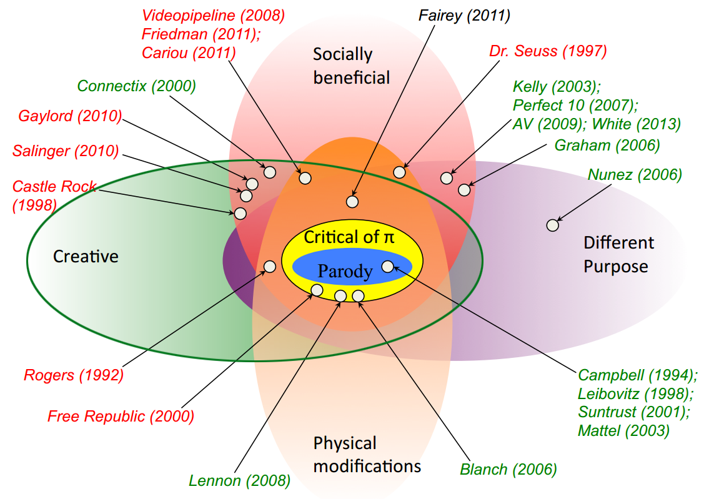
Case color legend: Defendant prevailed (green); Plaintiff prevailed (red); Unresolved (black).
Figure 116: Leading cases where “transformative” was defined as “creative” highlighted by the green ellipse

Acceptance of this suggestion would increase the set of circumstances in which defendants could successfully invoke the fair use doctrine, but the theory I’ve outlined is not always pushed in that direction. In particular, viewed from the perspective of the theory I have sketched, consumptive as opposed to transformative uses of copyrighted materials do not merit as much solicitude as the courts have sometimes given them. Recall Justice Blackmun’s comment in the Betamax case.

The situations in which fair use is most commonly recognized are listed in section 107 itself. Fair use may be found when a work is used “for purposes such as criticism, comment, news reporting, teaching, … scholarship, or research.” … Each of these uses reflects a common theme. Each is a productive use resulting in some added benefit to the public beyond that produced by the first author’s work. The fair use doctrine, in other words, permits works to be used for “socially laudable purposes”. I am aware of no case in which the reproduction of a copyrighted work for the sole benefit of the user has been held to be fair use.

I am much of his mind. While the productive – in other words, creative – uses of copyrighted materials deserve lots of scope, consumptive uses – in other words, uses for the sole benefit of the user – do not. Adoption of Blackmun’s position would lead to another heretical result. The declaration in the Betamax case that time shifting broadcast TV shows and films is a fair use might well have been wrong. But hold on. Wouldn’t adoption of Blackmun’s position have doomed VCRs? No. It probably instead would have resulted in a voluntary royalty system. Purchasers of VCRs would have paid a premium, which in turn would have been paid to the owners of the copyrights in the taped shows and films. This would have caused an increase in the cost of VCRs, and that cost might well have reduced somewhat the pace at which this technology spread, first in the US population and then globally. But from the standpoint of the cultural theory offered here, that would not have been so terrible.
A final comment about fair use. At the end of the preceding lecture, I suggested that the US version of the fair use doctrine suffers from a fundamental defect. It sets forth a set of four factors that judges must consider but does not indicate why those factors matter. The judges called upon to apply the doctrine thus must decide for themselves what the goal of the copyright system is and then construe the factors to advance that goal. Application of the doctrine is thus very hard to predict in advance. Adoption of the approach outlined in this lecture could address that defect. If lawmakers were willing to articulate a vision of the sort offered here and tie fair use to it, the result would be to reduce considerably the notorious uncertainty of this dimension of copyright law.
Let’s now move on to the sensitive subject of moral rights. When set against the backdrop of cultural theory, one aspect of moral rights is suspect – the right of integrity. As you know, the right of integrity, when fully implemented, protects artists and authors from the destruction or mutilation of their works. The result inevitably is to curb the interests of the people we used to call consumers to remix their creations. Artists’ interest in self-expression of course deserves considerable respect and protection, but perhaps not as much as some jurisdictions, particularly in continental Europe, currently afford them. In some contexts, the artists’ interests may have to be tempered by legal recognition of the equally important interests of consumers in self-expression and the overall cultural importance of semiotic democracy.
With respect to unique or limited edition works, perhaps preservation of the current regime is, on balance, sensible. No one should be permitted to melt down or desecrate one of the few castings of Rodin’s Thinker. But when copies of a work are not scarce, modification and remixing should be freer. An example would be colorization of black and white movies. So long as copies of the original film remain available, we should tolerate, even encourage, the creation and dissemination of colorized versions.
Other dimensions of moral rights, however, stand up much better to scrutiny from the standpoint of cultural theory. The right of attribution, for example, seems closely tied to the fundamental human need for self-expression, the ability to project one’s identity into the world and to be recognized by others. Requiring recognition of that sort would not materially impair the opportunities for remixing and secondary creativity. One doctrinal adjustment that could accommodate this insight would be to add to the US fair use calculus a requirement like that currently in the United Kingdom’s fair dealing system, namely a duty to give credit where credit is due.
Libraries contribute importantly to public education, defined expansively, as was suggested in the previous segment of this lecture. Thus, we should be skeptical of aspects or applications of copyright law that make it harder for libraries to operate. An example would be public lending rights which exist in Europe but as yet nowhere else. Such rights give copyright owners the ability to collect fees from libraries. If the libraries are able easily to pass along the cost of those fees to governments, which in turn pay for them out of general tax revenues, then the net result may not be bad. Indeed, it may give rise indirectly and inadvertently to a form of governmental funding for education. But in most developing countries, governments would not be able to absorb these costs, and thus the adoption of public lending rights would seriously burden libraries and likely force some of them to curtail their operations. That would be plainly inconsistent with the cultural theory and should be resisted.
The functions traditionally assumed by libraries are increasingly being assumed by other organizations. An example is Google, which sought in its ill-fated Google Print Library Project to make all books published in the world widely available in digital form. This was a highly commendable ambition. To be sure, there were opposing considerations, most obviously the interests of the authors and publishers being appropriately compensated. The best way of reconciling these goals was far from obvious, but one maneuver was promising. Oren Bracha proposed that we accept in this particular setting an opt-out rather than an opt-in rule. In other words, Google or other organizations should be permitted to digitize books and make the digital versions publicly available unless and until the copyright owners object. Shifting the burden to the copyright owners would have huge social benefits. Most importantly, it would enable widespread distribution of so-called orphan works, works that may still be in copyright but whose owners cannot be readily identified. Opening up all such works for public use unless and until the owners made themselves known and objected would do much to facilitate the dissemination of knowledge critical to a good society, and the burden on copyright owners would be slight. This brings us to formalities. In lecture number six, I suggested that many scholars now believe that the modern trend of abolishing formalities as preconditions to the acquisition or enforcement of copyrights is regrettable. The cultural theory sketched here suggests some of the reasons why. By granting copyrights automatically to creative works, we needlessly limit the scope of the public domain, and by failing to require compliance with a comprehensive registration system, we needlessly frustrate many potential licensing deals that would enable socially beneficial activities.
Cultural theory can also lend some support to the shaky arguments I discussed at the end of lecture number eight in favor of compulsory licenses. Specifically, two kinds of compulsory licenses look somewhat better when viewed from this angle – those that enable modifications of copyrighted works provided that the modifiers pay a governmentally-set fee, and those that give a break to educational activities, such as public broadcasting. The former, such as the cover license in section 115, had the effect of increasing the diversity of cultural products available to the public. Think of the richness of the menu of renditions of classic musical compositions that the cover license has enabled. The latter, of course, facilitate education broadly conceived and an informed citizenry.
A few minutes ago, I mentioned an example of differential pricing, specifically in the context of educational discounts for software. I now want to return to this issue and address it more broadly. Differential pricing of copies of copyrighted works is a very complicated subject when viewed from any angle. Assessed from the standpoint of cultural theory, it offers some intriguing possibilities but also poses some dangers. The principal opportunity is that differential pricing can have the beneficial effect of equalizing access to entertainment and informational products across income classes and countries and thus promotes the kind of distributive justice that figures importantly in cultural theory. This possibility is suggested by the facts of the Kirtsaeng case, which as you know is currently before the United States Supreme Court. Supap Kirtsaeng is a student who financed his education in large part by persuading his relatives living in his native Thailand to purchase inexpensive copies of textbooks that had been manufactured and sold in Thailand and ship them to Mr. Kirtsaeng, who was then studying at Cornell University in upstate New York. The large differential between the price at which the books were being sold in Thailand and the retail price in the United States enabled Mr. Kirtsaeng to make a healthy profit selling the books on eBay for somewhat less than the US list price. The issue currently before the Supreme Court is whether John Wiley, the owner of the copyrights in the books, should be able to stop this practice.
Admiration for Mr. Kirtsaeng’s entrepreneurial spirit and unease concerning the magnitude of the damage award to which he is exposed if he loses suggests the answer should be no. But consider what will happen if Kirtsaeng prevails. Publishers, feeling generalizations of his conduct, will almost certainly reduce the price differential between the US and poorer countries, thus rendering arbitrage of the sort he engaged in less attractive. The publishers could achieve this by lowering the US retail price, but for obvious reasons that’s unlikely. Instead, they will probably raise prices in Thailand and other developing countries. The result is that the residents of those countries will face higher financial hurdles when seeking educations. Assuming that we wish to apply our cultural theory on a global scale this is an unattractive outcome.
For similar reasons, we may wish to acquiesce in the technological protection measures that help film studios engage in so-called region coding of DVDs and now Blu-ray discs. The effect of those systems is that the disks sold in one region cannot be played on players that are sold in a different region. One of the goals of such systems is to enable the studios to sell discs at lower prices in poorer regions than in richer regions without fearing importation of the cheap versions into the wealthier regions. From the standpoint of distributive justice, it seems a good thing, not a bad one. But differential pricing is not an unalloyed good. Viewed from the standpoint of cultural theory it has at least four potential drawbacks. First, it sometimes results in a constriction, not expansion, of the set of people to whom the good at issue is provided. This all depends on the shape of the demand curves in the subdivided markets. Second, as Wendy Gordon observes, differential pricing can increase what she calls the granularity of social life, the sense that all of our conduct triggers microcharges. Third, as Yochai Benkler and Eric von Hippel contend, differential pricing can corrode a culturally beneficial practice and spirit of altruistic sharing – in other words, giving away your stuff for free. Last but not least, the dream that currently bedazzles many copyright owners of slicing their markets ever more finely creates a powerful incentive to collect extremely detailed information concerning the habits, incomes, and wealth of those customers. The result is a serious risk to privacy, one of the conditions that, as you know, figures in our vision of the good life. How can we balance these competing considerations? No blanket solution is readily apparent. The set of rules governing differential pricing that, all things considered, is most conducive to the good society unfortunately varies by context.
This concludes our examination of the possible implications of the particular variant of cultural theory that I have outlined here for the reform of copyright law proper. Next, I’ll consider a few ways in which the same theory might be applied outside copyright law and then consider some overall objections to this whole approach.

Supplements and Concerns
You will recall that when discussing welfare theory, I identified five ways in which a government can seek to offset the under production of public goods, such as literature, art, and scientific innovations. To review, those five strategies are – first, the government can provide the public good itself, as it does with respect to navigation, AIDS, and space research. Second, the government can select and subsidize private innovators, as it does with respect to much research involving health related sciences. Third, the government can offer prizes to successful innovators, an increasingly popular approach. Fourth, the government can adopt laws that reinforce innovator’s self-help strategies, such laws include protections for trade secrets, and the kind of anti-circumvention rules I mentioned a minute ago and that we will examine in more detail next week. Fifth, and not least, the government can protect producers against competition in the reproduction, distribution, and performance of their works.
As you know by now, copyright law is an example of the fifth approach. The topic for today is cultural theory, not welfare theory, but the same five options are relevant when we cast about for ways to advance the kinds of society commended by cultural theory. Some might be more efficacious than reforming copyright law itself. For example, if we believe that this set of cultural products being produced today is too thin to sustain the kind of culture and the set of opportunities for artists that we want, we could, as we’ve done in the previous segment of this lecture, tried to tune the copyright system. Or instead, we could supplement the incentives created by copyright protection with government subsidies for the type of work at issue. Several European countries already do this with respect to cinema. European national governments and some regional governments offer grants to filmmakers, typically new filmmakers or filmmakers pursuing unconventional projects, that supplement the revenues they can make by selling or exhibiting copies of their films. Where does the money come from? Typically from taxes, either general tax revenues or taxes on other forms of entertainment. The result is increased diversity in the films available to consumers. Whether the net result is unbalance attractive is perhaps a good test of the merits of this approach.
An even more radical possibility is the one I considered briefly in lecture number four. If we despaired of relying on the copyright system to compensate fairly the creators of musical compositions and films, we might consider replacing the copyright system altogether with respect to online distribution of sound recordings and films with an alternative compensation system. The gist of such a system, you’ll recall, is that fees would be collected, directly or indirectly, from businesses that capitalize upon consumers’ demand for digital recordings, but currently pay nothing to the creators of those recordings. Such businesses include Internet service providers, manufacturers of consumer electronic equipment, and media related application programs.
The funds collected in this manner would then be distributed to the creators. The formulas by which they were distributed would likely vary by country. In the United States, where suspicion of government is intense, the money would likely be parceled out among copyright owners in proportion to the relative popularity of their works. In Europe, as Philippe Aigrain has argued, relative popularity would likely be alloyed with other criteria when determining how the money is divided. Once such a system were in place, online distribution of movies and recorded music would be legalized.
Viewed from the standpoint of cultural theory, such a system would have two main advantages over our current regime. First, it not only would provide consumers lawful access to many more cultural products at low cost, it would free them legally to modify and redistribute those artifacts, thus enhancing semiotic democracy. No longer would YouTube’s copyright sniffing software suppress mash-ups that happen to contain snippets of other people’s material. Incidentally, YouTube’s software has balked at some of the lectures in this series, forcing us to appeal those rejections on the grounds that the snippets that I employ are shielded by fair use. Whether such appeals, however well founded, will continue to work remains to be seen. Back to main story. Second, by enabling artists to earn good incomes by providing their works directly to the public, such an alternative compensation system would sharply increase access to the variant of the good life associated with the creation of art. As we’ve seen, an alternative compensation system would not be perfect. Its disadvantages are cataloged below, but it would have great strengths.

Advantages
- For consumers
  - Large cost savings – they would pay less under this system than under the current combination of business models
  - Unlimited access to recorded media
  - The set of cultural products available to them would be larger and more diverse – reason: the diminished power of intermediaries would enable a larger and more diverse set of artists to reach consumers directly and thus earn sufficient revenue to cover costs
  - Increased opportunities for creative reuse of cultural products – semiotic democracy
- For creators
  - Opportunities to distribute works directly to consumers – reduced dependence on major intermediaries
  - Increased income
- For suppliers of devices and services – increased taxes offset by increased demand
- For public
  - Decreased litigation
  - Decreased law-breaking – avoid prolonged, culturally corrosive “war on piracy” closely analogous to the current “war on drugs”

Disadvantages
- Cross-subsidies
  - Result: distortions in consumer behavior, deadweight losses, and unfairness
  - Vary substantially with the method of taxation
  - Mitigate with Ramsey pricing (Benkler)
- Moral rights concerns
  - Classic moral rights (rights of Integrity and rights of Attribution)
  - Increased opportunities for creative reuse of digital copies threaten both
  - Possible responses:
    - Give artists the option to retain or relinquish rights of integrity – perhaps use financial incentives to increase their willingness to give up these rights, or a higher payout rate
    - Recognize that, with respect to cultural products distributed in multiple copies, rights of integrity are obsolete; by contrast, rights of attribution should enjoy increased protection (cf. Tushnet)
- Discretionary Governmental Power
  - Potential for inefficiency or corruption – cf. some collecting societies
  - Risk that officials would abuse their authority
  - Rent-seeking – lobbyists would seek to shape the distribution formula
- Leakage across national boundaries – the more broadly this system were adopted, the less serious would be this concern

One of the most difficult issues currently confronting lawmakers throughout the world is how, if at all, to shield so-called “traditional knowledge” against unauthorized uses. Roughly speaking, the term traditional knowledge refers to cultural products developed over long periods of time, typically by the members of indigenous groups. Examples include traditional music, dances, fabrics, costumes, folklore, and religious icons. Such things do not fit well the template of copyright law. In part because the authors of such things are usually collective, hard to identify, and long dead. In addition, the concerns of the groups who object to the non-permissive use of traditional cultural expressions (sometimes abbreviated as TCEs) are usually quite different from the combination of economic and personhood interests implicated by most copyrighted works. If copyright law doesn’t work well in this setting, what would work better? That’s far from clear. Countries continue to experiment with a wide variety of models. Various insight into those possible ways of dealing with traditional knowledge might be derived from the cultural theory we have outlined here. Unfortunately, those insights conflict. Cultural theory is thus arguably helpful in identifying some things we should strive to achieve or protect, but not particularly helpful in telling us how to do so. Here are some of the competing considerations.
- The use or performance of TCEs is one of the ways in which some communities define and sustain themselves. Because preservation of communities is one of the things commended by cultural theory, we should strive if possible to protect these practices from corrosion or dissipation.
- Protecting TCEs from appropriation by persons or firms outside the indigenous groups that created and sustained them would also promote cultural diversity by helping to resist the trend towards global cultural homogenization.
- Allowing indigenous groups to charge, or otherwise be compensated for uses of their TCEs, would also provide them a source of funds that would mitigate their impoverishment and promote distributive justice. Note however, that this third consideration is in some tension with the first and second, which seemed to presume that the TCEs would not spread.
On the other side of the ledger, protections for traditional knowledge are hard to reconcile with the value of semiotic democracy – the merit of enabling all persons, both members of and outsiders to the indigenous groups, to refashion cultural artifacts of all sorts. Such protections are also hard to reconcile with the value of autonomy, of enabling all persons to choose for themselves the cultural forms through which they will define themselves. More broadly, the impulse to protect TCEs against unauthorized used or modification, seems rooted in a static conception of identity that diverges from the more dynamic conception of identity that figures in the conception of the good life offered here. So what’s the right approach? It’s very hard to say. That question seems best left to the seminars that will accompany this lecture series.
All copyright theories have weaknesses, sore points. The theory I’ve outlined today is no exception in this regard. Cultural theory has two main weaknesses, both of which are likely apparent by now. The first is commonly referred to as the perils of paternalism, or as it’s sometimes called parentalism. Whichever term you prefer, it means efforts by governments to limit people’s freedom or otherwise channel their behavior, not to protect the interests of others, but for their own good. Legal rules of this sort are not unknown. Familiar examples are rules requiring motorcyclists to wear helmets, rules forbidding people to sell organs, bans on self-enslavement, prohibitions on the use of certain drugs, and the non-waivable character of the implied warranty of habitability in landlord tenant law. Nevertheless, such efforts are hazardous and controversial.
The reason why the specter of paternalism arises in the present context is that the vision of the good life, upon which this variant of cultural theory is founded, does not align exactly with what most people currently subjectively desire. Thus, to the extent the theory commends modifications of copyright law that will afford people more access to a life of the sort, and seeks to stimulate their appreciation of such a life, it does not defer entirely to people’s own assessment of their best interests, but instead pushes them in directions they might not be inclined to go, for their own good.
Three factors mitigate the troubling implications of that admission. The first, is that the gap between the vision outlined in the first segment of this lecture and people’s subjective desires is not as large as one might think. The findings of the group of scholars sometimes known as the Princeton Group concerning the ways in which people assess their own wellbeing are reassuring. In particular, the so-called day reconstruction method, pioneered by this group and applied to the members of many classes and to the residents of many countries, reveals that people take more pleasure in some of the things commended by the good life, such as intimacy and friendship, and less pleasure in consumption and the trappings of status than has traditionally been assumed. Second, none of the possible reforms I’ve outlined force people to do anything. You’re not coercive. Instead, they’re designed to alter incentives in an effort to invite or nudge, to use the term popularized by Thaler and Sunstein, people into better lives. Third, it’s not the case that adoption of these proposals would introduce paternalism into copyright law for the first time. As we’ve seen, extent copyright law already contains some even more coercive rules that constrain people’s freedom for their own good. The clearest examples are the non-waivable termination rights in sections 203 and 304 of the US statute, which I discussed in lecture number six. Why are those rights non-waivable? Because we wish to prevent artists from signing away their entitlements foolishly. In other words, we disable them from acting in ways that we think are not in their own best interests.
These three factors in combination may assuage our unease somewhat, but not entirely. Two arguments against initiatives of this general sort remain worrisome. The first is the fundamental argument made by liberal political theorists and leaders that governments ought to remain neutral concerning alternative theories of the good. The second is a prudential consideration. Even if paternalistic rules are not objectionable in principle, it’s foolhardy to entrust government officials with the power to override people’s own conceptions of their best interests.
This brings us to the second of the two major sore points about cultural theory. It would increase the degree to which the shape of our culture is determined by government officials. The risks associated with that strategy are familiar. Bureaucrats are not famous for wisdom. The persons and firms who stand to gain or lose from the decisions of the bureaucrats would dissipate scarce social assets trying to persuade those bureaucrats to take one tack or another. In the worst-case scenario, the officials’ decisions might be corrupt, either in the strong sense of being purchased by the affected parties, or the softer sense of being motivated by a desire to please the parties upon whose favor, and donations, the officials depend.
These risks can be reduced by carefully selecting the officials in whose hands power is placed or by instituting checks on their authority, but they cannot be eliminated altogether. Whether they are fatal to this enterprise, I leave to you.

Supplements to Copyright

Secondary Liability
The topic for today is supplements to copyright. Included in that topic are two main clusters of legal rules – the doctrine of secondary liability and the rules recently adopted by many countries that reinforce so-called technological protection measures. As usual, I’ll be focusing on the law in the United States, but I will also mention how the issues addressed today are implicated by multilateral treaties and how countries other than the United States handle them.
If copyright law were always obeyed, either because people voluntarily complied with its provisions or because they were perfectly enforced, the rules we consider today would almost certainly not exist. But as I’m sure you know, copyright law is not always obeyed. Indeed, broadly speaking, the frequency of disobedience seems to be increasing. Some level of disobedience is not necessarily terrible. We tolerate moderate levels of illegality in lots of fields. For example, violations of speed limits and of rules prohibiting the possession of certain drugs are common and have not, as yet, proven socially catastrophic. Indeed, in the context of copyright law, some degree of disobedience may be affirmatively beneficial. Infringement provides a mechanism by which people who could not afford the prices at which copies of copyrighted works are sold can gain access to those works. Because, as you know, copyrighted works are non-rivalrous, no one is injured when poor people gain access to copyrighted works for free. If people who could and otherwise would pay for access to the works begin to obtain them illegally for free, then the copyright owners do, of course, forfeit revenue. But so long as the levels of illegality remain moderate, the resultant leakage is tolerable and, as I say, arguably socially beneficial. If the leakage becomes too severe, however, then copyright owners begin to suffer serious injuries, and all of the various values advanced by copyright are imperiled. Lawmakers in such circumstances feel pressure to address the problem in some way. How? One obvious answer is to increase the civil and criminal penalties for engaging in copyright infringement. By making illegal conduct more costly, lawmakers could reduce its incident. We’ll consider strategies of this sort next week in the last lecture in this series when we discuss remedies. For now, I’ll note only that increasing penalties is not always efficacious and can have some serious side effects.
In this lecture, we’ll consider two other ways in which lawmakers have attempted to curb copyright infringement and to reduce the associated leakage of the system. The first of those strategies consist of bringing pressure to bear on third parties, specifically parties who do not themselves violate any of the exclusive rights enjoyed by copyright owners, but who enable or encourage violations by others. The basic idea is that, if we can force the third parties to withdraw their support for the infringers, or, better yet, induce those third parties to act affirmatively to curb infringement, we can increase the levels of compliance with the law. Before plunging into the details that currently implement this broad strategy, we should pause to consider the theories underlying this approach as a whole.
There are two general approaches used to justify and shape this strategy. The first is simple but important. Encouraging illegality is widely seen as immoral. The person who encourages lawbreaking may not be as blameworthy as the person who engages in it, but it’s still blameworthy to some extent and thus rightly subject to legal penalties. As we’ve seen, two of the general theories of copyright, the fairness theory and the personality theory, are founded at least in part on moral considerations. Viewed the lenses of those theories, authors and artists deserve either rewards for their labor or continuing control over projections of their personalities. Conduct that fails to respect their rights is immoral. Encouraging conduct that fails to respect authors’ and artists’ rights is, thus, also immoral. Perhaps to a lesser degree but immoral nonetheless, and thus properly subject to legal penalties. Sentiments of this sort, as we’ll see, color many judicial opinions in this field.
The second approach is more complicated and less intuitive. It’s associated with the welfare theory of copyright and more broadly with the utilitarian approach to law in general of which the welfare theory of copyright is one branch. This second approach is sometimes called gatekeeper theory. That term was invented by Professor Reinier Kraakman who pioneered this argument. In a seminal article, Kraakman points out that in a diverse array of contexts, the law enlists third parties to frustrate or penalize recalcitrant primary wrongdoers. Examples include the liability sometimes imposed on bartenders or social hosts when their drunk customers or guests cause injuries to themselves or others, penalties imposed on accountants when their clients engage in fraud, and penalties employed on employers who hire illegal immigrants. In other words, employers who facilitate the unlawful behavior of the immigrants themselves. Kraakman offers the following analytical framework to guide determinations of when it makes sense to employ this general technique.

Successful gatekeeping is likely to require:
1) serious misconduct that practicable penalties cannot deter;
2) missing or inadequate private gatekeeping incentives;
3) gatekeepers who can and will prevent misconduct reliably, regardless of the preferences and market alternatives of wrongdoers; and
4) gatekeepers whom legal rules can induce to detect misconduct at reasonable cost.

For subtle application of this framework, to override the problems, many but not all of which involve securities regulation, I encourage you to consult Kraakman’s article, which is available in the spring 1986 issue of the Journal of Law Economics and Organization. Our concern here is, of course, not the general theory of gatekeeper liability but with copyright law. As applied to copyright, Kraakman’s guidelines would suggest that penalties should be imposed on third parties in hopes of suppressing infringing behavior by others only if:
- Otherwise the incidence of copyright infringement would be unacceptably high because direct infringers cannot be controlled by socially acceptable sanctions.
- The third parties, left to their own devices, would not intervene to curb infringement and indeed might foster it.
- The third parties we might target are in a position to effectively suppress infringement. In other words, the direct infringers cannot engage in unlawful behavior without their aid.
- The social and economic costs of penalizing the third parties are not unacceptably high.
In many of the contexts I’ll be discussing this lecture, the first two requirements are probably met. The third and fourth, however, are not so invariably satisfied. When assessing the imposition of secondary liability in a particular context or case, you should ask yourself, if we penalize this particular third party, will the incidents of direct infringement diminish? Or will the direction infringers just find some other enabler? And what are the social costs of imposing secondary liability in this setting? This last question will be especially salient when dealing with so-called dual use technologies – in other words, technologies that can be and are used both to facilitate illegal behavior and to facilitate lawful and socially beneficial behavior. When considering the use of secondary liability to suppress such technologies, you should consider carefully whether the social benefits of blocking the bad uses exceed the social harms of blocking the good uses. If not, then the use of secondary liability reduces rather than enhances net social welfare.
So, to review: deployments of secondary liability in copyright law can and frequently are evaluated or justified from one of two perspectives – the immorality of helping someone to violate the rights of others, and the possible, though not inevitable, net benefits to social welfare of enlisting gatekeepers to control otherwise resistant forms of misconduct. With those two perspectives in mind, let’s turn to the law.
In the United States, the liability of third parties for facilitating the infringing behavior of others is managed by two offsetting sets of rules. The first set consists of doctrines of contributory and vicarious liability. The second consists of a set of statutory “safe harbors,” which are embodied in Section 512 of the statute, that immunize organizations that otherwise might be liable either for direct infringement or more likely for contributory or vicarious infringement. This doctrinal structure should by now be familiar to you. The doctrines of contributory and vicarious infringement give copyright owners a reasonably generous set of rights. Section 512 then carves out of those rights some specific exceptions and limitations. This pattern, I hope you see, resembles the relationship between Section 106 on one hand and Sections 107 through 122 on the other. Broad grants of rights subsequently qualified by exceptions.
The history behind this particular incarnation of the structure is unusual, but the structure itself is typical of copyright law. I will first briefly outline the main features of these supposed sets of rules and then examine a few of the cases in which courts have struggled to apply them.

17 USC § 106
Subject to sections 107 through 122, the owner of copyright under this title has the exclusive rights to do and to authorize any of the following:
(1) to reproduce the copyrighted work in copies or phonorecords;
(2) to prepare derivative works based upon the copyrighted work;
(3) to distribute copies or phonorecords of the copyrighted work to the public by sale or other transfer of ownership, or by rental, lease, or lending;
(4) in the case of literary, musical, dramatic, and choreographic works, pantomimes, and motion pictures and other audiovisual works, to perform the copyrighted work publicly;
(5) in the case of literary, musical, dramatic, and choreographic works, pantomimes, and pictorial, graphic, or sculptural works, including the individual images of a motion picture or other audiovisual work, to display the copyrighted work publicly; and
(6) in the case of sound recordings, to perform the copyrighted work publicly by means of a digital audio transmission.

The doctrines of contributory and vicarious infringement were developed by the courts with little or no guidance from the legislature. Sometimes these doctrines are said to be rooted in the language of Section 106 of the statute, which, as you can see above, gives copyright owners the exclusive right to “do or to authorize” any of the things we have considered in the past four lectures. Third parties who encourage copyright infringement might be said to be “authorizing” the infringing behavior, which, as you can see, Section 106 forbids. But this is a pretty thin read on which to rest a massive doctrinal edifice. It’s more accurate and honest to acknowledge that the courts have developed these doctrines on their own, and that the copyright statute does not meaningfully guide them.
The two doctrines are close cousins but have different origins. Contributory infringement emerged from general tort law. It’s said to implement the general principle that one who directly contributes to a tort should be held responsible along with the tortfeasor himself or herself. The role played by the moral principle I mentioned a few minutes ago should be apparent in this principle. By contrast, vicarious infringement is an outgrowth of the law of respondeat superior, the branch of the law of agency that governs the responsibility of employers for the misconduct of their employees. In the early 20th Century, the courts extended the respondeat superior principal well beyond employment relations to govern a variety of relationships in which defendants did not themselves engage in copyright infringement but had economic interests that were intertwined with those of parties who did engage in copyright infringement. By the middle of the 20th Century, the two doctrines had evolved to contain the following requirements. To hold a defendant liable for contributory infringement, a plaintiff must show three things.
- That someone had engaged in or was engaging in direct infringement;
- That the defendant had actual or constructive knowledge of that infringement; and
- That the defendant materially contributed to that infringement.
By contrast, to hold a defendant liable for vicarious infringement a plaintiff must show three somewhat different things.
- That someone had engaged in or was engaging in direct infringement;
- That the defendant benefited financially from that infringement; and
- That the defendant had the right and ability to supervise the direct infringement – in other words, to stop it and failed to do so.
Note that while actual or constructive knowledge is essential to contributory infringement, it’s not necessary for vicarious infringement. In that sense, vicarious infringement partakes more of the principle of strict liability than its contributory infringement cousin.
The classic illustration of these two doctrines was distilled from a set of cases in the early 20th century that involved dance halls (refer to Figure 117). Suppose that a musical group without permission performs some copyrighted musical compositions in front of a public audience. The playlist, in other words, the set of songs the group plays, had been selected by the group’s manager. The owner of the hall in which the performance takes place keeps a portion of the ticket prices paid by the members of the audience and makes no effort to prevent the group from playing the songs without permission. Under these circumstances, the owners of the copyrights in the songs would have three causes of action. A claim against the group for direct infringement, namely, as you know by now, a violation of the public performance right embodied in Section 106(4). A claim against the manager for contributory infringement because, although the manager himself did not publicly perform any compositions, he plainly knew of the band’s plan and encouraged it. And finally, a claim against the owner of the hall for vicarious infringement, because even if the owner did not know of the band’s plan, he is profiting from the band’s behavior and he failed to exercise his clear power to stop them.
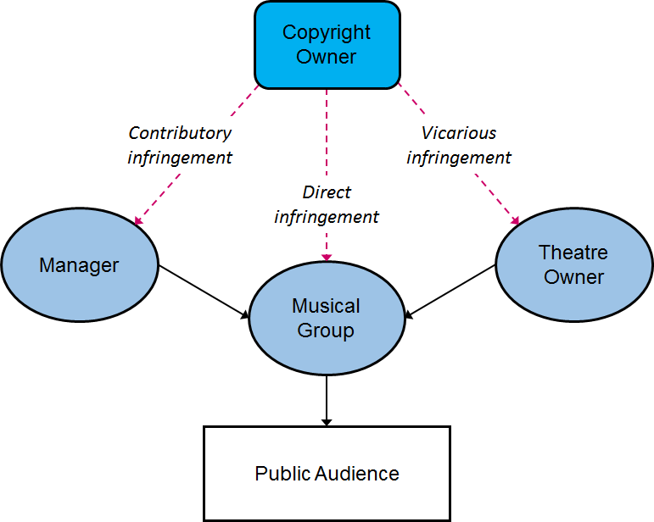
Figure 117: Actions that a copyright owner can take against parties for publicly performing their work in a dance hall without permission

All of this is straightforward, I hope. Now, let’s consider a few modern cases where the application of these principles is less clear-cut.
A prosaic but influential case was decided by the Court of Appeals for the Ninth Circuit in 1996. The defendant, Cherry Auction, was the operator of this flea market, located in Fresno, California. A flea market, otherwise known as a swap meet, is a marketplace where a large number of independent vendors sell merchandise, typically inexpensive or used merchandise, to customers who come hunting for bargains. In this instance, the vendors, as is typical, paid modest rental fees to Cherry Auction. Cherry Auction provided those vendors booth space, operated the parking facilities, and advertised the marketplace. In addition to collecting fees for the vendors, Cherry Auction collected entrance fees from the customers. Finally, Cherry Auction reserved the right to exclude any vendor for any reason. The plaintiff, Fonovisa, Incorporated, owns the copyrights in a large number of Latino sound recordings. Fonovisa complained several times at Cherry Auction that some of the vendors in the flea market were selling pirated copies of Fonovisa’s recordings, to no avail. Finally, Fonovisa brought suit against the flea market. Because Cherry Auction was not itself copying or distributing Fonovisa’s works, Cherry was not liable for direct copyright infringement. But if the facts were as Fonovisa alleged, then some of the vendors were surely violating Section 106(3) and were not shielded by the first sale doctrine embodied in section 109(a). If the reasons why the vendors were engaged in copyright infringement are not clear to you, you should pause here to review the first segment of lecture number eight. Fonovisa contended that Cherry Auction was secondarily liable for the vendors’ unlawful behavior, both under the doctrine of contributory infringement and under the doctrine of vicarious infringement. The trial court was unpersuaded and dismissed the suit for failure to state a claim upon which relief could be granted. The Court of Appeals for the Ninth Circuit reversed and remanded the case. In the opinion explaining its decision, the Ninth Circuit clarified and arguably expanded both secondary liability doctrines. With respect to contributory infringement, the court ruled that Fonovisa had sufficiently alleged knowledge of the infringing sales on the part of Cherry Auction. More importantly and controversially, the court ruled that “material contribution” of the sort required by the doctrine of contributory infringement could be established by showing that the defendant “provided the site and facilities for known infringing activity”. With respect to vicarious infringement, the Ninth Circuit ruled that Cherry Auction controlled the flea market site and had unconstrained authority to expel any vendor. It, thus, plainly had the right and ability to supervise the infringing activity. More importantly and controversially, the court ruled that the “financial interest” required to establish vicarious liability could be established by showing that the infringing behavior “enhanced the attractiveness of the defendant’s venue to potential customers” – in other words, that the infringing conduct acted as a draw, pulling customers toward the defendant’s site and thus enabling the defendant to earn more money. It should be apparent that this is an expansive interpretation. Taken literally, it would encompass many kinds of behavior in which the financial benefit to the defendant is more indirect than the sort enjoyed by the dance hall owners.
This concludes our examination of the basic principles of secondary liability. Next, we’ll examine a set of recent cases that have applied or modified those principles in context in which defendants supplied goods or services that are sometimes used for infringing purposes and sometimes for non-infringement purposes.

Dual-Use Technologies
The cases we’ve considered thus far involved defendants who operate sites – dance halls, flea markets, and so forth – in which third parties engaged in copyright infringement. Somewhat different, and more difficult, are cases in which the defendant sells a product, or provides a service, that its customers sometimes employ in ways that violate the copyright laws and sometimes employ in ways that do not. As I mentioned earlier, such cases have come to be known as “dual use technology cases.” There have been four major cases of this sort in the United States:
- The Sony (US S. Ct. 1984), or Betamax case, which I discussed in connection with the fair use doctrine in lecture number nine;
- A set of rulings concerning the Napster file sharing service (CA9 2001);
- A decision by the Court of Appeals for the Seventh Circuit involving one of the successors to Napster, known as Aimster (CA7 2003); and
- A second decision by the Supreme Court in the Grokster case (US S. Ct. 2005).
I’ll briefly describe the facts and holdings of these decisions.
In the Sony case, as you already know, the defendant prevailed. In all three of the file sharing cases, by contrast, the defendants lost. However, the ways in which they lost varied considerably. Put differently, the courts adjusted and then readjusted the law of secondary liability to address the changing structure of the file sharing systems. A charitable interpretation of this sequence of cases would depict it as an illustration of the flexibility and wisdom of common law adjudication. An uncharitable interpretation would see it as a manifestation of what is sometimes called result orientation – in other words, a determination by the courts to suppress a social practice they saw as pathological, and a willingness to contort the law to achieve that end. Which is the more apt interpretation, I leave to you.
The basic facts of the Betamax case, as you’ll recall, are that the film studios licensed television networks to broadcast their films to viewers with the expectations that the viewers would watch the embedded ads, and then buy some of the products promoted by those ads. The advertisers in turn would pay the TV networks fees, some of which the networks paid to the studios in the form of license fees. This longstanding business model was disrupted by Sony when it began manufacturing and selling VCRs, which, among other things, enabled the viewers to avoid watching the embedded advertisements, thus endangering the flows of revenue through the system. Because the viewers were using their machines to make verbatim copies of the studios’ films, the studios might have brought suit against the viewers, but the impracticability of that approach prompted the studios, instead, to bring suit against Sony, the manufacturer of the devices the viewers were employing. In the end, as you know, the studios lost in the Supreme Court – barely. The two interlocking rulings that enabled Sony to escape liability are set forth on the right. The second ruling we discussed in lecture number nine. Our concern here is with the first ruling. The key phrase in it comes at the end: “capable of substantial non-infringing uses.” Using the first letters of those words as an abbreviation, this dimension of the Sony decision might be called the COSNU defense.
Holdings of Sony
- The manufacturer of a device that can be used to violate the copyright laws is liable for contributory infringement, if and only if the device is not capable of substantial noninfringing uses.
- Timeshifting copyrighted programs is a fair use.
This standard for secondary liability, which the court adapted from a loosely analogous aspect of patent law, is quite generous to defendants. Taken literally it means that the manufacturer and distributive of a dual use technology does not need to show that his product is often used for legal purposes, or even that it is ever used for legal purposes, but merely that it is capable of being used for substantial legal purposes. Sony of course, easily passed that test because as we’ve seen, time shifting, which the Supreme Court for the reasons we’ve already considered determined to be lawful, was the most common use of VCRS. But the way in which the court phrased the COSNU defense seemed to offer an escape hatch to defendants whose products were much less often employed legally.
The relationship between the COSNU defense announced and applied in the Betamax case, and the overall doctrine of secondary liability, is not entirely clear, but it appears that the way in which the defense engages with the standard requirements is by negating the element of knowledge, which as you know, is one of the requirements of contributory infringement. More specifically, the fact that a device is capable of substantial non-infringing uses prevents the plaintiff, in the court’s words, from showing that the defendant “has sold equipment with constructive knowledge of the fact that its customers may use that equipment to make unauthorized copies of copyrighted material.” Now in theory the studios could have overcome that impediment if they could have shown that Sony had actual knowledge that a particular customer was using her machine illegally. For example, that a particular customer was using her machine for librarying, which even the majority of the Supreme Court seemed to assume did not qualify as a fair use. The studios did not make such a showing, and probably could not have done so. But this possibility, as we will see, played a role in some later cases.
Another ambiguity in the Betamax opinion concerns whether the COSNU defense applies only to claims of contributory infringement, or also to claims of vicarious infringement. Almost all the court’s opinion focuses on contributory infringement, but in one cryptic footnote, specifically footnote number 17, the court observed that “the lines between contributory infringement and vicarious liability are not clearly drawn. And that recent analysis of respondent’s unprecedented contributory infringement claim necessarily entails consideration of arguments and case law which might also be forwarded under other labels.” The court thereby left open the possibility that its ruling applied to vicarious liability as well. Again, this possibility didn’t much matter in the Betamax case itself, because in any event, the studios could not show that Sony had the right and ability to supervise the ways in which its customers used its machines and so could not establish vicarious liability, even if the COSNU defense were inapplicable to such claims. But it would make a difference in some subsequent cases.
So, that’s where things stood as of 1984. For the next 15 years, the COSNU defense, announced in the Betamax case, stood as a powerful bulwark for firms developing products and services that were sometimes used to engage in copyright infringement. What destabilized this doctrinal structure was the rise of file sharing. The next three cases in the sequence struggled to reconcile file sharing with the Betamax framework. The first, and arguably most famous of the three file sharing cases, was Napster. I’ve mentioned the Napster system and the associated legal controversy before. Here’s a somewhat more detailed description of the facts.
Napster consisted of a website and an application program that together enabled music fans to exchange copies of sound recordings (refer to Figure 118). The Napster website, which was www.napster.com, contained a directory listing all of the recordings that could be found on the hard drives of all of its members’ computers, and an index to those recordings. A music fan who wished to join the community and gain access to those recordings, would first log into the website and download from it a free piece of software known as MusicShare. After installing the software on his computer, the user would sign up by selecting a unique username, typically fictitious, and a password. He would then create on his computer a “user library” into which he would copy any recordings, typically in the form of MP3 files, that he wanted to share with other users. He would then log into the Napster system. His software would talk to the software on Napster’s servers. One result of that conversation is that a list of the files on his computer would appear in the Napster directory. The files themselves would not be copied onto the servers of Napster’s site, just their names. That’s the significance of the hollow circles in the diagram in Figure 118.
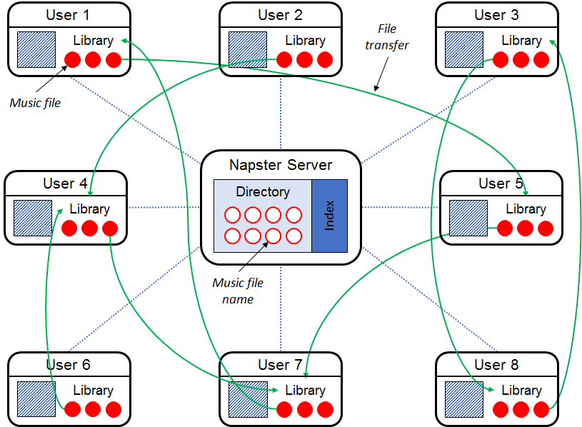
Figure 118: How Napster’s MusicShare software functioned

Other users would be doing the same thing. Suppose one of the subscribers, say user number two, wanted to find some recordings by Eric Clapton. She would submit a search request using Clapton’s name. If any of Clapton’s recordings appeared in the index, the software would identify which of the libraries of currently logged in subscribers contained those recordings, and provide that information to the application on user number two’s computer. That information would enable her computer to connect directly to one of those host computers, here belonging to user number one, download a copy of the file directly from the host computer, and save it on user number two’s hard drive. The fact that the two users’ computers were in direct contact explains the name peer to peer copying. User number two could then either play the file directly from her computer or, if she had a CD burner and the appropriate software, she could convert the MP3 file to a WAV file and copy it onto a CD, which could then be played on any CD player.
Now if only a few people engaged in this practice the owners of the copyrights and the compositions and recordings most likely would have tolerated it, just as they had tolerated the longstanding practice of teenagers making so-called mixed tapes for their friends. But the system grew extraordinarily fast. By October of 2000, roughly a year after its launch, it had 32 million subscribers. Four months later it had 80 million. Nor was it limited to the United States; indeed, the percentage of people with internet access who used Napster was higher in Canada, Argentina, Spain, and Brazil, than it was in the United States. Copyright owners, unsurprisingly, became increasingly concerned. Soon after the launch of the service, the Napster executives contacted the record companies and sought to obtain licenses to distribute their works. The record companies considered such an arrangement. Indeed Bertelsmann, the German parent company of one of the record companies, extended a loan of $80 million to Napster, and tried to persuade the other record companies to license their catalogs to Napster. But in the end, the record companies decided to litigate rather than negotiate.
As in the Betamax case, the companies could have brought suit against Napster’s subscribers, who are actually engaged in copying their works and distributing unauthorized copies. But again, the impracticability of that option prompted the copyright owners to pursue Napster instead. Because Napster was not itself copying recordings or distributing copies, the owners did not have a good claim for direct infringement. But they could and did contend that Napster was secondarily liable for the conduct of its subscribers. Judge Patel of the district court found in favor of the owners. Napster appealed to the Ninth Circuit, which ruled, in brief, that use of the Napster system to sample songs is not a fair use. Because Napster is capable of a substantial non-infringing use, the owners of the system lack the constructive knowledge of infringing uses necessary to support contributory liability. Note here the impact of the Betamax ruling. So far things look good for Napster. But its luck would not hold. Next the Court of Appeals ruled that because the Napster operators can ascertain whether a particular recording has been copied illegally, they have timely actual knowledge of specific acts of infringement necessary to support contributory liability. Remember that this was an option left open by the Betamax case that the Ninth Circuit in Napster seized it. Finally, for the same reason, the court of appeals ruled that the Napster operators have the “supervisory control” over the conduct of its subscribers necessary to support vicarious infringement.
Death came swiftly. By the summer 2002 the Napster system had been closed and the company filed for bankruptcy. Critics of the record companies argue that by suing Napster, they made a catastrophic strategic mistake. Had they agreed to license the Napster service they might have been able to collaborate in the construction of a lawful music subscription system, from which they could have earned a great deal and avoided alienating millions of consumers. By instead adopting a confrontational posture, the record companies delayed for roughly a decade the emergence of such services. By then the recording industry had shrunk by half: in the US its gross revenues in 1999 were around $13 billion; today they’re around $7 billion. Global revenues have shrunk at a corresponding pace: today they are around $16 billion. This collapse could’ve been avoided if the companies had embraced peer to peer technology, instead of trying to suppress it. The record companies, of course, disagree with this assessment. Capitulation to Napster, they argue, would have led to an even faster decline in the industry, as other unauthorized and thus free services sprang up and drew customers away. Perhaps. It’s unlikely we’ll ever be able to resolve this controversy.
So back to our story. Napster’s demise did indeed open the way for follow on similar services. One of them was Aimster, so named because it piggybacked on AOL’s instant messaging service. It was similar to Napster in many ways, but differed in one: encryption prevented the operators of the Aimster system from knowing the contents of the files its subscribers shared. Nevertheless, the intentions of the Aimster creators were reasonably clear from the fact that they provided users online tutorials showing them how to use the system to exchange sound recordings, most of which would likely be subject to copyright protection. Like its ancestors, Aimster attracted subscribers with extraordinary speed. It was launched on August 8, 2000. Within three days 20,000 people had signed up. By early 2001 it had 2.5 million registered users, and by the end of April 2001, the number had grown to 4.2 million. The purpose of the encryption included in Aimster’s design was, of course, to avoid the kind of “actual knowledge” of infringing behavior that had doomed Napster. In the judgment of the Court of Appeals for the Seventh Circuit, this was too clever by half. In the court’s judgment, Aimster was plainly liable for contributory infringement. The court brushed aside the COSNU defense that had saved Sony on a ground that the defendants had failed to present evidence of any lawful uses of their system. The court next ruled that the defendant’s strategy of see no evil could not save them. In its words, “willful blindness” is the equivalent of actual knowledge. Finally, material contribution was established by the defendant’s active encouragement of infringing uses of the system. Interestingly, the court was less sure that the defendants were liable for vicarious infringement. But no matter, contributory infringement was sufficient.
The holdings in the Aimster case were relatively unsurprising. Much more eye opening were some statements made by the court in dictum, suggesting doubts concerning the pillars on which the Betamax ruling had rested. Judge Posner writing for the court, expressed his disagreement with the Betamax formulation on two fronts. First, he contended that to trigger the COSNU defense a defendant must demonstrate that its product has substantial non-infringing uses, not merely that it is capable of substantial non-infringing uses. Adoption of this suggestion would entail converting the doctrine from a COSNU defense to a POSNU defense. Second, he argued that even if the defendant makes such a showing, if the infringing uses are substantial, the defendant must also show that it would have been “disproportionately costly” to design its product so as to eliminate or reduce the infringing uses. These principles were not necessary to the Aimster opinion, but they boded ill for the developers of dual use technologies.
The last of major file sharing cases involved the Grokster service. It differed from its predecessors, somewhat, in structure. Specifically, the FastTrack technology that it, along with some other companies employed, was decentralized. Not quite as decentralized as Nutella, a popular system developed by a renegade programmer at AOL, but more so than either Napster or Aimster. In brief, a FastTrack user interested in exchanging files would locate, with the aid of a central server, one of the set of computers connected to the Internet that functioned as so-called supernodes, coordinating search requests among clusters of users. Once engaged in the system, the user could submit a request, let’s say for a particular Clapton recording. If a copy of the requested recording were located on one of the connected users’ computers, it would be delivered to the requesting party with no further involvement by Grokster. Partly because of the structure, the system was used reasonably often for non-infringing purposes, such as distributing movie trailers, sharing the works of Shakespeare, and locating computer software for which distribution is permitted, as well as for exchanging recordings unlawfully.
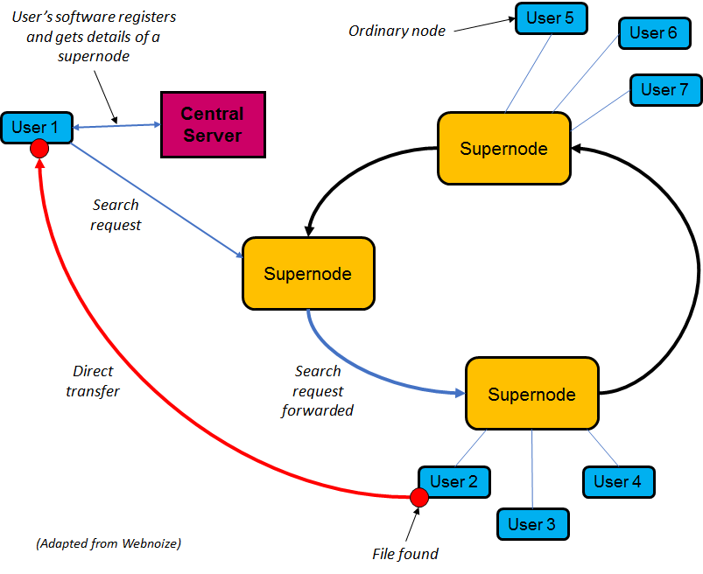
Figure 119: Grokster’s software functioned using FastTrack technology, which uses supernodes

These circumstances prompted the district court judge who first heard the copyright owners suit again Grokster to deny liability. The Court of Appeals for the Ninth Circuit also ruled in favor of Grokster, reasoning that the existence of legitimate uses of the system means that the defendants could not be charged with constructive knowledge of unlawful uses, just as Sony could not be charged with constructive knowledge of unlawful uses of its VCRs. Grokster did not learn of specific illegal uses of its technology until it was too late to stop them, and unlike Fonovisa, the defendants were not supplying the site and facilities for illegality, and had no affirmative duty to alter their software to prevent illegality. For all these reasons, in the judgment of the Ninth Circuit, defendants were not liable for contributory infringement. With respect to vicarious infringement, the plaintiffs had failed to establish, said the Ninth Circuit, the necessary right and ability of the defendants to supervise the direct infringers. These arguments, as I hope you see, are reasonably straightforward applications of the law as it existed at the time. The Ninth Circuit was not tilting the table in favor of the defendant’s. But the copyright owners and their supporters contended that this is where the current law leads. The law must be wrong, and should be modified. They asked the Supreme Court to revisit the Betamax case and to adjust the pertinent standard. How exactly? Various possible reforms were proposed. The copyright owners themselves contended that the COSNU defense, announced in Sony, should not apply when “the primary or principle use of a product or service is infringing.” The Solicitor General offered a different approach. Secondary liability should be imposed “if the defendant’s product is overwhelmingly used for infringing purposes, and the viability of the defendant’s business depends on the revenue and consumer interest generated by such infringement.” One group of economists argued instead that secondary liability should be imposed if the defendant “could eliminate or greatly reduce the level of infringement without significantly cutting down the quantity and quality of lawful uses.” You should hear, here, an echo of Judge Posner’s proposal in Aimster. The most radical approach was offered by another group of economists. Lower courts could should consider all economic variables in particular cases when deciding whether to impose secondary liability.
Other parties argued, instead, that the Betamax COSNU defense should be preserved because:
- Tighter standards for contributory vicarious infringement would endanger some socially valuable dual use technologies;
- The unpredictability of all of the proposed alternatives to COSNU, when combined with the threat of statutory damages, a topic we’ll examine next week, would chill innovation; and
- The entertainment industry could be saved, they argued, through less radical forms of therapy.
In the end, the Supreme Court split the difference. It left the Sony COSNU defense intact, but it added to the set of forms of secondary liability a new doctrine, adapted from other sources, which it referred to as “inducement.” The key sentence in the Supreme Court’s opinion announcing this rule is set forth below.

[O]ne who distributes a device with the object of promoting its use to infringe copyright, as shown by clear expression or other affirmative steps taken to foster infringement, is liable for the resulting acts of infringement by third parties.

The question immediately arises: how does a plaintiff go about proving inducement of this sort? The court’s answer by offering evidence of “purposeful, culpable expression and conduct.” What kinds of evidence will suffice? Not that the defendant knew that his product or service was sometimes used for unlawful purposes – that was not enough to give rise to liability in the Betamax case, as we saw, and it’s still not enough. Nor is it sufficient for plaintiff to offer evidence the defendant is providing customers generic product support. Something more is essential in order to demonstrate inducement.
In its opinion, the Supreme Court identified four sorts of relevant evidence: advertising illegal uses, targeting customers known to engage in illegal uses, failure to adopt infringement reducing technologies, and commercial sense of the enterprise that depends on illegal uses. The last two types of evidence, though relevant, will not be enough on their own to succeed, it seems. A plaintiff needs some evidence of the first two types, advertising unlawful uses, or targeting kinds of consumers known to be engaging in infringement, such as reaching out to former Napster subscribers who are now looking for a substitute file sharing service.
Like most Supreme Court opinions, the Grokster ruling contained some ambiguities. For instance, in one crucial sentence the court indicated that liability under the inducement theory arises when the distributor intended and encouraged the product to be used to infringe. The two verbs in that sentence are different. The former suggests a subjective standard, under which the crucial variable is the defendant’s state of mind; evidence pertaining to the defendant’s intention would thus be relevant. The latter, by contrast, suggests an objective standard, under which only the defendant’s conduct would be germane. These and other ambiguities are tacitly left to the lower courts to work out, but the principal implications of the Grokster ruling are clear enough. If you actively promote unlawful uses of your product or service, you’re in trouble. Ironically this standard, had it been in place in the late 1970s, might have led to a different result in the Betamax case. As you’ll recall, Sony sponsored some advertisements that seemed to tout the use of its VCRs for librarying, not just time shifting, and librarying is an activity that the Supreme Court subsequently seemed to assume was unlawful. This appears to be the kind of active promotion of illegality that the court in Grokster condemns.
Whatever the merits of the Grokster approach, evaluating conduct in the past, it is likely to have diminishing force in the future. Why? Because attentive potential defendants will be sure not to advertise or otherwise promote the unlawful uses of their products and services, and to avoid mentioning such things in their internal correspondence. In short, the inducement rule is likely to catch the unsophisticated creators of startups, not sophisticated actors with good lawyers. That’s not an optimal legal standard.
Thus far we’ve been examining the expansion in recent years of the judge made doctrines of secondary liability. But there’s another force to be reckoned with. An economically and politically important group of businesses that are potentially vulnerable to liability under these expanding rules, have sought and obtained qualified immunity, specifically in 1998, as part of the so-called Digital Millennium Copyright Act, commonly abbreviated as DMCA, a group of companies that provide a variety of internet based services persuaded Congress to grant them protection against copyright liability – both direct and secondary liability – provided that they complied with some reasonably precise requirements. The complex rules giving these enterprises protection are now embodied in section 512 of the copyright statute.

17 USC § 512: Statutory Safe Harbors
(a) ISPs (passive intermediaries) exempt
(b) No liability for passive caching
I OSPs (store information for mass distribution to others) exempt if comply with notice and takedown
(d) Search engines (information location tools) exempt if comply with notice and takedown
(f) Penalties for abusive notice and takedowns
(i) Duty to terminate repeat infringers and to “accommodate ... standard technical measures” used by copyright owners
(m) No duty to monitor

The details of section 512 are much too intricate to examine in this lecture. What I will do in the remainder of this segment of the lecture is to sketch the basic principles underlying this portion of the statute, and to describe the most important of the judicial opinions that thus far has construed section 512. A subset of the components of 512 are set forth above. Internet service providers, meaning passive intermediaries who simply carry packets of information from one party to another, are not liable for copyright infringement, provided that they do not select the stuff that is sent, or who it is sent to, or modify it en route. This should not be surprising. The Postal Service is also not liable if some of the letters it carries contain unlawful material. Things less obvious when we shift from ISPs to so-called OSPs, online service providers, which are defined in section 512(k)(1)(b) as providers of online services or network access or the operators of facilities therefore. To qualify for the section 512 safe harbor, such entities must abide by the requirements set forth in 512(i) – in brief, adopting, announcing, and abiding by a policy for terminating people who repeatedly abuse their services, and accommodating reasonable technological protection measures adopted by the copyright owners.
If an OSP qualifies, it enjoys immunity with respect to various activities, including, unsurprisingly, passive caching of the material that turns out to be infringing. The most controversial of the activities for which OSPs may secure immunity concerns not carrying packets from one person to another, or caching it for faster retrieval, but rather storing material sent to them by one person, and making that material accessible to lots of other people. In 1998, this practice was not terribly common, but it is now ubiquitous. OSPs who do this are free of liability if they:
- Publicly identify an agent the copyright owners can contact to tell them that specific works are being stored on their systems unlawfully;
- Abide by a detailed set of procedures for removing such material from their systems, or resolving disagreements between the copyright owners and the posters concerning their legality;
- Lack the kind of specific knowledge of illegality spelled out in section 512I(1)(a); and
- Lack the kind of financial interest spelled out in section 512I(1)(b).
The clauses pertaining to knowledge and financial interest should sound roughly familiar to you. They pertain to the same kinds of concerns that have long figured in the doctrines of contributory infringement and vicarious infringement, respectively. But those concepts take here an unusual form, and serve an unusual role. If an OSP are accused of storing and distributing infringing stuff and can show that he lacks both of these things, he’s home free. If he cannot, he’s not necessarily liable, but must run the gauntlet of the doctrines of direct and secondary liability we’ve considered in the last four weeks. So, much hinges on how exactly these requirements are construed.
The case that to date has examined these requirements most detail is Viacom versus YouTube. The basic facts are likely familiar to most of you. YouTube was founded in 2005 by three former employees of PayPal. The purpose of the initial version of YouTube was not entirely clear, but its principal function soon became to enable people to post video clips, and make them available for the world to watch. It grew extremely rapidly. By 2007, YouTube was the dominant site of its kind, and its lead over its rivals continued to increase. YouTube’s success was attributable in part to the sophistication and convenience of its technology, and in part to the support it received from Google, which purchased the company in November of 2006 in a stock for stock transaction worth roughly $1.5 billion. Last, but not least, YouTube flourished in part because it was willing, particularly in the early years, to host videos consisting of or containing commercial copyrighted material, which lots of users wanted to see. The owners of the copyrights in those materials reacted in various ways to the rise of YouTube. Some shrugged. Some negotiated licenses with YouTube or Google, permitting them to host their content. And finally, a few brought law suits.
Included in this last group was Viacom, the entertainment giant that owned the copyrights in many television shows, episodes of which were uploaded to YouTube without permission by fans, and then watched by other fans. The numbers were large. In 2007, when it initiated the lawsuit, Viacom identified 63,497 clips then hosted on YouTube that, Viacom contended, contained its copyrighted material. YouTube acknowledged that some of the videos on its site contained copyrighted material and promptly removed the 63,000 clips identified by Viacom. But having done so, YouTube asserted that it bore no further legal responsibility. Having complied with the so-called notice and takedown procedures, that as we’ve seen are mandated by section 512, YouTube contended that it was entitled to the benefit of the safe harbor of section 512I, and thus could not be liable for direct or secondary copyright infringement. Viacom, as you might expect, disagreed. Here’s a statement released by Mike Fricklas, Viacom’s general counsel, summarizing the company’s stance.

From “Our Case Against YouTube” by Mike Fricklas in the Washington Post, March 24, 2007:
YouTube has described itself as the place to go for video. It is far more than the kind of passive Web host or e-mail service the DMCA protects – it is an entertainment destination. The public at large is not attracted to YouTube’s storage facility or technical functionality – people are attracted to the entertainment value of what’s on the site.
And YouTube reaps financial benefits from that attraction through selling the traffic to advertisers. While an e-mail provider is paid to facilitate and manage the exchange of e-mail traffic, and competes in that fashion, YouTube lures consumers and competes by having great content – a resoundingly substantial part of which it did not create or pay for.
Does YouTube have “knowledge” of copyrighted material on its site? Does it have the “right and ability to control” the content? Yes and yes. If the public knows what’s there, then YouTube’s management surely does. YouTube’s own terms of use give it clear rights, notably the right to take anything down. YouTube actively monitors its content. For example, its managers remove pornography and hate content and, as was recently reported, claim they can detect and remove “spam.” Without knowledge and control, how could YouTube create “channels” and “featured videos” sections on its site? YouTube has even offered to find infringing content for copyright owners – but only if they do a licensing deal first.
Is it fair to burden YouTube with finding content on its site that infringes others’ copyright? Putting the burden on the owners of creative works would require every copyright owner, big and small, to patrol the Web continually on an ever-burgeoning number of sites. That’s hardly a workable or equitable solution. And it would tend to disadvantage ventures such as the one recently announced by NBC Universal and News Corp. that are built on respect for copyright. Under the law, the obligation is right where it belongs: on the people who derive a benefit from the creative works and are in the position to keep infringement out of their businesses.

This paragraph succinctly states the arguments that Viacom hoped to use to deny YouTube the benefit of section 512I. As you’ll recall, that provision does not apply when a defendant either has actual knowledge of infringing material on its site, or receives a financial benefit directly attributable to infringement, which the defendant has the right and ability to control. Fricklas, as you can see, contends that YouTube fails to satisfy both of those requirements, either of which is fatal to its 512I defense.
This paragraph, aimed more at a general, public audience, explains why, in Viacom’s opinion, it’s fair to require sites like YouTube to purge their systems of infringing material, rather than to require copyright owners constantly to monitor such sites.
So, those are the arguments. The district court sided with YouTube on all contested issues, and granted its summary judgment motion. In 2012, the Court of Appeals for the Second Circuit reversed. The interpretations of the key provisions of section 512 adopted by the Court of Appeals were, as we will see, highly favorable to OSPs like YouTube, but not quite as favorable as the interpretations that had been adopted by the district court. Thus, the Court of Appeals remanded the case for reconsideration in light of its clarified rules. Here, then, are the key portions of the Court of Appeals’ opinion.
First, the court ruled that the disqualification contained in 512I(1)(A)(i) is triggered only by actual “subjective” knowledge of specific infringing material on the dependent’s site, or willful blindness of the sort that doomed Napster. The disqualification contained in 512(c)(1)(A)(ii), the so-called red flag provision, is triggered only by actual subjective knowledge of facts that would have made infringement objectively obvious to a reasonable person. Merely being aware that there’s lots of infringing material on one’s site is not enough to trigger either of those provisions. However, the court ruled, Viacom had pointed to a few instances in which internal correspondence by YouTube executives suggested that they were aware of specific infringing files on their site, from which a jury might infer the requisite level of knowledge.
Next, the Court of Appeals ruled that the disqualification contained in 512I(1)(B) is triggered only by proof of somewhat greater control over the infringing behavior than is required for ordinary vicarious infringement. Otherwise, the court pointed out, the safe harbor of 512(c) wouldn’t be of much value, because would give defendants immunity only from conduct that would not trigger vicarious liability anyway.
So, what sort of additional control would cause a forfeiture of the safe harbor protection? Not merely the ability to block access to material posted on its service, but perhaps the sort of “purposeful, culpable expression and conduct” that, as we saw, the Supreme Court in Grokster suggested would give rise to liability for inducement.
Uncertain on the score, the Court of Appeals suggested that the district court think about it further.
Finally, the Court of Appeals construed 512I itself, broadly interpreting it to apply to all software functions performed by sites like YouTube “for the purpose of facilitating access to user stored material.”
The state of the law governing OSPs after the Viacom decision, might be depicted graphically as is shown in Figure 120. As you now know, OSPs are potentially liable not just for direct copyright infringement, but also for any of the forms of secondary infringement: contributory, vicarious, and, post-Grokster, inducement. Section 512I not only gives greater specificity to the limits of those doctrine, but also, more importantly, allows OSPs to engage in some kinds of conduct that, in the absence of 512, would give rise to liability. In particular, hosting material without enough specific or red flag knowledge that particular pieces are infringing to trigger the disqualifications of 512I(1)(A), and without the tight level of control necessary to trigger the disqualification of 512(c)(1)(B).
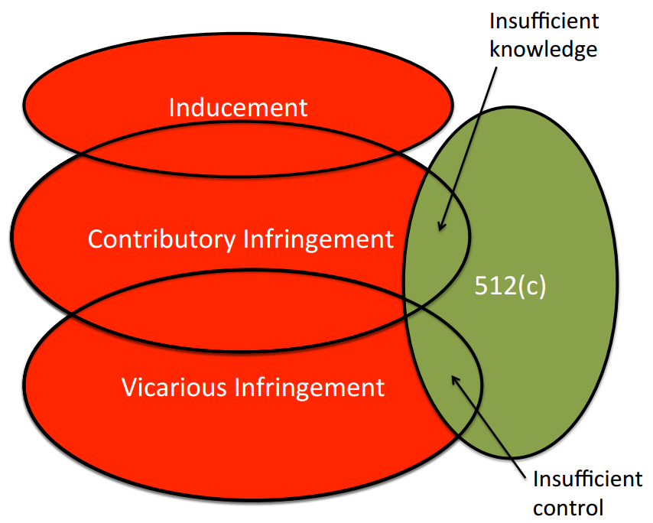
Figure 120: The state of the law governing OSPs after the Viacom decision

Exactly what kinds of conduct fall into the zones identified by the arrows in this diagram will have to be worked out in subsequent litigation. But this seems to be the structure that OSPs must and may now rely upon, at least if the Second Circuit approach holds.
This concludes our discussion of secondary liability and the especially troublesome issues presented by so-called dual use technologies. In the next section, we’ll turn to a very different topic: technological protection measures.

Tech Protection Measures
The story of how most countries in the world came to adopt legal reinforcements for technological protection measures (TPMs) is very long and complicated. In this last segment of the lecture, I’ll provide you an abridged version of the story. If you’d like more detail you might consult chapter three of my book, Promises to Keep, from which this abridged version will be distilled.
In the early 1990’s, entertainment companies, dismayed by the increasing frequency with which digital copies of their products were being copied and redistributed, and by the apparent inability of the law to halt this behavior, began to experiment with encryption as an alternative way of preventing, or at least discouraging, unauthorized uses their products. Examples of such experiments included the content scramble system (CSS), which is used to inhibit reproduction of the copies of audiovisual works housed on DVDs; the secure digital music initiative (SDMI), which was supposed to provide even stronger protection for sound recordings; and the Real Audio and Real Video formats, developed by the firm Real Networks, that enabled users of those formats to turn on or off of a virtual switch, which controlled whether persons to whom formatted works were streamed could make copies of these works. As the entertainment companies soon discovered, this strategy was at best imperfect. Every time they deployed one of these technologies someone, surprisingly often a teenager, would crack it. Once the technological wrappers had been removed, the naked digital files could be re-distributed promiscuously.
- Government provides the good
- Government selects and subsidizes private innovators
- Government issues prizes to successful private producers
- Legal reinforcement of self-help strategies
- Government protects producers against competition

So, the entertainment companies began to look to the law for aid. To understand the nature of the strategy it may help to turn, once again, to copyright theory. You’ll recall that the premise of the welfare theory of copyright, and of intellectual property in general, is that intellectual products are public goods that will be produced at suboptimal levels unless the government intervenes in some way to stimulate their creation and dissemination. Over the centuries, governments had used five different techniques to provide the necessary stimulus. The five options, with which you should now be familiar, are listed on the right. Until this point in the lecture, we have been overwhelmingly concerned with the fifth option, the essence of which is that the government protects authors and artists against competition – in other words, forbids competitors to make, distribute, or perform copies of their works without permission. That, as you well know, is the fundamental principle of copyright law, at least as seen through the lens of welfare theory. When the entertainment companies sought the assistance of the law in buttressing their shaky encryption systems, they were in effect stepping outside the zone of copyright law and relying on an altogether different approach. In particular, they were employing a variant of strategy number four. They were relying upon a self-help approach, specifically technological protections for copies of their works, and soliciting legal reinforcement for that strategy. In this respect, their approach was analogous to trade secret law. In that context as well, companies rely on self-help, specifically efforts to keep their innovations secret, but then turn to the law for aid when economic espionage or faithless employees cause that secrecy to fail. In short, the entertainment companies’ new approach was not really an example of copyright law at all, even though, as you’ll see, they plugged the statutory reforms they sought into the copyright statute in the United States. In truth, this approach is a different animal altogether and had quite different strengths and weaknesses. For that reason, it’s sometimes referred to as paracopyright.
Back to our story. The law in the United States as it existed in the mid-1990’s failed to provide the entertainment companies the aid they sought. To be sure, the federal statutes contained a few specialized provisions that forbade circumvention of particular encryption systems – for example, it was illegal to manufacture or distribute devices designed to descramble the signals provided by cable television systems or digital satellite systems – but there was no provision forbidding encryption circumvention in general. Judge-made law was even more unhelpful. For example, in the case of Volt Corporation vs. Quaid Software, the Fifth Circuit Court of Appeals had ruled that the creation and sale of a software program designed to circumvent the copy controls on a diskette did not make the creator of such a program liable for contributory copyright infringement, because the program had a substantial non-infringing use, mainly enabling the making of archival copies. And as I explained in lecture number nine, in the Sega enterprises case the Ninth Circuit had refused to find a game manufacturer liable when it circumvented Sega’s lockout mechanism preventing unlicensed game developers from building games compatible with its Genesis console.
So, existing law was unhelpful the companies therefore sought new law. The path to the reforms they wanted proved circuitous. First, they plead their case to the Information Infrastructure Task Force (IITF), the group appointed by President Clinton to articulate and implement the administration’s vision for the National Information Infrastructure. The crucial subcommittee within the IITF was the working group on intellectual property rights, chaired by Bruce Lehman, a former copyright industry lobbyist who had recently been appointed the commissioner of patents and trademarks. Lehman and the IITF proved receptive. In their preliminary report, known as the “green paper,” and again in their final report, known as the “white paper,” they recommended the adoption of a “prohibition on devices, products, components, and services that defeat technological methods of preventing unauthorized use of copyrighted materials,” ignoring the objections of some vigorous critics of this proposal. Surprisingly, however, Congress was more attentive to the critics’ arguments and, moreover, was distracted by an upcoming election, and as a result failed to adopt the administration’s recommendation. So, Mr. Lehman cleverly pursued an alternative approach. Instead of continuing to pound on Congress’s door, he turned to treaty making. In 1996, in his capacity as the United States delegate to the World Intellectual Property Organization, Lehman pressed for adoption of a new treaty that would embody the critical provisions of the now rejected argument in the white paper. He didn’t get all that he wanted, but he was able to secure – specifically in Article 11 of the WIPO Copyright Treaty – a moderate version of the provisions that he had originally sought.

WIPO Copyright Treaty (1996), article 11
Contracting Parties shall provide adequate legal protection and effective legal remedies against the circumvention of effective technological measures that are used by authors in connection with the exercise of their rights under this Treaty or the Berne Convention and that restrict acts, in respect of their works, which are not uthorized by the authors concerned or permitted by law.

Lehman then returned to the United States and approached Congress with a new argument. Congress, he argued, needed to modify federal law in the United States to fulfill the obligations to which the United States would soon be subject under the new treaty. There ensued a protracted hard fought battle among the relevant interest groups, a battle chronicled by Pam Samuelson. Lehman and his allies eventually emerged bloody but victorious, specifically as part of the Digital Millennium Copyright Act (DMCA). They obtained two new provisions now embodied in sections 1201 and 1202 of the copyright statute. Of the two provisions, 1201 is the more important. The critical language is below.

17 USC § 1201
(a)(1)(A): No person shall circumvent a technological measure that effectively controls access to a work protected under this title
…
(a)(2): No person shall manufacture, import, offer to the public, provide, or otherwise traffic in any technology, product, service, device, component, or part thereof, that—
(A) is primarily designed or produced for the purpose of circumventing a technological measure that effectively controls access to a work protected under this title;
(B) has only limited commercially significant purpose or use other than to circumvent a technological measure that effectively controls access to a work protected under this title; or
I is marketed by that person or another acting in concert with that person with that person’s knowledge for use in circumventing a technological measure that effectively controls access to a work protected under this title.

Section 1201(a)(1)(A) effectively controls access to copyrighted work. Section 1201(a)(2) provides that no person shall manufacture or import, offer to the public, provide or otherwise traffic in any technology product service device component or part thereof that is primarily designed or produced for the purpose of such circumvention. Finally, section 1201(b) contains a similar ban on the production or distribution of technology primarily designed to circumvent technologies that effectively protect the exclusive rights of a copyright owner – the exclusive rights to reproduce the work adapted, performed publicly, and so forth. Parties injured by violations of these rules can bring civil lawsuit to halt the practices and collect damages. In addition, willful violation of the rules for commercial advantage or personal gain subjects the offender to substantial criminal penalties.
As you undoubtedly noticed, there are some important ambiguities in these provisions. What exactly does “circumvent” mean? For example, if I give my password to a friend who then uses it to gain access to a copyrighted recording or program, have I or has she circumvented the technological protection system that requires that password? What does it mean to “effectively control access” to a copyrighted work? What activities other than manufacturing and distributing are encompassed by the ban on trafficking in circumvention technologies? Some of these ambiguities are addressed, though not with great clarity, by definitions contained in other parts of the statute.
Exceptions
- Libraries may circumvent in order to decide whether to buy
- Police may circumvent to conduct an investigation
- 1201(f): Reverse Engineering for Interoperability
- 1201(g): Encryption research
- 1201(h): Protecting Minors from Pornography
- Special Exemptions created by Copyright Office – applicable only to circumvention of access controls
- MDY Industries, 629 F.3d 928 (9th Cir. 2010)
The prohibitions contained in 1201(a) and 1201(b) are tempered, as you can see on the right, by a list of exceptions, some of which are also vague. For example, technologies that are not primarily designed for circumvention, have a more limited commercially significant purpose other than convention, and are not marketed for circumvention, are exempt. Nonprofit libraries, archives, and educational institutions are sometimes permitted to engage in circumvention in order to decide whether to acquire copyrighted work. Circumvention activities for the purpose of reverse engineering to achieve interoperability among computer programs, security testing, encryption research, and controlling minors access to pornography are all privileged. Finally, every three years the librarian of Congress is required to promulgate regulations exempting from the anti-circumvention provision persons who would otherwise be adversely affected in their ability to make non-infringing uses. The most recent round of regulations in 2010 generated some intriguing safe harbors.
In culmination, the importance of the issues addressed by these statutory provisions and the ambiguity of several of their dimensions have generated a great deal of litigation. The principal cases are listed on the righthand side of the next page. (If you follow the links in the mind map, you will find summaries of their facts and holdings and copies of the opinions themselves.) In the first and arguably most important wave of these cases, the copyright owners that had pressed for these statutes and that stood to benefit most from expensive interpretations of them prevailed decisively. In later cases, however, the courts have rejected especially aggressive applications of the provisions. A very rough generalization concerning the pattern of outcomes in these cases is that the more they have to do with the kinds of entertainment products that initially provoked the statute – music, films, games, and so forth – the more likely the courts are to find that the behavior of the defendants were unlawful. By contrast, in cases where the plaintiffs have sought to rely on these statutory provisions to support business models unrelated to traditional entertainment products, the courts have been much less sympathetic. That’s a crude guideline, to be sure, but for better or worse it has some explanatory force.
Principal cases dealing with the issue of tech protection measures
- Streambox (WD WA 2000)
- Corley
- Felten
- Elcomsoft (2002)
- IMS (SDNY 2004)
- Lexmark, 387 F.3d 522 (CA6 2004)
- Chamberlain, 381 F.3d 1178 (CAFC 2004)
- STK, 421 F.3d 1307 (CAFC 2005)
- Blizzard, 422 F.3d 630 (CA8 2005)
- RealNetworks, 641 F. Supp. 2d 913 (N.D. Cal. 2009)
- MDY Industries, 629 F.3d 928 (9th Cir. 2010)
By way of illustration, I’ll describe two of the cases. Here’s the first. In 1999, John Johansen, a 15-year-old Norwegian, reverse engineered a licensed DVD player and used the information he obtained to write a short program designed to descramble a signal that had been scrambled by the CSS security system – the system that is designed to prevent ripping DVD’s. Johansen’s program, which he called DCSS, was relatively simple. The original version consisted of 60 lines of computer code. It has since been reduced to seven. Although Johansen’s original purpose apparently was the relatively benign goal of developing a DVD player that could operate on the Linux operating system, his creation enabled many other less innocent uses of the video recordings distributed on DVD’s. Once descrambled, they could be stored, compressed, reproduced and redistributed. Copies of DCSS spread quickly over the internet. Within a month, many websites offered user-friendly downloadable versions the program in both source code and object code. The major film studios, seeking to stop or at least slow the spread of what they regarded as an infection, invoked the DMCA to demand that the operators of those websites remove the program from their servers. Some of those operators, including Eric Corely, the editor of a print magazine boldly named 2600: The Hacker Quarterly, and an accompanying website refused to comply. In response, the studios brought suit, accusing Corley and others of “trafficking in circumvention technology.” Judge Lewis Kaplan found that the defendants had indeed violated Section 1201(a)(2), the ban on trafficking in technology designed to circumvent restrictions on access to copyrighted works. In his judgment, none of the statutory exemptions were applicable. He then rejected the defendant’s argument that the statute so construed would violate the First Amendment’s protection for freedom of speech. In his final ruling, Kaplan ordered the defendants to remove the program for their servers, and more controversially, to disable all hyperlinks to other websites where copies of the program could be found.
The Court of Appeals for the Second Circuit affirmed, like Judge Kaplan, the Court of Appeals found all of the exemptions inapplicable, nor did the statute, even when thus broadly construed, violate the First Amendment. The court conceded that the anti-trafficking provisions in general and as applied in this case, did restrict speech, but that restriction it ruled is content neutral, advances a substantial government purpose unrelated to the suppression of expression, mainly assisting copyright owners and preventing unwanted access to their property, and burdened speech no more than necessary to achieve that end. And thus, it’s constitutional.
The ruling in the Corley case seems to have had little effect on the distribution of DCSS. While the case was ongoing, hackers and Corley sympathizers continued to distribute the program in a wide variety of formats – on t-shirts, in the form of a haiku, set to music, and so forth. On the other hand, the ready availability of DCSS on the internet still today does not seem to have adversely affected the use or profitability of commercial DVD’s. The revenues generated by which are tracked by the yellow sectors of the graph in Figure 121. As you can see, the ready availability of DCSS starting in 1999 certainly did not prevent the DVD format from conquering the home video market. Perhaps copyright owners’ anxiety was unfounded. In any event, the Corley case has proved highly influential. Its crucial features include a lenient interpretation of the requirements that technological protection measures effectively control access to a copyrighted work, an expansive interpretation of the prohibition on trafficking in circumvention technology, rejection of the position that TPMs must accommodate the privileges traditionally enjoyed by users under the fair use doctrine, and last but not least, the declaration that despite these interpretations, the statute does not run afoul of the federal constitution.
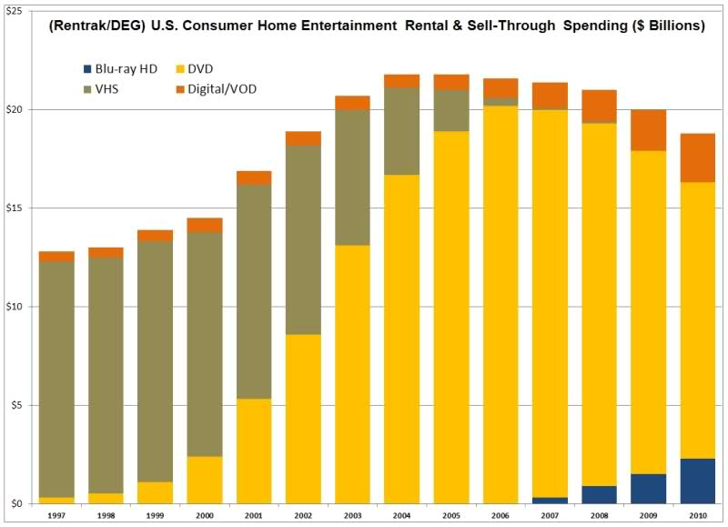
Figure 121: US consumer home entertainment rental and sell-through spending (2010)

An example of a decision that took a more skeptical view of TPMs and invocations of the law to reinforce them is Chamberlain, decided by the Court of Appeals for the Federal Circuit in 2004. Chamberlain manufactures and sells garage door openers, devices that enable homeowners to avoid the inconvenience of getting out of their cars to open their garages when they returned home. A homeowner need only press a button on the remote control and the machine will cause the door open. Chamberlain’s system incorporated a copyrighted “rolling code” computer program that constantly changed the transmitter signal needed to open the garage door. Now, as you know, with some frequency homeowners lose or break the remote controls necessary to run their systems. The defendant in this case, Skylink, catered to such consumers, offering them replacement generic remote controls capable of opening Chamberlain’s doors, as well as those of other garage door opening companies. Chamberlain was unhappy, primarily it seems because Skylink was undercutting Chamberlain’s ability to sell its own replacement remote controls. So, Chamberlain brought a DMCA suit against Skylink, contending that Skylink’s products “circumvent the security inherent in rolling codes” and therefore that “Skylink is in violation of the anti-trafficking clause of the DMCA’s anti-circumvention provisions, specifically 1201(a)(2).” Court of Appeals for the Federal Circuit eventually rejected this claim ruling broadly that 1201 prohibits only forms of access that bare a reasonable relationship to the protections of the Copyright Act otherwise affords copyright owners. As David Nimmer, the son of Melville Nimmer and a notable copyright scholar in his own right, points out, it’s very difficult to derive such a limitation on the scope of 1201 from the language of the statute or from the legislative history. And, indeed, the Court of Appeals for the Ninth Circuit, in the more recent MDY case, refused to follow the Federal Circuit in restricting the reach of the statute in this fashion. But MDY involved video games, not garage door openers. Though the statute itself makes no reference to the nature of the device in which the copyrighted work guarded by the TPM is embedded and thus, as Nimmer argues, the distinction between Chamberlain and MDY is hard to justify on the basis of statutory interpretation, it’s neither surprising, nor terribly troubling, that the courts are more protective of entertainment products, where unauthorized reproduction is arguably pernicious, than they are of more industrial products, where we have long thought competition is socially beneficial.
So, that’s where things currently stand in the United States. The legal reinforcement of TPMs is by no means limited to the US. 90 countries currently are signatories to the WIPO Copyright Treaty and the WIPO Performances and Phonograms Treaty that, as we’ve seen, impose on member countries duties to adopt and enforce rules of this general sort. How have other countries sought to implement the principle? The responses, as you might expect, vary considerably. As my colleague Urs Gasser points out, the language of the relevant treaty provisions leave member countries considerable discretion on several fronts. Most importantly, the treaties leave countries free to decide whether to buttress only TPMs that reinforce the kind of exclusive rights enjoyed by copyright owners, namely the rights of production, distribution, public performance, and so forth, or also TPMs that limit user’s ability to gain access to copyrighted works.
The countries are also free, if they could figure out how to do so, not to penalize circumventions of TPMs for the purpose of exercising one of the privileges recognized by the copyright system, such as the privilege of engaging in fair uses. On the latter issue, the European Union has adopted an approach very different from the United States. You’ll recall that in the US the DMCA contains a list of specific exemptions to the coverage of Section 1201 plus an administrative mechanism enabling the Librarian of Congress periodically for three years to add additional exceptions. That list is widely considered to be very narrow, enabling copyright owners in the United States to use TPMs to curtail lots of activities that they would be unable to forbid by invoking the regular rights under the copyright statute itself. The EU, by contrast, requires member countries to create mechanisms to ensure the TPMs do not interfere with the privileges that consumers enjoy under copyright law, unless the rights holders develop and implement such mechanisms voluntarily. Gasser points out the countries within the EU have sought to accommodate that obligation differently. Greece and Lithuania, for example, have set up mediation systems in hopes of reconciling TPMs with the traditional privileges of users. The United Kingdom has set up a special administrative mechanism that purports to enable aggrieved users to challenge TPMs that constrain their freedom to make lawful uses of copyrighted materials. And Ireland permits aggrieved users to appeal directly to the Irish High Court. Whether any of these mechanisms is effective is far from clear, but they at least purport to tilt the scales more toward consumers than does the United States.
During the past 15 years, controversy over legal reinforcement of TPMs has been intense. My guess, for what it’s worth, is that in the future the controversy will gradually fade. The reason is not because countries will converge upon a solution to this issue that satisfies all parties – that’s extremely unlikely. The reason, rather, is that TPMs and their legal supplements are designed primarily to protect business models that rely upon distributing copies of copyrighted works to consumers. Increasingly, nowadays, the businesses that have traditionally depended on copyright law are shifting to cloud-based business models that do not depend upon providing consumers copies of works. As a result, for better or worse, technological shields enveloping such copies will become less important. At the same time, alternative practical and legal mechanisms for preserving the traditional privileges of consumers will become more important.

Remedies

Equitable Relief
There are three types of remedy for copyright infringement – equitable, legal, and criminal. The first two types are available to the prevailing plaintiffs in civil suits. In other words, a copyright owner who, in a civil lawsuit, successfully demonstrates that a defendant has engaged in copyright infringement may attain either or both equitable or legal remedies. In addition, a person who engages in some types of copyright infringement may be prosecuted by the government and, if convicted, subjected to criminal sanctions. The three segments of this lecture will examine these three types of remedy in sequence.
The primary form of equitable relief consists of injunctions. Injunctions are orders by courts directing someone to do something or, more commonly, to stop doing something. In copyright suits, by far the most common type of injunction is an instruction to the defendant to cease engaging in the behavior that a court has deemed to be infringing. Statutory authority for the issuance of such injunctions is contained in section 502 of the copyright statute.
17 USC § 502
(a) Any court having jurisdiction of a civil action arising under this title may, subject to the provisions of section 1498 of title 28, grant temporary and final injunctions on such terms as it may deem reasonable to prevent or restrain infringement of a copyright.
(b) Any such injunction may be served anywhere in the United States on the person enjoined; it shall be operative throughout the United States and shall be enforceable, by proceedings in contempt or otherwise, by any United States court having jurisdiction of that person. The clerk of the court granting the injunction shall, when requested by any other court in which enforcement of the injunction is sought, transmit promptly to the other court a certified copy of all the papers in the case on file in such clerk’s office.

As you can see, section 502 provides that “any court having jurisdiction of a civil action arising under this title may grant temporary and final injunctions on such terms as it may deem reasonable to prevent or restrain infringement of a copyright.” Note the reference to “temporary and final injunctions.” Those adjectives allude to the fact that there are, in the American legal system, two species of injections – permanent injunctions and so-called preliminary injunctions.
Permanent injunctions, as their name suggests, are typically issued at the conclusion of a copyright infringement suit. Preliminary injunctions, as their name suggests, are issued by a court before the conclusion of the suit – often long before the conclusion of the suit – when it becomes apparent that the defendant will likely in the end lose, and that allowing the defendant’s behavior to continue in the meantime would cause the plaintiff serious injury. The principals governing when it’s appropriate for courts to issue either of these two types of injunction are set forth below.
To obtain a permanent injunction, plaintiff must show
(a) the plaintiff has suffered an irreparable injury;
(b) monetary damages are inadequate to compensate for that injury;
(c) the balance of hardships favors the plaintiff; and
(d) the public interest would not be disserved by a permanent injunction.
To obtain a preliminary injunction, plaintiff must show
(a) the plaintiff is likely to suffer an irreparable injury;
(b) monetary damages will be inadequate to compensate for that injury;
(c) the balance of hardships favors the plaintiff;
(d) the public interest would not be disserved by an injunction; and
I likelihood of success on the merits.

These principles were not developed in the context of copyright infringement lawsuits. Rather, they were developed by the courts – specifically by the federal courts – to govern equitable relief in general.
As you can see, the traditional rule was that a plaintiff, in order to obtain a permanent injunction, must show – first, that she has suffered an irreparable injury; second, that the monetary damages would be inadequate to compensate her for that injury; third, that she would suffer more serious hardship if an injunction were denied than would the defendant if an injunction were granted; and finally, that the public interest would not be disserved by the issuance of an injunction.
The traditional rules governing preliminary injunctions were slightly different. To obtain one of these, a plaintiff was obliged to show – first, that she is likely to suffer an irreparable injury if the defendant’s conduct continues; second, that monetary damages would be inadequate to compensate her for that injury; third, that the balance of hardships, again, tilts in her favor; fourth, that the public interest would not be disturbed; and last but not least, that she is likely, at the conclusion of the lawsuit, to succeed in demonstrating the illegality of the defendant’s behavior. This last factor has the effect of making judicial decisions concerning the availability of preliminary injunctive relief into provisional assessments of the merits of the plaintiff’s claims. Although technically only provisional, in practice such judgments often terminate controversies.
As I say, these principles have long governed the availability of injunctive relief in general. By contrast, in copyright lawsuits, until quite recently, different standards obtained. Specifically, courts in copyright suits were more likely to grant either preliminary or permanent injunctions than in most other kinds of controversies. Courts typically took the position that a demonstration by the plaintiff that she is likely to succeed on the merits of a copyright infringement suit gives rise to a presumption of irreparable harm sufficient to warrant issuance of a preliminary or permanent injunction. As a result, granting injunctions to prevailing plaintiffs was routine. To be sure, it was not automatic. On occasions, courts would deny injunctions in special circumstances. The three most famous instances in which courts suggested that injunctions should not invariably be granted are listed on the right.
Three famous cases where courts suggested injunctions should not be granted
- Abend (CA9 1988)
- Campbell (US 1994) (dictum) – courts might refuse to enjoin parodies that exceed the scope of fair use
- Tasini (US 2001) – discourage grants of injunctive relief that would frustrate the “goals of copyright law”
You may recall that in the case of Stewart versus Abend, the author of a short story granted a license to make a motion picture based on that story – a license that eventually ended up in the hands of James Stewart and Alfred Hitchcock – and resulted, in their hands, in the creation of the movie Rear Window. Unfortunately, both for the author and for the movie makers, the author of the short story died before the end of his first 28-year copyright term and thus, he was unable to renew the copyright. Instead, his executor renewed the copyright, and then assigned it to a third party who promptly brought suit against Hitchcock and his company, seeking to enjoin future performances of Rear Window unless and until the defendants obtained a new license. You’ll recall that the Supreme Court eventually sided with the plaintiff – the assignee of the renewal term. However, the Court of Appeals for the Ninth Circuit took the position that the plaintiff was not necessarily entitled to an injunction. Instead, in view of the good faith reliance by the filmmakers on the original license, a reasonable monetary award would be more appropriate than an injunction.
Another special circumstance was identified by the United States Supreme Court in the Campbell case, which I discussed in lecture number nine. You’ll recall that the Supreme Court in that case took the position that the defendant who, without permission, prepares a parody of a copyrighted work is likely to prevail under the fair use doctrine. However, Justice Souter, writing for the court, suggested that parodist would not always succeed. After taking into account all four of the fair use factors, a court might conclude that a particular parody should not be deemed a fair use. In such circumstances, however, Souter suggested, in dictum, that the defendant might be permitted to continue to distribute his or her parody, provided he or she paid the plaintiff an appropriate damage award.
Finally, in the Tasini case, the Supreme Court suggested, again in dictum, that injunctive relief could be denied when it’s issuance would frustrate “the goals of copyright law.” The upshot, in short, is that courts occasionally rejected plaintiffs’ requests for injunctions. In the overwhelming majority of cases, however, prevailing plaintiffs were deemed to be entitled to injunctive relief.
In 2006, the Supreme Court decided a case that changed this landscape fundamentally. Until that date, most federal courts had dealt with patent infringement suits in much the same way they dealt with copyright infringement suits – granting injunctive relief nearly automatically to prevailing plaintiffs. The Supreme Court, in eBay vs MercExchange, declared that that practice could not be justified on the basis of the language of the patent statute. Henceforth, the court ruled that traditional rules, which I summarized a minute ago, should be employed to determine whether injunctive relief was appropriate in patent cases. In particular, a plaintiff would have to establish, among other things, that the balance of hardships tilted in her favor and that the issuance of an injunction would not undermine the public interest. The opinion of the Supreme Court in the eBay case did not provide much guidance concerning what adherence to those rules would produce. However, two concurring opinions in the case did so. Chief Justice Roberts, in an opinion joined by justices Scalia and Ginsburg, suggested that in the future federal courts, when applying the traditional rules governing equitable relief to patent disputes, should continue to be somewhat more favorably disposed to the issuance of injunctions than in non-patent cases in light of the traditional practice of granting such injunctions nearly automatically. By contrast, Justice Kennedy, in an opinion joined by justices Stevens, Souter and Breyer, identified three circumstances in which, in their judgment, court should be especially reluctant to issue injunctions – when the plaintiff is a so-called non-practicing entity, sometimes referred to as a patent troll; when the patent at issue covers one component of a complex product, and thus issuance of an injunction would give the patentee disproportionate bargaining power when negotiating for a subsequent license; and when the patent at issue pertains to a method of doing business, a context in which patent protection, they believed, is especially problematic. Although, as you can see, Justice Kennedy was only speaking for four justices, his opinion has proven to be influential in patent law.
In the eBay decision, the Supreme Court intimated that the issuance of injunctions in copyright cases should be governed by the same principles that henceforth would govern the issuance injunctions in patent cases. As one might expect, given that clear signal, most district courts in copyright cases subsequently adopted the eBay approach. But a few continued to adhere to the traditional practice, which, as we’ve seen, strongly favored plaintiffs. In 2010 and 2011, the influential Courts of Appeals in the Second and Ninth Circuits removed any remaining doubt concerning the applicability of eBay to copyright. In the Salinger and Perfect 10 cases, those courts ruled decisively that permanent and preliminary injunctions could be granted in copyright cases only upon satisfaction of the traditional multi-factor tests.
So, that’s where things stand today. The net result is that it is significantly harder nowadays to obtain an injunction than it was seven years ago. This shift likely seems to you quite technical, and it is. But its impact is fundamental. In the growing percentage of cases in which prevailing copyright plaintiffs are denied injunctive relief and are granted only damages, the courts are, in effect, creating compulsory licensing regimes forcing, in other words, copyright owners to accept a governmentally determined license fee in return for allowing defendants to continue to engage in conduct forbidden by copyright law. Plaintiffs who would prefer to charge more, or to deny permission altogether, have no choice but to accept the amount of money selected by the court and to tolerate the continuation of the defendant’s behavior.
Twice, earlier in this lecture series, we have discussed the merits and demerits of compulsory licensing systems. First, from the perspective of welfare theory, and then in the context of public performance rights. At the time, we were primarily concerned with compulsory licensing systems that had been created by statute. As we saw, such statutory regimes now govern several uses of copyrighted works – for example, covers of copyrighted songs, retransmissions of signals by cable television or satellite systems, juke boxes, derivative works based upon the restored foreign copyrights, and so forth. But judicially created compulsory licenses implicate many of the same concerns that arise in connection with statutory compulsory licenses. I hope that you can see how the eBay decision has had the effect of sharply increasing the set of such judicial compulsory licenses. Whether that impact will be socially and culturally beneficial remains to be seen.

Damages
The plaintiffs in most copyright infringement suits are interested in money in addition to, or sometimes instead of, the kind of injunctive relief considered in the previous segment of this lecture. In the United States, such plaintiffs are able to rely on three different principles when seeking financial recoveries. First, they could obtain “actual damages”. In other words, enough money to compensate them for the injuries they have sustained. Second, they can recover profits made by the defendants attributable to the defendant’s infringing behavior so long as those profits are not duplicative of the actual damages sustained by the plaintiffs. Last, but not least, instead of either actual damages or lost profits, plaintiffs may recover so-called statutory damages – sums of money that bear no necessary relationship to either the magnitude of the injuries the plaintiff sustained or to the profits wrongfully earned by the defendants.
The first two of these forms of recovery, actual damages and defendant’s profits, are conventional. Although the methods by which they are calculated in US courts are somewhat unusual, these two types of monetary recovery may be found in the copyright systems of most countries in the world and indeed are often granted to the victims of many other kinds of unlawful behavior, both in the United States and elsewhere. The third form of recovery, by contrast, is unusual. Relatively few countries currently recognize so-called statutory damages and there’s considerable controversy over whether they should.
I’ll now spend some time describing how these three types of financial recovery work. When I’m done, I’ll step back from the trees and consider the ongoing debate concerning which dimensions of this forest make sense and which do not.

17 USC § 504(b)
Actual Damages and Profits. — The copyright owner is entitled to recover … any profits of the infringer that are attributable to the infringement and are not taken into account in computing the actual damages. In establishing the infringer’s profits, the copyright owner is required to present proof only of the infringer’s gross revenue, and the infringer is required to prove his or her deductible expenses and the elements of profit attributable to factors other than the copyrighted work.

The statutory authority for the first approach is contained in section 504(b) of the statute. As you can see above, that provision entitles a copyright owner to recover “the actual damages suffered by him or her as a result of the infringement.” The purpose of this provision is to enable a successful plaintiff to recoup all of the money she lost because of the defendant’s infringement. The most clear-cut example consists of profits the plaintiff would have earned had the defendant not encroached upon her copyright unlawfully. The conventional way of proving such lost profits by the plaintiff is to introduce evidence of the volume of sales at the plaintiff likely would have enjoyed in the absence of the defendant’s behavior combined with evidence concerning the profit the plaintiff would likely have earned on each of those sales. A less well established variant of this approach permits the plaintiff to recoup losses she sustained if she was forced to reduce the price of authorized copies of her work in order to compete with the infringing defendant. This component of actual damages certainly makes sense as a matter of theory, but case law support for it is thin.
A recent addition to the set of types of actual damages is the so-called value of use theory. The idea underlying this variant is that a plaintiff should be able to recover from a defendant an amount of money equivalent to the license fee that the defendant would have paid to the plaintiff in order to obtain permission to engage in the conduct at issue. Somewhat more specifically, this variant permits a plaintiff to recover from the defendant the amount that a willing licensee would have paid a willing licensor for the right to engage in that conduct. In determining that amount, courts take into account such factors as the customs prevailing in the industry in question, the terms on which the plaintiff herself had previously granted licenses to other parties to engage in similar activities, and perhaps special circumstances that would have prompted the plaintiff to demand unusually high or low licensees.
As I say, this so-called value of use theory is a relatively recent innovation. It was pioneered by the Seventh Circuit Court of Appeals in the Deltak case in 1985. The Court of Appeals for the Second Circuit, which, as you know, enjoys disproportionate influence in copyright law, initially rejected this basis of liability. But in 2001, in the case of Davis versus The Gap, the Second Circuit embraced it. A year later, the Ninth Circuit did as well. Nevertheless, the argument remains highly controversial. Critics contend that it fails to take into account the likelihood that if the defendant had been aware of the illegality of his activity, he might not have engaged in it at all and thus would not have paid the plaintiff any license fees. In short, the critics argue, this theory gives the plaintiff a windfall.
Finally, some courts have been willing to allow plaintiffs to recover under the heading of actual damages sums of money necessary to compensate them for what might be described as indirect or collateral injuries. Included in this grab bag are such things as money the plaintiff was forced to spend in order to modify her own product to compete with the defendant’s infringing product, loss of goodwill because of the presence in the market of the defendant’s infringing product misled consumers into thinking that the plaintiff’s version was not unique, and ancillary revenue that the plaintiff may have lost because the defendant failed to give her appropriate credit for her creations.
Either the plaintiff or the defendant may insist that these issues be resolved by a jury rather than by the trial judge. The way in which burdens of proof are allocated at trial is that the plaintiff bears the initial burden of showing a reasonable probability that there’s a causal connection between the defendant’s infringing activities and the plaintiff’s injuries. The defendant then has an opportunity to rebut those assertions. If he fails to do so, the plaintiff is entitled to recover.
The statutory basis of the plaintiff’s a right to recover the defendant’s profits is also contained in section 504(b). As you can see, that provision indicates that a copyright owner is entitled to recover “any profits of the infringer that are attributable to the infringement and are not taken into account in computing actual damages.” The last clause in this sentence prevents a plaintiff from using this device to achieve a double recovery. In other words, any profit the defendant reaped that derived from sales diverted from the plaintiff must be excluded from the plaintiff’s recovery under this theory, because they’ve already been taken into account under the heading of actual damages. As a practical matter, this exclusion means that the opportunity to recover a defendant’s profits is most beneficial to plaintiffs in two situations. First, where there are more than two competitors in the relevant market and thus that the defendant’s profits were diverted not just from the plaintiff, but also from a third party. Second, where the defendant has a much larger business than the plaintiff and thus was able to sell many more products than the plaintiff could have done.
Burdens of proof under this heading are allocated as follows. The plaintiff must introduce evidence of the defendant’s gross revenues. The statute, as you can see, does not require the plaintiff to show that the revenue at issue is attributable to the defendant’s unlawful behavior. But the courts have added that important qualification to the plaintiff’s burden.
So, what kinds of revenues count under this standard? The principal examples are those I just mentioned. Namely, revenues earned by the defendant from sales of an infringing product. What about revenues he earned from sales of related non-infringing products that were boosted in some way by sales of the infringing products? These are recoverable in theory, but difficult to prove. Occasionally courts have also been willing to count under this heading revenues generated by advertisements created and distributed by the defendants that contain infringing material. Usually, however, such recoveries are denied because the plaintiff is unable to establish a causal connection between the advertisements at issue and the defendant’s enhanced sales. Finally, revenue attributable to the enhancement of a defendant’s goodwill caused by his sales of infringing products are, again, recoverable in theory, but almost never provable in practice.
Of course, the defendant’s gross revenue overstates the magnitude of his illicit gain. To determine his profit, we must deduct from his revenues the associated costs. For obvious reasons, the burden to introduce evidence concerning the magnitude of those costs is borne by the defendant, not the plaintiff. What kinds of expenditures may fairly be counted as costs? In answering that question, courts typically look to generally accepted accounting principles. An interesting nuance under this heading is that a defendant is permitted to deduct income taxes unless his infringement was willful. Intriguing issues arise when the defendant’s product consists of a combination of infringing material and non-infringing original material contributed by the defendant. Under such circumstances, the defendant is permitted to introduce evidence showing what portion of the revenue generated by the composite product is properly attributable to his own non-infringing contribution, and thus not properly payable to the plaintiff. Delicate and difficult questions lurk here concerning what features of products matter to consumers.
Remember for example, the controversy between the photographer Art Rogers and Jeff Koons arising out of Koons’ use of this photograph as the reference work for this sculpture. As you’ll recall, Koons’ effort to excuse this behavior on the basis of the Fair Use Doctrine failed. Rogers was thus entitled to damages. Included in the sum to which Rogers was entitled was the profit that Koons earned as a result of his infringement. Koons made a lot of money by selling copies of his sculpture. Specifically, three of the four copies he made were sold to collectors for a total sum of $367,000. A substantial portion of that sum represented profit. Koons argued, plausibly, that much of the profit was attributable to his own creative contributions, not to the value he derived from Rogers photos. He also argued that some of that profit derived from a third source, specifically from Koons’ artistic reputation. Koons is something of a star in the art world. The large amounts that collectors pay for his works are attributable, in large part, to the fact that Koons made them, not to their final form. In this particular case, Koons contended that Rogers did not deserve to share in that reputational premium. The Court of Appeals for the Second Circuit agreed. Here’s the pertinent language.
On the subject of apportioning profits, the copyright law requires that Koons have the opportunity to establish those elements of profit attributable to factors other than the copyrighted work. These elements may include Koons’ own notoriety and his related ability to command high prices for his work. To the extent that Koons is able to prove that the profits at issue derive solely from his own position in the art world, he should be allowed to retain them.

We come finally to the controversial topic of statutory damages. Here’s how they work. Section 504I provides that at any point before final judgment in a copyright case, the plaintiff may renounce the recovery of actual damages and defendant’s profits and instead opt to recover an amount of money set by a jury or the judge. How much money? The pertinent statutory provision sets forth some broad ranges, but gives the decision maker lots of discretion in picking a point within those ranges. The currently applicable ranges are shown in Figure 122. The default, as you can see, is between $750 per infringed copyrighted work and $30,000 per infringed work. If the defendant’s conduct was willful, meaning that the defendant knew that his conduct violated the copyright statute, then the range is between $750 and $150,000. A lower range, as you can see, applies if the defendant’s behavior was innocent, meaning that “the infringer was not aware and had no reason to believe that his or her acts constituted an infringement of copyright.” In other words, innocence in this sense has both a subjective and an objective component. To qualify for the lower range, it’s not enough that a defendant was unaware of the illegality of his actions; it’s also necessary that his misimpression had been reasonable.
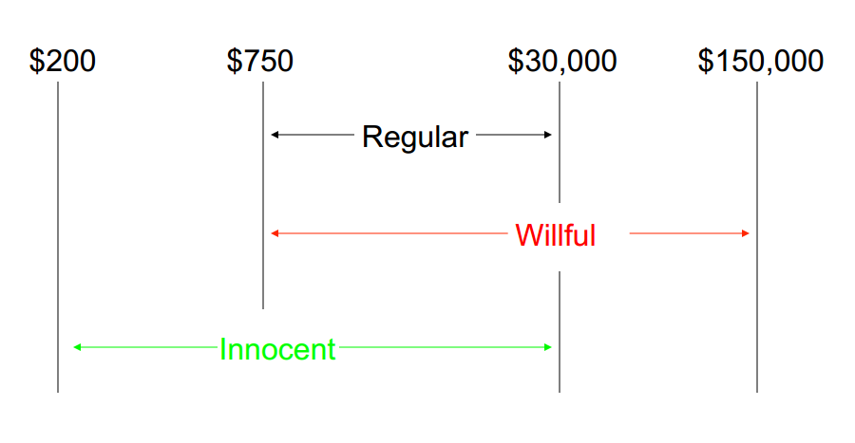
Figure 122: Ranges of statutory damages

Who picks the amount of statutory damages within these broad ranges? Congress, as you can see from the text of the statute, clearly contemplated that “the court,” meaning the trial judge, would make that determination. But the United States Supreme Court in the Feltner case determined that the Seventh Amendment provides a right to a jury trial in all issues pertinent to an award of statutory damages under Section 504(a), including the amount of the award itself. The upshot is that every time you see the word court in 504(c), you should replace it with the word jury. What factors should the decision maker rely upon when setting that amount? The only guideline the statute itself provides is that it should be the amount that the court considers just. When, after Feltner, courts delegate this determination to juries, they usually instruct the juries to pick the amount the juries consider just. Sometimes the judges suggest other factors that the jury could consider when making their choice, such as evidence of how much the plaintiff was actually harmed, the need to deter wrongdoing in the future, the nature of the plaintiff’s work, and so forth. But these are just suggestions. Within the ranges set by the statute, the jury is largely in constraint.
If the defendant has infringed only one of the plaintiff’s copyrighted works, say a novel or a musical composition, then as we’ve seen, the maximum amount of statutory damages the plaintiff can recover is $150,000. But if the plaintiff has infringed two of the plaintiff’s works, the amount doubles. If three, it triples, and so forth. The key variable, to repeat, is not the number of occasions on which the defendant has engaged in an infringement. It’s the number of works he has infringed. In some cases, that number is not obvious. For example, if I rip a CD containing 12 sound recordings, have I infringed one work or 12? For obvious reasons, it makes a big difference. The general standard the courts use in such circumstances is that the individual pieces are deemed distinct works if and only if they have independent economic value, and applying that criterion, courts unavoidably exercise some discretion and often tacitly exercise that discretion in an effort to do rough justice.
A crucial limitation on the availability of statutory damages is that with narrow exceptions, they are only available if the plaintiff registered her work prior to the defendant’s infringement. As you know from lecture number six, registration of a copyright is now optional in the US. But registration gives a copyright owner some advantages. The availability of statutory damages in case of infringement is perhaps the most important of those advantages.
In addition to damages of these three sorts, parties who prevail in copyright infringement suits can sometimes recover their court costs and their attorney’s fees. These amounts are not trivial. Attorney’s fees in particular can be very large. Indeed, anxiety about possible liability for attorney’s fees is often the principal driver that motivates settlements of infringement suits. That anxiety derives in part from the fact that both costs and attorney’s fees are more commonly awarded in copyright cases than in most other types of suit in the United States. With respect to both costs and fees, the trial court is empowered to make awards “in its discretion.” The kinds of factors the courts look to when exercising that discretion include the strength of the losing party’s substantive arguments – the stronger they were, the less likely will be the court to award fees – the legitimacy of the reasons why the losing party litigated the case, the need to deter abusive litigation by similarly situated parties in the future, conversely the importance of not deterring legitimate efforts to defend legal rights or to resolve unsettled legal issues, and so forth. The same standards are applied when assessing requests for costs and fees made by prevailing defendants as when assessing such suggestions made by victorious plaintiffs.
An intriguing variation on these themes suggested by Judge Posner in the Gonzalez case is that a judge should be more willing to award attorney’s fees, particularly when the defendant’s behavior was willful, if the magnitude of the compensatory or statutory damages that the plaintiff could collect is modest. And thus, unless the plaintiff could recover such fees, she might be disinclined to assert her rights.
Finally, it should be emphasized that attorney’s fees, like statutory damages, are only available to copyright owners who registered their works prior to the infringement. This reinforces the incentive I mentioned to register one’s works.
Underlying this rather intricate combination of rules are five general themes or objectives. Sometimes these themes reinforce one another, but sometimes they are in tension. When considering how, if at all, this system of remedies should be modified, it’s helpful to bring these objectives to the surface. When they conflict, it’s necessary to decide which is the more important.
Purposes behind seeking damages
- Compensation
- Avoid unjust enrichment
- Deterrence
- Punishment
- Maintain the balance between private rights and the public interest
The first, and least surprising purpose, is to compensate copyright owners. In other words, to indemnify them against loss. A copyright owner who’s been injured by a defendant’s infringement should be able to recoup from the defendant all of her losses.
All four of the general theories of copyright law we have considered in this lecture series provide support for this first objective. Viewed through the lens of either fairness or personality theory, the rights that the law confers upon copyright owners are grounded in moral considerations. The moral right to a fair return for one’s hard creative work, or the moral right to protection of the fragile bond between oneself and one’s creations. Fidelity to those moral considerations requires at a minimum that copyright owners not suffer uncompensated injuries when their legal rights are abridged. Viewed through the lens of either welfare or cultural theory, the rights that the law accords authors and artists are designed to induce them to behave in ways that will advance some larger goal, generating and disseminating works that will advance net social welfare, or will foster a rich and stimulating culture. Authors and artists will not be so induced if they are exposed to uncompensated abridgments of their rights. So, as to this first point, there’s not much controversy.
The second of the objectives is the prevention of unjust enrichment. We don’t want infringers to profit from their wrongdoing even if copyright owners do not suffer thereby. This is a very common sentiment. Not just in copyright law, but in other fields as well. It looms large in contract law, for example. But despite its ubiquity, it’s harder to justify and harder to connect convincingly to the general theories upon which copyright law rests. It seems connected to the same intuition that prompts us to recoil or object when a murderer writes a book recounting his crime and collects royalties from it.
The third goal helps reinforce the somewhat shaky foundations of the second – deterrence. We want to craft remedies that discourage potential infringers from violating copyright owners’ entitlements in the future. Litigation is enormously time consuming and painful. A copyright owner forced to litigate can never be truly made whole. Thus, if possible, we want to deter people from infringing their rights in the first instance. One way to do so is to award and publicize monetary judgments that will make potential defendants think twice or thrice.
The fourth ambition is punishment. Copyright infringement is wrong. We want to penalize the people who engage in it. Not just to deter similar conduct in the future, but because the infringers deserve it. Another word for this is retribution.
Finally, copyright law, as you know by now, aspires to create and maintain a delicate balance between on one hand, the entitlements of creators, and on the other hand, the interests of the public in making use of their creations. The primary expression of the latter is the long list of statutory and judicial exceptions and limitations. Embedded in the copyright statute, the most famous of which the United States is the Fair Use Doctrine. Against this back drop, we want to craft a set of remedies that will maintain that balance. In particular, just as we want to ensure that copyright owners have appropriate incentives to assert their rights, so we want to ensure that users have appropriate incentives to assert their privileges. In this respect, copyright infringement is fundamentally different from homicide say, or rape. In those contexts, we’re not particularly concerned about over enforcement. If someone is not entirely sure what constitutes manslaughter or sexual assault and his behavior is, to use the legal vernacular, “chilled” a bit, we’re not troubled. That such people are prompted to steer well clear of a vague line is not a serious problem. And copyright law, by contrast, chilling borderline behavior – in other words, discouraging people from engaging in activities that approach but do not cross the line of legality – is a serious problem. When setting and interpreting the rules governing damage awards, we want to avoid it. By now, the reason why these goals sometimes conflict should be clear. Goal number three, and even more so goal number four, sometimes counsel larger awards than is optimal from the standpoint of goal number five.
The context in which these considerations are currently most salient is statutory damages. Most countries in the world do not currently permit copyright owners to recover statutory damages. A thorough analysis of the law of each nation in this regard can be found in a forthcoming article by Pam Samuelson, Tara Wheatland, and Phil Hill. Phil, as I think you know, is one of the teaching fellows in the edX course for which these lectures were in part prepared. The authors of that study demonstrate that only 24 of the 177 member states in the World Intellectual Property Organization currently allow recovery of statutory damages. And very few of the countries that do have such regimes also have copyright based industries comparable in size and health to those in the United States. The US is currently trying to change the state of affairs. Its diplomatic representatives are using various levers to try to induce other nations to adopt systems that resemble the system in force in the US. Why? Primarily because US based organizations representing at least some copyright owners have asked them to do so.
Critics of this initiative make three arguments.
First, many countries, unlike the United States, regard punishment of offenders as an inappropriate function of civil damage awards. Punishment, they believe, should be left to the criminal law, to which we’ll return in the last segment of this lecture. The reason why this is relevant is that over time, the US system of statutory damages has gradually taken on an ever more punitive role. Originally adopted primarily as a mechanism to provide compensation for copyright owners who have trouble proving the magnitude of the injuries they suffer, it now works in large part to penalize infringers. Many observers, especially outside the US, think that that’s not a role for private lawsuits.
Second, the critics point out that the broad ranges of permissible awards under the US system and the paucity of meaningful guidance concerning how awards should be set within those ranges give judges and now juries too much discretion and result, consequently, in unpredictable, even arbitrary awards. Uncertainty of this sort is especially threatening to the delicate balance between private rights and the public interest.
Third, and finally, some critics point out that the statutory damage system generates perverse results when applied in situations in which a defendant infringes a large number of works, each of which has only modest economic value. Because as we’ve seen, copyright owners are permitted to recover statutory damages for each work, the result is to enable them to recover amounts that dwarf the injuries that the copyright owners actually suffer.
The context in which this unanticipated problem has proven especially serious has been file sharing. The large majority of the individual defendants who’ve been sued by the record companies for unlawfully copying and redistributing sound recordings through file sharing networks have settled the claims for modest amounts of money. But the few defendants who have not settled have incurred enormous awards. Jammie Thomas Rasset, for example, was found to have infringed the copyrights in 24 recordings, and after a series of three trials, ended up with a damage award of $222,000. Joel Tenenbaum was found to have willfully violated the copyrights in 30 recordings and ended up with a damage award of $675,000. In both of those cases, the trial judges balked at the magnitude of the jury’s awards. In both instances, the judges concluded that the awards were so large as to violate the federal constitution. In both instances, however, the Court of Appeals reversed. Although the grounds on which the two courts of appeals did so differed, in the Thomas-Rasset case, the Eighth Circuit rejected the defendant’s constitutional argument on the following ground. “Applying the Williams standard, we conclude that an award of $9,250 per each of the 24 works is not so severe and oppressive as to be wholly disproportionate to the offense and obviously unreasonable.” Congress, exercising its wide latitude of discretion, set a statutory damages range for willful copyright infringement of $750 to $150,000 per infringed work. The award here is toward the lower end of this broad range. As in Williams, the interests of the public, the numberless opportunities for committing the offense, and the need for securing uniform adherence to federal law support the constitutionality of the award. In the Tenenbaum case, the First Circuit concluded that the trial judge should have avoided the constitutional question. However, in so ruling, the First Circuit strongly intimated that like the Eighth Circuit, it believed the Constitution had not been violated.
24 sound recordings
1. | $222,000  District Court grants new trial, after concluding that it has misinterpreted “distribution”
2. | $1,920,000  District Courts reduces to $54,000
3. | $1,500,000  District Courts reduces to $54,000;  Eighth Circuit Court of Appeal grants RIAA’s motion to reinstate $222,000
Figure 123: Verdicts in the Thomas-Rassett case

In both of these cases, the United States Supreme Court declined to review the Court of Appeals decision. As a result, we do not yet have a conclusive answer concerning the constitutionality of such applications of the statutory damage regime. And we’re not likely to get a conclusive declaration in the near future. The net result is that the struggle over statutory damages will continue in the political arena. Reformers in the United States will seek to curb them. Skeptics in other countries will likely continue to resist them, or more modestly, to discipline statutory damages with guidelines more precise than the vague standards used in the US. By contrast, representatives of copyright based industries in the United States will continue to defend statutory damages and argue for the adoption of the US model elsewhere. How this struggle will end remains to be seen.

Criminal Penalties
I suggested, in the preceding segment of this lecture, that many people believe that retribution and perhaps deterrence are inappropriate roles for private copyright infringement suits. Such things, is commonly said, should be left to the criminal law. Why? In part because the government, representing the people as a whole not individual parties, is the right party to identify behavior worthy of punishment and to impose such punishments. A more subtle explanation sometimes offered is that enforcement of criminal law, unlike enforcement of civil law, is controlled by prosecutors who can and do exercise discretion in selecting, from among the surplus of potentially punishable actions, those that truly merit prosecution. Arguably, in short, there’s an important role for criminal sanctions in the law of copyright.
For better or worse until recently, the role that criminal law actually played was modest. Although the United States first adopted criminal copyright penalties in 1897, until the late 20th Century, they were rarely applicable to instances of copyright infringement and even more rarely enforced. In the last 15 years, the tide has turned. Congress repeatedly has both expanded the set of activities that are subject to criminal penalties and increased the magnitude of those penalties. Prosecutions, relying on the strength and rules, have been increasing. Here are a few manifestations of this trend.
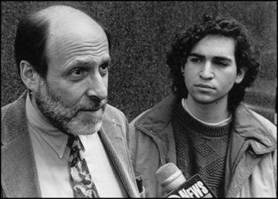
Figure 124: David LaMacchia (right) with his lawyer

In 1994, David LaMacchia, then an MIT graduate student shown in Figure 124 with his lawyer, set up an electronic bulletin board and encouraged users to upload to it copies of popular commercial software programs which other users could then download to their own computers. At the time, Section 505(a) of the copyright statute was, in the court’s judgment, the only applicable criminal provision, and it required the government to prove that the defendant acted quote willfully and for the purpose of commercial advantage or private financial gain close quote. Because LaMacchia had not sought to profit in any way from his actions, he escaped liability. In response, Congress adopted the so-called No Electronic Theft Act, which closed what it saw as a loophole by adding, as an additional possible basis of liability, that the defendant made multiple copies of copyrighted works worth more than $2,500. The relevant provision has since been amended to make it even easier for the government. The current version of Section 505(a) allows conviction upon a showing that the defendant reproduced or distributed during any 180-day period one or more copies or phonorecords of one or more copyrighted works, which have a total retail value of more than $1,000. These statutory adjustments have since enabled the government to secure guilty pleas from defendants who engaged in conduct similar to LaMacchia’s.
The growth of criminal copyright
- 1997: No Electronic Theft Act
- 1998: Digital Millennium Copyright Act (DCMA)
- 2004: Anti-Counterfeiting Amendments Act
- 2005: Family Entertainment and Copyright Act
- 2008: Prioritizing Resources and Organization for Intellectual Property Act (“Pro-IP Act”)
- 2011: Anti-Counterfeiting Trade Agreement (ACTA)
It should be emphasized that the pertinent criminal penalties are not trivial. In addition to fines, defendants convicted under 505(a) are potentially subject to substantial terms of imprisonment. Back to our list. As you know from the previous lecture, in 1998, Congress adopted the Digital Millennium Copyright Act, which, among other things, added to the copyright statute Section 1201, which imposes serious criminal sanctions on persons who circumvent technological protection measures or traffic in technology designed for such circumvention. In 2004, Congress adopted the Anti-Counterfeiting Amendments Act, which criminalized trafficking in false labels on copyrighted works. The following year, it added the Family Entertainment and Copyright Act, which penalized the recording of movies in theaters. Finally, in 2008, Congress adopted the Prioritizing Resources and Organization for Intellectual Property Act, the Pro-IP Act for short, which converted to felonies most copyright related offenses that previously had been misdemeanors and increased the resources of the Justice Department for pursuing IP related crimes.
Since then, the United States has sought during trade negotiations to persuade other nations to increase the levels of criminal copyright enforcement in their own jurisdictions. The most important such initiative to date is the Anti-Counterfeiting Trade Agreement, in whose negotiation the United States was a major participant. Article 23 of ACTA requires member countries, among other things, to quote provide for criminal procedures and penalties to be applied at least in cases of willful copyright or related rights piracy on a commercial scale. The next clause in the provision attempts to grapple with the same issues addressed in the No Electronic Theft Act “acts carried out on a commercial scale include, at least those carried out as commercial activities for direct or indirect economic or commercial advantage.”
As you know from lecture number one, ACTA has not yet entered into force and may never do so. But if it does, it will extend the US trend toward increasingly expensive criminal copyright liability to other member countries.
These legislative initiatives have been accompanied by an increasing in the frequency of prosecution, both in the US and in other countries. Among the most high-profile cases was the successful prosecution in Sweden of the four people who set up and ran the file sharing site Pirate Bay, although the Swedish authorities seem to have had trouble enforcing the relatively modest prison terms and fines imposed on those four defendants. Even more notorious are the ongoing efforts of the US prosecutors to extradite and prosecute Kim Dotcom, the flamboyant creator of the New Zealand-based site Megaupload. Before it was shut down, Megaupload was definitely a for profit enterprise. Between 2005 and 2012, according to the indictment in the case, Megaupload earned more than $150 million in paid subscriptions and more than $25 million in advertising fees. In 2010 alone, Mr. Dotcom himself earned more than $42 million.
Not all of these prosecutions have resulted in convictions. For example, Isamu Kaneko, the Japanese developer of the Winny file sharing system, was ultimately acquitted on the ground that the system, although most often used for illegal purposes, was capable of substantial non-infringing uses. Note the echo of the Betamax CONSU defense here. But in most of these cases, the government has ultimately prevailed.
One of the most recent prosecutions came painfully close to home. Aaron Swartz was a brilliant young programmer and internet activist. Among many other things, he helped found the social news site Reddit and helped Larry Lessig establish Creative Commons about which you learned in lecture number six. Swartz believed deeply that information of all sorts should be widely accessible. And that belief proved his undoing. In 2011, while he was a fellow at Harvard’s Safra Center, Swartz surreptitiously downloaded a large number of journal articles from the website of JSTOR, a massive nonprofit repository of such articles, to a laptop computer that he placed in a closet at the Massachusetts Institute of Technology. Most likely, Swartz intended to make the articles available to the public at large. But he never did so. His actions were detected, and he was arrested. He subsequently returned to JSTOR all of the data he had downloaded. JSTOR itself, the ostensible victim of Swartz’ misconduct, released a statement indicating that it would not bring a civil copyright infringement suit against him and did not support a criminal prosecution. Nevertheless, the United States Attorney in Boston pressed forward with the prosecution. Swartz was indicted, not for violating Section 506(a), but for “wire fraud, computer fraud, unlawfully obtaining information from a protected computer, and recklessly damaging a protected computer.” In a press release accompanying the indictment, the US Attorney announced that “if convicted on these charges, Swartz faces up to 35 years in prison to be followed by three years of supervised release, restitution, forfeiture, and a fine of up to $1 million.”
Swartz’s lawyer sought to negotiate a plea bargain. The prosecutors reportedly were willing to accept a deal under which Swartz would serve only six months in jail but no less. The lawyers failed to come to terms. A trial loomed. In January of this year, at the age of 26, Swartz committed suicide. Several forces and circumstances undoubtedly contributed to his decision to end his life, but one of them, undoubtedly, was anxiety caused by the ongoing prosecution and the prospect of a trial and likely conviction and imprisonment.
His suicide could and should have been avoided. To be sure, Swartz most likely had committed a crime. Owen Kerr a specialist in this field, may well have been right when he wrote, “All of the charges against Swartz were based on established case law. Indeed, once the decision to charge the case had been made, the charges brought here were pretty much what any good federal prosecutor would have charged.” But one of the crucial responsibilities of a prosecutor is to decide not just when successful criminal prosecution is possible but when it is appropriate. Prosecutors, as we’ve seen, have discretion not to bring charges at all, to bring lesser charges than they might, or to accept lenient plea bargains. This is just the sort of case in which the exercise of such discretion is warranted, even demanded. Swartz’s motives were altruistic, not mercenary. He had no interest in making money. His goal was to make scholarship more widely available. The contrast between his motives and those of all the other defendants I canvased a few minutes ago is stark. JSTOR, the victim of his unlawful behavior, acknowledged that JSTOR had not been harmed and sought no civil remedy.
Now, to repeat, Swartz was certainly not blameless. Arguably, his actions were misguided. A colorable argument could be made that the uncontrolled dissemination of scholarly articles that he sought to accomplish would have seriously disrupted the business of academic publishing and thus threaten several the interest that this course has sought to highlight. A better, more responsible way of making scholarship more widely available would have been either to seek reform of the copyright statute or the rules that govern governmentally-funded research, or as my colleague Stuart Shieber has done, to persuade professors or their universities to insist that academic articles be posted on publicly available websites. In short, the methods that Swartz chose to pursue his vision may well have been wrong. But there’s a big difference between misguided idealism and the sort of self-serving piracy at which the criminal statutes are primarily aimed. Perhaps some sort of criminal penalty was warranted in this case, perhaps a deferred prosecution agreement which would have been effective in preventing Swartz from engaging in similar conduct in the future – perhaps – but certainly not six months in jail. In short, the prosecutors in this case failed to exercise their power wisely. I know and respect one of those prosecutors. He’s not a cruel person. But he and his colleagues acted irresponsibly, and the result was tragedy.
From that tragedy, at least two lessons can be drawn. First, criminal sanctions are both formidable and dangerous. They have important social functions, but their power makes them risky. The hazard that they will be imposed in appropriate circumstances is exacerbated by the large and increasing diversity of the sets of circumstances, and the kinds of technologies implicated by copyright law, and the kinds of activities that may constitute copyright infringement. It’s impossible for legislators to anticipate all of those circumstances and to differentiate them on the basis of the severity of the harms they threaten and consequently the severity of the sanctions they merit. It’s, thus, imperative that the people who control the machinery, the criminal law exercise their power sensitively and wisely.
The second broader point is that the copyright system as a whole is an extraordinarily complex and powerful machine. As I hope you now see, it affects myriad dimensions of the global economy and culture. It seeks, simultaneously, to advance many different social goals and to protect many different rights and freedoms, some of which are intention. Effectively operating a machine this complex and important requires care and, again, wisdom. When tuned intelligently and deployed thoughtfully, copyright has enormous and growing benefits. If it is out of tune or deployed thoughtlessly, it can cause great harm. My ambition in this lecture series has been to provide you the information and analytical tools you need not just to understand the copyright system as it currently exists but to participate in the ongoing project of adopting that machine to deal responsibly with changing social and cultural circumstances. I hope you have found the lectures helpful in this regard. Thank you for your patience and attention.

Appendices
- Sources
Figure 4: Studio photograph of Oscar Wilde taken by Napoleon Sarony, the subject of Burrow-Giles Lithographic Co. v. Sarony 111 U.S. 53 (1884), page 10
http://www.oscarwildeinamerica.org/sarony/sarony-photographs.html#item119

Figure 8: A maps showing the Berne Convention signatory countries (as of January 2016), page 36
https://en.wikipedia.org/wiki/File:Berne_Convention_signatories.svg

Figure 9: Berlin Hauptbahnhof, designed by Meinhard von Gerkan, page 36
https://commons.wikimedia.org/wiki/File:Berlinhbf.jpg
Figure 13: The Dickson-Edison Kinetoscope, page 47
http://www.pbs.org/wgbh/amex/edison/gallery/05.html

Figure 16: Buddhist monks from the Namgyal Monastery creating a sand mandala, page 55
http://www.namgyal.org/mandalas/background.cfm

Figure 19: Press release by the Recording Industry Association of America (RIAA) welcoming the introduction of the Performance Rights Act, page 60
http://www.riaa.com/newsitem.php?id=7BE7264B-5BC4-C823-777D-73D5B410805A

Figure 20: Press release by the National Association of Broadcasters (NAB) opposing the introduction of the Performance Rights Act, page 61
http://www.nab.org/advocacy/issue.asp?id=1889

Figure 26: Brandir International, Inc. v. Cascade Pacific Lumber Co. – the Bandir ribbon rack, page 73
http://www.ribbonrack.com
Figure 27: Two of cheerleading uniforms offered by Varsity Brand, page 74
http://midsizeinsider.com/en-US/24/varsity-brands-boosts-the-business-of-ch#.VndyYlqSUig (site now defunct)

Figure 28: Five of the cheerleading uniform registrations belonging to Varisty Brand, page 75
https://www.bg.law/u-s-supreme-court-issues-decision-in-star-athletica-l-l-c-v-varsity-brands-inc-et-al

Figure 29: The Jewish Museum in Berlin, designed by Daniel Libeskind, page 77
http://daniel-libeskind.com

Figure 56: The Toyota Solera, page 110
http://www.youdontknowblog.com/wp-content/uploads/imgToyota-Solara2.jpg

Figure 59: The RMS Titanic, page 111
http://www.noaanews.noaa.gov/stories2011/20110531_rmstitanic.html

Figure 60: A photo of the bow of the Titatnic wreck, page 112
https://en.wikipedia.org/wiki/File:Titanic_wreck_bow.jpg

Figure 61: Poster for the musical play “Rent” – Oregon version, page 113
https://en.wikipedia.org/wiki/File:Rentpostera.jpg

Figure 62: Poster for the musical play “Rent” – Jarkarta version, page 114
http://winminded.deviantart.com/art/Rent-Musical-in-Jakarta-poster-303978929

Figure 64: James Earl Reid's sculpture commemorating homelesness, page 123
http://www.unc.edu/~unclng/display5-05.htm

Figure 67: Copyright registrations (excluding renewals), 1910 – 2000, page 136
From Christopher Sprigman, “Reformalizing Copyright,” 57 Stan. L. Rev. 485, 499 (2004).

Figure 68: Rate of copyright renewals, 1910 – 2000, page 136
From Christopher Sprigman, “Reformalizing Copyright,” 57 Stan. L. Rev. 485, 499 (2004).

Figure 91: The mayor character in the TV show “Fun Stuff” contrasted with the mayor of McDonaldland, page 176
http://24.media.tumblr.com/tumblr_m6ceznOrWv1r8rcv1o1_500.jpg

Figure 93: Prince’s “Love Symbol #2”, page 182
https://upload.wikimedia.org/wikipedia/en/thumb/a/af/Prince_logo.svg/2000px-Prince_logo.svg.png

Figure 94: Pickett's guitar design, page 182
https://princeology.files.wordpress.com/2007/09/symbol.jpeg

Figure 109: Mattel’s Barbie and photos from Forsythe’s series “Food Chain Barbie”, page 235
http://s7d2.scene7.com/is/image/Mattel/N4978_02?$null$ [Barbie]
http://web.archive.org/web/20041210175947/http://ncac.org/store/forsythesphotos.htm [Forsythe’s photos]

Figure 114: Implementation status of the 22 exceptions and limitations to copyright for all 28 EU member states, page 249
http://copyrightexceptions.eu

Figure 121: US consumer home entertainment rental and sell-through spending (2010), page 305
http://forums.highdefdigest.com/high-definition-smackdown/118789-npd-more-people-buy-dvds-than-watch-netflix-streaming-3.html

Figure 124: David LaMacchia (right) with his lawyer, page 321
http://tech.mit.edu/V114/N68/lamacchia.00n.html

- Document History

Version | Date | Description | Author
1.0 | 2017/04/12 | First release. | Marc Pelteret
1.1 | 2018/01/08 | Updated chapter 9.3. (new lecture video). | Marc Pelteret
1.2 | 2018/02/07 | Updated chapter 3.6. (new lecture video). | Marc Pelteret

The following video lectures were used as the basis for this document.

Lecture Title | Lecture Date | Updated in Document Version
01.1 The Foundations of Copyright Law - Introduction | 7 January 2016 | 1.0
01.2 The Foundations of Copyright Law - Originality | 7 January 2016 | 1.0
01.3 The Foundations of Copyright Law - Idea-Expression Distinction | 7 January 2016 | 1.0
01.4 The Foundations of Copyright Law - Multilateral Treaties | 7 January 2016 | 1.0
02.1 Fairness and Personality Theories - Introduction | 14 January 2013 | 1.0
02.2 Fairness and Personality Theories - Fairness | 14 January 2013 | 1.0
02.3 Fairness and Personality Theories - Personality | 14 January 2013 | 1.0
03.1 The Subject Matter of Copyright - Literature (and Software) | 4 November 2014 (reformatted) | 1.0
03.2 The Subject Matter of Copyright - Drama and choreography | 4 November 2014 (reformatted) | 1.0
03.3 The Subject Matter of Copyright - Music | 4 November 2014 (reformatted) | 1.0
03.4 The Subject Matter of Copyright - Audiovisual Works | 4 November 2014 (reformatted) | 1.0
03.5 The Subject Matter of Copyright - Fictional Characters | 4 November 2014 (reformatted) | 1.0
03.6 The Subject Matter of Copyright - Architectural Works | 8 January 2018 | 1.2
04.1 Welfare Theory - The Utilitarian Framework | 13 December 2013 | 1.0
04.2 Welfare Theory - The Incentive Theory of Copyright | 13 December 2013 | 1.0
04.3 Welfare Theory - Applications and Assessment | 13 December 2013 | 1.0
05.1 Authorship - Sole Authorship | 4 November 2014 (reformatted) | 1.0
05.2 Authorship - Joint Authorship | 4 November 2014 (reformatted) | 1.0
05.3 Authorship - Works for Hire | 4 November 2014 (reformatted) | 1.0
06.1 The Mechanics of Copyright - The Decline of Formalities | 4 November 2014 (reformatted) | 1.0
06.2 The Mechanics of Copyright - Duration | 4 November 2014 (reformatted) | 1.0
06.3 The Mechanics of Copyright - Protective Provisions | 4 November 2014 (reformatted) | 1.0
07.1 The Rights to Reproduce and Modify - Reproduction | 19 February 2013 | 1.0
07.2 The Rights to Reproduce and Modify - Improper Approprian | 19 February 2013 | 1.0
07.3 The Rights to Reproduce and Modify - Derivative Works | 19 February 2013 | 1.0
08.1 The Right to Distribute, Perform, & Display - Distribution | 27 February 2014 | 1.0
08.2 The Right to Distribute, Perform, & Display - Performances | 22 October 2014 | 1.0
08.3 Exceptions and Limitations | 27 February 2014 | 1.0
09.1 Fair Use - The History of Fair Use | 6 March 2013 | 1.0
09.2 Fair Use - Fair Use Today | 6 March 2013 | 1.0
09.3 Fair Use - Other Approaches | Uploaded on 27 March 2017 | 1.1
10.1 Cultural Theory - Premises | 11 March 2013 | 1.0
10.2 Cultural Theory - Implications | 11 March 2013 | 1.0
10.3 Cultural Theory - Supplements and Concerns | 11 March 2013 | 1.0
11.1 Supplements to Copyright - Secondary Liability | 29 March 2013 | 1.0
11.2 Supplements to Copyright - Dual-Use Technologies | 29 March 2013 | 1.0
11.3 Technological Protection Measures | 29 March 2013 | 1.0
12.1 Remedies - Equitable Relief | 1 April 2013 | 1.0
12.2 Remedies - Damages | 1 April 2013 | 1.0
12.3 Remedies - Criminal Penalties | 1 April 2013 | 1.0

Benkler, “Coase’s Penguin” (2002) and Benkler, “Sharing Nicely” (2004).
Duncan Kennedy, "Form and Substance in Private-Law Adjudication," 89 Harv. L. Rev. 1685 (1976). http://duncankennedy.net/documents/Form%20and%20Substance%20in%20Private%20Law%20Adjudication.pdf

